Mineral Titles Act
NOTICE OF GRANT OF A MINERAL TITLE
Title Type and Number: | Extractive Mineral Permit 31676
Granted: | 02 October 2023, for a period of 5 Years
Area: | 54.00 Hectares
Locality: | NOONAMAH
Name of Holder/s: | 100% YEBNA SANDS PTY LTD [ACN. 606 114 603]
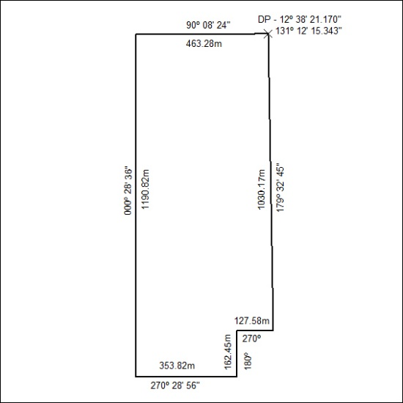

410/23

