Mineral Titles Act 2010
NOTICE OF LAND CEASING TO BE A MINERAL TITLE AREA
Title Type and Number: | Exploration Licence 31692
Area Ceased on: | 27 September 2023
Area: | 4 Blocks, 12.37 km²
Locality: | MALLAPUNYAH
Name of Applicant(s)/Holder(s): | 100% CERBERUS RESOURCES PTY LTD [ACN. 615 192 535]
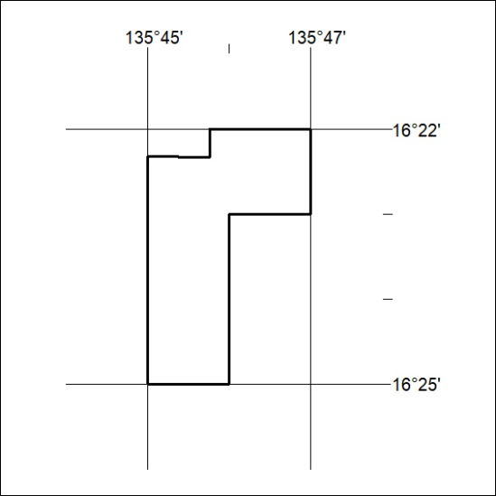

384/23

Mineral Titles Act 2010
NOTICE OF LAND CEASING TO BE A MINERAL TITLE AREA
Title Type and Number: | Exploration Licence 32080
Area Ceased on: | 27 September 2023
Area: | 12 Blocks, 38.13 km²
Locality: | DOREEN
Name of Applicant(s)/Holder(s): | 100% ECLIPSE METALS LIMITED* [ACN. 142 366 541]
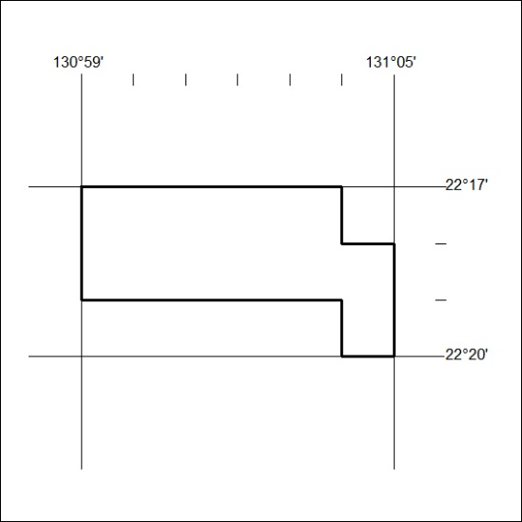

385/23

