Mineral Titles Act 2010
NOTICE OF LAND CEASING TO BE A MINERAL TITLE AREA
Title Type and Number: | Exploration Licence 32879
Area Ceased on: | 13 July 2023
Area: | 45 Blocks, 130.76 km²
Locality: | BATCHELOR
Name of Applicant(s)/Holder(s): | 100% BASE EXPLORATION PTY LTD [ACN. 647 687 652]
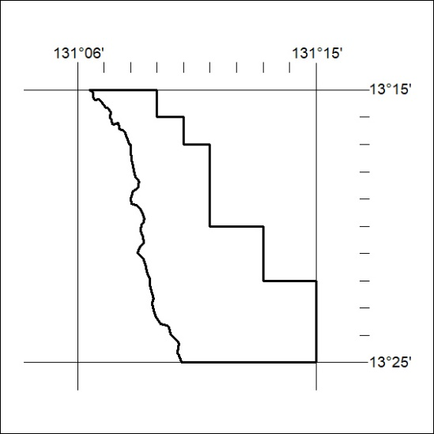

284/23

Mineral Titles Act 2010
NOTICE OF LAND CEASING TO BE A MINERAL TITLE APPLICATION AREA
Title Type and Number: | Exploration Licence 33310
Area Ceased on: | 12 July 2023
Area: | 25 Blocks, 76.70 km²
Locality: | McDILLS
Name of Applicant(s)/Holder(s): | 100% MCCLEARY Norman Sydney
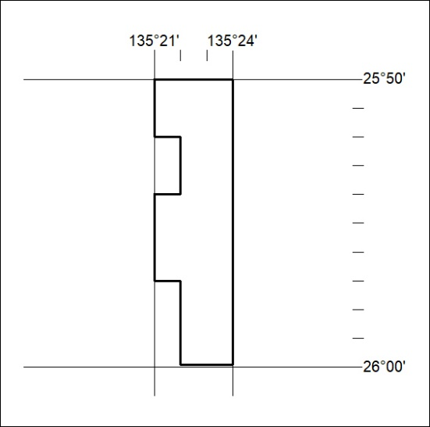

285/23
Mineral Titles Act 2010
NOTICE OF LAND CEASING TO BE A MINERAL TITLE APPLICATION AREA
Title Type and Number: | Exploration Licence 33312
Area Ceased on: | 12 July 2023
Area: | 137 Blocks, 424.64 km²
Locality: | ETINGAMBRA
Name of Applicant(s)/Holder(s): | 100% MCCLEARY Norman Sydney
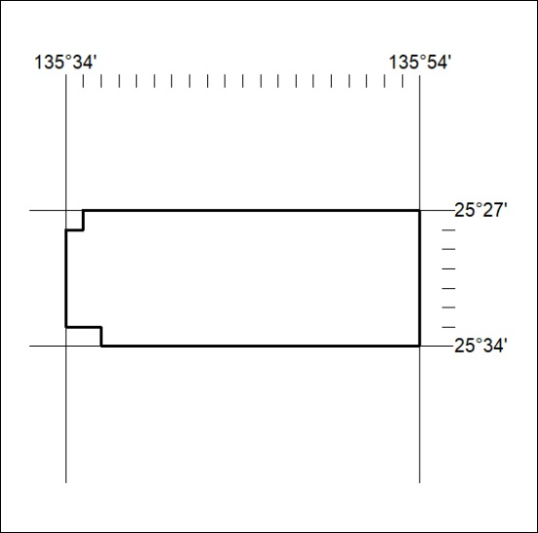

286/23

Mineral Titles Act 2010
NOTICE OF LAND CEASING TO BE A MINERAL TITLE APPLICATION AREA
Title Type and Number: | Exploration Licence 33319
Area Ceased on: | 12 July 2023
Area: | 19 Blocks, 40.29 km²
Locality: | LUKIN
Name of Applicant(s)/Holder(s): | 100% MCCLEARY Norman Sydney
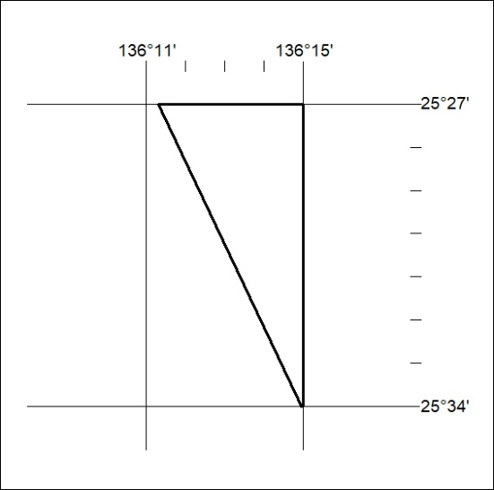

287/23

