Mineral Titles Act 2010
NOTICE OF LAND CEASING TO BE A MINERAL TITLE APPLICATION AREA
Title Type and Number: | Exploration Licence 33304
Area Ceased on: | 12 May 2023
Area: | 250 Blocks, 813.20 km²
Locality: | MITTIEBAH
Name of Applicant(s)/Holder(s): | 100% GIBB RIVER DIAMONDS LIMITED* [ACN. 129 158 550]
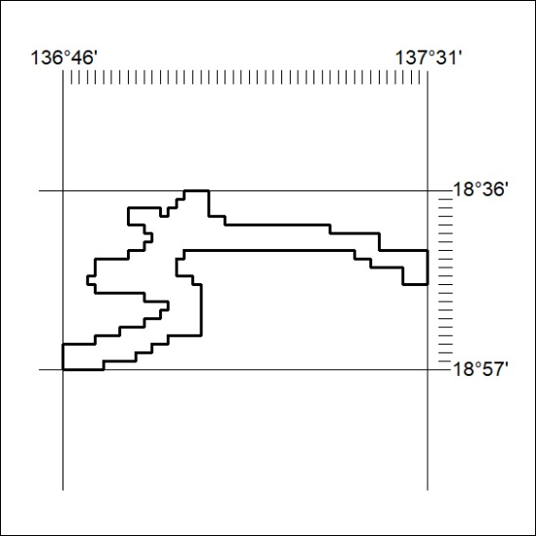

142/23

Mineral Titles Act 2010
NOTICE OF LAND CEASING TO BE A MINERAL TITLE APPLICATION AREA
Title Type and Number: | Exploration Licence 33305
Area Ceased on: | 12 May 2023
Area: | 2 Blocks, 5.70 km²
Locality: | CARRARA
Name of Applicant(s)/Holder(s): | 100% GIBB RIVER DIAMONDS LIMITED* [ACN. 129 158 550]
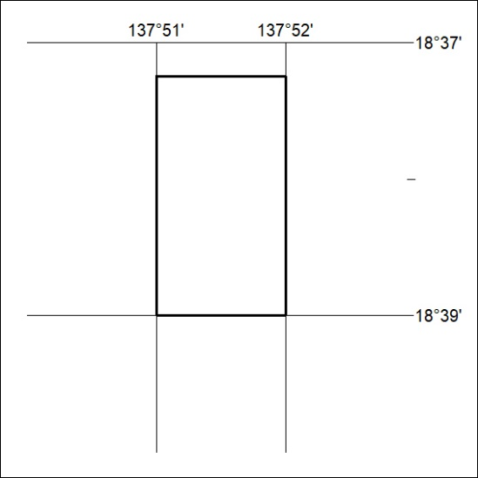

143/23
Mineral Titles Act 2010
NOTICE OF LAND CEASING TO BE A MINERAL TITLE AREA
Title Type and Number: | Extractive Mineral Exploration Licence 32672
Area Ceased on: | 12 May 2023
Area: | 6 Blocks, 12.67 km²
Locality: | AILERON
Name of Applicant(s)/Holder(s): | 100% ARAFURA NOLANS PROJECT PTY LTD* [ACN. 118 158 900]
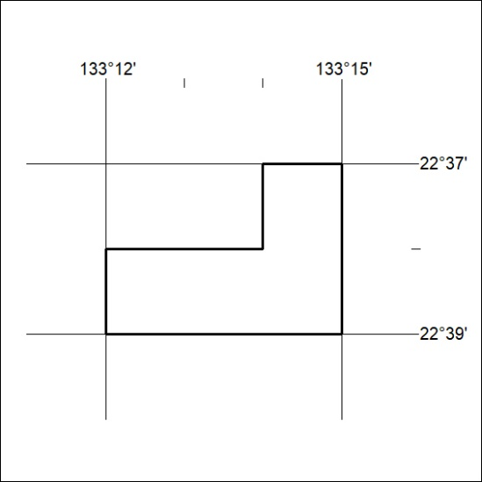

144/23

Mineral Titles Act 2010
NOTICE OF LAND CEASING TO BE A MINERAL TITLE AREA
Title Type and Number: | Extractive Mineral Exploration Licence 32673
Area Ceased on: | 12 May 2023
Area: | 6 Blocks, 12.68 km²
Locality: | AILERON
Name of Applicant(s)/Holder(s): | 100% ARAFURA NOLANS PROJECT PTY LTD* [ACN. 118 158 900]
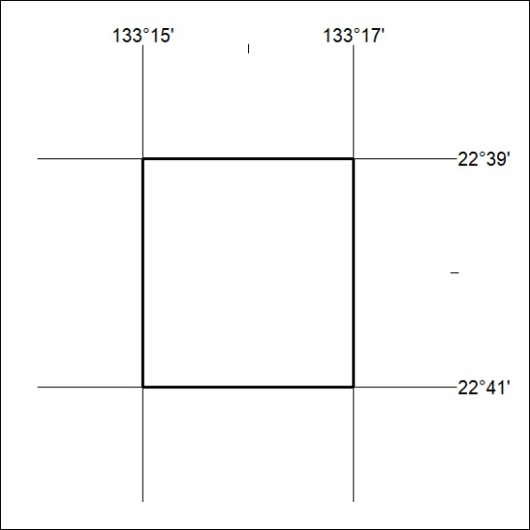

145/23
Mineral Titles Act 2010
NOTICE OF LAND CEASING TO BE A MINERAL TITLE AREA
Title Type and Number: | Extractive Mineral Exploration Licence 32674
Area Ceased on: | 12 May 2023
Area: | 8 Blocks, 12.67 km²
Locality: | AILERON
Name of Applicant(s)/Holder(s): | 100% ARAFURA NOLANS PROJECT PTY LTD* [ACN. 118 158 900]
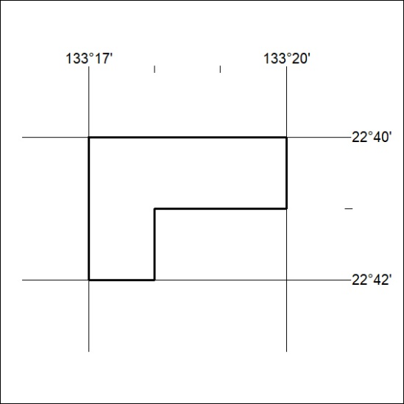

146/23

Mineral Titles Act 2010
NOTICE OF LAND CEASING TO BE A MINERAL TITLE AREA
Title Type and Number: | Extractive Mineral Exploration Licence 32675
Area Ceased on: | 12 May 2023
Area: | 4 Blocks, 12.67 km²
Locality: | AILERON
Name of Applicant(s)/Holder(s): | 100% ARAFURA NOLANS PROJECT PTY LTD* [ACN. 118 158 900]
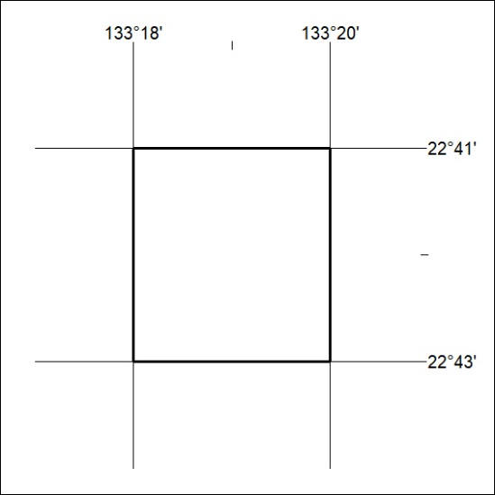

147/23
Mineral Titles Act 2010
NOTICE OF LAND CEASING TO BE A MINERAL TITLE AREA
Title Type and Number: | Extractive Mineral Exploration Licence 32676
Area Ceased on: | 12 May 2023
Area: | 4 Blocks, 12.67 km²
Locality: | AILERON
Name of Applicant(s)/Holder(s): | 100% ARAFURA NOLANS PROJECT PTY LTD* [ACN. 118 158 900]
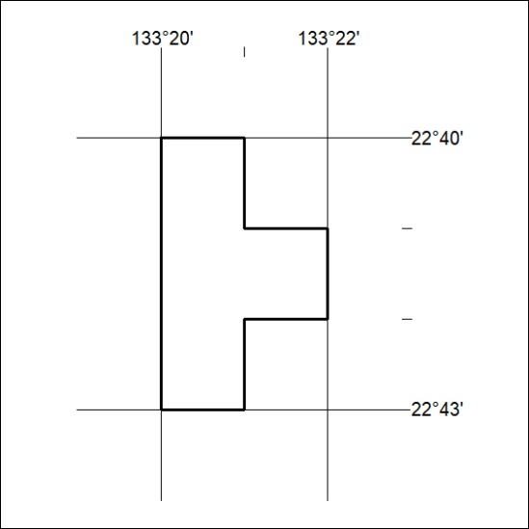

148/23

