Mineral Titles Act 2010
NOTICE OF LAND CEASING TO BE A MINERAL TITLE AREA
Title Type and Number: | Exploration Licence 32682
Area Ceased on: | 18 April 2023
Area: | 53 Blocks, 157.75 km²
Locality: | RIDDOCH
Name of Applicant(s)/Holder(s): | 100% ARC MARLBOROUGH PTY LIMITED [ACN. 127 139 780]
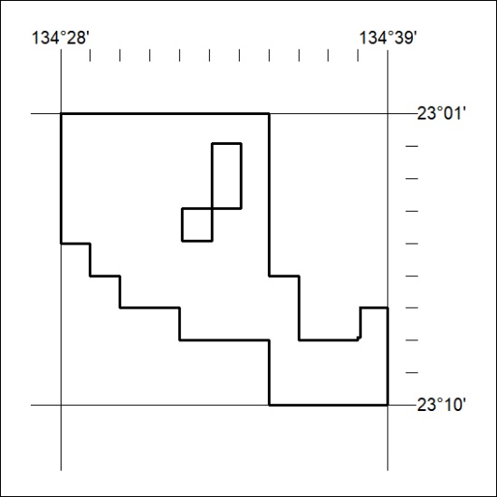

104/23

