Mineral Titles Act 2010
NOTICE OF LAND CEASING TO BE A MINERAL TITLE AREA
Title Type and Number: | Exploration Licence 24329
Area Ceased on: | 27 January 2023
Area: | 18 Blocks, 60.52 km²
Locality: | BATHURST ISLAND
Name of Applicant(s)/Holder(s): | 100% TIWI RESOURCES PTY LTD [ACN. 054 667 051]
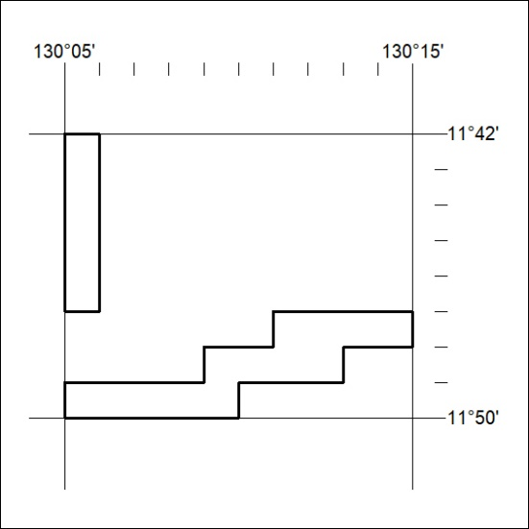

028/23

Mineral Titles Act 2010
NOTICE OF LAND CEASING TO BE A MINERAL TITLE APPLICATION AREA
Title Type and Number: | Exploration Licence 29243
Area Ceased on: | 27 January 2023
Area: | 77 Blocks, 233.12 km²
Locality: | BATHURST ISLAND
Name of Applicant(s)/Holder(s): | 100% RIO TINTO EXPLORATION PTY LIMITED [ACN. 000 057 125]
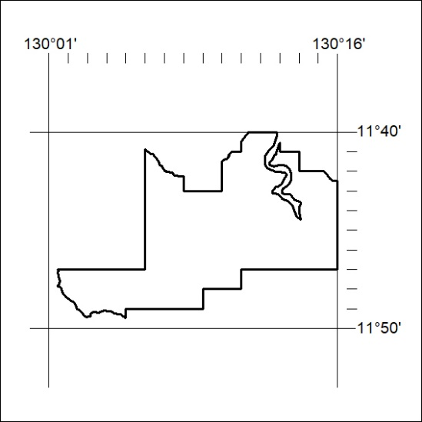

029/23
Mineral Titles Act 2010
NOTICE OF LAND CEASING TO BE A MINERAL TITLE APPLICATION AREA
Title Type and Number: | Exploration Licence 32786
Area Ceased on: | 27 January 2023
Area: | 81 Blocks, 209.30 km²
Locality: | SNAKE BAY
Name of Applicant(s)/Holder(s): | 100% RIO TINTO EXPLORATION PTY LIMITED [ACN. 000 057 125]
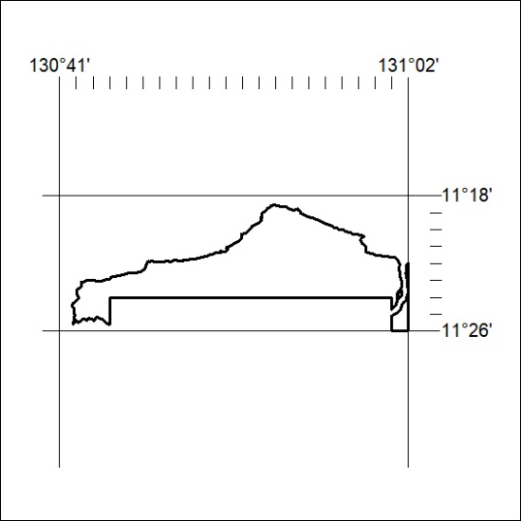

030/23

