Mineral Titles Act
NOTICE OF GRANT OF A MINERAL TITLE
Title Type and Number: | Exploration Licence 32762
Granted: | 11 March 2022, for a period of 6 Years
Area: | 37 Blocks, 117.15 km²
Locality: | DELNY
Name of Holder/s: | 100% IGO NEWSEARCH PTY LTD [ACN. 142 192 701]
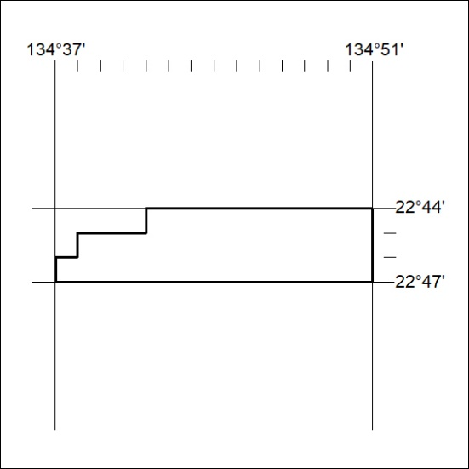
Area granted is indicated above. The titleholder is not permitted to exercise occupational rights on any land that is subject to a development title, or an application for a development title. Any land the subject of a Reserved Land gazettal under the Mineral Titles Act and all land vested in the Commonwealth of Australia is also excluded by description but not excised from the grant area.
54/22

Mineral Titles Act
NOTICE OF GRANT OF A MINERAL TITLE
Title Type and Number: | Exploration Licence 32763
Granted: | 11 March 2022, for a period of 6 Years
Area: | 69 Blocks, 218.54 km²
Locality: | DNEIPER
Name of Holder/s: | 100% IGO NEWSEARCH PTY LTD [ACN. 142 192 701]
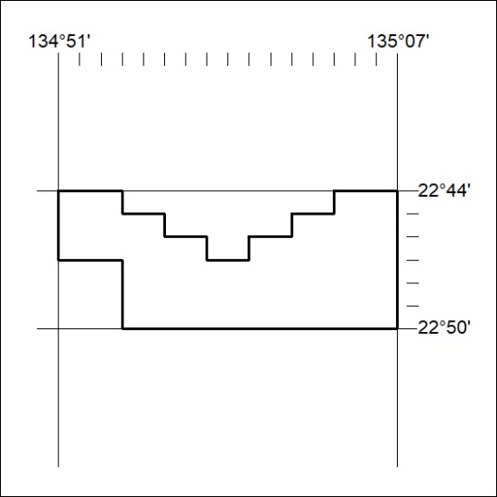
Area granted is indicated above. The titleholder is not permitted to exercise occupational rights on any land that is subject to a development title, or an application for a development title. Any land the subject of a Reserved Land gazettal under the Mineral Titles Act and all land vested in the Commonwealth of Australia is also excluded by description but not excised from the grant area.
55/22

Mineral Titles Act
NOTICE OF GRANT OF A MINERAL TITLE
Title Type and Number: | Exploration Licence 32764
Granted: | 11 March 2022, for a period of 6 Years
Area: | 128 Blocks, 405.47 km²
Locality: | DNEIPER
Name of Holder/s: | 100% IGO NEWSEARCH PTY LTD [ACN. 142 192 701]
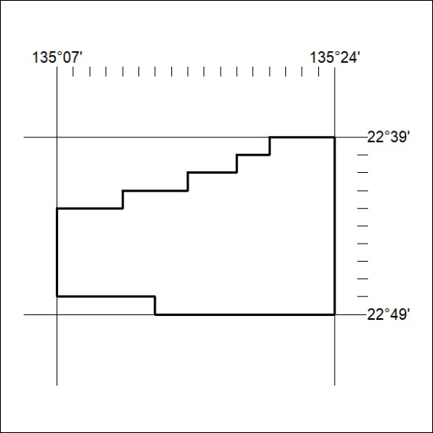
Area granted is indicated above. The titleholder is not permitted to exercise occupational rights on any land that is subject to a development title, or an application for a development title. Any land the subject of a Reserved Land gazettal under the Mineral Titles Act and all land vested in the Commonwealth of Australia is also excluded by description but not excised from the grant area.
56/22

Mineral Titles Act
NOTICE OF GRANT OF A MINERAL TITLE
Title Type and Number: | Exploration Licence 32765
Granted: | 11 March 2022, for a period of 6 Years
Area: | 249 Blocks, 787.63 km²
Locality: | DNEIPER
Name of Holder/s: | 100% IGO NEWSEARCH PTY LTD [ACN. 142 192 701]
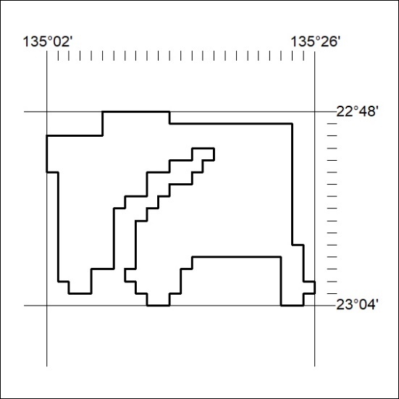
Area granted is indicated above. The titleholder is not permitted to exercise occupational rights on any land that is subject to a development title, or an application for a development title. Any land the subject of a Reserved Land gazettal under the Mineral Titles Act and all land vested in the Commonwealth of Australia is also excluded by description but not excised from the grant area.
57/22

Mineral Titles Act
NOTICE OF GRANT OF A MINERAL TITLE
Title Type and Number: | Exploration Licence 32766
Granted: | 11 March 2022, for a period of 6 Years
Area: | 220 Blocks, 696.49 km²
Locality: | DNEIPER
Name of Holder/s: | 100% IGO NEWSEARCH PTY LTD [ACN. 142 192 701]
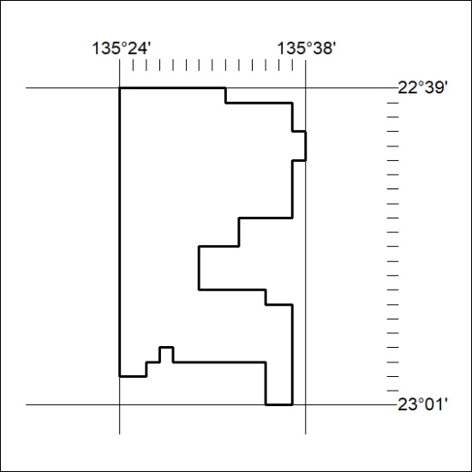
Area granted is indicated above. The titleholder is not permitted to exercise occupational rights on any land that is subject to a development title, or an application for a development title. Any land the subject of a Reserved Land gazettal under the Mineral Titles Act and all land vested in the Commonwealth of Australia is also excluded by description but not excised from the grant area.
58/22

Mineral Titles Act
NOTICE OF GRANT OF A MINERAL TITLE
Title Type and Number: | Exploration Licence 32767
Granted: | 11 March 2022, for a period of 6 Years
Area: | 79 Blocks, 249.40 km²
Locality: | QUARTZ
Name of Holder/s: | 100% IGO NEWSEARCH PTY LTD [ACN. 142 192 701]
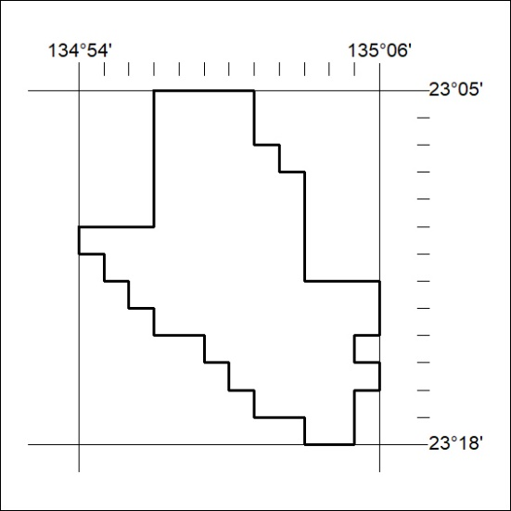
Area granted is indicated above. The titleholder is not permitted to exercise occupational rights on any land that is subject to a development title, or an application for a development title. Any land the subject of a Reserved Land gazettal under the Mineral Titles Act and all land vested in the Commonwealth of Australia is also excluded by description but not excised from the grant area.
59/22

Mineral Titles Act
NOTICE OF GRANT OF A MINERAL TITLE
Title Type and Number: | Exploration Licence 32771
Granted: | 11 March 2022, for a period of 6 Years
Area: | 248 Blocks, 783.03 km²
Locality: | BRAHMA
Name of Holder/s: | 100% IGO NEWSEARCH PTY LTD [ACN. 142 192 701]
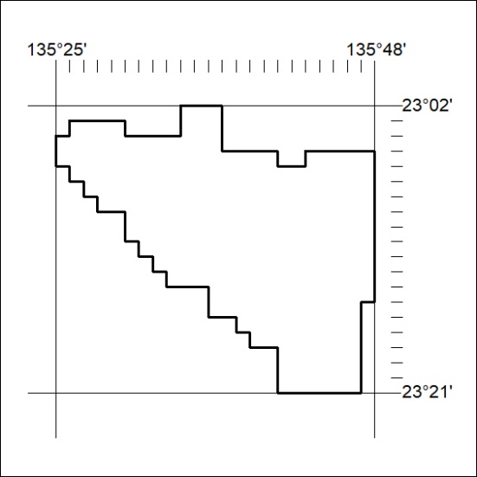
Area granted is indicated above. The titleholder is not permitted to exercise occupational rights on any land that is subject to a development title, or an application for a development title. Any land the subject of a Reserved Land gazettal under the Mineral Titles Act and all land vested in the Commonwealth of Australia is also excluded by description but not excised from the grant area.
60/22

Mineral Titles Act
NOTICE OF GRANT OF A MINERAL TITLE
Title Type and Number: | Exploration Licence 32775
Granted: | 11 March 2022, for a period of 6 Years
Area: | 109 Blocks, 343.86 km²
Locality: | DELNY
Name of Holder/s: | 100% IGO NEWSEARCH PTY LTD [ACN. 142 192 701]
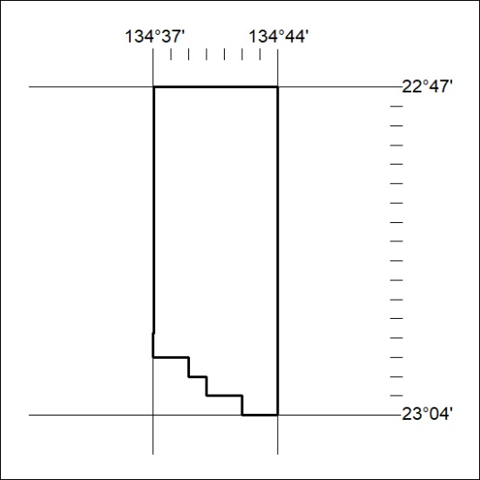
Area granted is indicated above. The titleholder is not permitted to exercise occupational rights on any land that is subject to a development title, or an application for a development title. Any land the subject of a Reserved Land gazettal under the Mineral Titles Act and all land vested in the Commonwealth of Australia is also excluded by description but not excised from the grant area.
61/22

Mineral Titles Act
NOTICE OF GRANT OF A MINERAL TITLE
Title Type and Number: | Exploration Licence 32777
Granted: | 11 March 2022, for a period of 6 Years
Area: | 232 Blocks, 695.76 km²
Locality: | DELNY
Name of Holder/s: | 100% IGO NEWSEARCH PTY LTD [ACN. 142 192 701]
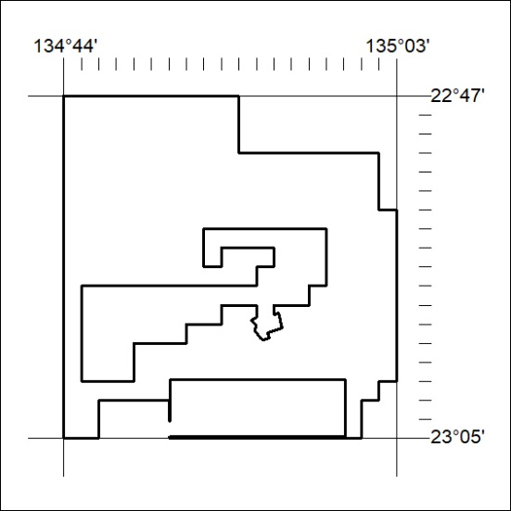
Area granted is indicated above. The titleholder is not permitted to exercise occupational rights on any land that is subject to a development title, or an application for a development title. Any land the subject of a Reserved Land gazettal under the Mineral Titles Act and all land vested in the Commonwealth of Australia is also excluded by description but not excised from the grant area.
62/22

Mineral Titles Act
NOTICE OF GRANT OF A MINERAL TITLE
Title Type and Number: | Exploration Licence 32778
Granted: | 11 March 2022, for a period of 6 Years
Area: | 214 Blocks, 672.17 km²
Locality: | JERVOIS RANGE
Name of Holder/s: | 100% IGO NEWSEARCH PTY LTD [ACN. 142 192 701]
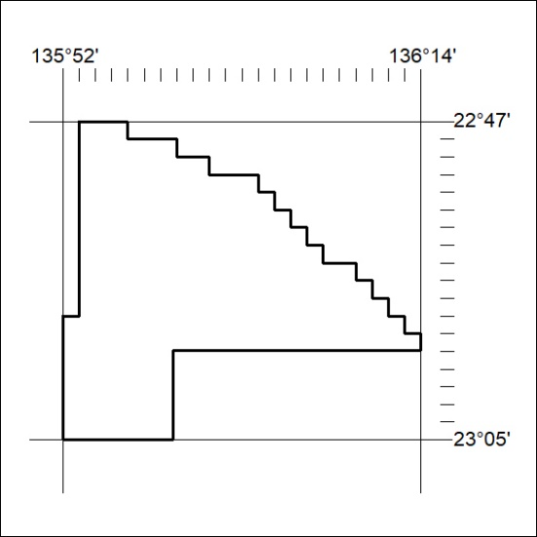
Area granted is indicated above. The titleholder is not permitted to exercise occupational rights on any land that is subject to a development title, or an application for a development title. Any land the subject of a Reserved Land gazettal under the Mineral Titles Act and all land vested in the Commonwealth of Australia is also excluded by description but not excised from the grant area.
63/22

Mineral Titles Act
NOTICE OF GRANT OF A MINERAL TITLE
Title Type and Number: | Exploration Licence 32779
Granted: | 11 March 2022, for a period of 6 Years
Area: | 180 Blocks, 552.37 km²
Locality: | BRAHMA
Name of Holder/s: | 100% IGO NEWSEARCH PTY LTD [ACN. 142 192 701]
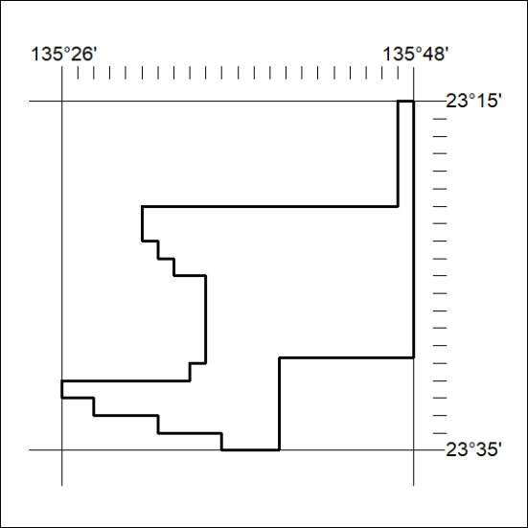
Area granted is indicated above. The titleholder is not permitted to exercise occupational rights on any land that is subject to a development title, or an application for a development title. Any land the subject of a Reserved Land gazettal under the Mineral Titles Act and all land vested in the Commonwealth of Australia is also excluded by description but not excised from the grant area.
64/22

Mineral Titles Act
NOTICE OF GRANT OF A MINERAL TITLE
Title Type and Number: | Exploration Licence 32780
Granted: | 11 March 2022, for a period of 6 Years
Area: | 250 Blocks, 756.46 km²
Locality: | BRAHMA
Name of Holder/s: | 100% IGO NEWSEARCH PTY LTD [ACN. 142 192 701]
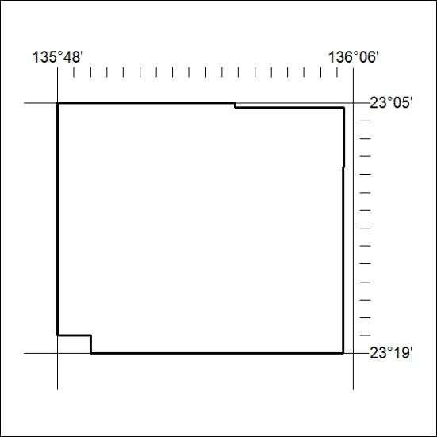
Area granted is indicated above. The titleholder is not permitted to exercise occupational rights on any land that is subject to a development title, or an application for a development title. Any land the subject of a Reserved Land gazettal under the Mineral Titles Act and all land vested in the Commonwealth of Australia is also excluded by description but not excised from the grant area.
65/22

Mineral Titles Act
NOTICE OF GRANT OF A MINERAL TITLE
Title Type and Number: | Exploration Licence 32781
Granted: | 11 March 2022, for a period of 6 Years
Area: | 200 Blocks, 591.87 km²
Locality: | BRAHMA
Name of Holder/s: | 100% IGO NEWSEARCH PTY LTD [ACN. 142 192 701]
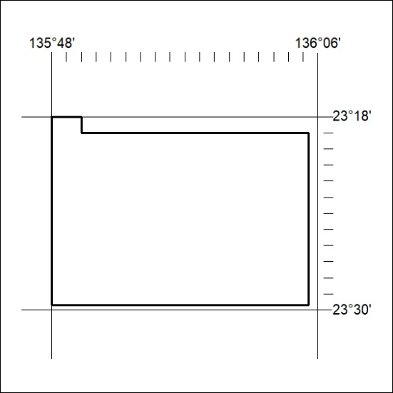
Area granted is indicated above. The titleholder is not permitted to exercise occupational rights on any land that is subject to a development title, or an application for a development title. Any land the subject of a Reserved Land gazettal under the Mineral Titles Act and all land vested in the Commonwealth of Australia is also excluded by description but not excised from the grant area.
66/22

Mineral Titles Act
NOTICE OF GRANT OF A MINERAL TITLE
Title Type and Number: | Exploration Licence 32783
Granted: | 11 March 2022, for a period of 6 Years
Area: | 249 Blocks, 773.11 km²
Locality: | JINKA
Name of Holder/s: | 100% IGO NEWSEARCH PTY LTD [ACN. 142 192 701]
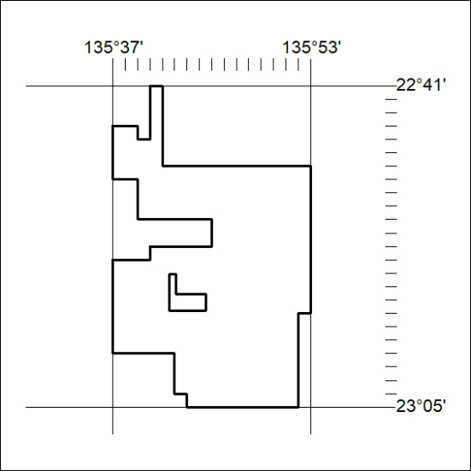
Area granted is indicated above. The titleholder is not permitted to exercise occupational rights on any land that is subject to a development title, or an application for a development title. Any land the subject of a Reserved Land gazettal under the Mineral Titles Act and all land vested in the Commonwealth of Australia is also excluded by description but not excised from the grant area.
67/22

