Avian influenza (AI), commonly called bird flu, is an infectious viral disease of birds that occurs worldwide. There are many strains of the AI virus.
AI viruses mostly circulate in wild bird populations causing no disease or only mild disease. However, when some strains of the virus infect domestic poultry, such as chickens, they can cause severe disease. On rare occasions, some strains of AI virus can infect and cause disease in humans.

How could AI enter Australia and how does it spread?
AI is spread by wild birds, particularly ducks, contaminating food or water supplies. Migratory birds (predominantly shore birds and waders from nearby countries in South East Asia) can pose a risk if they harbour AI infection and then mingle with and transmit this infection to waterfowl that are nomadic within Australia. These nomadic birds can then mingle with and spread the infection to domestic birds, such as poultry.
The disease is also spread by animal-to-animal contact, bites and scratches, and the movement of infected live birds, poultry products or contaminated feed, equipment and materials. The disease can survive in faeces, on feathers, eggs or meat, and in water.

What can you do
- Keep your equipment and poultry yard or aviary clean.
- Avoid contact between your birds and wild birds.
- Don’t let feed and water become contaminated by faeces or other animal waste.
- Limit visitors to your birds.
- Quarantine new birds and monitor for at least 30 days before introducing them to your existing flock.
- Know the signs of disease
- Immediately report any sick or dead birds
If you see any unusual symptoms in your birds or find that a number of them have died within a short period of time, be on the safe side and report it immediately to your local veterinarian or the Emergency Animal Disease Hotline on 1800 675 888.

What to look for
All bird species are thought to be susceptible to AI, with reports showing it to occur in more than 140 species, including domestic poultry (chickens, turkeys, pheasants, partridges, quail, pigeons, ducks, geese, guinea fowl and ostriches) and wild birds.
Signs may include:
- swollen heads, sometimes with bruising
- dullness
- drop in egg production
- respiratory distress (open-mouth breathing, coughing, sneezing)
- diarrhoea
- loss of appetite
- sudden death of several or more birds
- reluctance to move, eat or drink
- droopy appearance
- inability to walk or stand
- unusual head and neck posture.
Figure 1: Swelling and bruising of the head
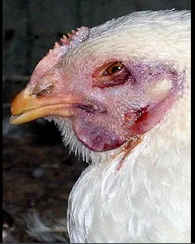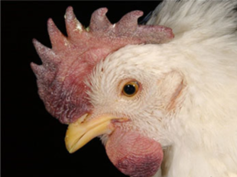
Source: USDA, Plum Island Animal Disease Center

