Mineral Titles Act
NOTICE OF GRANT OF A MINERAL TITLE
Title Type and Number: | Exploration Licence 32731
Granted: | 23 December 2021, for a period of 6 Years
Area: | 198 Blocks, 612.69 km²
Locality: | AVON
Name of Holder/s: | 100% TECK AUSTRALIA PTY LTD [ACN. 091 271 911]
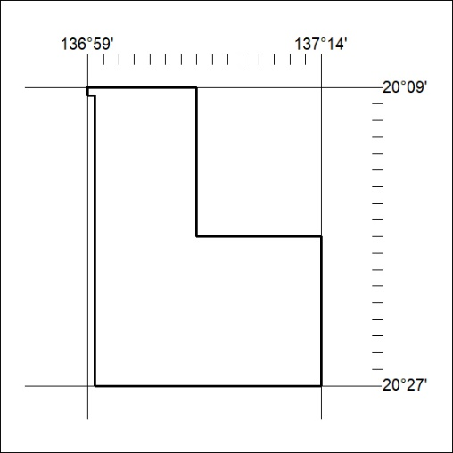
Area granted is indicated above. The titleholder is not permitted to exercise occupational rights on any land that is subject to a development title, or an application for a development title. Any land the subject of a Reserved Land gazettal under the Mineral Titles Act and all land vested in the Commonwealth of Australia is also excluded by description but not excised from the grant area.

485/21

Mineral Titles Act
NOTICE OF GRANT OF A MINERAL TITLE
Title Type and Number: | Exploration Licence 32732
Granted: | 23 December 2021, for a period of 6 Years
Area: | 198 Blocks, 637.49 km²
Locality: | AVON
Name of Holder/s: | 100% TECK AUSTRALIA PTY LTD [ACN. 091 271 911]
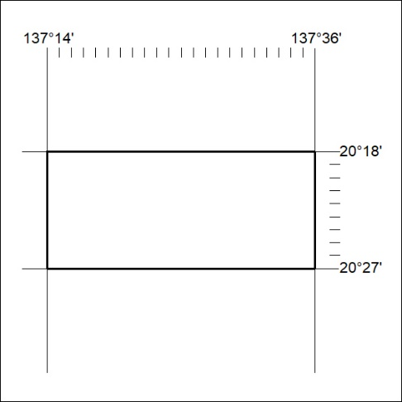
Area granted is indicated above. The titleholder is not permitted to exercise occupational rights on any land that is subject to a development title, or an application for a development title. Any land the subject of a Reserved Land gazettal under the Mineral Titles Act and all land vested in the Commonwealth of Australia is also excluded by description but not excised from the grant area.

486/21

Mineral Titles Act
NOTICE OF GRANT OF A MINERAL TITLE
Title Type and Number: | Exploration Licence 32733
Granted: | 23 December 2021, for a period of 6 Years
Area: | 220 Blocks, 709.27 km²
Locality: | AVON
Name of Holder/s: | 100% TECK AUSTRALIA PTY LTD [ACN. 091 271 911]
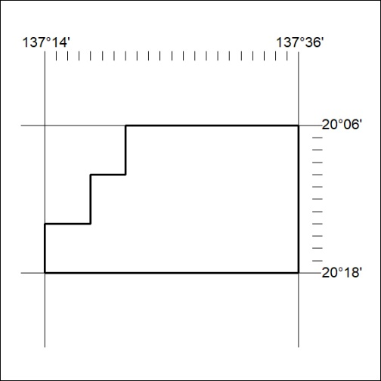
Area granted is indicated above. The titleholder is not permitted to exercise occupational rights on any land that is subject to a development title, or an application for a development title. Any land the subject of a Reserved Land gazettal under the Mineral Titles Act and all land vested in the Commonwealth of Australia is also excluded by description but not excised from the grant area.

487/21

Mineral Titles Act
NOTICE OF GRANT OF A MINERAL TITLE
Title Type and Number: | Exploration Licence 32734
Granted: | 23 December 2021, for a period of 6 Years
Area: | 201 Blocks, 649.10 km²
Locality: | MIKADO
Name of Holder/s: | 100% TECK AUSTRALIA PTY LTD [ACN. 091 271 911]
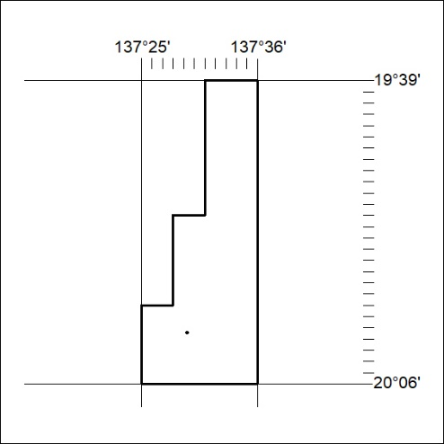
Area granted is indicated above. The titleholder is not permitted to exercise occupational rights on any land that is subject to a development title, or an application for a development title. Any land the subject of a Reserved Land gazettal under the Mineral Titles Act and all land vested in the Commonwealth of Australia is also excluded by description but not excised from the grant area.

488/21

Mineral Titles Act
NOTICE OF GRANT OF A MINERAL TITLE
Title Type and Number: | Exploration Licence 32742
Granted: | 23 December 2021, for a period of 6 Years
Area: | 19 Blocks, 60.39 km²
Locality: | DOREEN
Name of Holder/s: | 100% ROCKTON RESOURCES LIMITED [ACN. 649 337 351]
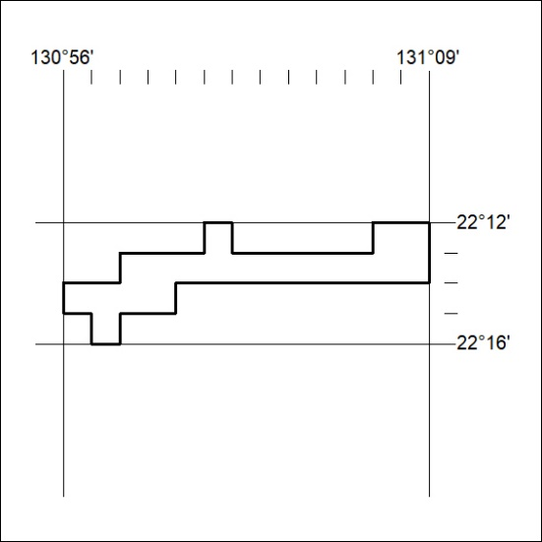
Area granted is indicated above. The titleholder is not permitted to exercise occupational rights on any land that is subject to a development title, or an application for a development title. Any land the subject of a Reserved Land gazettal under the Mineral Titles Act and all land vested in the Commonwealth of Australia is also excluded by description but not excised from the grant area.

489/21

