Activities and Ideas
EVERYDAY ACTIVITIES
READ  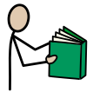  - Read street signs and other writing you see on a walk | 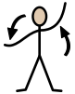  MOVE  - Go for a walk | DRAW OR WRITE  - Write or draw a map of where you walked | SPEAK AND LISTEN  - Tell someone who didn’t come on the walk what you did and saw.
DURING THIS WEEK
FINE MOTOR  - Use playdough and some kitchen tools (egg-flip, garlic crusher, grater, rolling pin). What different playdough shapes can you make? | CREATIVE  - Use water and a brush to paint a wall outside. How quickly will it dry? | CONSTRUCTION  - Make a playdough person. Use containers or boxes to make the right sized house for the playdough person. | COOK  - Make playdough using an online recipe. Talk about the colours, the steps, words like first, next, mix, stand.
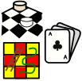  GAMES  • Do a puzzle together. | 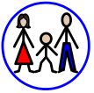  CONNECT  • Play Simon says  - Eg; Simon says put your hands on your head | 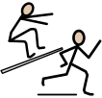  ACTIVE  • Go for a twenty-minute walk around your neighbourhood | RELAXATION  - Read a book. What was the story about? Who was your favourite character?
MUSIC  - Find out a family member’s favourite song. Dress up and perform the song for them. Was it easy or hard to learn the words? What is the song about? | TECHNOLOGY  - Make a parachute for a small toy. Does it work? | HELPING  • Pack away your things each day. Make labels for where things belong around the house. Draw pictures or write the words. | FREE CHOICE  • Choose something you would like to do.
T-Year 2:
Placemat 6

