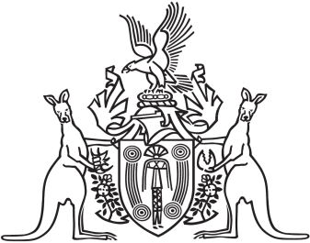
Northern Territory of Australia

Government Gazette
ISSN-0157-833X
No. S107 17 December 2018
Northern Territory of Australia
Water Legislation Amendment Act 2018
Commencement Notice
I, Vicki Susan O'Halloran, Administrator of the Northern Territory of Australia, under section 2 of the Water Legislation Amendment Act 2018 (No. 29 of 2018), fix 31 December 2018 as the day on which the Act commences.
Dated 17 December 2018
V. S. O'Halloran
Administrator

