Northern Territory of Australia

Government Gazette
ISSN-0157-8324
No. G50 12 December 2018
Christmas/New Year Publication
The Office of the Parliamentary Counsel will be closed from Tuesday 25 December to Tuesday 1 January inclusive.
The last General Gazette for 2018 will be published on Wednesday 19 December.
The first General Gazette for 2019 will be published on Thursday 3 January.
Special gazettes can be published up to 12 noon on Monday 24 December and from Wednesday 2 January 2019.

General information
The Gazette is published by the Office of the Parliamentary Counsel.
The Gazette will be published every Wednesday, with the closing date for notices being the previous Friday at 4.00 pm.
Notices not received by the closing time will be held over until the next issue.
Notices will not be published unless a Gazette notice request form together with a copy of the signed notice and a clean copy of the notice in Word or PDF is emailed to gazettes@nt.gov.au
Notices will be published in the next issue, unless urgent publication is requested.

Availability
The Gazette will be available online at 12 Noon on the day of publication at https://nt.gov.au/about-government/gazettes
Unauthorised versions of Northern Territory Acts and Subordinate legislation are available online at https://legislation.nt.gov.au/

Northern Territory of Australia

Local Government Act
Vesting of Crown Land in Litchfield Council
I, Gerald Francis McCarthy, Minister for Housing and Community Development, under section 185(2) of the Local Court Act, vest in Litchfield Council as a road the part of section 674, Hundred of Cavenagh, as shown on Survey Plan S2018/028 in the Schedule.
Dated 28 November 2018
G. F. McCarthy
Minister for Housing and Community Development
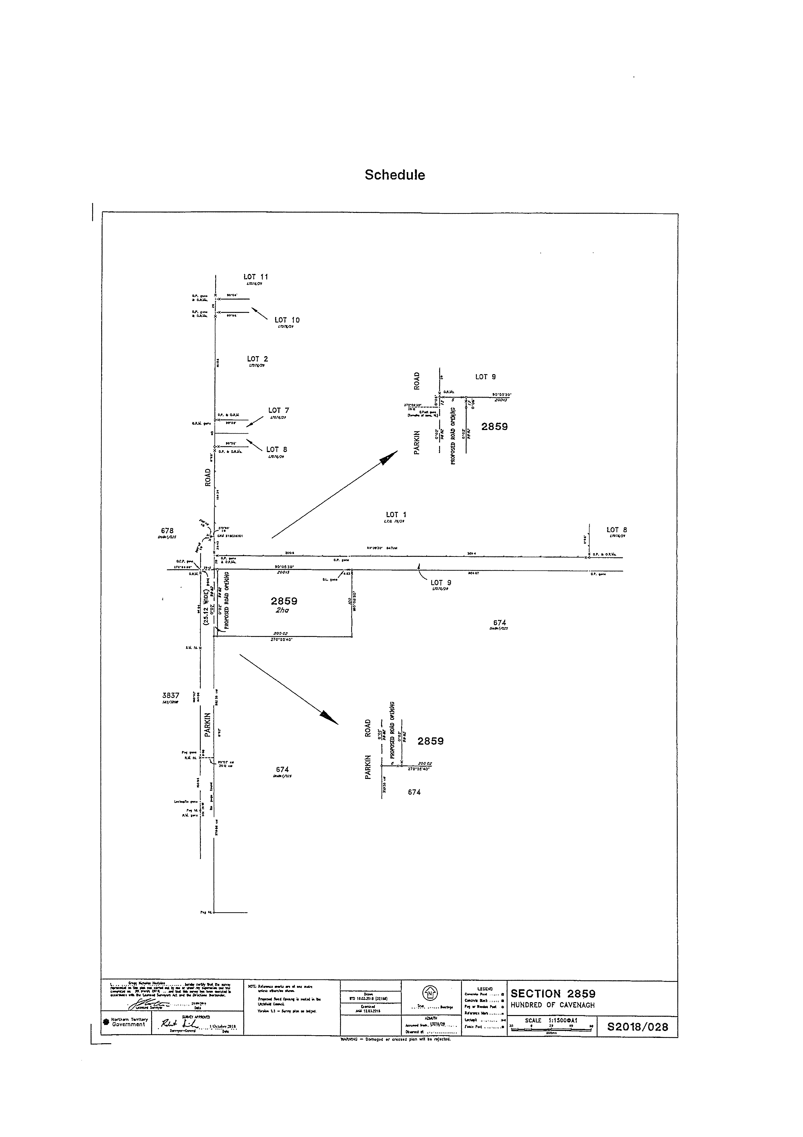
Northern Territory
Associations Act
Notice of Dissolution of Associations
I, Malcolm John Bryant, as a delegate of the Commissioner, pursuant to section 65(5) of the Associations Act, give notice that the associations specified in the Schedule are dissolved.
Dated: 5 December 2018
M. J. Bryant
Delegate of Commissioner
Note: Enquiries should be directed to Malcolm Bryant at Licensing NT, Department of the Attorney-General and Justice, Level 3, NAB House, 71 Smith Street, Darwin. Phone: (08) 8999 1339 or email agd.licensingnt@nt.gov.au.
____________________________
Schedule
01761c | Just Rock Alice Springs Incorporated
IA02899 | Capoeira Angola Cultural Centre Australia (NT Branch) Incorporated
IA03013 | COAT NT Chapter Incorporated
IA03044 | Darwin Football League Incorporated
IA03084 | Streetz Incorporated
IA03200 | Omada Ellinon Greek Language Book Club Incorporated
IA03273 | NT Fly Fishers Incorporated
IA03285 | Territory Trails Incorporated
_____________________________
Northern Territory of Australia

Strehlow Research Centre Act
Strehlow Research Centre Board
Appointment of Members
I, Lauren Jane Moss, Minister for Tourism and Culture:
(a) under section 14(1) of the Strehlow Research Centre Act and with reference to section 14(1)(a) of the Act, appoint Michael John Liddle to be a member of the Strehlow Research Centre Board (the Board) for 3 years on and from 1 January 2019; and
(b) under section 14(1) of the Act and with reference to section 14(1)(d) of the Act, appoint Michael Anthony Sitzler to be a member of the Board for 3 years on and from 1 January 2019.
Dated 5 December 2018
L. J. Moss
Minister for Tourism and Culture

Northern Territory of Australia
Transport of Dangerous Goods by Road and Rail
(National Uniform Legislation) Act
Appointment of Officers
I, Stephen Hugh Gelding, the Competent Authority:
- under section 23(1) of the Transport of Dangerous Goods by Road and Rail (National Uniform Legislation) Act and with reference to section 44 (1) of the Interpretation Act, terminate all appointments of authorised officers in force immediately before the date of this instrument; and
- under section 23(1) of the Transport of Dangerous Goods by Road and Rail (National Uniform Legislation) Act, appoint the people named in the Schedule to be authorised officers and exercise the powers under:
- sections 31, 32, 33, 34, 35, 36, 37, 38, 39, 40, 44, 45, 46, 47, 48, 49, 50, 54, 55, 56, 57, 58, 59, 62, 63, 64, 65, 86, 88, 90, 93, 95, 96 and 99 of the Transport of Dangerous Goods by Road and Rail (National Uniform Legislation) Act; and
- regulation 232 of the Transport of Dangerous Goods by Road and Rail (National Uniform Legislation) Regulations.
The power to amend a notice pursuant to sections 88 and 96 is restricted to minor amendments:
- for clarification; or
- to correct errors or references; or
- to reflect changes of address or other circumstances.
Dated 6 December 2018
S. H. Gelding
Work Health Authority
_________________________________
Schedule
Allan Crombie Fischer
Amber Louise Sayers
Andrew James Lucas
Anthony Paul Clifford
Anthony John Waite
Brian Cleary
Brian Wingrove
Bruce Wayne McKinley
Carolynne Murrell
Christos Despotis
Collins Dubere Gipey
David James Mallett
Fiona Louise Peters
Fred James Munro
Gillian Hylton
Joseph Peter Pisani
Kenneth John Orwell
Kerry Lee-Anne Barnaart
Maria Staunton
Maria Rigas
Neil William Burgess
Nigel Butler
Rebecca Sue Trimble
Robert Stanley Fereday
Robin Leslie Paget Smith
Stewart Pritchard
Stuart Dean Hand
Police officers of or above the rank of Constable
_________________________________
General Gazette Publication Dates 2019
Gazette Number | Publication Date | Closing Date
1 | 3 January | 28 December
2 | 9 January | 4 January
3 | 16 January | 11 January
4 | 23 January | 18 January
5 | 30 January | 25 January
6 | 6 February | 1 February
7 | 13 February | 8 February
8 | 20 February | 15 February
9 | 27 February | 22 February
10 | 6 March | 1 March
11 | 13 March | 8 March
12 | 20 March | 15 March
13 | 27 March | 22 March
14 | 3 April | 29 March
15 | 10 April | 5 April
16 | 17 April | 12 April
17 | 24 April | 19 April
18 | 1 May | 26 April
19 | 8 May | 3 May
20 | 15 May | 10 May
21 | 22 May | 17 May
22 | 29 May | 24 May
23 | 5 June | 31 May
24 | 12 June | 7 June
25 | 19 June | 14 June
26 | 26 June | 21 June
27 | 3 July | 28 June
28 | 10 July | 5 July
29 | 17 July | 12 July
30 | 24 July | 19 July
31 | 31 July | 26 July
32 | 7 August | 2 August
33 | 14 August | 9 August
34 | 21 August | 16 August
35 | 28 August | 23 August
36 | 4 September | 30 August
37 | 11 September | 6 September
38 | 18 September | 13 September
39 | 25 September | 20 September
40 | 2 October | 27 September
41 | 9 October | 4 October
42 | 16 October | 11 October
43 | 23 October | 18 October
44 | 30 October | 25 October
45 | 6 November | 1 November
46 | 13 November | 8 November
47 | 20 November | 15 November
48 | 27 November | 22 November
49 | 4 December | 29 November
50 | 11 December | 6 December
51 | 18 December | 13 December

