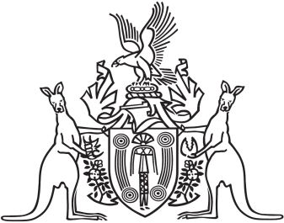
Northern Territory of Australia

Government Gazette
ISSN-0157-833X
No. S95 30 November 2018

Assent to Proposed Law
Her Honour the Administrator declared assent to the following proposed law:
29 November 2018
Northern Territory Environment Protection Authority Amendment Act 2018 (Act No. 27 of 2018)
Michael Tatham
Clerk of the Legislative Assembly
30 November 2018

