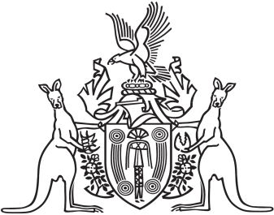
Northern Territory of Australia

Government Gazette
ISSN-0157-833X
No. S88 7 November 2018
Northern Territory of Australia

Territory Parks and Wildlife Conservation Act
Notice of Operation of Joint Management Plan
I, Lauren Jane Moss, Minister for Tourism and Culture, under section 25AG of the Territory Parks and Wildlife Conservation Act, give notice that:
(a) the Tjoritja / West MacDonnell National Park Joint Management Plan (the Plan) has come into operation; and
(b) copies of the Plan may be:
(i) inspected during business hours at the office of the Parks, Wildlife and Heritage Division of the Department of Tourism and Culture, Tom Hare Building, Arid Zone Research Institute, South Stuart Highway, Alice Springs; and
(ii) obtained from the Department of Tourism and Culture's website: https://dtc.nt.gov.au/parks-and-wildlife-commission/park-management-strategies-consultation/management-plans.
Dated 2 November 2018
L. J. Moss
Minister for Tourism and Culture

