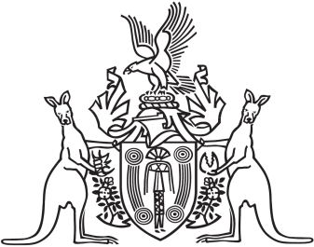
Northern Territory of Australia

Government Gazette
ISSN-0157-833X
No. S54 11 July 2018
Northern Territory of Australia
Crown Lands Act
Invitation for Applications for Lease of Crown Land
I, Sharon Lesley Jones, Director Crown Land Estate in the Department of Infrastructure, Planning and Logistics, as the delegate of the Minister of Infrastructure, Planning and Logistics, under section 13(1) of the Crown Lands Act and with reference to section 13(3) of the Act, invite applications for a lease of land and give notice of the following:
- the land is part Lot 10177 Town of Darwin, comprising
approximately 5 ha and the purpose for which the land may be used currently is international water theme park and associated mixed use development, including (but not limited to) accommodation options, entertainment precincts, public open space, recreational activities, and food and retail outlets;
- the lease will be granted for a term of years as determined by the Minister and will be subject to the general conditions specified by the Act;
- it is proposed to include in the lease a provision by virtue of which the lessee may acquire an estate in fee simple in the land;
- applications for the lease may be lodged:
  - during the period starting on 4 June 2018 and ending at 2pm on 22 August 2018 (the application period); and
  - by a person who has registered an interest during the application period on the following website:
www.business.nt.gov.au/waterpark
- a person who has registered an interest during the application period:
  - will be provided by the Department of Trade, Business and Innovation (the Department) with relevant documents for the invitation process; and
  - must, if making an application for the lease, lodge a hard copy of the completed application before the end of the application period with the Darwin Theme Park Project Director, Level 5 Charles Darwin Centre, 19 The Mall, Darwin;
- a member of the public may obtain details of the land from the Department at the address mentioned in paragraph (e)(ii).
Dated 11 July 2018
S. L. Jones
Director Crown Land Estate

