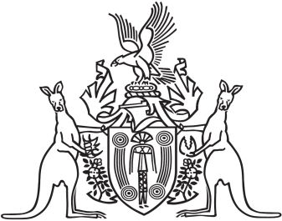
Northern Territory of Australia

Government Gazette
ISSN-0157-833X
No. S37 6 June 2018
Northern Territory of Australia

Liquor Amendment (Point of Sale Intervention) Act 2018
Commencement Notice
I, Vicki Susan O'Halloran, Administrator of the Northern Territory of Australia, under section 2 of the Liquor Amendment (Point of Sale Intervention) Act 2018 (No. 9 of 2018), fix the day on which this notice is published in the Gazette as the day on which the Act commences.
Dated 1 June 2018
V. S. O'Halloran
Administrator

