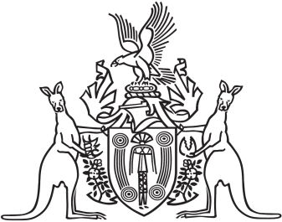
Northern Territory of Australia

Government Gazette
ISSN-0157-833X
No. S10 21 February 2018
Public Trustee Act
Notice of Application to Manage the Property of
Patrick Joseph Moriarty
I, Demetrios Laouris, Public Trustee for the Northern Territory pursuant to section 59(3) of the Public Trustee Act give notice that I will be applying to the Supreme Court of the Northern Territory for appointment as manager of the property of Patrick Joseph Moriarty.
Dated 20 February 2018
Demetrios Laouris
Public Trustee for the Northern Territory

