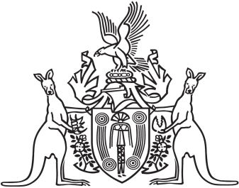
Northern Territory of Australia

Government Gazette
ISSN-0157-833X
No. S83 14 November 2017

Assent to Proposed Laws
Her Honour the Administrator assented to the following proposed laws:
8 November 2017
Assembly Members and Statutory Officers (Remuneration and Other Entitlements) Amendment Act 2017 (Act No 20 of 2017)
Criminal Code Amendment (Dangerous Navigation of Vessels) Act 2017 (Act No 21 of 2017)
Michael Tatham
Clerk of the Legislative Assembly

