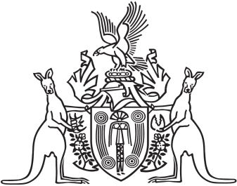
Northern Territory of Australia

Government Gazette
ISSN-0157-833X
No. S68 10 October 2017
Corrigendum
The notice of Request for Making of the Mutual Recognition Amendment (NSW Container Deposit Scheme) Regulations 2017 (the Regulations) published in Gazette S67, 9 October 2017, was incomplete. Schedule 1 below forms the Schedule as mentioned in proposed regulation 4 of the Regulations.
