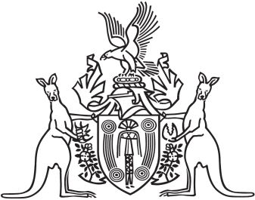
Northern Territory of Australia

Government Gazette
ISSN-0157-833X
No. S53 26 July 2017
Northern Territory of Australia
Public and Environmental Health Act
Notification of Making Guidelines
I, Hugh Crosbie Heggie, Chief Health Officer:
(a) under section 101(4) of the Public and Environmental Health Act, give notice of the following:
(i) The Department of Health has developed the “Guideline for the reporting of elevated blood lead levels in the Northern Territory” to ensure the systematic reporting of elevated blood lead levels in the Northern Territory to the Department of Health. Accurate and timely surveillance of this public health issue will allow Department of Health’s public health agencies to support health practitioners, Top End Health Service, Central Australia Health Service and other relevant authorities to prevent and reduce harmful exposure to lead in the Northern Territory.
(b) I have adopted the guidelines entitled “Guideline for the reporting of elevated blood lead levels”
(c) The guidelines take effect on 1 August 2017;
(d) Copies of the guidelines may be inspected or purchased:
(i) At the following website:
https://health.nt.gov.au/professionals/centre-for-disease-control/resources-and-publications; or
(ii) Between 8.00 am and 4.21 pm, Monday to Friday at;
Centre for Disease Control
Department of Health
Ground floor Building 4 Royal Darwin Hospital Campus
Paracelsus Road, Tiwi NT
Dated 24 July 2017
H. C. Heggie
Chief Health Officer

