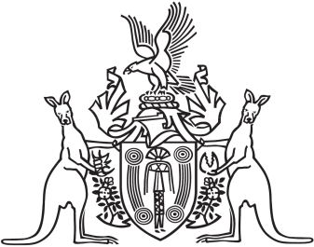
Northern Territory of Australia

Government Gazette
ISSN-0157-833X
No. S49 13 July 2017
Northern Territory of Australia

Local Government Act
City of Palmerston
Extension of Time for Holding Next Periodic General Election
I, Gerald Francis McCarthy, Minister for Housing and Community Development, under section 96 of the Local Government Act and with reference to regulation 57 of the Local Government (Electoral) Regulations, extend the time, to 17 March 2018, for holding the next periodic general election of the City of Palmerston.
Dated 12 July 2017
G. F. McCarthy
Minister for Housing and Community Development

