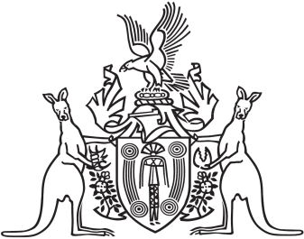
Northern Territory of Australia

Government Gazette
ISSN-0157-833X
No. S45 4 July 2017

Notification of Subordinate Legislation
Notice is given of the making of the following subordinate legislation, effective from the date specified:
Subordinate Legislation | Commencement details | Empowering Act
Plant Health Amendment Regulations 2017  (No. 22 of 2017) | Date of this Gazette | Plant Health Act
For copies of legislation please direct your request to the Print Management Unit, email pmu.ntg@nt.gov.au or phone (08) 8999 6727

