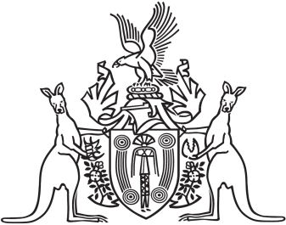
Northern Territory of Australia

Government Gazette
ISSN-0157-833X
No. S35 26 June 2017
Northern Territory of Australia

Local Government Act
Reinstatement of Suspended Members
Belyuen Community Government Council
I, Gerald Francis McCarthy, Minister for Housing and Community Development, under section 224(5)(a) of the Local Government Act, reinstate the suspended members of the Belyuen Community Government Council on and from 1 August 2017.
Dated 23 June 2017
G. F. McCarthy
Minister for Housing and Community Development
Northern Territory of Australia

Local Government Act
Belyuen Shire
Change of Number of Members to be Elected
I, Gerald Francis McCarthy, Minister for Housing and Community Development:
(a) under section 9(2) of the Local Government Act and with reference to section 9(1)(i) of the Act, change the number of members to be elected for Belyuen Shire from 8 members to 5 members; and
(b) make that change for the purpose of conducting the next general election to be held for Belyuen Shire and determining the composition of the Belyuen Community Government Council after that election.
Dated 23 June 2017
G. F. McCarthy
Minister for Housing and Community Development

