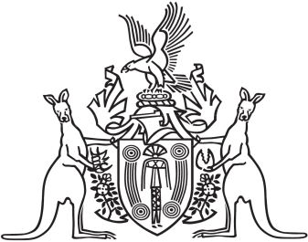
Northern Territory of Australia

Government Gazette
ISSN-0157-833X
No. S16 7 April 2017
Northern Territory of Australia
Licensed Surveyors Act
Notification of Directions given with Respect to
the Practice to be Followed by Licensed Surveyors
I, Craig Leslie Sandy, the Chairperson of the Surveyors Board of the Northern Territory of Australia, give notice that the Board has given the following directions under section 47(1) of the Licensed Surveyors Act:
Survey Practice Directions 2017, Connection to Coordinated Reference Marks (CRM) and Traverses on Survey Plans and Sacred Sites
The direction took effect on Wednesday, 22nd February 2017.
Copies of the above directions may be obtained from: www.surveyorsboard.nt.gov.au
Dated this 24th day of March 2017
C. L. Sandy
Chairperson of the Board

