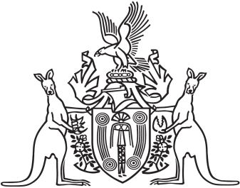
Northern Territory of Australia

Government Gazette
ISSN-0157-833X
No. S94 17 August 2016
Northern Territory of Australia
Medicines, Poisons and Therapeutic Goods Act
Sonic Healthplus Darwin Declarations and Approval
I, Dinesh Kumar Arya, Chief Health Officer:
- under section 252 of the Medicines, Poisons and Therapeutic Goods Act, declare the clinic specified in the Schedule, Part A, to be a place to which Part 2.6 of the Act applies; and
- under section 254(1) of the Act, approve each Scheduled substance treatment protocol specified in the Schedule, Part B, for the clinic specified in the Schedule, Part A; and
- under section 250(1)(a) of the Act, declare each nurse practising at the clinic specified in the Schedule, Part A, who has the qualifications specified in the Schedule, Part C, to be an approved nurse to supply, administer to another person and possess the Schedule 4 substances specified in the Schedule, Part D, in accordance with each Scheduled substance treatment protocol specified in the Schedule, Part B.
Dated 14 August 2016
D. K. Arya
Chief Health Officer

Schedule

Part A
Sonic HealthPlus Darwin 22 Smith Street
Darwin NT 0800

Part B
Title Author

Corporate Immunisation Protocols Handbook for Sonic Health Pty Ltd, Revised Edition - 2016, Version 2.3 (July 2016)
Ordering and Storage of Vaccines Policy, Version 1.9
Sonic HealthPlus
Sonic HealthPlus

Part C
- The qualifications prescribed for section 65(1A) of the Act.
- Successful completion of the unit of competency HLTAD001 -Provide cardiopulmonary resuscitation.

Part D
Hepatitis A Vaccine Hepatitis B Vaccine
Vaccine - Diphtheria/Tetanus
Vaccine - Hepatitis A/Hepatitis B
Vaccine - Influenza

