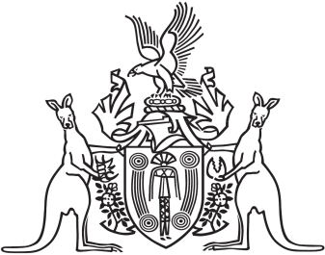
Northern Territory of Australia

Government Gazette
ISSN-0157-833X
No. S83 4 August 2016
Northern Territory of Australia

Interpretation Act
Notification of Making of By-Laws under
Territory Parks and Wildlife Conservation Act
I, Bess Nungarrayi Price, Minister for Parks and Wildlife, under section 63(3) of the Interpretation Act, give notice that the Parks and Wildlife Commission of the Northern Territory has made the following by-laws under section 71 of the Territory Parks and Wildlife Conservation Act:
Subordinate Legislation No. 40 of 2016: Territory Parks and Wildlife Conservation Amendment By-laws 2016
Copies of the by-laws may be purchased at the Print Management Unit, Department of the Chief Minister, 22 Mitchell Street, Darwin NT. The Print Management Unit may be contacted by email at pmu.dcm@nt.gov.au.
Dated 3 August 2016
B. N. Price
Minister for Parks and Wildlife

