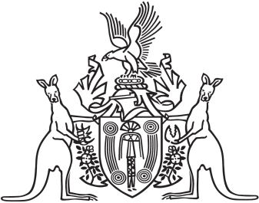
Northern Territory of Australia

Government Gazette
ISSN-0157-833X
No. S66 15 July 2016
Northern Territory of Australia

Weeds Management Act
Approval of Weed Management Plan
for Grader Grass (Themeda Quadrivalvis)
I, Gary John Higgins, Minister for Land Resource Management:
(a) under section 10(1) of the Weeds Management Act, approve the "Weed Management Plan for Grader grass (Themeda quadrivalvis) 2016", prepared by the Weed Management Branch of the Department of Land Resource Management, as a weed management plan for the purposes mentioned in section 10(1)(a) to (d) of the Act; and
(b) under section 11(4) of the Act, specify that the plan is to remain in force for 10 years on and from the date of this instrument.
Dated 6 July 2016
G. J. Higgins
Minister for Land Resource Management

