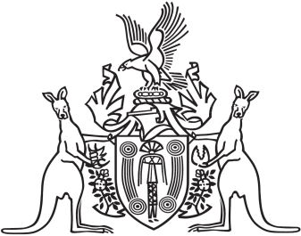
Northern Territory of Australia

Government Gazette
ISSN-0157-833X
No. S38 3 May 2016

Assent to Proposed Laws
His Honour the Administrator assented to the following proposed law:
29 April 2016
Personal Violence Restraining Orders Act 2016 (Act No. 10 of 2016)
Yours sincerely

Marianne Conaty
Deputy Clerk of the Legislative Assembly

