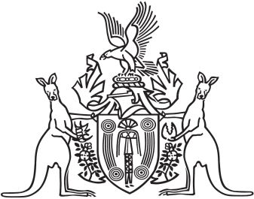
Northern Territory of Australia

Government Gazette
ISSN-0157-833X
No. S30 26 April 2016
Northern Territory of Australia

Crown Lands Act
Reserve No. 1663 (Blatherskite Park Reserve)
Termination of Appointments of Trustees
I, Bess Nungarrayi Price, Minister for Local Government and Community Services, under section 79(2) of the Crown Lands Act, terminate the appointments of Bradden Anthony Bellette and David Allan Cunningham as trustees of Reserve No. 1663 (Blatherskite Park Reserve).
Dated 22 April 2016
B. N. Price
Minister for Local Government and Community Services

