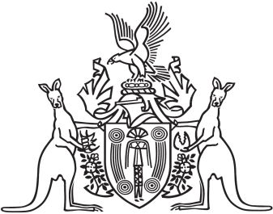
Northern Territory of Australia

Government Gazette
ISSN-0157-833X
No. S21 31 March 2016
Ports Management Act
Declaration of Exempt Ship
I, Anthony John James O’Malley, Regional Harbourmaster and Pilotage Authority for the Port of Darwin, in pursuance of Sections 64 of the Ports Management Act, declare the following ship exempt from the requirement to take or have on board a licenced pilot within the Port of Darwin compulsory pilotage area:
“Ile De Batz” | Cable Lay | IMO Number 9247041
This declaration is valid for the period 31 March 2016 to 02 April 2016.
Dated 31 March 2016
A. J. J. O' Malley
Regional Harbourmaster

