Road Agency Approval Process – Major Developments
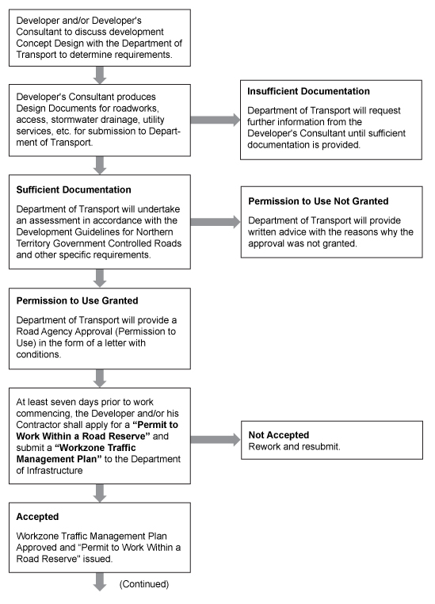
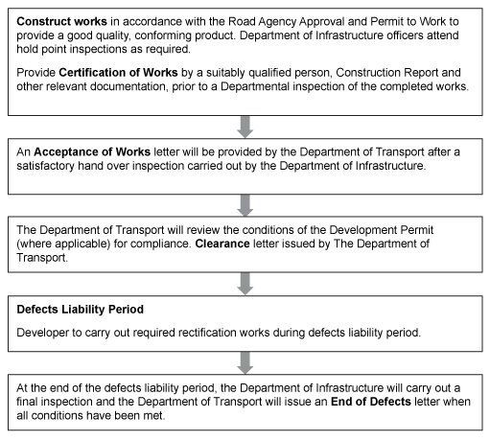

Flowchart steps

- Developer and/or Developer's Consultant to discuss development Concept Design with the Department of Transport to determine requirements.

- Developer's Consultant produces Design Documents for roadworks, access, stormwater drainage, utility services, etc. for submission to Department of Transport.

OR
2.1 Insufficient Documentation
Department of Transport will request further information from the Developer's Consultant until sufficient documentation is provided.

- Sufficient Documentation
Department of Transport will undertake an assessment in accordance with the Development Guidelines for Northern Territory Government Controlled Roads and other specific requirements.

OR

3.1 Permission to Use Not Granted
Department of Transport will provide written advice with the reasons why the approval was not granted.

- Permission to Use Granted
Department of Transport will provide a Road Agency Approval (Permission to Use) in the form of a letter with conditions.

- At least seven days prior to work commencing, the Developer and/or his Contractor shall apply for a “Permit to Work Within a Road Reserve” and submit a “Workzone Traffic Management Plan” to the Department of Infrastructure
OR
5.1 Not Accepted
Rework and resubmit.
- Accepted
Workzone Traffic Management Plan Approved and “Permit to Work Within a Road Reserve" issued.

- Construct works in accordance with the Road Agency Approval and Permit to Work to provide a good quality, conforming product. Department of Infrastructure officers attend hold point inspections as required.

Provide Certification of Works by a suitably qualified person, Construction Report and other relevant documentation, prior to a Departmental inspection of the completed works.

- An Acceptance of Works letter will be provided by the Department of Transport after a satisfactory hand over inspection carried out by the Department of Infrastructure.

- The Department of Transport will review the conditions of the Development Permit (where applicable) for compliance. Clearance letter issued by The Department of Transport.

- Defects Liability Period
Developer to carry out required rectification works during defects liability period.

- At the end of the defects liability period, the Department of Infrastructure will carry out a final inspection and the Department of Transport will issue an End of Defects letter when all conditions have been met.

