Mineral Titles Act 2010
NOTICE OF LAND CEASING TO BE A MINERAL TITLE AREA
Title Type and Number: | Exploration Licence 33155
Area Ceased on: | 09 January 2026
Area: | 117 Blocks, 369.76 km²
Locality: | MT SANFORD
Name of Applicant(s)/Holder(s): | 100% FUTURE ENERGY MINERALS LIMITED [ACN. 678 599 230]
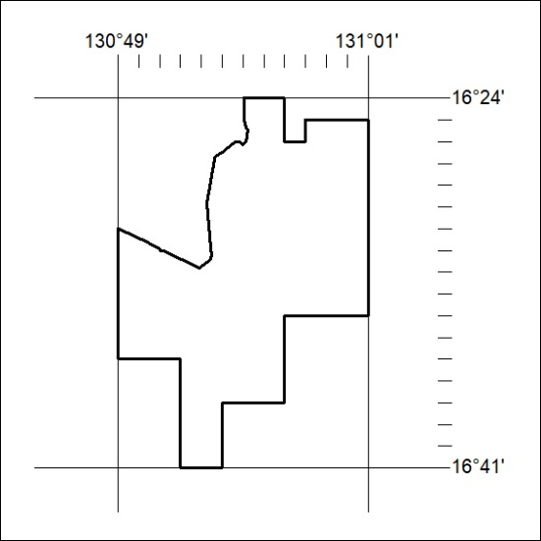

08/26

