Mineral Titles Act 2010
NOTICE OF LAND CEASING TO BE A MINERAL TITLE AREA
Title Type and Number: | Exploration Licence 32497
Area Ceased on: | 27 May 2025
Area: | 117 Blocks, 379.36 km²
Locality: | ALEXANDRIA
Name of Applicant(s)/Holder(s): | 100% BREMA RESOURCES PTY LTD [ACN. 643 480 693]
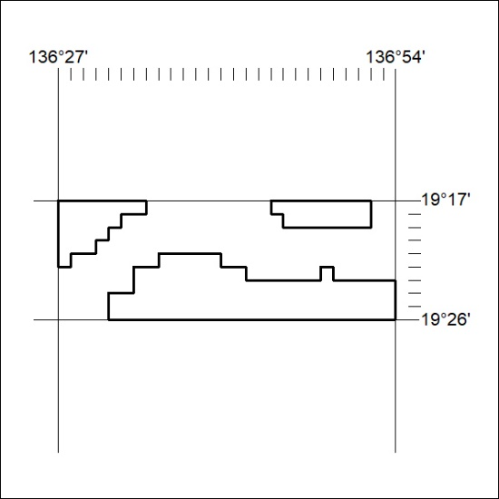

327/25

Mineral Titles Act 2010
NOTICE OF LAND CEASING TO BE A MINERAL TITLE AREA
Title Type and Number: | Exploration Licence 32500
Area Ceased on: | 27 May 2025
Area: | 125 Blocks, 400.67 km²
Locality: | PLAYFORD
Name of Applicant(s)/Holder(s): | 100% BREMA RESOURCES PTY LTD [ACN. 643 480 693]
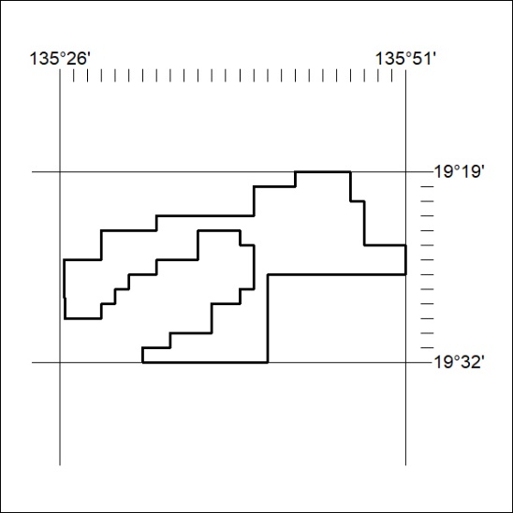

328/25

