Mineral Titles Act 2010
NOTICE OF LAND CEASING TO BE A MINERAL TITLE AREA
Title Type and Number: | Exploration Licence 31983
Area Ceased on: | 06 May 2025
Area: | 14 Blocks, 41.73 km²
Locality: | LAUGHLEN
Name of Applicant(s)/Holder(s): | 100% MATSON Paul Richard
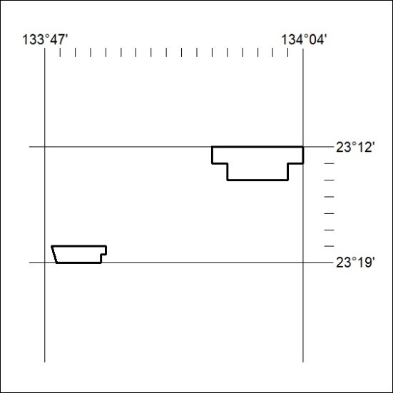

296/25

