Mineral Titles Act 2010
NOTICE OF LAND CEASING TO BE A MINERAL TITLE AREA
Title Type and Number: | Exploration Licence 32721
Area Ceased on: | 29 April 2025
Area: | 87 Blocks, 279.55 km²
Locality: | BAUHINIA DOWNS
Name of Applicant(s)/Holder(s): | 100% BAUDIN RESOURCES PTY LTD [ACN. 618 455 593]
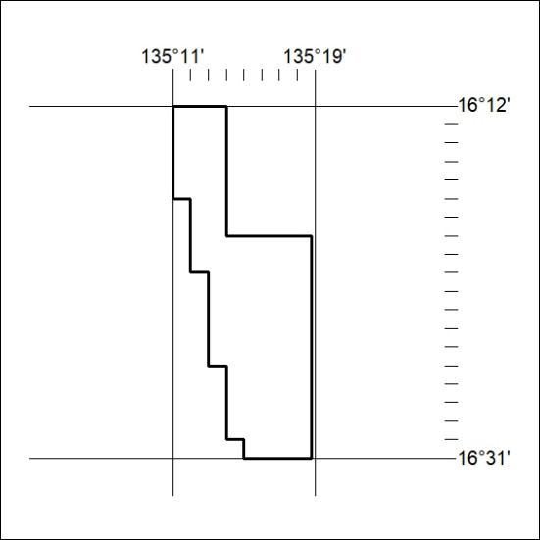

293/25

