Mineral Titles Act 2010
NOTICE OF LAND CEASING TO BE A MINERAL TITLE AREA
Title Type and Number: | Exploration Licence 31287
Area Ceased on: | 11 April 2025
Area: | 96 Blocks, 313.33 km²
Locality: | BOXER
Name of Applicant(s)/Holder(s): | 100% XAVIER RESOURCES PTY LTD [ACN. 623 262 304]
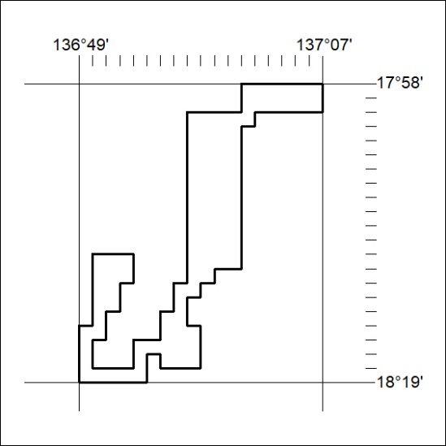

265/25

Mineral Titles Act 2010
NOTICE OF LAND CEASING TO BE A MINERAL TITLE AREA
Title Type and Number: | Exploration Licence 32229
Area Ceased on: | 11 April 2025
Area: | 70 Blocks, 228.45 km²
Locality: | BOXER
Name of Applicant(s)/Holder(s): | 100% XAVIER RESOURCES PTY LTD [ACN. 623 262 304]
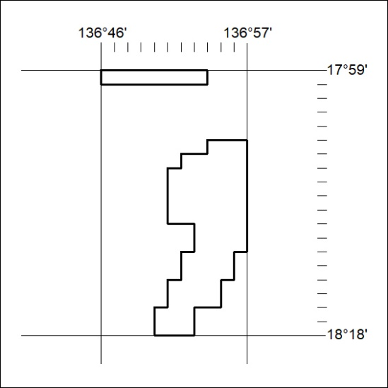

266/25

Mineral Titles Act 2010
NOTICE OF LAND CEASING TO BE A MINERAL TITLE AREA
Title Type and Number: | Exploration Licence 32577
Area Ceased on: | 11 April 2025
Area: | 114 Blocks, 352.98 km²
Locality: | CARRARA
Name of Applicant(s)/Holder(s): | 100% CARRARA RESOURCES PTY LTD [ACN. 657 094 454]
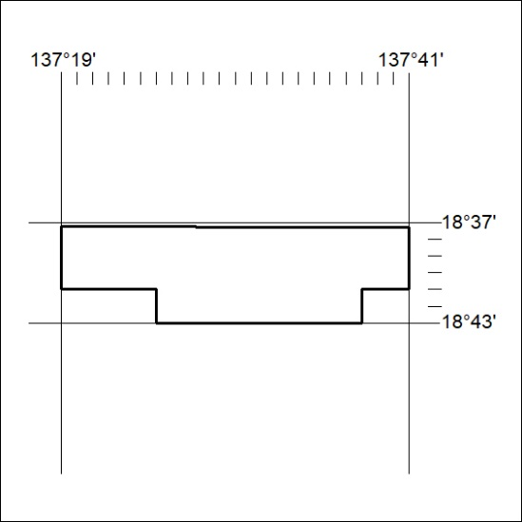

267/25

Mineral Titles Act 2010
NOTICE OF LAND CEASING TO BE A MINERAL TITLE AREA
Title Type and Number: | Exploration Licence 32620
Area Ceased on: | 11 April 2025
Area: | 47 Blocks, 135.07 km²
Locality: | MITCHIEBO
Name of Applicant(s)/Holder(s): | 100% CARRARA RESOURCES PTY LTD [ACN. 657 094 454]
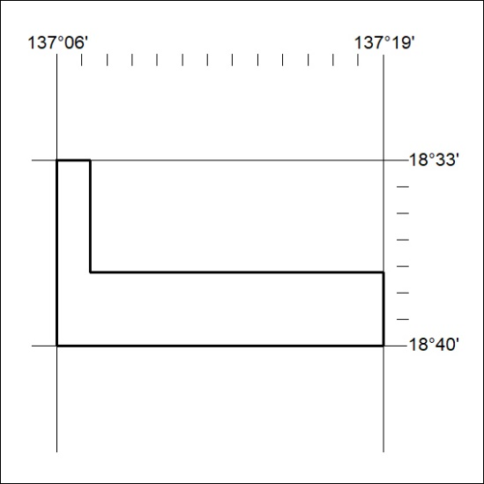

268/25

Mineral Titles Act 2010
NOTICE OF LAND CEASING TO BE A MINERAL TITLE AREA
Title Type and Number: | Exploration Licence 32622
Area Ceased on: | 11 April 2025
Area: | 63 Blocks, 196.80 km²
Locality: | CARRARA
Name of Applicant(s)/Holder(s): | 100% CARRARA RESOURCES PTY LTD [ACN. 657 094 454]
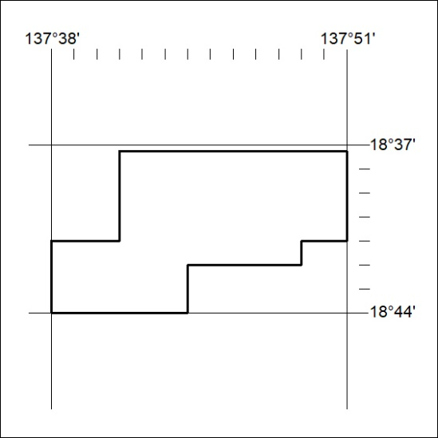

269/25

Mineral Titles Act 2010
NOTICE OF LAND CEASING TO BE A MINERAL TITLE AREA
Title Type and Number: | Exploration Licence 32849
Area Ceased on: | 11 April 2025
Area: | 71 Blocks, 231.47 km²
Locality: | PARADISE BORE
Name of Applicant(s)/Holder(s): | 100% XAVIER RESOURCES PTY LTD [ACN. 623 262 304]
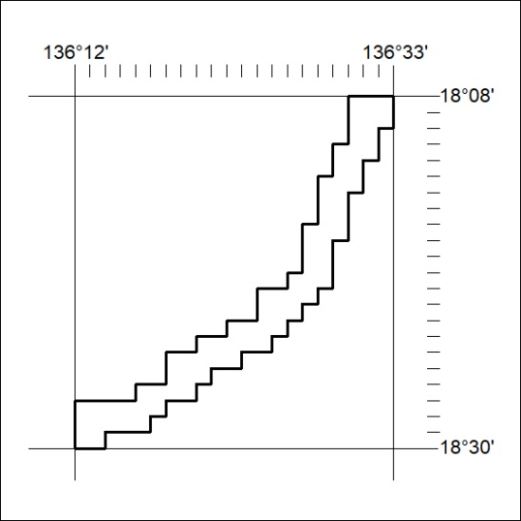

270/25

Mineral Titles Act 2010
NOTICE OF LAND CEASING TO BE A MINERAL TITLE AREA
Title Type and Number: | Exploration Licence 32850
Area Ceased on: | 11 April 2025
Area: | 249 Blocks, 812.06 km²
Locality: | BOXER
Name of Applicant(s)/Holder(s): | 100% XAVIER RESOURCES PTY LTD [ACN. 623 262 304]
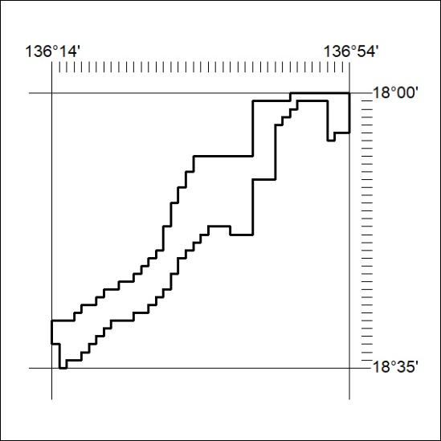

271/25

Mineral Titles Act 2010
NOTICE OF LAND CEASING TO BE A MINERAL TITLE AREA
Title Type and Number: | Exploration Licence 33612
Area Ceased on: | 11 April 2025
Area: | 23 Blocks, 23.39 km²
Locality: | BENMARA
Name of Applicant(s)/Holder(s): | 100% XAVIER RESOURCES PTY LTD [ACN. 623 262 304]
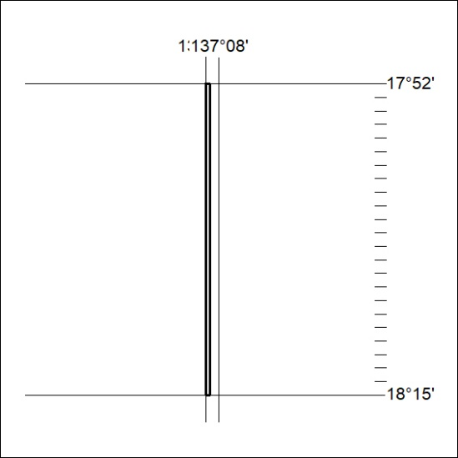

272/25

Mineral Titles Act 2010
NOTICE OF LAND CEASING TO BE A MINERAL TITLE AREA
Title Type and Number: | Exploration Licence 33613
Area Ceased on: | 11 April 2025
Area: | 118 Blocks, 384.34 km²
Locality: | BOXER
Name of Applicant(s)/Holder(s): | 100% XAVIER RESOURCES PTY LTD [ACN. 623 262 304]
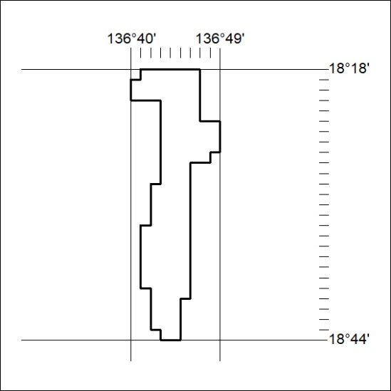

273/25

Mineral Titles Act 2010
NOTICE OF LAND CEASING TO BE A MINERAL TITLE APPLICATION AREA
Title Type and Number: | Exploration Licence 33920
Area Ceased on: | 14 April 2025
Area: | 250 Blocks, 761.44 km²
Locality: | UNDOOLYA
Name of Applicant(s)/Holder(s): | 100% BROKERAGEDIRECT PTY LTD [ACN. 629 383 357]
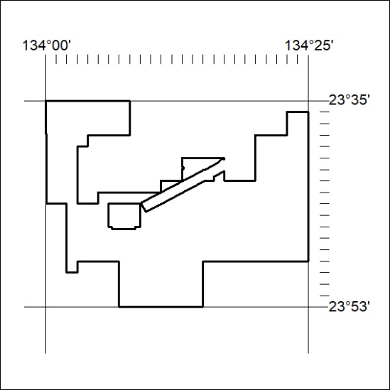

274/25

Mineral Titles Act
NOTICE OF GRANT OF A MINERAL TITLE
Title Type and Number: | Exploration Licence 33932
Granted: | 11 April 2025, for a period of 6 Years
Area: | 82 Blocks, 262.03 km²
Locality: | ANNINGIE
Name of Holder/s: | 100% LITHIUM DEVELOPMENTS PTY LTD [ACN. 612 245 020]
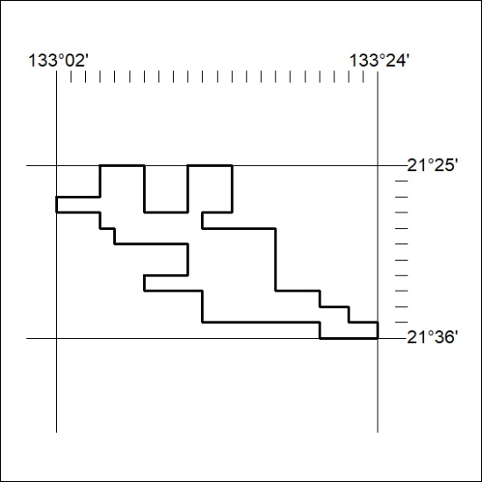
Area granted is indicated above. The titleholder is not permitted to exercise occupational rights on any land that is subject to a development title, or an application for a development title. Any land the subject of a Reserved Land gazettal under the Mineral Titles Act and all land vested in the Commonwealth of Australia is also excluded by description but not excised from the grant area.
275/25

Mineral Titles Act
NOTICE OF GRANT OF A MINERAL TITLE
Title Type and Number: | Exploration Licence 33933
Granted: | 11 April 2025, for a period of 6 Years
Area: | 14 Blocks, 44.78 km²
Locality: | CRAWFORD
Name of Holder/s: | 100% LITHIUM DEVELOPMENTS PTY LTD [ACN. 612 245 020]
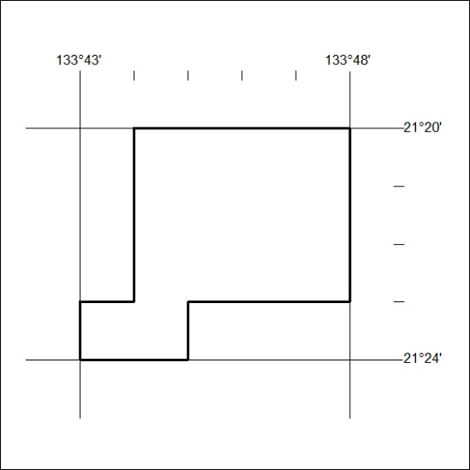
Area granted is indicated above. The titleholder is not permitted to exercise occupational rights on any land that is subject to a development title, or an application for a development title. Any land the subject of a Reserved Land gazettal under the Mineral Titles Act and all land vested in the Commonwealth of Australia is also excluded by description but not excised from the grant area.
276/25

