Mineral Titles Act 2010
NOTICE OF LAND CEASING TO BE A MINERAL TITLE AREA
Title Type and Number: | Exploration Licence 31012
Area Ceased on: | 10 March 2025
Area: | 14 Blocks, 45.91 km²
Locality: | LANCEWOOD
Name of Applicant(s)/Holder(s): | 100% RIPPLE RESOURCES PTY LTD [ACN. 127 220 768]
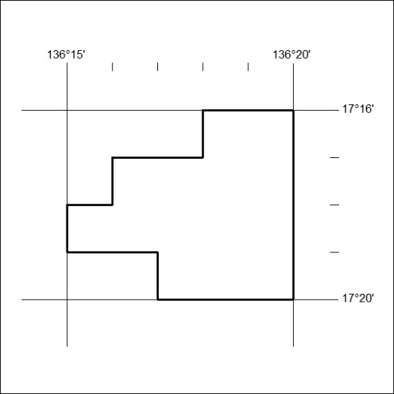

89/25

