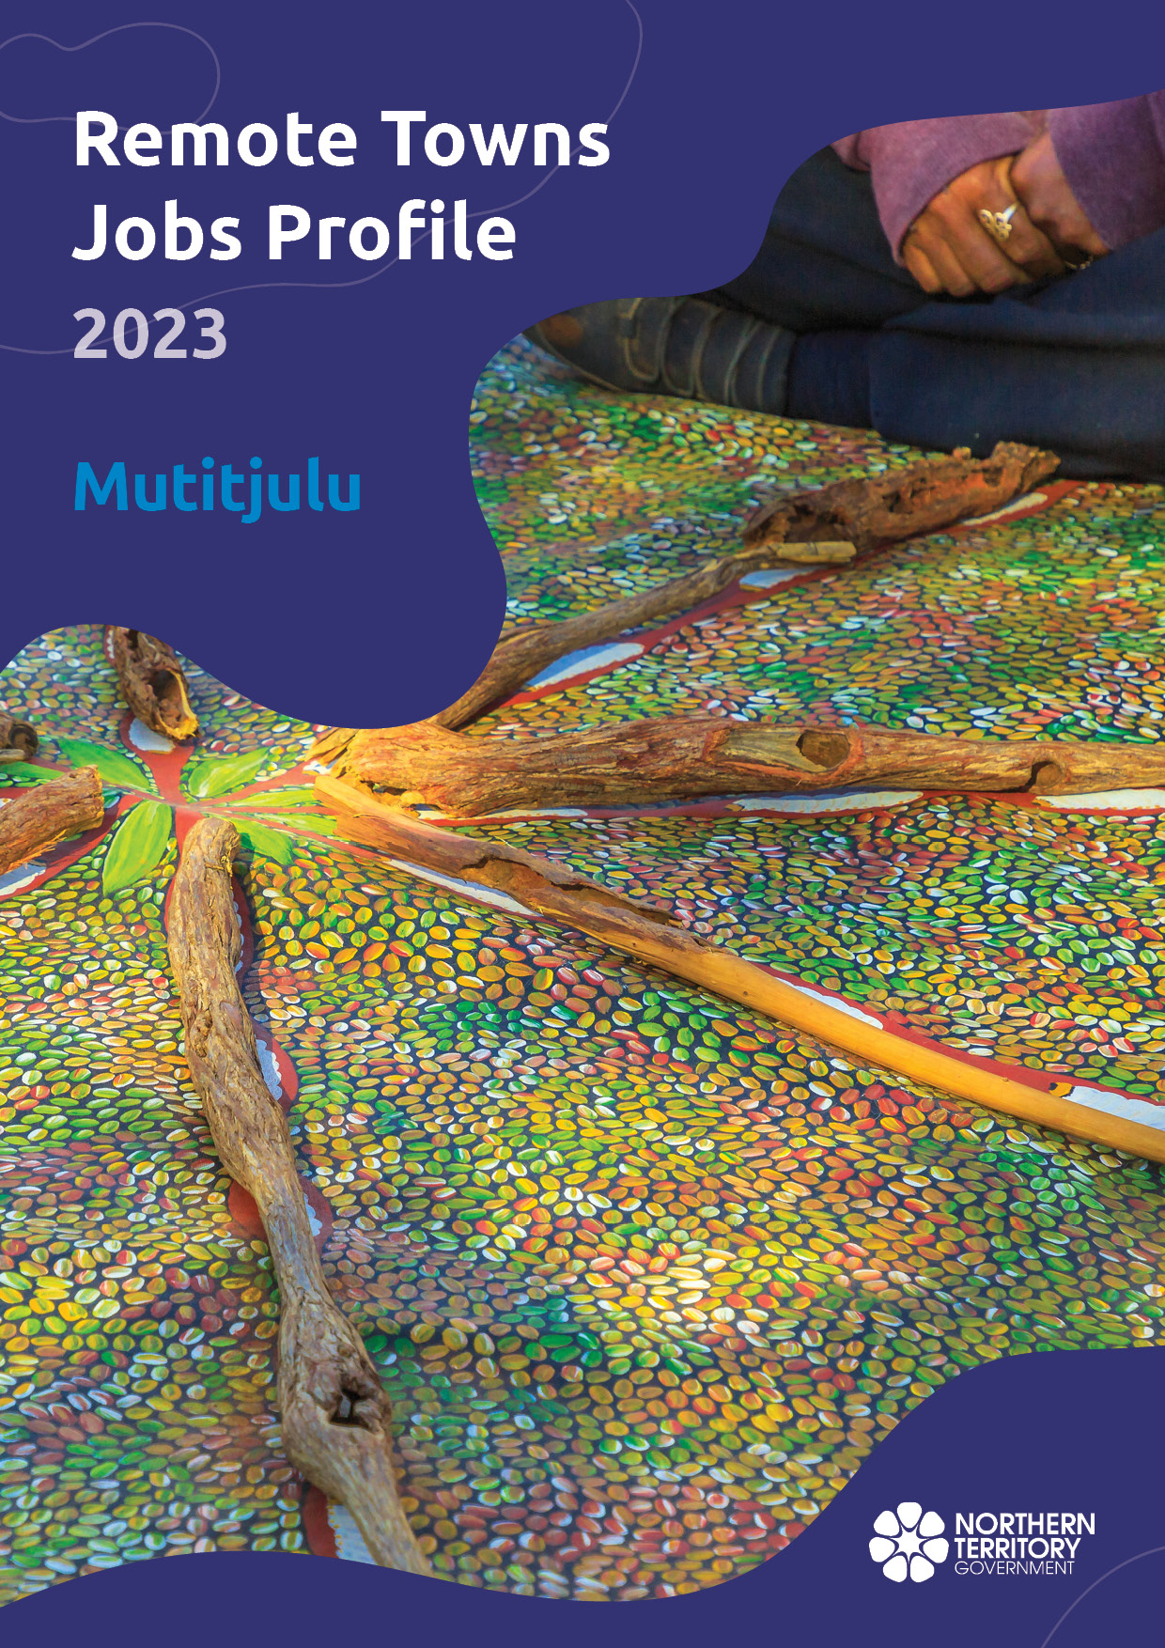

**© Northern Territory of Australia 2025**

**Preferred Reference:** Department of Trade, Business and Asian Relations, 2023 Remote Towns Jobs Profiles, Northern Territory Government, January 2025, Darwin.

**Front cover image:** Aboriginal bush painting at Karrke Aboriginal Cultural Experience.

**Disclaimer**

The data in this publication was collected by conducting a survey of businesses located in the 28 remote town boundaries. This body of work was completed in 2023 by the former Northern Territory Department of Industry, Tourism and Trade.

The collection methodology was created in accordance with Australian Bureau of Statistics data quality framework principles. Data in this publication is only reflective of those businesses reported on as operating in the town at the time of data collection (see table at the end of publication for list of businesses reported on). To comply with privacy legislation or where appropriate, some data in this publication may have been adjusted and will not reflect the actual data reported by businesses. As a result of this, combined with certain data not being reported by some businesses, some components may not add to totals. Changes over time may also reflect change in business propensity to report on certain data items rather than actual changes over time. Total figures have generally not been adjusted. Caution is advised when interpreting the comparisons made to the earlier 2011, 2014 and 2017 publications as the businesses identified and reported on and the corresponding jobs may differ between publications. The surveys have not always gathered data on training and jobs in the same years.

**Notes for each table and chart are ordered alphabetically and listed at the end of the publication.**

The Northern Territory of Australia exercised due care and skill to ensure that at the time of publication the information contained in this publication is true and correct. However, it is not intended to be relied on as professional advice or used for commercial purposes. The Territory gives no warranty or assurances as to the accuracy of the information contained in the publication and to the maximum extent permitted by law accepts no direct or indirect liability for reliance on its content.

Any use of this report for commercial purposes is not endorsed by the Department of Trade, Business and Asian Relations.

Contents

Mutitjulu 4

Introduction 5

Summary 6

Jobs Overview 7

Jobs filled by Aboriginality 8

Jobs by Sector: Private and Public 10

Job Status: Permanent and Temporary 14

Job Vacancies 16

Jobs by Industry 18

Jobs by Occupation 23

Jobs by Industry by Occupation 25

Jobs by Gender 27

Jobs by Age 30

Vocational Education and Training 34

Population 37

Community Development Program 39

Businesses 40

Notes 41

Abbreviations and Acronyms 42

# Mutitjulu

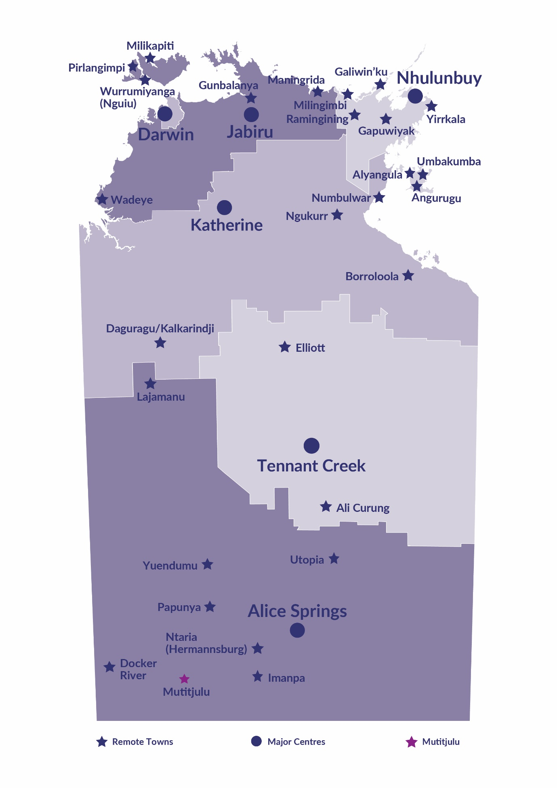Mutitjulu is located inside the boundary of the Uluru-Kata Tjuta National Park, 460 kilometres southwest of Alice Springs, with population of 294 residents.

*Source: Northern Territory Department of Industry, Tourism and Trade*

# Introduction

This jobs profile provides a snapshot of jobs and the characteristics of job holders in Mutitjulu as of September 2023.

Trends from the surveys conducted in 2011, 2014, and 2017 are also described. Additionally, it presents data on Community Development Program activity, Population, and Vocational Education and Training.

This job profile is one of 28 profiles developed for remote towns in the Northern Territory. It is anticipated these, and subsequent profiles will contribute to a robust evidence base to inform decision making in and relating to these remote Territory towns.

This profile contains information collected by the Northern Territory businesses operating within the town and is supplemented by other administrative data sets and information.

Each profile provides up-to-date information that is intended to inform the planning and design of current and future government programs and as an evidence base to inform decision making relating to workforce development, enterprise and job opportunities.

The profile may best be understood as a point-in-time tool. The number of business surveys from which the data was drawn is significantly less than in earlier surveys, and business participation has decreased with each survey. For Mutitjulu, 46% fewer businesses than in 2017 are reported here.

The data collection methodology and corresponding questionnaire were created in partnership with the Australian Bureau of Statistics (ABS) and in accordance with ABS data quality framework and survey principles.

The Northern Territory Department of Industry, Tourism and Trades’ Territory Engagement and Delivery, Skills Initiative and VET data teams collaborated with the Northern Institute at Charles Darwin University to facilitate the surveys and reports.

The information collected and reported on represents a significant goodwill investment by those businesses and organisations that participated. Each business is listed at the end of this publication.

# Summary

The 2023 jobs profile was developed based on responses from 8 businesses operating within the Mutitjulu town boundary, 6 less than in the 2017 survey. Of these, there were:

* 5 businesses from the Private Sector, accounting for 59 filled jobs or 53% of total filled jobs
* 3 businesses from the Public Sector, accounting for 52 filled jobs or 47% of total filled jobs

A total of 134 filled and vacant jobs in Mutitjulu were reported.[1]

The 2023 profile highlights:

* there were 111 filled jobs of which:
* 45 jobs (41%) were filled by Aboriginal people
* 66 jobs (59%) were filled by non-Aboriginal people
* 25% of employed Aboriginal people are working in the Private Sector
* Aboriginal females made up 47% of total Aboriginal filled jobs
* there were 23 vacant jobs, of which:
* job vacancies as a percentage of jobs is 17%
* job vacancies equate to 1 in 6 jobs
* 18 vacancies were in the Professionals and Community and Personal Service Workers areas
* Professional, Scientific and Technical Services was the largest industry employer in 2023 with 46 filled jobs followed by Public Administration and Safety with 36 employees
* Primary Industry was the largest training activity sector in 2023, with 37 students followed by Engineering and Mining with 16 students.

The overall population in Mutitjulu remain unchanged at 294 people between 2011 and 2021.

In comparison, the overall Northern Territory population increased by 9.7% between 2011 and 2021.

In 2021, the working age population (15 years and over) in Mutitjulu was an estimated 234 people compared to 224 in 2011, an increase by 4.5%.

There were 0.6 jobs in Mutitjulu per working age person compared to 0.3 jobs per working age person across the 28 remote towns in the Northern Territory.

# Jobs Overview

Table 1: Count of filled jobs and vacancies, 2017 & 2023 (a)(b)

|  |  |  |  |
| --- | --- | --- | --- |
|  | **2017** | **2023** | **Change 2017-2023** |
| **Total All Jobs** | **195** | **134** | **-61** |
| **Vacancies** | **14** | **23** | **9** |
| Vacancies as % of Total All Jobs | 7.73% | 17.2% | 9.4 ppt |
| **Filled Jobs** | **181** | **111** | **-70** |
| Full-time | 146 | 79 | -67 |
| Part-time | 35 | 32 | -3 |

Source: Northern Territory Department of Industry, Tourism and Trade

Chart 1: Count of vacant jobs and filled jobs by full-time/part-time status, 2017 & 2023 (a)(b)

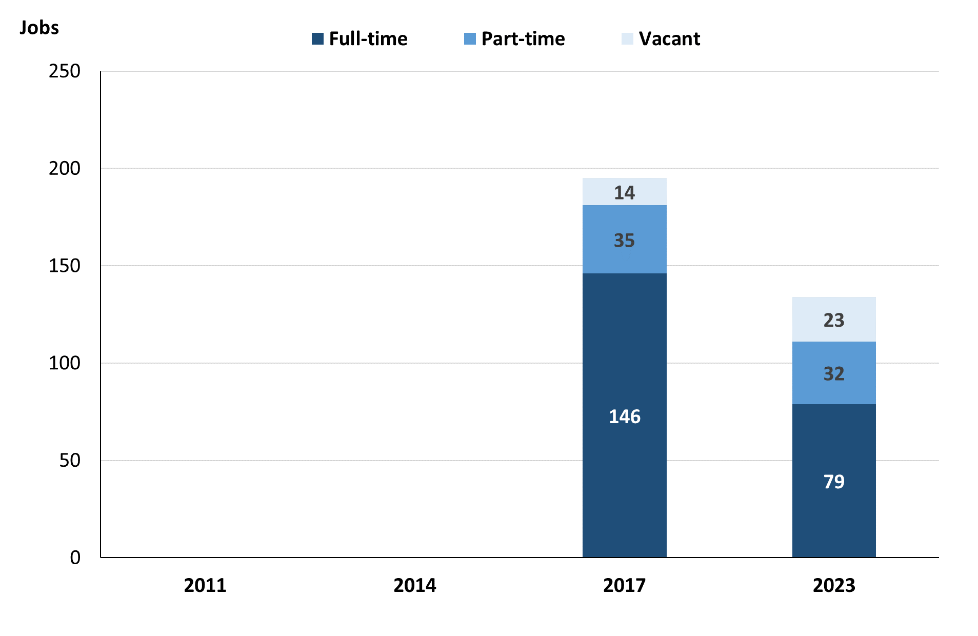

Source: Northern Territory Department of Industry, Tourism and Trade

In 2023 in Mutitjulu:

* there was a total of 111 **filled jobs**, a decrease of 70 jobs from 2017. Of these:
* 79 were **full-time** jobs, a decrease of 67 jobs from 2017
* 32 were **part-time** jobs, a decrease of 3 jobs from 2017
* there were 23 total job **vacancies**, an increase of 9 vacancies from 2017.

# Jobs filled by Aboriginality

Chart 2: Count of filled jobs by Aboriginality, 2017 & 2023 (a)(c)

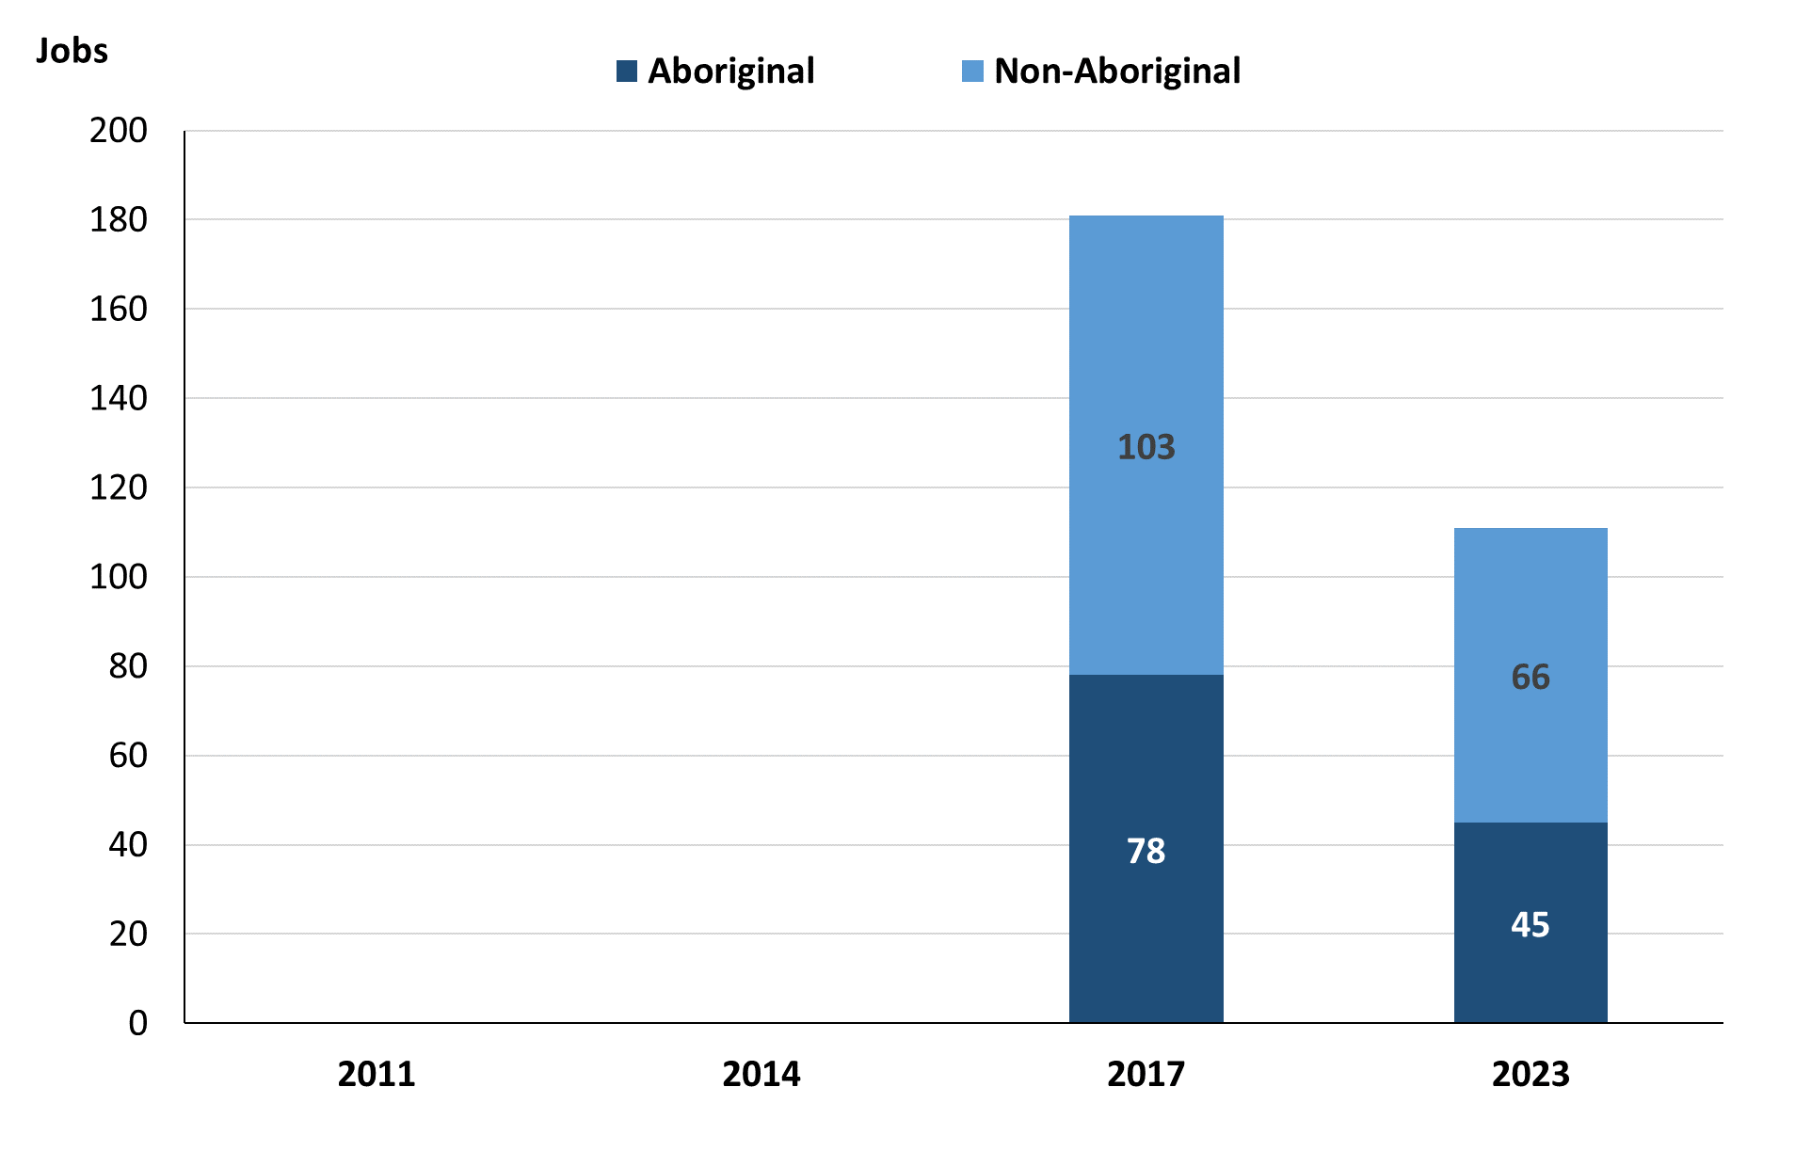

Source: Department of Industry, Tourism and Trade

In 2023 in Mutitjulu:

* of the 111 **filled jobs**:
* **Aboriginal** people filled 45 jobs, a decrease of 33 jobs from 2017
* **non-Aboriginal** people filled 66 jobs, a decrease of 37 jobs from 2017
* **Aboriginal** people accounted for 41% of job holders compared to 43% in 2017.

Table 2: Count of filled jobs by full-time/part-time status, 2017 & 2023 (a)(b)(c)

|  |  |  |  |  |  |  |  |  |  |
| --- | --- | --- | --- | --- | --- | --- | --- | --- | --- |
| **Indicator** | **2017** | | | **2023** | | | **Change**  **2017-2023** | | |
| **Aboriginal** | **Non-Aboriginal** | **Total** | **Aboriginal** | **Non-Aboriginal** | **Total** | **Aboriginal** | **Non-Aboriginal** | **Total** |
| Full-time | 57 | 89 | **146** | 21 | 58 | **79** | -36 | -31 | **-67** |
| Part-time | 21 | 14 | **35** | 24 | 8 | **32** | 3 | -6 | **-3** |
| **Total** | **78** | **103** | **181** | **45** | **66** | **111** | **-33** | **-37** | **-70** |

Source: Northern Territory Department of Industry, Tourism and Trade

Chart 3: Count of filled jobs by full-time/part-time status, 2017 & 2023 (a)(b)(c)

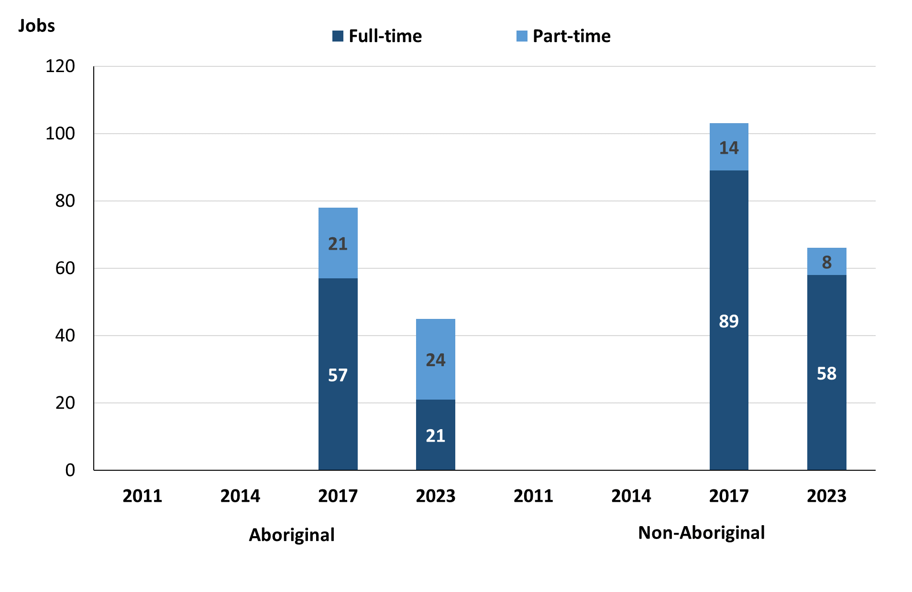

Source: Northern Territory Department of Industry, Tourism and Trade

In 2023 in Mutitjulu:

* of the 111 **filled jobs**:
* 21 were **full-time** jobs filled by **Aboriginal** people, a decrease of 36 jobs from 2017
* 24 were **part-time** jobs filled by **Aboriginal** people, an increase of 3 jobs from 2017
* 58 were **full-time** jobs filled by **non-Aboriginal** people, a decrease of 31 jobs from 2017
* 8 were **part-time** jobs filled by **non-Aboriginal** people, a decrease of 6 jobs from 2017.

# Jobs by Sector: Private and Public

Table 3: Count of filled jobs by sector of business, 2017 & 2023 (a)(c)(d)

|  |  |  |  |  |  |  |  |  |  |
| --- | --- | --- | --- | --- | --- | --- | --- | --- | --- |
| **Indicator** | **2017** | | | **2023** | | | **Change**  **2017-2023** | | |
| **Aboriginal** | **Non-Aboriginal** | **Total** | **Aboriginal** | **Non-Aboriginal** | **Total** | **Aboriginal** | **Non-Aboriginal** | **Total** |
| **Public Sector** | 24 | 36 | **60** | 17 | 35 | **52** | -7 | -1 | **-8** |
| Australian Government | 21 | 25 | **46** | 14 | 29 | **43** | -7 | 4 | **-3** |
| Territory Government | 3 | 11 | **14** | 1 | 5 | **6** | -2 | -6 | **-8** |
| Local Government | 0 | 0 | **0** | 2 | 1 | **3** | 2 | 1 | **3** |
| **Private Sector** | 54 | 67 | **121** | 28 | 31 | **59** | -26 | -36 | **-62** |
| **Total** | **78** | **103** | **181** | **45** | **66** | **111** | **-33** | **-37** | **-70** |

Source: Northern Territory Department of Industry, Tourism and Trade

Chart 4: Count of filled jobs by sector of business, 2023 (a)(d)

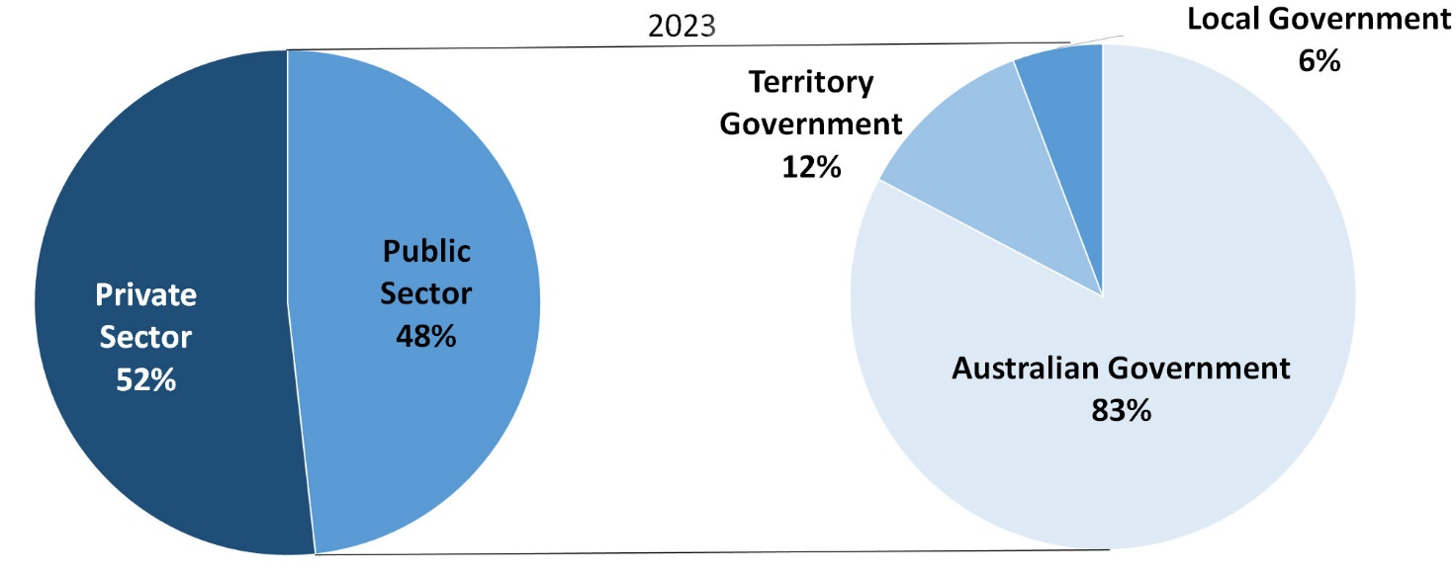

Source: Northern Territory Department of Industry, Tourism and Trade

In 2023 in Mutitjulu:

* there were 52 jobs in the **Public Sector**, a decrease of 8 jobs from 2017. Of these:
* 43 jobs were in the Australian Government, a decrease of 3 jobs from 2017
* 6 jobs were in the Territory Government, a decrease of 8 jobs from 2017
* 3 jobs were in the Local Government, an increase of 3 jobs from 2017
* there were 59 jobs in the **Private Sector**, a decrease of 62 jobs from 2017.

Chart 5: Count of filled jobs by sector of business, 2017 & 2023 (a)(c)(d)

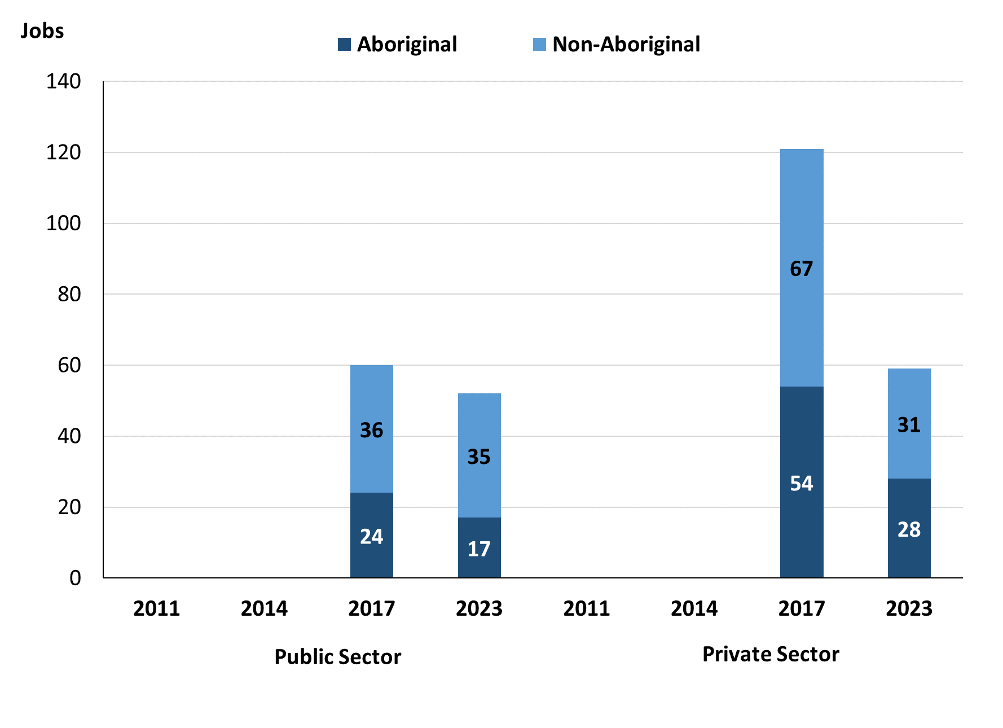

Source: Northern Territory Department of Industry, Tourism and Trade

In 2023 in Mutitjulu:

* of the 52 jobs in the **Public Sector**:
* **Aboriginal** people filled 17 jobs, a decrease of 7 jobs from 2017
* **non-Aboriginal** people filled 35 jobs, a decrease of 1 job from 2017
* of the 59 jobs in the **Private Sector**:
* **Aboriginal** people filled 28 jobs, a decrease of 26 jobs from 2017
* **non-Aboriginal** people filled 31 jobs, a decrease of 36 jobs from 2017.

Chart 6: Count of filled jobs by sector and full-time/part-time status, 2017 & 2023 (a)(b)(d)

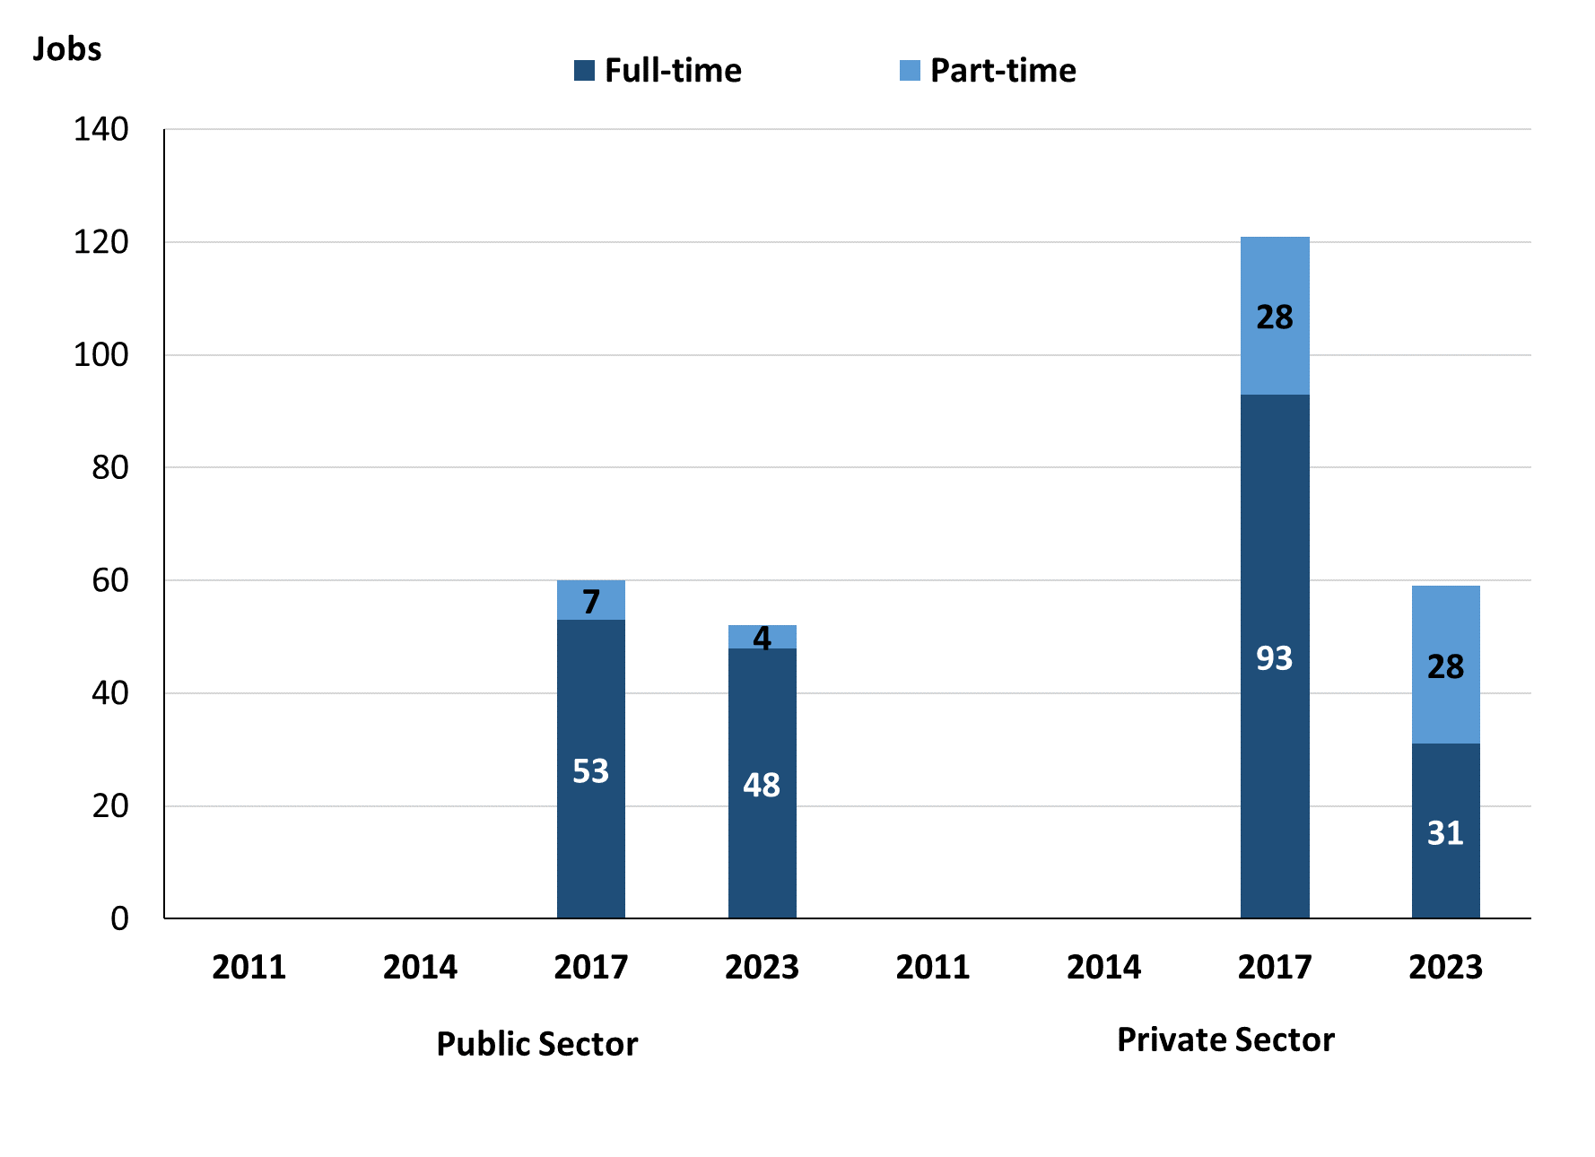

Source: Northern Territory Department of Industry, Tourism and Trade

In 2023 in Mutitjulu:

* of the 52 jobs in the **Public Sector**:
* 48 were full-time jobs, a decrease of 5 jobs from 2017
* 4 were part-time jobs, a decrease of 3 jobs from 2017
* of the 59 jobs in the **Private Sector**:
* 31 were full-time jobs, a decrease of 62 jobs from 2017
* 28 were part-time jobs, unchanged from 2017.

Table 4: Count of filled jobs by full-time/part-time status by sector, 2017 & 2023 (a)(b)(c)(d)

|  |  |  |  |  |  |  |  |  |  |
| --- | --- | --- | --- | --- | --- | --- | --- | --- | --- |
| **Indicator** | **2017** | | | | | | | | |
| **Aboriginal** | | | **Non-Aboriginal** | | | **Total** | | |
| **Full-time** | **Part-time** | **Total** | **Full-time** | **Part-time** | **Total** | **Full-time** | **Part-time** | **Total** |
| Public Sector | 19 | 5 | **24** | 34 | 2 | **36** | 53 | 7 | **60** |
| Private Sector | 38 | 16 | **54** | 55 | 12 | **67** | 93 | 28 | **121** |
| **Total** | **57** | **21** | **78** | **89** | **14** | **103** | **146** | **35** | **181** |

|  |  |  |  |  |  |  |  |  |  |
| --- | --- | --- | --- | --- | --- | --- | --- | --- | --- |
| **Indicator** | **2023** | | | | | | | | |
| **Aboriginal** | | | **Non-Aboriginal** | | | **Total** | | |
| **Full-time** | **Part-time** | **Total** | **Full-time** | **Part-time** | **Total** | **Full-time** | **Part-time** | **Total** |
| Public Sector | 17 | 0 | **17** | 31 | 4 | **35** | 48 | 4 | **52** |
| Private Sector | 4 | 24 | **28** | 27 | 4 | **31** | 31 | 28 | **59** |
| **Total** | **21** | **24** | **45** | **58** | **8** | **66** | **79** | **32** | **111** |

Source: Northern Territory Department of Industry, Tourism and Trade

In 2023 in Mutitjulu there were:

* 17 jobs in the **Public Sector** filled by **Aboriginal** people, a decrease of 7 jobs from 2017, of which:
* 17 were full-time jobs, a decrease of 2 jobs from 2017
* none were part-time jobs, a decrease of 5 jobs from 2017
* 28 jobs in the **Private Sector** filled by **Aboriginal** people, a decrease of 26 jobs from 2017, of which:
* 4 were full-time jobs, a decrease of 34 jobs from 2017
* 24 were part-time jobs, an increase of 8 jobs from 2017
* 35 jobs in the **Public Sector** filled by **non-Aboriginal** people, a decrease of 1 job from 2017, of which:
* 31 were full-time jobs, a decrease of 3 jobs from 2017
* 4 were part-time jobs, an increase of 2 jobs from 2017
* 31 jobs in the **Private Sector** filled by **non-Aboriginal** people, a decrease of 36 jobs from 2017, of which:
* 27 were full-time jobs, a decrease of 28 jobs from 2017
* 4 were part-time jobs, a decrease of 8 jobs from 2017.

# Job Status: Permanent and Temporary

Table 5: Count of filled jobs by employment status, 2017 & 2023 (a)(c)(e)

|  |  |  |  |  |  |  |  |  |  |
| --- | --- | --- | --- | --- | --- | --- | --- | --- | --- |
| **Indicator** | **2017** | | | **2023** | | | **Change**  **2017-2023** | | |
| **Aboriginal** | **Non-Aboriginal** | **Total** | **Aboriginal** | **Non-Aboriginal** | **Total** | **Aboriginal** | **Non-Aboriginal** | **Total** |
| Permanent | 51 | 95 | **146** | 22 | 49 | **71** | -29 | -46 | **-75** |
| Temporary | 27 | 8 | **35** | 23 | 17 | **40** | -4 | 9 | **5** |
| **Total** | **78** | **103** | **181** | **45** | **66** | **111** | **-33** | **-37** | **-70** |

Source: Department of Industry, Tourism and Trade

**Chart 7: Count of filled jobs by employment status, 2017 & 2023 (a)(c)(e)**

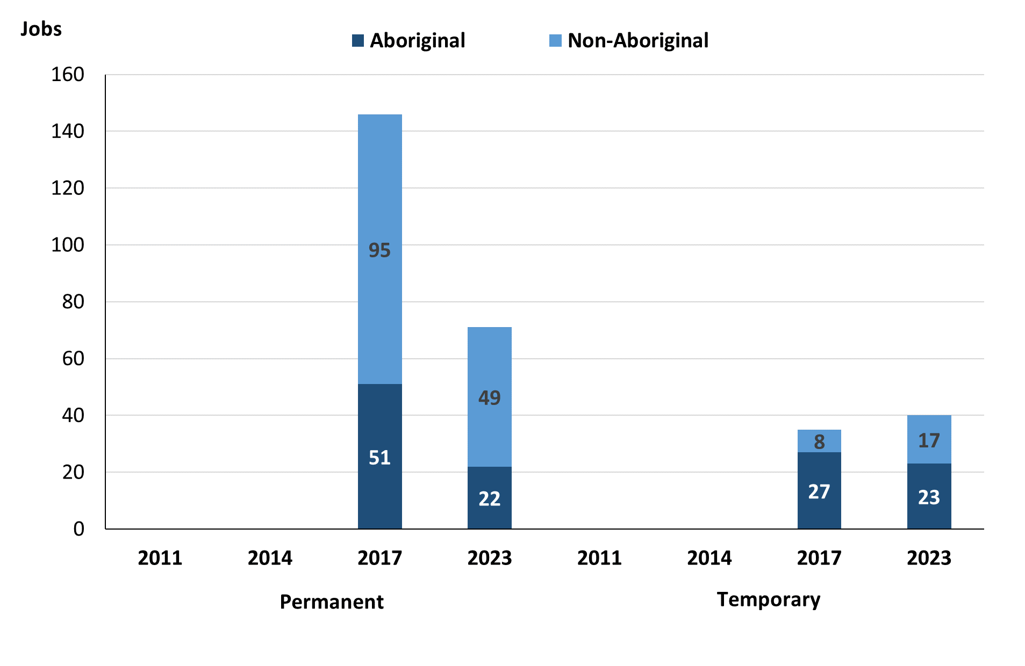

Source: Northern Territory Department of Industry, Tourism and Trade

In 2023 in Mutitjulu there were:

* 71 **permanent** jobs, a decrease of 75 jobs from 2017, of which:
* **Aboriginal** people filled 22 jobs, a decrease of 29 jobs from 2017
* **non-Aboriginal** people filled 49 jobs, a decrease of 46 jobs from 2017
* 40 **temporary** jobs, an increase of 5 jobs from 2017, of which:
* **Aboriginal** people filled 23 jobs, a decrease of 4 jobs from 2017
* **non-Aboriginal** people filled 17 jobs, an increase of 9 jobs from 2017.

Table 6: Count of filled jobs by sector and employment status, 2017 & 2023 (a)(c)(d)(e)

|  |  |  |  |  |  |  |  |  |  |
| --- | --- | --- | --- | --- | --- | --- | --- | --- | --- |
| **Indicator** | **2017** | | | | | | | | |
| **Aboriginal** | | | **Non-Aboriginal** | | | **Total** | | |
| **Perm** | **Temp** | **Total** | **Perm** | **Temp** | **Total** | **Perm** | **Temp** | **Total** |
| Public Sector | 22 | 2 | **24** | 36 | 0 | **36** | 58 | 2 | **60** |
| Private Sector | 29 | 25 | **54** | 59 | 8 | **67** | 88 | 33 | **121** |
| **Total** | **51** | **27** | **78** | **95** | **8** | **103** | **146** | **35** | **181** |

|  |  |  |  |  |  |  |  |  |  |
| --- | --- | --- | --- | --- | --- | --- | --- | --- | --- |
| **Indicator** | **2023** | | | | | | | | |
| **Aboriginal** | | | **Non-Aboriginal** | | | **Total** | | |
| **Perm** | **Temp** | **Total** | **Perm** | **Temp** | **Total** | **Perm** | **Temp** | **Total** |
| Public Sector | 17 | 0 | **17** | 34 | 1 | **35** | 51 | 1 | **52** |
| Private Sector | 5 | 23 | **28** | 15 | 16 | **31** | 20 | 39 | **59** |
| **Total** | **22** | **14** | **45** | **49** | **16** | **66** | **71** | **30** | **111** |

Source: Northern Territory Department of Industry, Tourism and Trade

In 2023 in Mutitjulu:

* of the 52 jobs in the **Public Sector**, a decrease of 8 jobs from 2017, of which:
* 51 jobs were **permanent**, a decrease of 7 jobs from 2017, of which:
* **Aboriginal** people filled 17 jobs, a decrease of 5 jobs from 2017
* **non-Aboriginal** people filled 34 jobs, a decrease of 2 jobs from 2017
* 1 job was **temporary**, a decrease of 1 job from 2017, of which:
* **Aboriginal** people filled 0 jobs, a decrease of 2 jobs from 2017
* a **non-Aboriginal** person filled 1 job, an increase of 1 job from 2017
* of the 59 jobs in the **Private Sector**, a decrease of 62 jobs from 2017, of which:
* 20 jobs were **permanent**, a decrease of 68 jobs from 2017, of which:
* **Aboriginal** people filled 5 jobs, a decrease of 24 jobs from 2017
* **non-Aboriginal** people filled 15 jobs, a decrease of 44 jobs from 2017
* 39 jobs were **temporary**, an increase of 6 jobs from 2017, of which:
* **Aboriginal** people filled 23 jobs, a decrease of 2 jobs from 2017
* **non-Aboriginal** people filled 16 jobs, an increase of 8 jobs from 2017.

# Job Vacancies

Table 7: Job vacancies, 2017 & 2023

|  |  |  |  |
| --- | --- | --- | --- |
| **Indicator** | **2017** | **2023** | **Change 2017-2023** |
| **Job vacancies** | **14** | **23** | **9** |

Source: Northern Territory Department of Industry, Tourism and Trade

Table 8: Job vacancies by occupation, 2017 & 2023 (f)(g)

|  |  |  |  |
| --- | --- | --- | --- |
| **Occupation (ANZSCO major group)** | **2017** | **2023** | **Change 2017-2023** |
| Clerical and Administrative Workers | 3 | 0 | -3 |
| Community and Personal Service Workers | 4 | 7 | 3 |
| Labourers | 1 | 0 | -1 |
| Managers | 1 | 1 | 0 |
| Professionals | 5 | 11 | 7 |
| Technicians and Trades Workers | 0 | 2 | 2 |
| Other | 0 | 2 | 2 |
| **Total** | **14** | **23** | **9** |

Source: Northern Territory Department of Industry, Tourism and Trade

Table 9: Job vacancies by job title, 2023 profile (f)

|  |  |
| --- | --- |
| **Job Vacancy** | **No.** |
| Aboriginal and Torres Strait Islander Education Worker | 2 |
| Aboriginal and Torres Strait Islander Land and Sea Ranger | 3 |
| Building and Engineering Technician | 1 |
| Café and Restaurant Manager | 1 |
| Café Worker | 1 |
| Classroom Teacher | 3 |
| Electrotechnology and Telecommunications Trade Worker | 1 |
| Park Ranger | 5 |
| Tourist Information Officer | 4 |
| Vocational Education Teacher | 1 |
| Welfare Support Worker | 1 |
| **Total** | **23** |

Source: Northern Territory Department of Industry, Tourism and Trade

In 2023 in Mutitjulu:

* there were 23 **vacancies** reported, an increase of 9 vacancies from 2017
* of the 23 reported vacancies, the largest requirements were for:
* 11 Professionals, the majority of which are in the following jobs:
* Aboriginal and Torres Strait Islander Land and Sea Ranger
* Classroom Teacher
* Park Ranger
* 7 Community and Personal Service Workers, the majority of which are in the following jobs:
* Aboriginal and Torres Strait Islander Education Worker
* Tourist Information Officer.

# Jobs by Industry

Table 10: Count of filled jobs by industry of business, 2017 & 2023 (a)(h)

|  |  |  |  |  |  |
| --- | --- | --- | --- | --- | --- |
| **Industry (ANZSIC Division)** | **2017** | | **2023** | | **Change 2017-2023** |
| **Total** | **% of Total** | **Total** | **% of Total** | **Total** |
| Accommodation and Food Services | 14 | 7.7% | 0 | 0.0% | -14 |
| Administrative and Support Services | 11 | 6.1% | 0 | 0.0% | -11 |
| Arts and Recreation Services | 62 | 34.3% | 18 | 16.2% | -44 |
| Education and Training | 24 | 13.3% | 4 | 3.6% | -20 |
| Health Care and Social Assistance | 49 | 27.1% | 7 | 6.3% | -42 |
| Professional, Scientific and Technical Services | 0 | 0.0% | 46 | 41.4% | 46 |
| Public Administration and Safety | 12 | 6.6% | 36 | 32.4% | 24 |
| Retail Trade | 9 | 5.0% | 0 | 0.0% | -9 |
| **Total** | **181** | **100.0%** | **111** | **100.0%** | **-70** |

Source: Northern Territory Department of Industry, Tourism and Trade

In 2023 in Mutitjulu:

* the Professional, Scientific and Technical Services industry was the **largest industry employer**, with 46 filled jobs or 41.4% of filled jobs, an increase of 46 jobs from 2017
* **other significant** industry employers were:
* Public Administration and Safety with 36 jobs (or 32.4% of filled jobs), an increase of 24 jobs from 2017
* Arts and Recreation Services with 18 jobs (or 16.2% of filled jobs), a decrease of 44 jobs from 2017
* Health Care and Social Assistance with 7 jobs (or 6.3% of filled jobs), a decrease of 42 jobs from 2017.

Table 11: Count of filled jobs by industry of business, 2017 & 2023 (a)(c)(h)

|  |  |  |  |  |  |  |  |  |  |
| --- | --- | --- | --- | --- | --- | --- | --- | --- | --- |
| **Industry (ANZSIC division)** | **2017** | | | **2023** | | | **Change**  **2017-2023** | | |
| **Aboriginal** | **Non-Aboriginal** | **Total** | **Aboriginal** | **Non-Aboriginal** | **Total** | **Aboriginal** | **Non-Aboriginal** | **Total** |
| Accommodation and Food Services | 14 | 0 | **14** | 0 | 0 | **0** | -14 | 0 | **-14** |
| Administrative and Support Services | 9 | 2 | **11** | 0 | 0 | **0** | -9 | -2 | **-11** |
| Arts and Recreation Services | 21 | 41 | **62** | 5 | 13 | **18** | -16 | -28 | **-44** |
| Education and Training | 8 | 16 | **24** | 1 | 3 | **4** | -7 | -13 | **-20** |
| Health Care and Social Assistance | 18 | 31 | **49** | 3 | 4 | **7** | -15 | -27 | **-42** |
| Professional, scientific and technical services | 0 | 0 | **0** | 16 | 30 | **46** | 16 | 30 | **46** |
| Public Administration and Safety | 7 | 5 | **12** | 20 | 16 | **36** | 13 | 11 | **24** |
| Retail Trade | 1 | 8 | **9** | 0 | 0 | **0** | -1 | -8 | **-9** |
| **Total** | **78** | **103** | **181** | **45** | **66** | **111** | **-33** | **-37** | **-70** |

Source: Northern Territory Department of Industry, Tourism and Trade

Chart 8: Count of filled jobs by top 5 industries, 2023 (a)(c)(h)

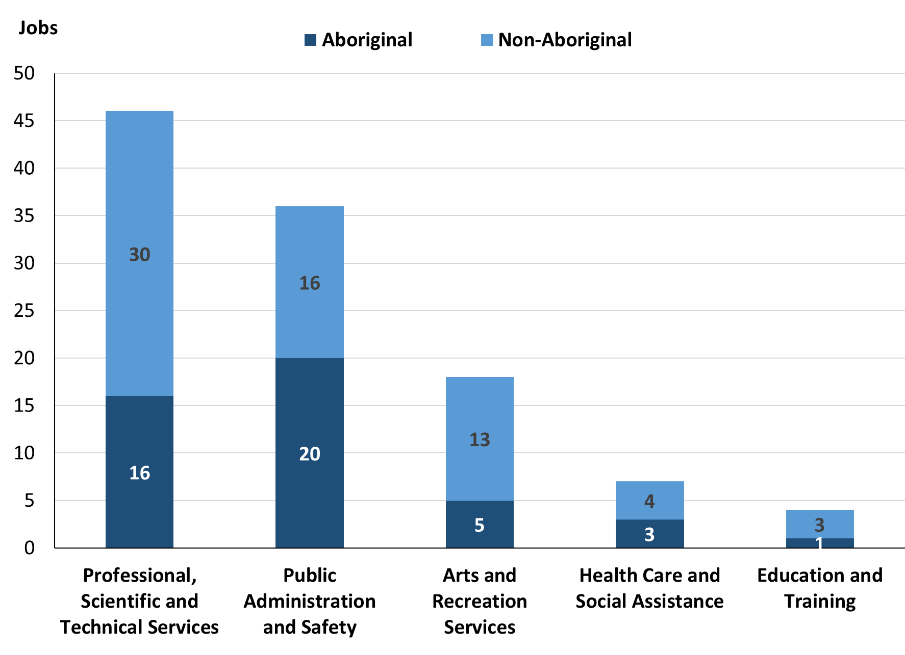

Source: Northern Territory Department of Industry, Tourism and Trade

In 2023 in Mutitjulu of the:

* 45 jobs filled by **Aboriginal** people, there were:
* 20 jobs in Public Administration and Safety, an increase of 13 jobs from 2017
* 16 jobs in Professional, scientific and technical services, an increase of 16 jobs from 2017
* 5 jobs in Arts and Recreation Services, a decrease of 16 jobs from 2017
* 66 jobs filled by **non-Aboriginal** people, there were:
* 30 jobs in Professional, scientific and technical services, an increase of 30 jobs from 2017
* 16 jobs in Public Administration and Safety, an increase of 11 jobs from 2017
* 13 jobs in Arts and Recreation Services, a decrease of 28 jobs from 2017.

Table 12: Count of filled jobs by industry and employment status, 2017 (a)(c)(e)(h)

|  |  |  |  |  |  |  |  |  |  |
| --- | --- | --- | --- | --- | --- | --- | --- | --- | --- |
| **Industry (ANZSIC division)** | **2017** | | | | | | | | |
| **Aboriginal** | | | **Non-Aboriginal** | | | **Total** | | |
| **Perm** | **Temp** | **Total** | **Perm** | **Temp** | **Total** | **Perm** | **Temp** | **Total** |
| Accommodation and Food Services | 2 | 12 | **14** | 0 | 0 | **0** | 2 | 12 | **14** |
| Administrative and Support Services | 6 | 3 | **9** | 1 | 1 | **2** | 7 | 4 | **11** |
| Arts and Recreation Services | 21 | 0 | **21** | 40 | 1 | **41** | 61 | 1 | **62** |
| Education and Training | 1 | 7 | **8** | 14 | 2 | **16** | 15 | 9 | **24** |
| Health Care and Social Assistance | 18 | 0 | **18** | 31 | 0 | **31** | 49 | 0 | **49** |
| Public Administration and Safety | 3 | 4 | **7** | 4 | 1 | **5** | 7 | 5 | **12** |
| Retail Trade | 0 | 1 | **1** | 5 | 3 | **8** | 5 | 4 | **9** |
| **Total** | **51** | **27** | **78** | **95** | **8** | **103** | **146** | **35** | **181** |

Source: Northern Territory Department of Industry, Tourism and Trade

Table 13: Count of filled jobs by industry and employment status, 2023 (a)(c)(e)(h)

|  |  |  |  |  |  |  |  |  |  |
| --- | --- | --- | --- | --- | --- | --- | --- | --- | --- |
| **Industry (ANZSIC division)** | **2023** | | | | | | | | |
| **Aboriginal** | | | **Non-Aboriginal** | | | **Total** | | |
| **Perm** | **Temp** | **Total** | **Perm** | **Temp** | **Total** | **Perm** | **Temp** | **Total** |
| Accommodation and Food Services | 0 | 0 | **0** | 0 | 0 | **0** | 0 | 0 | **0** |
| Administrative and Support Services | 0 | 0 | **0** | 0 | 0 | **0** | 0 | 0 | **0** |
| Arts and Recreation Services | 0 | 5 | **5** | 0 | 13 | **13** | 0 | 18 | **18** |
| Education and Training | 1 | 0 | **1** | 2 | 1 | **3** | 3 | 1 | **4** |
| Health Care and Social Assistance | 3 | 0 | **3** | 4 | 0 | **4** | 7 | 0 | **7** |
| Professional, scientific and technical services | 16 | 0 | **16** | 30 | 0 | **30** | 46 | 0 | **46** |
| Public Administration and Safety | 2 | 18 | **20** | 13 | 3 | **16** | 15 | 21 | **36** |
| Retail Trade | 0 | 0 | **0** | 0 | 0 | **0** | 0 | 0 | **0** |
| **Total** | **22** | **23** | **45** | **49** | **17** | **66** | **71** | **40** | **111** |

Source: Northern Territory Department of Industry, Tourism and Trade

In 2023 in Mutitjulu of the:

* 71 **permanent** jobs, there were:
* 46 jobs in Professional, scientific and technical services, an increase of 46 jobs from 2017, including:
* **Aboriginal** people filled 16 jobs, an increase of 16 jobs from 2017
* **non-Aboriginal** people filled 30 jobs, an increase of 30 jobs from 2017
* 15 jobs in Public Administration and Safety, an increase of 8 jobs from 2017, including:
* **Aboriginal** people filled 2 jobs, a decrease of 1 job from 2017
* **non-Aboriginal** people filled 13 jobs, an increase of 9 jobs from 2017
* 7 jobs in Health Care and Social Assistance, a decrease of 42 jobs from 2017, including:
* **Aboriginal** people filled 3 jobs, a decrease of 15 jobs from 2017
* **non-Aboriginal** people filled 4 jobs, a decrease of 27 jobs from 2017
* 40 **temporary** jobs, there were:
* 21 jobs in Public Administration and Safety, an increase of 16 jobs from 2017, including:
* **Aboriginal** people filled 18 jobs, an increase of 14 jobs from 2017
* **non-Aboriginal** people filled 3 jobs, an increase of 2 jobs from 2017
* 18 jobs in Arts and Recreation Services, an increase of 17 jobs from 2017, including:
* **Aboriginal** people filled 5 jobs, an increase of 5 jobs from 2017
* **non-Aboriginal** people filled 13 jobs, an increase of 12 jobs from 2017
* 1 job in Education and Training, a decrease of 8 jobs from 2017, including:
* **Aboriginal** people filled 0 jobs, a decrease of 7 jobs from 2017
* a **non-Aboriginal** people filled 1 job, a decrease of 1 job from 2017.

# Jobs by Occupation

Table 14: Count of filled jobs by occupation, 2017 & 2023 (a)(f)(g)

|  |  |  |  |  |  |
| --- | --- | --- | --- | --- | --- |
| **Occupation (ANZSCO major group)** | **2017** | | **2023** | | **Change 2017-2023** |
| **Total** | **% of Total** | **Total** | **% of Total** | **Total** |
| Clerical and Administrative Workers | 18 | 9.9% | 25 | 22.5% | 7 |
| Community and Personal Service Workers | 65 | 35.9% | 49 | 44.1% | -16 |
| Labourers | 17 | 9.4% | 2 | 1.8% | -15 |
| Machinery Operators and Drivers | 1 | 0.6% | 1 | 0.9% | 0 |
| Managers | 19 | 10.5% | 2 | 1.8% | -17 |
| Professionals | 49 | 27.1% | 24 | 21.6% | -25 |
| Sales Workers | 9 | 5.0% | 0 | 0.0% | -9 |
| Technicians and Trades Workers | 3 | 1.7% | 8 | 7.2% | 5 |
| **Total** | **181** | **100.0%** | **111** | **100.0%** | **-70** |

Source: Northern Territory Department of Industry, Tourism and Trade

Chart 9: Count of top 6 filled jobs by occupation, 2017 & 2023 (a)(f)(g)

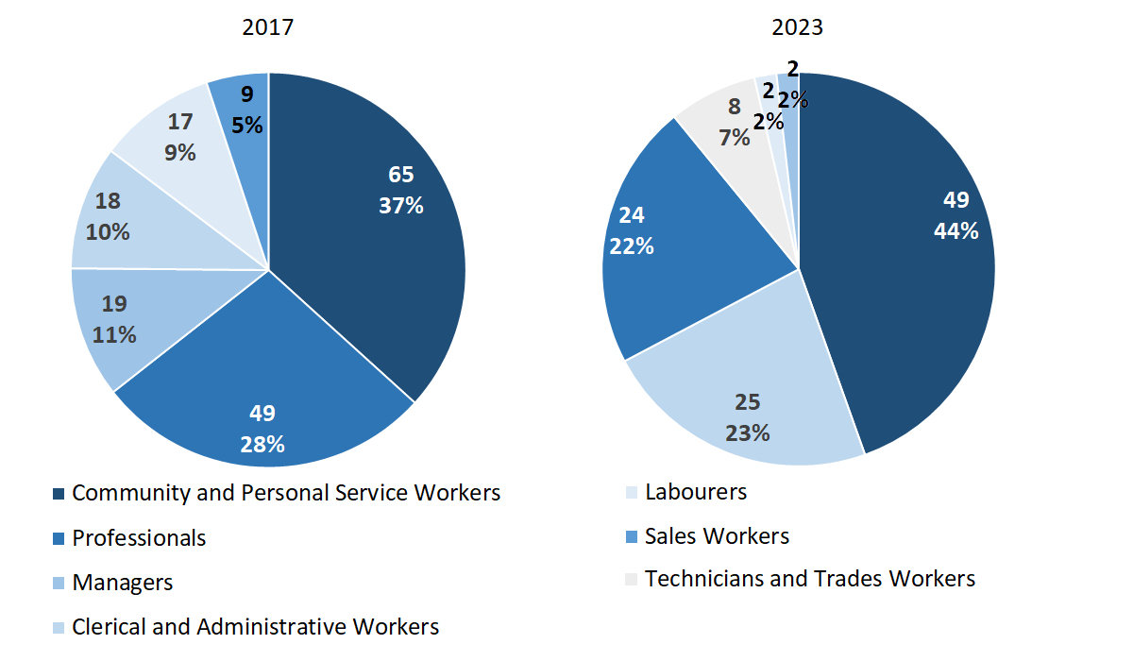Source: Northern Territory Department of Industry, Tourism and Trade

In 2023 in Mutitjulu:

* Community and Personal Service Workers was **the largest occupation classification** in terms of filled jobs, accounting for 49 jobs (44.1% of total filled jobs), a decrease of 16 jobs from 2017
* **other significant** occupation classifications were:
* Clerical and Administrative Workers (25 jobs or 22.5%), an increase of 7 jobs from 2017
* Professionals (24 jobs or 21.6%), a decrease of 25 jobs from 2017
* Technicians and Trades Workers (8 jobs or 7.2%), an increase of 5 jobs from 2017.

**Table 15: Count of filled jobs by ANZSCO occupation, 2017 & 2023 (a)(c)(f)(g)**

|  |  |  |  |  |  |  |  |  |  |
| --- | --- | --- | --- | --- | --- | --- | --- | --- | --- |
| **Occupation (ANZSCO major group)** | **2017** | | | **2023** | | | **Change 2017-2023** | | |
| **Aboriginal** | **Non-Aboriginal** | **Total** | **Aboriginal** | **Non-Aboriginal** | **Total** | **Aboriginal** | **Non-Aboriginal** | **Total** |
| Clerical and Administrative Workers | 5 | 13 | **18** | 5 | 20 | **25** | 0 | 7 | **7** |
| Community and Personal Service Workers | 33 | 32 | **65** | 28 | 21 | **49** | -5 | -11 | **-16** |
| Labourers | 10 | 7 | **17** | 1 | 1 | **2** | -9 | -6 | **-15** |
| Machinery Operators and Drivers | 1 | 0 | **1** | 0 | 1 | **1** | -1 | 1 | **0** |
| Managers | 2 | 17 | **19** | 0 | 2 | **2** | -2 | -15 | **-17** |
| Professionals | 23 | 26 | **49** | 6 | 18 | **24** | -17 | -8 | **-25** |
| Sales Workers | 3 | 6 | **9** | 0 | 0 | **0** | -3 | -6 | **-9** |
| Technicians and Trades Workers | 1 | 2 | **3** | 5 | 3 | **8** | 4 | 1 | **5** |
| **Total** | **78** | **103** | **181** | **45** | **66** | **111** | **-33** | **-37** | **-70** |

Source: Northern Territory Department of Industry, Tourism and Trade

In 2023 in Mutitjulu of the:

* 45 jobs filled by **Aboriginal** people, there were:
* 28 Community and Personal Service Workers, a decrease of 5 jobs from 2017
* 6 Professionals, a decrease of 17 jobs from 2017
* 5 Clerical and Administrative Workers, unchanged from 2017
* 66 jobs filled by **non-Aboriginal** people, there were:
* 21 Community and Personal Service Workers, a decrease of 11 jobs from 2017
* 20 Clerical and Administrative Workers, an increase of 7 jobs from 2017
* 18 Professionals, a decrease of 8 jobs from 2017.

# Jobs by Industry by Occupation

**Table 16: Count of filled jobs by occupation and by industry, 2017 (a)(f)(g)(h)**

|  |  |  |  |  |  |  |  |  |  |  |
| --- | --- | --- | --- | --- | --- | --- | --- | --- | --- | --- |
| **2017** | | | | | | | | | | |
| **Industry (ANZSIC Division)** | **Occupation (ANZSCO major group)** | | | | | | | | | |
| **Clerical and Administrative Workers** | **Community and Personal Service Workers** | **Labourers** | **Machinery Operators and Drivers** | **Managers** | **Professionals** | **Sales Workers** | **Technicians and Trades Workers** | **Other Occupations** | **Total** |
| Accommodation and Food Services | 0 | 5 | 5 | 0 | 0 | 0 | 3 | 1 | 0 | **14** |
| Administrative and Support Services | 4 | 3 | 0 | 0 | 2 | 2 | 0 | 0 | 0 | **11** |
| Arts and Recreation Services | 5 | 13 | 1 | 0 | 7 | 34 | 2 | 0 | 0 | **62** |
| Education and Training | 4 | 6 | 3 | 0 | 3 | 7 | 0 | 1 | 0 | **24** |
| Health Care and Social Assistance | 4 | 33 | 1 | 0 | 4 | 6 | 0 | 1 | 0 | **49** |
| Public Administration and Safety | 1 | 5 | 5 | 0 | 1 | 0 | 0 | 0 | 0 | **12** |
| Retail Trade | 0 | 0 | 2 | 1 | 2 | 0 | 4 | 0 | 0 | **9** |
| **Total** | **18** | **65** | **17** | **1** | **19** | **49** | **9** | **3** | **0** | **181** |

Source: Northern Territory Department of Industry, Tourism and Trade

**Table 17: Count of filled jobs by occupation and by industry, 2023 (a)(f)(g)(h)**

|  |  |  |  |  |  |  |  |  |  |  |
| --- | --- | --- | --- | --- | --- | --- | --- | --- | --- | --- |
| **2023** | | | | | | | | | | |
| **Industry (ANZSIC Division)** | **Occupation (ANZSCO major group)** | | | | | | | | | |
| **Clerical and Administrative Workers** | **Community and Personal Service Workers** | **Labourers** | **Machinery Operators and Drivers** | **Managers** | **Professionals** | **Sales Workers** | **Technicians and Trades Workers** | **Other Occupations** | **Total** |
| Arts and Recreation Services | 5 | 3 | 0 | 1 | 1 | 6 | 0 | 2 | 0 | **18** |
| Education and Training | 0 | 0 | 0 | 0 | 0 | 4 | 0 | 0 | 0 | **4** |
| Health Care and Social Assistance | 3 | 0 | 0 | 0 | 0 | 4 | 0 | 0 | 0 | **7** |
| Professional, scientific and technical services | 12 | 25 | 0 | 0 | 0 | 7 | 0 | 2 | 0 | **46** |
| Public Administration and Safety | 5 | 21 | 2 | 0 | 1 | 3 | 0 | 4 | 0 | **36** |
| **Total** | **25** | **49** | **2** | **1** | **2** | **24** | **0** | **8** | **0** | **111** |

Source: Northern Territory Department of Industry, Tourism and Trade

In 2023 in Mutitjulu:

* Community and Personal Service Workers had the majority of jobs with 49 jobs (the largest occupation group) were shared across the Professional, scientific and technical services with 25 jobs and Public Administration and Safety industries with 21 jobs,
* Professional, scientific and technical services (the largest industry group) provided 46 filled jobs within an industry group,
* Arts and Recreation Services and Health Care and Social Assistance showed a decrease of 44 and 42 filled jobs between 2023 and 2017 respectively,
* Professional, scientific and technical services was a new industry in 2023 with 46 filled jobs, this industry had nil filled jobs in 2017,
* Public Administration and Safety showed an increase of 24 filled jobs between 2023 and 2017.

# Jobs by Gender

**Table 18: Count of filled jobs by gender, 2017 & 2023 (a)(c)(i)**

|  |  |  |  |  |  |  |  |  |  |
| --- | --- | --- | --- | --- | --- | --- | --- | --- | --- |
| **Indicator** | **2017** | | | **2023** | | | **2017-2023 Change** | | |
| **Aboriginal** | **Non-Aboriginal** | **Total** | **Aboriginal** | **Non-Aboriginal** | **Total** | **Aboriginal** | **Non-Aboriginal** | **Total** |
| Male | 44 | 34 | **78** | 24 | 27 | **51** | -20 | -7 | **-27** |
| Female | 33 | 69 | **102** | 21 | 38 | **59** | -12 | -31 | **-43** |
| **Total** | **77** | **103** | **180** | **45** | **66** | **111** | **-32** | **-37** | **-69** |

Source: Northern Territory Department of Industry, Tourism and Trade

**Chart 10: Count of filled jobs by gender, 2017 & 2023 (a)(c)(i)**

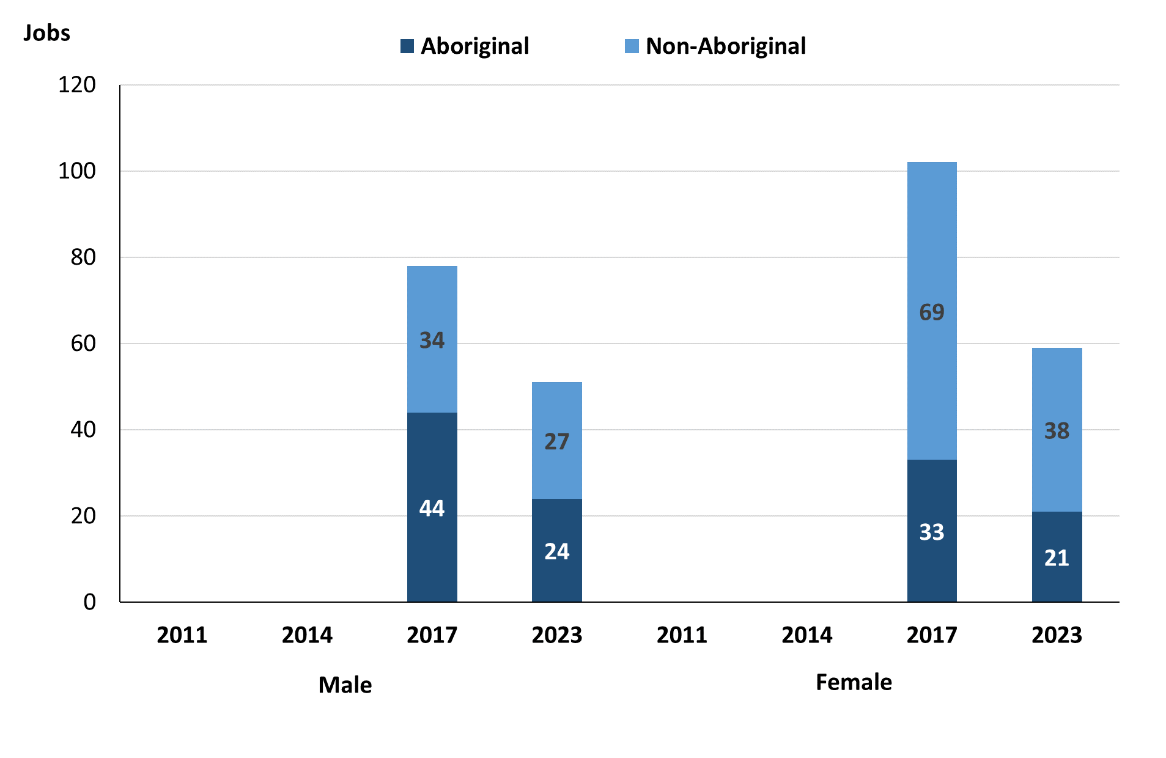

Source: Northern Territory Department of Industry, Tourism and Trade

In 2023 in Mutitjulu, there were:

* 51 jobs **filled by males**, a decrease of 27 jobs from 2017, of which:
* 24 were **Aboriginal**, a decrease of 20 jobs from 2017
* 27 were **non-Aboriginal**, a decrease of 7 jobs from 2017
* 59 jobs **filled by females**, a decrease of 43 jobs from 2017, of which:
* 21 were **Aboriginal**, a decrease of 12 jobs from 2017
* 38 were **non-Aboriginal**, a decrease of 31 jobs from 2017.

**Table 19: Count of filled jobs by gender, by full-time/part-time status, by job permanency and by sector, 2017 (a)(b)(c)(d)(e)(i)**

|  |  |  |  |  |  |  |  |  |  |
| --- | --- | --- | --- | --- | --- | --- | --- | --- | --- |
| **2017** | | | | | | | | | |
| **Indicator** | **Male** | | | **Female** | | | **Total** | | |
| **Aboriginal** | **Non-Aboriginal** | **Total** | **Aboriginal** | **Non-Aboriginal** | **Total** | **Aboriginal** | **Non-Aboriginal** | **Total** |
| Full-time | 37 | 31 | **68** | 19 | 58 | **77** | 57 | 89 | **146** |
| Part-time | 7 | 3 | **10** | 14 | 11 | **25** | 21 | 14 | **35** |
| **Total** | **44** | **34** | **78** | **33** | **69** | **102** | **78** | **103** | **181** |
| Permanent | 29 | 30 | **59** | 21 | 65 | **86** | 51 | 95 | **146** |
| Temporary | 15 | 4 | **19** | 12 | 4 | **16** | 27 | 8 | **35** |
| **Total** | **44** | **34** | **78** | **33** | **69** | **102** | **78** | **103** | **181** |
| Public Sector | 17 | 14 | **31** | 6 | 22 | **28** | 24 | 36 | **60** |
| Private Sector | 27 | 20 | **47** | 27 | 47 | **74** | 54 | 67 | **121** |
| **Total** | **44** | **34** | **78** | **33** | **69** | **102** | **78** | **103** | **181** |

Source: Department of Industry, Tourism and Trade

**Table 20: Count of filled jobs by gender, by full-time/part-time status, by job permanency and by sector, 2023 (a)(b)(c)(d)(e)(i)**

|  |  |  |  |  |  |  |  |  |  |
| --- | --- | --- | --- | --- | --- | --- | --- | --- | --- |
| **2023** | | | | | | | | | |
| **Indicator** | **Male** | | | **Female** | | | **Total** | | |
| **Aboriginal** | **Non-Aboriginal** | **Total** | **Aboriginal** | **Non-Aboriginal** | **Total** | **Aboriginal** | **Non-Aboriginal** | **Total** |
| Full-time | 11 | 23 | **34** | 10 | 34 | **44** | 21 | 58 | **79** |
| Part-time | 13 | 4 | **17** | 11 | 4 | **15** | 24 | 8 | **32** |
| **Total** | **24** | **27** | **51** | **21** | **38** | **59** | **45** | **66** | **111** |
| Permanent | 11 | 20 | **31** | 11 | 29 | **40** | 22 | 49 | **71** |
| Temporary | 13 | 7 | **20** | 10 | 9 | **19** | 23 | 17 | **40** |
| **Total** | **24** | **27** | **51** | **21** | **38** | **59** | **45** | **66** | **111** |
| Public Sector | 10 | 15 | **25** | 7 | 20 | **27** | 17 | 35 | **52** |
| Private Sector | 14 | 12 | **26** | 14 | 18 | **32** | 28 | 30 | **58** |
| **Total** | **24** | **27** | **51** | **21** | **38** | **59** | **45** | **66** | **111** |

Source: Northern Territory Department of Industry, Tourism and Trade

In 2023 in Mutitjulu of:

* of the 51 jobs **filled by males**, there were:
* 24 jobs filled by **Aboriginal** males, a decrease of 20 jobs from 2017, including:
* 11 full-time jobs, a decrease of 26 jobs from 2017
* 13 part-time jobs, an increase of 6 jobs from 2017
* 11 permanent jobs, a decrease of 18 jobs from 2017
* 13 temporary jobs, a decrease of 2 jobs from 2017
* 10 Public Sector jobs, a decrease of 7 jobs from 2017
* 14 Private Sector jobs, a decrease of 13 jobs from 2017
* 27 jobs filled by **non-Aboriginal** males, a decrease of 7 jobs from 2017, including:
* 23 full-time jobs, a decrease of 8 jobs from 2017
* 4 part-time jobs, an increase of 1 job from 2017
* 20 permanent jobs, a decrease of 10 jobs from 2017
* 7 temporary jobs, an increase of 3 jobs from 2017
* 15 Public Sector jobs, an increase of 1 job from 2017
* 12 Private Sector jobs, a decrease of 8 jobs from 2017
* of the 59 jobs **filled by females**, there were:
* 21 jobs filled by **Aboriginal** females, a decrease of 12 jobs from 2017, including:
* 10 full-time jobs, a decrease of 9 jobs from 2017
* 11 part-time jobs, a decrease of 3 jobs from 2017
* 11 permanent jobs, a decrease of 10 jobs from 2017
* 10 temporary jobs, a decrease of 2 jobs from 2017
* 7 Public Sector jobs, an increase of 1 job from 2017
* 14 Private Sector jobs, a decrease of 13 jobs from 2017
* 38 jobs filled by **non-Aboriginal** females, a decrease of 31 jobs from 2017, including:
* 34 full-time jobs, a decrease of 24 jobs from 2017
* 4 part-time jobs, a decrease of 7 jobs from 2017
* 29 permanent jobs, a decrease of 36 jobs from 2017
* 9 temporary jobs, an increase of 5 jobs from 2017
* 20 Public Sector jobs, a decrease of 2 jobs from 2017
* 18 Private Sector jobs, a decrease of 29 jobs from 2017.

# Jobs by Age

**Table 21: Count of filled jobs by age, 2017 & 2023 (a)(c)(j)**

|  |  |  |  |  |  |  |  |  |  |
| --- | --- | --- | --- | --- | --- | --- | --- | --- | --- |
| **Indicator** | **2017** | | | **2023** | | | **Change 2017-2023** | | |
| **Aboriginal** | **Non-Aboriginal** | **Total** | **Aboriginal** | **Non-Aboriginal** | **Total** | **Aboriginal** | **Non-Aboriginal** | **Total** |
| 15-24 years | 16 | 6 | **22** | 5 | 10 | **15** | -11 | 4 | **-7** |
| 25-44 years | 43 | 54 | **97** | 19 | 27 | **46** | -24 | -27 | **-51** |
| 45+ years | 18 | 43 | **61** | 14 | 21 | **35** | -4 | -22 | **-26** |
| **Total** | **78** | **103** | **181** | **45** | **66** | **111** | **-32** | **-37** | **-69** |

Source: Northern Territory Department of Industry, Tourism and Trade

**Chart 11: Count of filled jobs by age, 2017 & 2023 (a)(c)(j)**

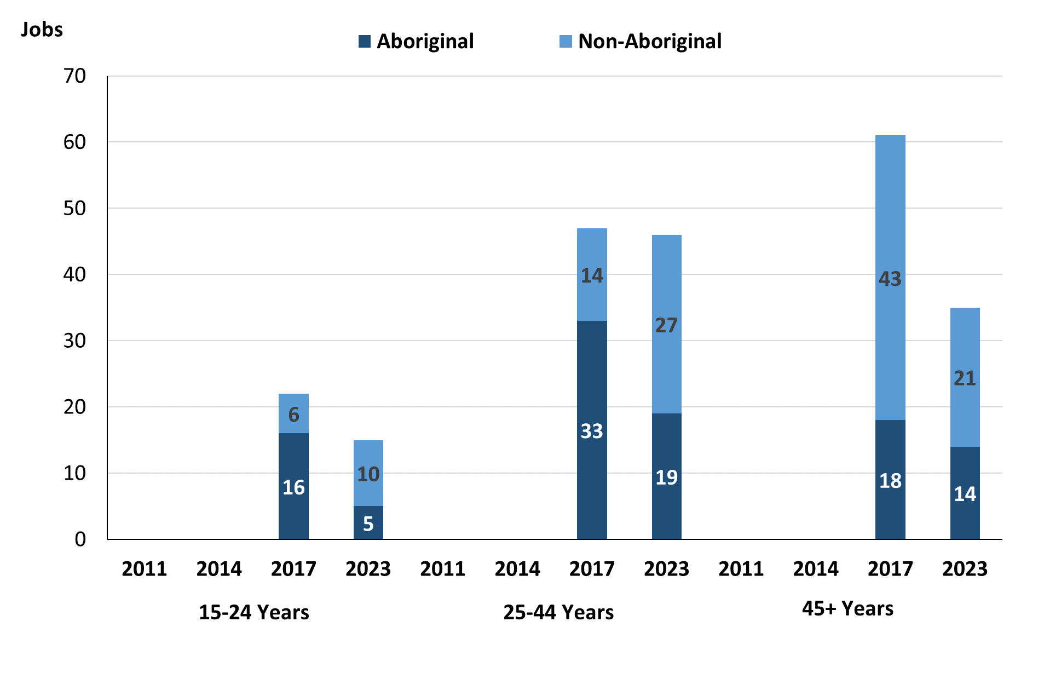

Source: Northern Territory Department of Industry, Tourism and Trade

In 2023 in Mutitjulu there were:

* 15 **jobs filled** by people aged **15-24 years**, a decrease of 7 jobs from 2017. Of these:
* **Aboriginal** people filled 5 jobs, a decrease of 11 jobs from 2017
* **non-Aboriginal** people filled 10 jobs, an increase of 4 jobs from 2017
* 46 **jobs filled** by people aged **25-44 years**, a decrease of 51 jobs from 2017. Of these:
* **Aboriginal** people filled 19 jobs, a decrease of 24 jobs from 2017
* **non-Aboriginal** people filled 27 jobs, a decrease of 27 jobs from 2017
* 35 **jobs filled** by people aged **45+ years**, a decrease of 26 jobs from 2017. Of these:
* **Aboriginal** people filled 14 jobs, a decrease of 4 jobs from 2017
* **non-Aboriginal** people filled 21 jobs, a decrease of 22 jobs from 2017.

**Table 22: Count of filled jobs by age, by full-time/part-time status, by job permanency and by sector, July 2017 (a)(b)(c)(d)(e)(i)**

|  |  |  |  |  |  |  |  |  |  |  |  |  |  |
| --- | --- | --- | --- | --- | --- | --- | --- | --- | --- | --- | --- | --- | --- |
| **2017** | | | | | | | | | | | | | |
| **Indicator** | **15-24 years** | | | **25-44 years** | | | **45+ years** | | | **Total** | | | |
| **Aboriginal** | **Non-Aboriginal** | **Total** | **Aboriginal** | **Non-Aboriginal** | **Total** | **Aboriginal** | **Non-Aboriginal** | **Total** | **Aboriginal** | **Non-Aboriginal** | **Total** |
| Full-time | 15 | 6 | **21** | 32 | 47 | **79** | 9 | 36 | **45** | 57 | 89 | **146** |
| Part-time | 1 | 0 | **1** | 11 | 7 | **18** | 9 | 7 | **16** | 21 | 14 | **35** |
| **Total** | **16** | **6** | **22** | **43** | **54** | **97** | **18** | **43** | **61** | **78** | **103** | **181** |
| Permanent | 7 | 3 | **10** | 31 | 53 | **84** | 12 | 39 | **51** | 51 | 95 | **146** |
| Temporary | 9 | 3 | **12** | 12 | 1 | **13** | 6 | 4 | **10** | 27 | 8 | **35** |
| **Total** | **16** | **6** | **22** | **43** | **54** | **97** | **18** | **43** | **61** | **78** | **103** | **181** |
| Public Sector | 4 | 0 | **4** | 16 | 23 | **39** | 3 | 13 | **16** | 24 | 36 | **60** |
| Private Sector | 12 | 6 | **18** | 27 | 31 | **58** | 15 | 30 | **45** | 54 | 67 | **121** |
| **Total** | **16** | **6** | **22** | **43** | **54** | **97** | **18** | **43** | **61** | **78** | **103** | **181** |

Source: Northern Territory Department of Industry, Tourism and Trade

**Table 23: Count of filled jobs by age, by full-time/part-time status, by job permanency and by sector, September 2023 (a)(b)(c)(d)(e)(i)**

|  |  |  |  |  |  |  |  |  |  |  |  |  |  |
| --- | --- | --- | --- | --- | --- | --- | --- | --- | --- | --- | --- | --- | --- |
| **2023** | | | | | | | | | | | | | |
| **Indicator** | **15-24 years** | | | **25-44 years** | | | **45+ years** | | | **Total** | | | |
| **Aboriginal** | **Non-Aboriginal** | **Total** | **Aboriginal** | **Non-Aboriginal** | **Total** | **Aboriginal** | **Non-Aboriginal** | **Total** | **Aboriginal** | **Non-Aboriginal** | **Total** |
| Full-time | 1 | 9 | **10** | 11 | 23 | **34** | 8 | 20 | **28** | 21 | 58 | **79** |
| Part-time | 4 | 1 | **5** | 8 | 4 | **12** | 6 | 1 | **7** | 24 | 8 | **32** |
| **Total** | **5** | **10** | **15** | **19** | **27** | **46** | **14** | **21** | **35** | **45** | **66** | **111** |
| Permanent | 1 | 7 | **8** | 13 | 19 | **32** | 7 | 17 | **24** | 22 | 49 | **71** |
| Temporary | 4 | 3 | **7** | 6 | 8 | **14** | 7 | 4 | **11** | 23 | 17 | **40** |
| **Total** | **5** | **10** | **15** | **19** | **27** | **46** | **14** | **21** | **35** | **45** | **66** | **111** |
| Public Sector | 1 | 7 | **8** | 11 | 15 | **26** | 5 | 13 | **18** | 17 | 35 | **52** |
| Private Sector | 4 | 3 | **7** | 8 | 12 | **20** | 9 | 8 | **17** | 21 | 23 | **44** |
| **Total** | **5** | **10** | **15** | **19** | **27** | **46** | **14** | **21** | **35** | **45** | **66** | **111** |

Source: Northern Territory Department of Industry, Tourism and Trade

In 2023 in Mutitjulu of the:

* 15 **jobs filled** by people aged **15-24 years**, there were:
* 5 jobs filled by **Aboriginal** people, of which:
* 1 was a full-time job, a decrease of 14 jobs from 2017
* 4 were part-time jobs, an increase of 3 jobs from 2017
* 1 was a permanent job, a decrease of 6 jobs from 2017
* 4 were temporary jobs, a decrease of 5 jobs from 2017
* 1 was a Public Sector job, a decrease of 3 jobs from 2017
* 4 were Private Sector jobs, a decrease of 8 jobs from 2017
* 10 jobs filled by **non-Aboriginal** people, of which:
* 9 were full-time jobs, an increase of 3 jobs from 2017
* 1 was a part-time job, an increase of 1 job from 2017
* 7 were permanent jobs, an increase of 4 jobs from 2017
* 3 were temporary jobs, unchanged from 2017
* 7 were Public Sector jobs, an increase of 7 jobs from 2017
* 3 were Private Sector jobs, a decrease of 3 jobs from 2017
* 46 **jobs filled** by people aged **25-44 years**, there were:
* 19 jobs filled by **Aboriginal** people, of which:
* 11 were full-time jobs, a decrease of 21 jobs from 2017
* 8 were part-time jobs, a decrease of 3 jobs from 2017
* 13 were permanent jobs, a decrease of 18 jobs from 2017
* 6 were temporary jobs, a decrease of 6 jobs from 2017
* 11 were Public Sector jobs, a decrease of 5 jobs from 2017
* 8 were Private Sector jobs, a decrease of 19 jobs from 2017
* 27 jobs filled by **non-Aboriginal** people, of which:
* 23 were full-time jobs, a decrease of 24 jobs from 2017
* 4 were part-time jobs, a decrease of 3 jobs from 2017
* 19 were permanent jobs, a decrease of 34 jobs from 2017
* 8 were temporary jobs, an increase of 7 jobs from 2017
* 15 were Public Sector jobs, a decrease of 8 jobs from 2017
* 12 were Private Sector jobs, a decrease of 19 jobs from 2017
* 35 **jobs filled** by people aged **45+ years**, there were:
* 14 jobs filled by **Aboriginal** people, of which:
* 8 were full-time jobs, a decrease of 1 job from 2017
* 6 were part-time jobs, a decrease of 3 jobs from 2017
* 7 were permanent jobs, a decrease of 5 jobs from 2017
* 7 were temporary jobs, an increase of 1 job from 2017
* 5 were Public Sector jobs, an increase of 2 jobs from 2017
* 9 were Private Sector jobs, a decrease of 6 jobs from 2017
* 21 jobs filled by **non-Aboriginal** people, of which:
* 20 were full-time jobs, a decrease of 16 jobs from 2017
* 1 was a part-time job, a decrease of 6 jobs from 2017
* 17 were permanent jobs, a decrease of 22 jobs from 2017
* 4 were temporary jobs, unchanged from 2017
* 13 were Public Sector jobs, unchanged from 2017
* 8 were Private Sector jobs, a decrease of 22 jobs from 2017.

# Vocational Education and Training

Table 24: Northern Territory Vocational Education and Training (VET) students, 2016 & 2023 (k)

|  |  |  |  |  |  |
| --- | --- | --- | --- | --- | --- |
| **VET Funding Group** | **2016** | | **2023** | | **Change** |
| **No.** | **% of Total** | **No.** | **% of Total** | **2016-2023** |
| Arts, Entertainment, Sports and Recreation | 30 | 37% | 0 | 0% | -30 |
| Business and Clerical | 39 | 48% | 0 | 0% | -39 |
| Community Services, Health and Education | 11 | 13% | 6 | 10% | -5 |
| Engineering and Mining | 0 | 0% | 16 | 26% | 16 |
| Primary Industry | 0 | 0% | 37 | 60% | 37 |
| Sales and Personal Service | 0 | 0% | 1 | 2% | 1 |
| Tourism and Hospitality | 2 | 2% | 0 | 0% | -2 |
| Transport and Storage | 0 | 0% | 2 | 3% | 2 |
| **Total** | **82** | **100%** | **62** | **100%** | **-20** |

Source: Northern Territory Department of Industry, Tourism and Trade

In Mutitjulu in 2023:

* there were 62 **VET students**, a decrease of 20 students from 2016,
* VET activity with the most students were Primary Industry with 37 students,
* Engineering and Mining had 16 students,
* Community Services, Health and Education had 6 students,
* Primary Industry reported the largest increase in students with 37 more students compared to 2016,
* Business and Clerical reported the largest decrease in students with 39 less students over the same period.

Table 25: Northern Territory Vocational Education and Training (VET) unit enrolments, 2016 & 2023 (l)

|  |  |  |  |  |  |
| --- | --- | --- | --- | --- | --- |
| **VET Funding Group** | **2016** | | **2023** | | **Change** |
| **No.** | **% of Total** | **No.** | **% of Total** | **2016-2023** |
| Arts, Entertainment, Sports and Recreation | 27 | 42% | 0 | 0% | -27 |
| Business and Clerical | 37 | 57% | 0 | 0% | -37 |
| Community Services, Health and Education | 1 | 2% | 43 | 12% | 42 |
| Engineering and Mining | 0 | 0% | 118 | 32% | 118 |
| Primary Industry | 0 | 0% | 203 | 55% | 203 |
| Sales and Personal Services | 0 | 0% | 1 | 0% | 1 |
| Tourism and Hospitality | 0 | 0% | 0 | 0% | 0 |
| Transport and Storage | 0 | 0% | 2 | 1% | 2 |
| **Total** | **65** | **100%** | **367** | **100%** | **302** |

Source: Northern Territory Department of Industry, Tourism and Trade

In Mutitjulu in 2023:

* there were 367 **VET unit enrolments**, an increase of 302-unit enrolments from 2016
* VET activity with the most unit enrolments were Primary industry with 23-unit enrolments,
* Engineering and mining had 118-unit enrolments,
* Community Services, Health and Education had 43-unit enrolments,
* Primary industry reported the largest increase in unit enrolments with 203 more-unit enrolments compared to 2016,
* Business and Clerical reported the largest decrease in unit enrolments with 37 less unit enrolments over the same period.

Table 26: Northern Territory Vocational Education and Training (VET) nominal hours, 2016 & 2023 (m)

|  |  |  |  |  |  |
| --- | --- | --- | --- | --- | --- |
| **VET Funding Group** | **2016** | | **2023** | | **Change** |
| **No.** | **% of Total** | **No.** | **% of Total** | **2016-2023** |
| Arts, Entertainment, Sports and Recreation | 1650 | 54% | 0 | 0% | -1650 |
| Business and Clerical | 1415 | 46% | 0 | 0% | -1415 |
| Community Services, Health and Education | 0 | 0% | 2378 | 21% | 2378 |
| Engineering and Mining | 0 | 0% | 2140 | 19% | 2140 |
| Primary Industry | 0 | 0% | 6900 | 60% | 6900 |
| Sales and Personal Services | 0 | 0% | 40 | 0% | 40 |
| Transport and Storage | 0 | 0% | 80 | 1% | 80 |
| **Total** | **3065** | **100%** | **11538** | **100%** | **8473** |

Source: Northern Territory Department of Industry, Tourism and Trade

In Mutitjulu in 2023:

* there were 11,538 **VET nominal hours** delivered, an increase of 8,473 nominal hours delivered from 2016,
* VET activity with the most nominal hours delivered were Primary Industry with 6,900 nominal hours,
* Community Services, Health and Education had 2,378 nominal hours,
* Engineering and Mining had 2,140 nominal hours,
* Primary Industry reported the largest increase in nominal hours delivered with 6,900 more nominal hours compared to 2016,
* Arts, Entertainment, Sports and Recreation reported the largest decrease in nominal hours delivered with 1,650 less nominal hours over the same period.

Caveat: *Nominal hours are based on the hours funded through Northern Territory Government contracts and fee for service. Students and units include delivery that may have been funded in a previous year. Because of these factors, a direct match cannot be made between hours and student/units.*

**Table 27: Northern Territory Vocational Education and Training (VET) unit completions, 2016 & 2023 (n)**

|  |  |  |  |  |  |
| --- | --- | --- | --- | --- | --- |
| **VET Funding Group** | **2016** | | **2023** | | **Change** |
| **No.** | **% of Total** | **No.** | **% of Total** | **2016-2023** |
| Arts, Entertainment, Sports and Recreation | 59 | 38% | 0 | 0% | -59 |
| Business and Clerical | 76 | 49% | 0 | 0% | -76 |
| Community Services, Health and Education | 17 | 11% | 17 | 6% | 0 |
| Engineering and Mining | 0 | 0% | 72 | 25% | 72 |
| Primary Industry | 0 | 0% | 202 | 69% | 202 |
| Sales and Personal Services | 0 | 0% | 0 | 0% | 0 |
| Tourism and Hospitality | 2 | 1% | 0 | 0% | -2 |
| Transport and Storage | 0 | 0% | 2 | 1% | 2 |
| **Total** | **154** | **100%** | **293** | **100%** | **139** |

Source: Northern Territory Department of Industry, Tourism and Trade

In Mutitjulu in 2023:

* there were 293 **VET unit completions**, an increase of 139-unit completions from 2016
* VET activity with the most unit completions were Primary industry with 202 completions,
* Engineering and mining had 72-unit completions,
* Community Services, Health and Education had 17-unit completions,
* Primary industry reported the largest increase in unit completions with 202 more-unit completions compared to 2016,
* Business and Clerical reported the largest decrease in unit completions with 76 less unit completions over the same period.

# Population

**Table 28: Population distribution by gender and age (p)(r)**

|  |  |  |  |  |  |  |  |  |  |
| --- | --- | --- | --- | --- | --- | --- | --- | --- | --- |
| **Indicator** | **2011** | | | **2021** | | | **Change (2011-2021)** | | |
| **Male** | **Female** | **Total** | **Male** | **Female** | **Total** | **Male** | **Female** | **Total** |
| **0-4 years** | 13 | 14 | **27** | 14 | 14 | **28** | 1 | 0 | **1** |
| **5-14 years** | 21 | 20 | **41** | 19 | 20 | **39** | -2 | 0 | **-2** |
| **15-24 years** | 23 | 16 | **39** | 27 | 22 | **49** | 4 | 6 | **10** |
| **25-44 years** | 52 | 57 | **109** | 46 | 52 | **98** | -6 | -5 | **-11** |
| **45-64 years** | 26 | 29 | **55** | 25 | 34 | **59** | -1 | 5 | **4** |
| **65+ years** | 11 | 10 | **21** | 14 | 14 | **28** | 3 | 4 | **7** |
| **Total** | **150** | **144** | **294** | **140** | **154** | **294** | **-10** | **10** | **0** |

*Source: Australian Bureau of Statistics*

In 2021 in Mutitjulu:

* there were an estimated 294 people, of which:
* 140 (47.6%) were male
* 154 (52.4%) were female
* between 2011 and 2021, the overall population in Mutitjulu remain unchanged from 2011, compared to -0.5% across the 28 remote towns and 1.0% Territory wide
* the male population decreased by 10 people from 2011
* the female population increased by 10 people from 2011
* in 2021, the working age population (15 years and over) in Mutitjulu was an estimated 234 people (79.6% of the total population) compared with 224 people (76.2% of the total population) in 2011. Of these:
* 49 (16.7%) were between 15 and 24 years of age
* 98 (33.3%) were between 25 and 44 years of age
* 59 (20.1%) were between 45 and 64 years of age
* 28 (9.5%) were over 65 years of age
* of the 234 people of working age:
* 112 (47.9%) were male
* 122 (52.1%) were female.

There were 0.6 jobs in Mutitjulu per working age person compared to 0.3 jobs per working age person across the 28 remote towns in the Northern Territory.

**Chart 12: Population comparison (p)(q)**

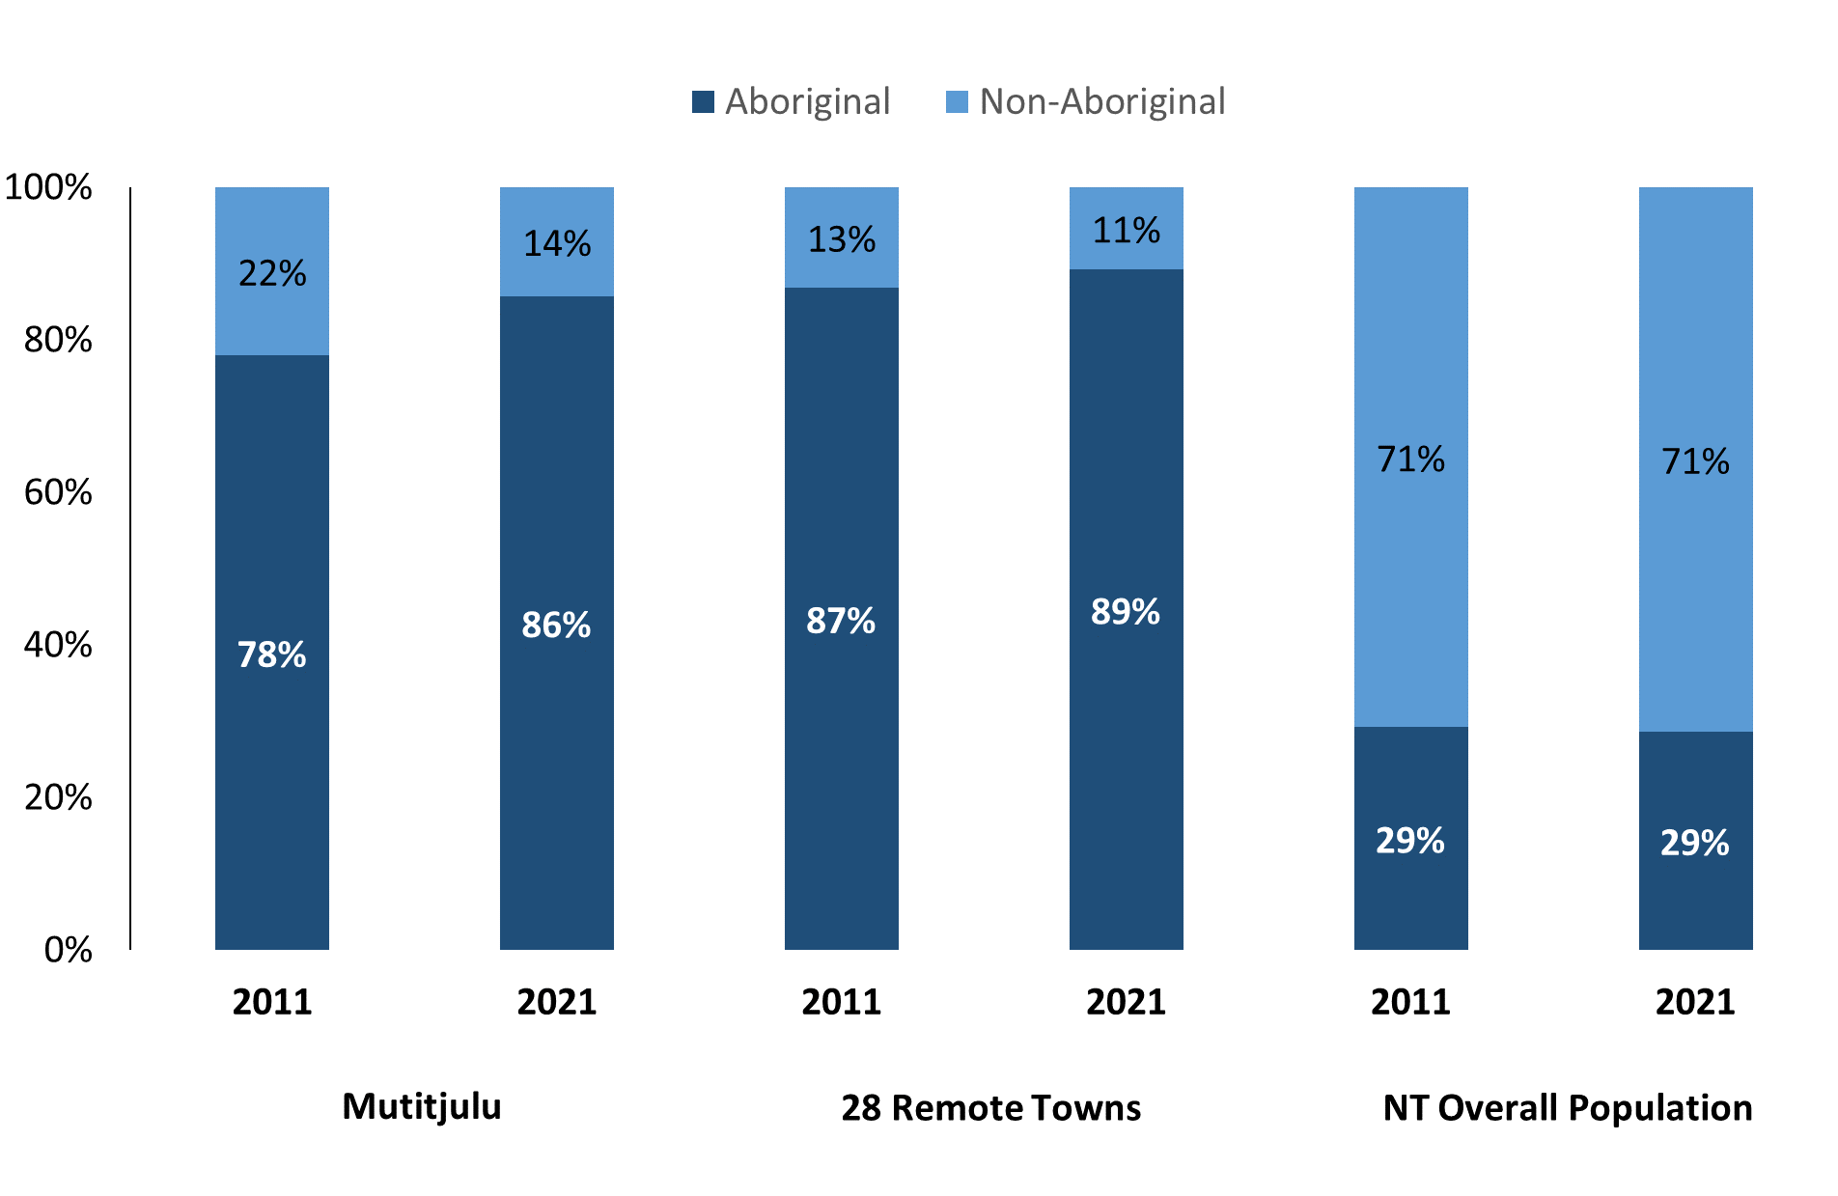

*Source: Australian Bureau of Statistics*

In 2021 in Mutitjulu:

* 86% of the population in Mutitjulu were **Aboriginal**, compared to 78% in 2011
* 89% of the population across all 28 remote towns were **Aboriginal**
* 29% of the NT population were **Aboriginal**.

**Table 29: Unemployment and Aboriginal participation rates (q)**

|  |  |  |  |  |  |  |
| --- | --- | --- | --- | --- | --- | --- |
|  | **Mutitjulu** | | | **Northern Territory** | | |
| **Aboriginal** | **Non-Aboriginal** | **Total** | **Aboriginal** | **Non-Aboriginal** | **Total** |
| **Unemployment rate** | 24.0% | 0.0% | 16.1% | 20.8% | 3.2% | 5.6% |
| **Participation rate** | 40.8% | 94.9% | 55.1% | 35.4% | 78.3% | 64.9% |

*Source: Australian Bureau of Statistics*

In 2021 in Mutitjulu the:

* **total unemployment rate** was 16.1% compared to 5.6% for the total Northern Territory
* **Aboriginal unemployment rate** was 24.0% compared to 20.8% for the total Northern Territory
* **non-Aboriginal** **unemployment rate** was 0.0% compared to 3.2% for the total Northern Territory
* **total participation rate** was 55.1% compared to 64.9% for the total Northern Territory
* **Aboriginal participation rate** was 40.8% compared to 35.4% for the total Northern Territory
* **non-Aboriginal participation rate** was 94.9% compared to 78.3% for the total Northern Territory.

# Community Development Program

**Table 30: Community Development Program Aboriginal Job Seekers, 31 December 2023 (o)**

|  |  |  |
| --- | --- | --- |
| **Indicator** | **Aboriginal** | |
| **No.** | **%** |
| **Total Aboriginal Job Seekers** | 130 | N/A |
| **Age (years)** | | |
| 15-24 | 36 | 27.7% |
| 25-44 | 59 | 45.4% |
| 45+ | 35 | 26.9% |
| **Total** | 130 | 100.0% |
| **Gender** | | |
| Male | 69 | 53.1% |
| Female | 61 | 46.9% |
| **Total** | 130 | 100.0% |
| **Employment Outcome – 1 January 2023 to 31 December 2023** | | |
| 13 Weeks | <20 | N/A |
| 26 Weeks | <20 | N/A |

*Source: Department of Prime Minister and Cabinet*

**Chart 13: Community Development Program Aboriginal Job Seekers by Gender,**

**31 December 2023 (o)**

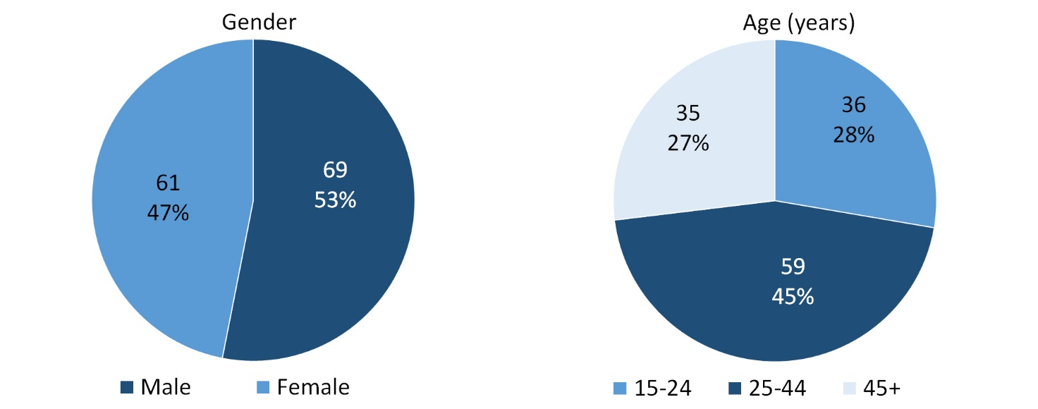

*Source: Department of Prime Minister and Cabinet*

As of 31 December 2023, in Mutitjulu, there were 130 CDP **Aboriginal** job seekers, of these:

* 69 (53.1%) were male and 61 (46.9%) were female
* 36 (27.7%) were aged 15-24 years, 59 (45.4%) were aged 25-44 years, and 35 (26.9%) were aged 45+ years
* between 1 January 2023 to 31 December 2023, less than 20 had reached the 13 week reporting milestone and less than 20 had reached the 26 week reporting milestone.

# Businesses

**Table 31: Businesses by sector (d)(s)**

|  |  |  |
| --- | --- | --- |
| **Business Name** | **Reported on in 2017** | **Reported on in 2023** |
| **PUBLIC SECTOR** | | |
| **Department of Education** | Yes | **Yes** |
| Department of Health | Yes | No |
| **Director National Parks trading as Uluru Kata Tjura National Park** | Yes | **Yes** |
| **Northern Territory Police, Fire Emergency Services** | Yes | **Yes** |
| PRIVATE SECTOR | | |
| **Anangu Uwankaraku Punu Aboriginal Corporation trading as Maruku Arts** | Yes | **Yes** |
| Australian Regional and Remote Community Services trading as Tjilpi Pampaku Ngura Flexible Aged Care and Community Care | Yes | No |
| **Central Land Council** | No | **Yes** |
| **Mutitjulu Community Aboriginal Corporation** | Yes | **Yes** |
| Mutitjulu Community Aboriginal Corporation trading as Ininti café | Yes | No |
| Mutitjulu Community Health Service (Aboriginal Corporation) | Yes | No |
| **Ngaanyatjarra Pitjantjatjara Yankunytjatjara Women's Council Aboriginal Corporation (NPY Women’s Council)** | No | **Yes** |
| **Rise-Ngurratjuta Pty Ltd** | No | **Yes** |
| Nyangatjatjara Aboriginal Corporation | Yes | No |
| The Trustee for The Ininti Store Trust trading as Ininti Store | Yes | No |
| The Trustee for The Walkatjara Trust - Walkatjara Art | Yes | No |
| The Trustee for Wana Ungkunytja Trust trading as Anangu Jobs | Yes | No |
| Voyages Aboriginal Tourism Australia Pty Ltd trading as Voyages Ayers Rock Resort | Yes | No |

*Source:* Northern Territory *Department of Industry, Tourism and Trade*

*Note: Business names captured have been identified by the current 2023 Business ABN name listed.*

In 2023 in Mutitjulu:

* there were 8 businesses reported on, of which:
* 3 businesses were from the Public Sector (37.5%)
* 5 businesses were from the Private Sector (62.5%).

# Notes

1. These counts represent numbers of filled jobs and not the number of people. As such the totals represent the total number of filled jobs, not the total number of employees. This count is not directly comparable to the total number of employed people as a person may have several jobs or one job may be shared by more than one person.
2. Full-time is defined as a job usually requiring 35 hours or more per week or that required 35 hours or more work during the reference week. Part-time is defined as a job usually requiring less than 35 hours per week or that required less than 35 hours work during the reference week. The reference week refers to the period that respondents were asked to provide information about. In most instances it would be the week prior to the week the questionnaire was completed. Questionnaires were predominantly conducted in June and July.
3. Care needs to be taken when analysing the counts of filled jobs by Aboriginal people. Aboriginality was reported by the business representative completing the questionnaire.
4. Sector was classified using the Standard Economic Sector of Classifications of Australia (SESCA), 2008.
5. Job permanency is classified according to what the business believes the level of job permanency is based on guidelines provided by data collectors. Those guidelines state a permanent job has paid annual and/or sick leave entitlements while a temporary job includes casual and fixed-term contract jobs.
6. Classified according to the Australian and New Zealand Standard Classification of Occupations (ANZSCO), 2006, major occupation level.
7. Other Occupations include jobs where occupation was not stated, not known or inadequately described.
8. Classified using the Australian and New Zealand Standard Industrial Classification (ANZSIC), 2006, division level.
9. Care needs to be taken when analysing the counts of filled jobs by the gender of people in the jobs. The gender of the person employed in a job is reported by the business representative completing the questionnaire.
10. Care needs to be taken when analysing the counts of filled jobs by the age of people in the jobs. The age of the person employed in a job is reported by the business representative completing the questionnaire.
11. Students represent the number of individual clients that enrolled in a Vocational Education and Training unit during the calendar year.
12. Unit enrolments represent the count of individual units that students enrolled in during the calendar year.
13. Nominal hours delivered is the sum of the nominal hours of the units commenced during the calendar year regardless of when the course enrolment commenced.
14. Unit completions are the count of all successfully completed units reported in the calendar year regardless of the year of commencement of the units.
15. The Community Development Program (CDP) supports job seekers in remote Australia to build skills, address barriers and contribute to their communities through a range of flexible activities. Under the CDP, job seekers with activity requirements are expected to do up to 25 hours per week of work-like activities that benefit their community. It should be noted that some CDP participants may be reported on within the profile if they are attached to a filled position with an employer captured in the survey. Due to confidentiality issues, data below 20 people is not published.
16. Population estimates for both 2011 and 2021 are taken from the estimated resident population (ERP) data produced by the Australian Bureau of Statistics (ABS) and based on Australian Statistical Geography Standard (ASGS) Statistical Area Level 1 (SA1) regions. ERP are official estimates of the Australian population, which link people to a place of usual residence with Australia. All ERP data sources, including the Census of Population and Housing (Census), are subject to error (including inaccuracies in collection, recording and processing data) and should be used with caution.
17. Indigenous population proportions, unemployment and workforce participation rates are based on ABS Census counts at ASGS Indigenous Locations (ILOCs) for each remote town.
18. Working-age population includes all residents aged 15 years and over (commonly referred to as the civilian population) and consists of people that are employed, unemployed or not in the labour force.
19. A ‘business’ has been defined as any organisation that has undertaken productive activities in the last year, including companies, non-profit organisations, government departments and enterprises operating within the designated remote geography (town), and has one or more employees in paid employment and an Australian Business Number (ABN).

# Abbreviations and Acronyms

ABN Australian Business Number

ABS Australian Bureau of Statistics

ANZSCO Australian and New Zealand Standard Classification of Occupations

ANZSIC Australian and New Zealand Standard Industrial Classification

ASGS Australian Statistical Geography Standard

CDP Community Development Program

ERP Estimated Resident Population

ILOC Indigenous Locations

nec Not Elsewhere Classified

No. Number

Perm Permanent

ppt Percentage point

RJCP Remote Jobs and Communities Program

Temp Temporary

SA1 Statistical Area Level 1

VET Vocational Education and Training

1. The number of filled jobs does not represent numbers of people as a person may have several jobs or one job may be shared by more than one person.