**© Northern Territory of Australia 2025**

**Preferred Reference:** Department of Trade, Business and Asian Relations, 2023 Remote Towns Jobs Profiles, Northern Territory Government, January 2025, Darwin.

**Front cover image:** *Vitex rotundifolia* – known commonly as Beach Vitex

Image credit: Robyn Wing

**Disclaimer**

The data in this publication was collected by conducting a survey of businesses located in the 28 remote town boundaries. This body of work was completed in 2023 by the former Northern Territory Department of Industry, Tourism and Trade.

The collection methodology was created in accordance with Australian Bureau of Statistics data quality framework principles. Data in this publication is only reflective of those businesses reported on as operating in the town at the time of data collection (see table at the end of publication for list of businesses reported on). To comply with privacy legislation or where appropriate, some data in this publication may have been adjusted and will not reflect the actual data reported by businesses. As a result of this, combined with certain data not being reported by some businesses, some components may not add to totals. Changes over time may also reflect change in business propensity to report on certain data items rather than actual changes over time. Total figures have generally not been adjusted. Caution is advised when interpreting the comparisons made to the earlier 2011, 2014 and 2017 publications as the businesses identified and reported on and the corresponding jobs may differ between publications. The surveys have not always gathered data on training and jobs in the same years.

**Notes for each table and chart are ordered alphabetically and listed at the end of the publication.**

The Northern Territory of Australia exercised due care and skill to ensure that at the time of publication the information contained in this publication is true and correct. However, it is not intended to be relied on as professional advice or used for commercial purposes. The Territory gives no warranty or assurances as to the accuracy of the information contained in the publication and to the maximum extent permitted by law accepts no direct or indirect liability for reliance on its content.

Any use of this report for commercial purposes is not endorsed by the Department of Trade, Business and Asian Relations.

Contents

Ramingining 4

Introduction 5

Summary 6

Jobs Overview 7

Jobs filled by Aboriginality 8

Jobs by Sector: Private and Public 11

Job Status: Permanent and Temporary 17

Job Vacancies 21

Jobs by Industry 23

Jobs by Occupation 29

Jobs by Industry by Occupation 33

Jobs by Gender 36

Jobs by Age 42

Vocational Education and Training 48

Population 55

Community Development Program 57

Businesses 58

Notes 59

Abbreviations and Acronyms 60

# Ramingining

Ramingining is located to the west of the Glyde River about 30 kilometres south-east of Milingimbi Island; with a population of 812 residents. Nhulunbuy is 206 kilometres away by air and Maningrida is 85 kilometres by road to the east. The main Nhulunbuy-Katherine Road is 100 kilometres to the south.

*Source: Northern Territory Department of Industry, Tourism and Trade*

# Introduction

This jobs profile provides a snapshot of jobs and the characteristics of job holders in Ramingining as of September 2023. Trends from the surveys conducted in 2011, 2014, and 2017 are also described. Additionally, it presents data on Community Development Program activity, Population, and Vocational Education and Training.

This job profile is one of 28 profiles developed for remote towns in the Northern Territory. It is anticipated these, and subsequent profiles will contribute to a robust evidence base to inform decision making in and relating to these remote Territory towns.

This profile contains information collected by the Northern Territory Department of Industry, Tourism and Trade from businesses operating within the town and is supplemented by other administrative data sets and information.

Each profile provides up-to-date information that is intended to inform the planning and design of current and future government programs and as an evidence base to inform decision making relating to workforce development, enterprise and job opportunities.

The profile may best be understood as a point-in-time tool. The number of business surveys from which the data was drawn is significantly less than in earlier surveys, and business participation has decreased with each survey. For Ramingining, 15% fewer businesses than in 2017 are reported here.

The data collection methodology and corresponding questionnaire were created in partnership with the Australian Bureau of Statistics (ABS) and in accordance with ABS data quality framework and survey principles.

The Northern Territory Department of Industry, Tourism and Trades’ Territory Engagement and Delivery, Skills Initiative and VET data teams collaborated with the Northern Institute at Charles Darwin University to facilitate the surveys and reports.

The information collected and reported on represents a significant goodwill investment by those businesses and organisations that participated. Each business is listed at the end of this publication.

# Summary

The 2023 jobs profile was developed based on responses from 11 businesses operating within the Ramingining town boundary, 2 less than in the 2017 survey. Of these, there were:

* 7 businesses from the Private Sector, accounting for 132 filled jobs or 59% of total filled jobs
* 4 businesses from the Public Sector, accounting for 90 filled jobs or 41% of total filled jobs
* 6 businesses participated in all four surveys (completed in 2011, 2014, 2017 and 2023).

A total of 258 filled and vacant jobs in Ramingining were reported, a decrease of 8 jobs from 2017.[1]

The 2023 profile highlights:

* there were 222 filled jobs of which:
* 169 jobs (76%) were filled by Aboriginal people, a decrease of 35 jobs from 2017
* 53 jobs (24%) were filled by non-Aboriginal people, an increase of 4 jobs from 2017
* 51% of employed Aboriginal people are working in the Private Sector
* Aboriginal people accounted for 76% of job holders in the town compared to 81% in 2017
* Aboriginal females made up 55% of total Aboriginal filled jobs in the town compared to 39% in 2017
* there were 36 vacant jobs, of which:
* job vacancies as a percentage of jobs increased to 14% in 2023 from 4.9% in 2017
* job vacancies equate to 1 in 7 jobs
* 15 of the vacancies were in the Professionals and Community and Personal Service Workers areas
* Public Administration and Safety and Retail Trade were the two largest industry employers in 2023
* Education and Training had the highest increase in filled jobs between 2023 and 2017
* new industry employers were Accommodation and Food Services and Professional, Scientific and Technical Services, each had 9 filled jobs in 2023, despite both recording nil filled jobs in 2017 and 2014
* training had an increase of 111 student numbers between 2023 and 2016
* Primary Industry had the highest student numbers in 2023
* Tourism and Hospitality training sector recorded the highest decrease of 15 student numbers between 2023 and 2016.

The overall population in Ramingining decreased by 21 people (-2.5%) between 2011 and 2021 to 812 people.

In comparison, the overall Northern Territory population increased by 9.7% between 2011 and 2021.

In 2021, the working age population (15 years and over) in Ramingining was an estimated 608 people compared to 601 in 2011, an increase of 1.2%.

There were 0.4 jobs in Ramingining per working age person compared to 0.3 jobs per working age person across the 28 remote towns in the Northern Territory.

# Jobs Overview

Table 1: Count of filled jobs and vacancies, 2011, 2014, 2017 & 2023 (a)(b)

|  |  |  |  |  |  |  |  |
| --- | --- | --- | --- | --- | --- | --- | --- |
|  | **2011** | **2014** | **2017** | **2023** | **Change 2011-2014** | **Change 2014-2017** | **Change 2017-2023** |
| **Total All Jobs** | **148** | **182** | **266** | **258** | **34** | **84** | **-8** |
| **Vacancies** | **11** | **12** | **13** | **36** | **1** | **1** | **23** |
| Vacancies as % of Total All Jobs | 7.4% | 6.6% | 4.9% | 14.0% | -0.8 ppt | -1.7 ppt | 9.1 ppt |
| **Filled Jobs** | **137** | **170** | **253** | **222** | **33** | **83** | **-31** |
| Full-time | 77 | 80 | 68 | 110 | 3 | -12 | 42 |
| Part-time | 60 | 90 | 185 | 112 | 30 | 95 | -73 |

Source: Northern Territory Department of Industry, Tourism and Trade

Chart 1: Count of vacant jobs and filled jobs by full-time/part-time status, 2011, 2014, 2017 & 2023 (a)(b)

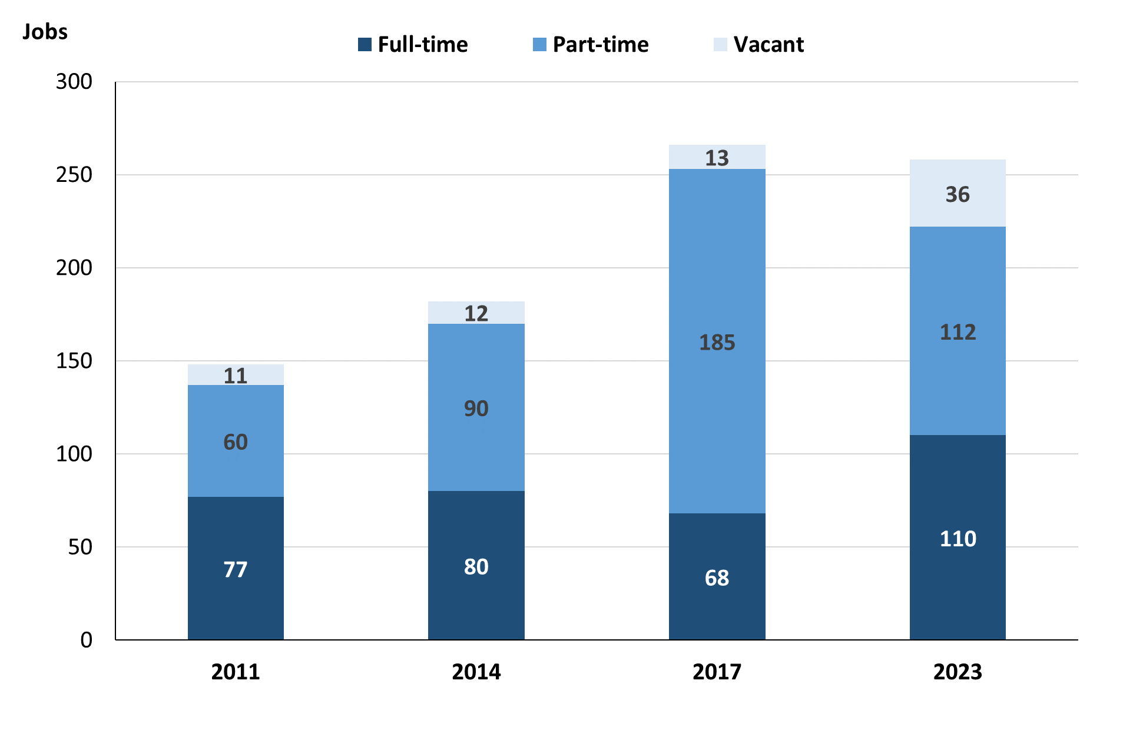

Source: Northern Territory Department of Industry, Tourism and Trade

In 2023 in Ramingining:

* there was a total of 222 **filled jobs**, a decrease of 31 jobs from 2017 and an increase of 52 jobs from 2014
* of the 222 **filled jobs** in 2023:
* 110 were **full-time** jobs, an increase of 42 jobs from 2017 and an increase of 30 jobs from 2014
* 112 were **part-time** jobs, a decrease of 73 jobs from 2017 and an increase of 22 jobs from 2014
* there were 36 total **job vacancies** in 2023, an increase of 23 vacancies from 2017 and an increase of 24 vacancies from 2014.

# Jobs filled by Aboriginality

Chart 2: Count of filled jobs by Aboriginality, 2011, 2014, 2017 & 2023 (a)(c)

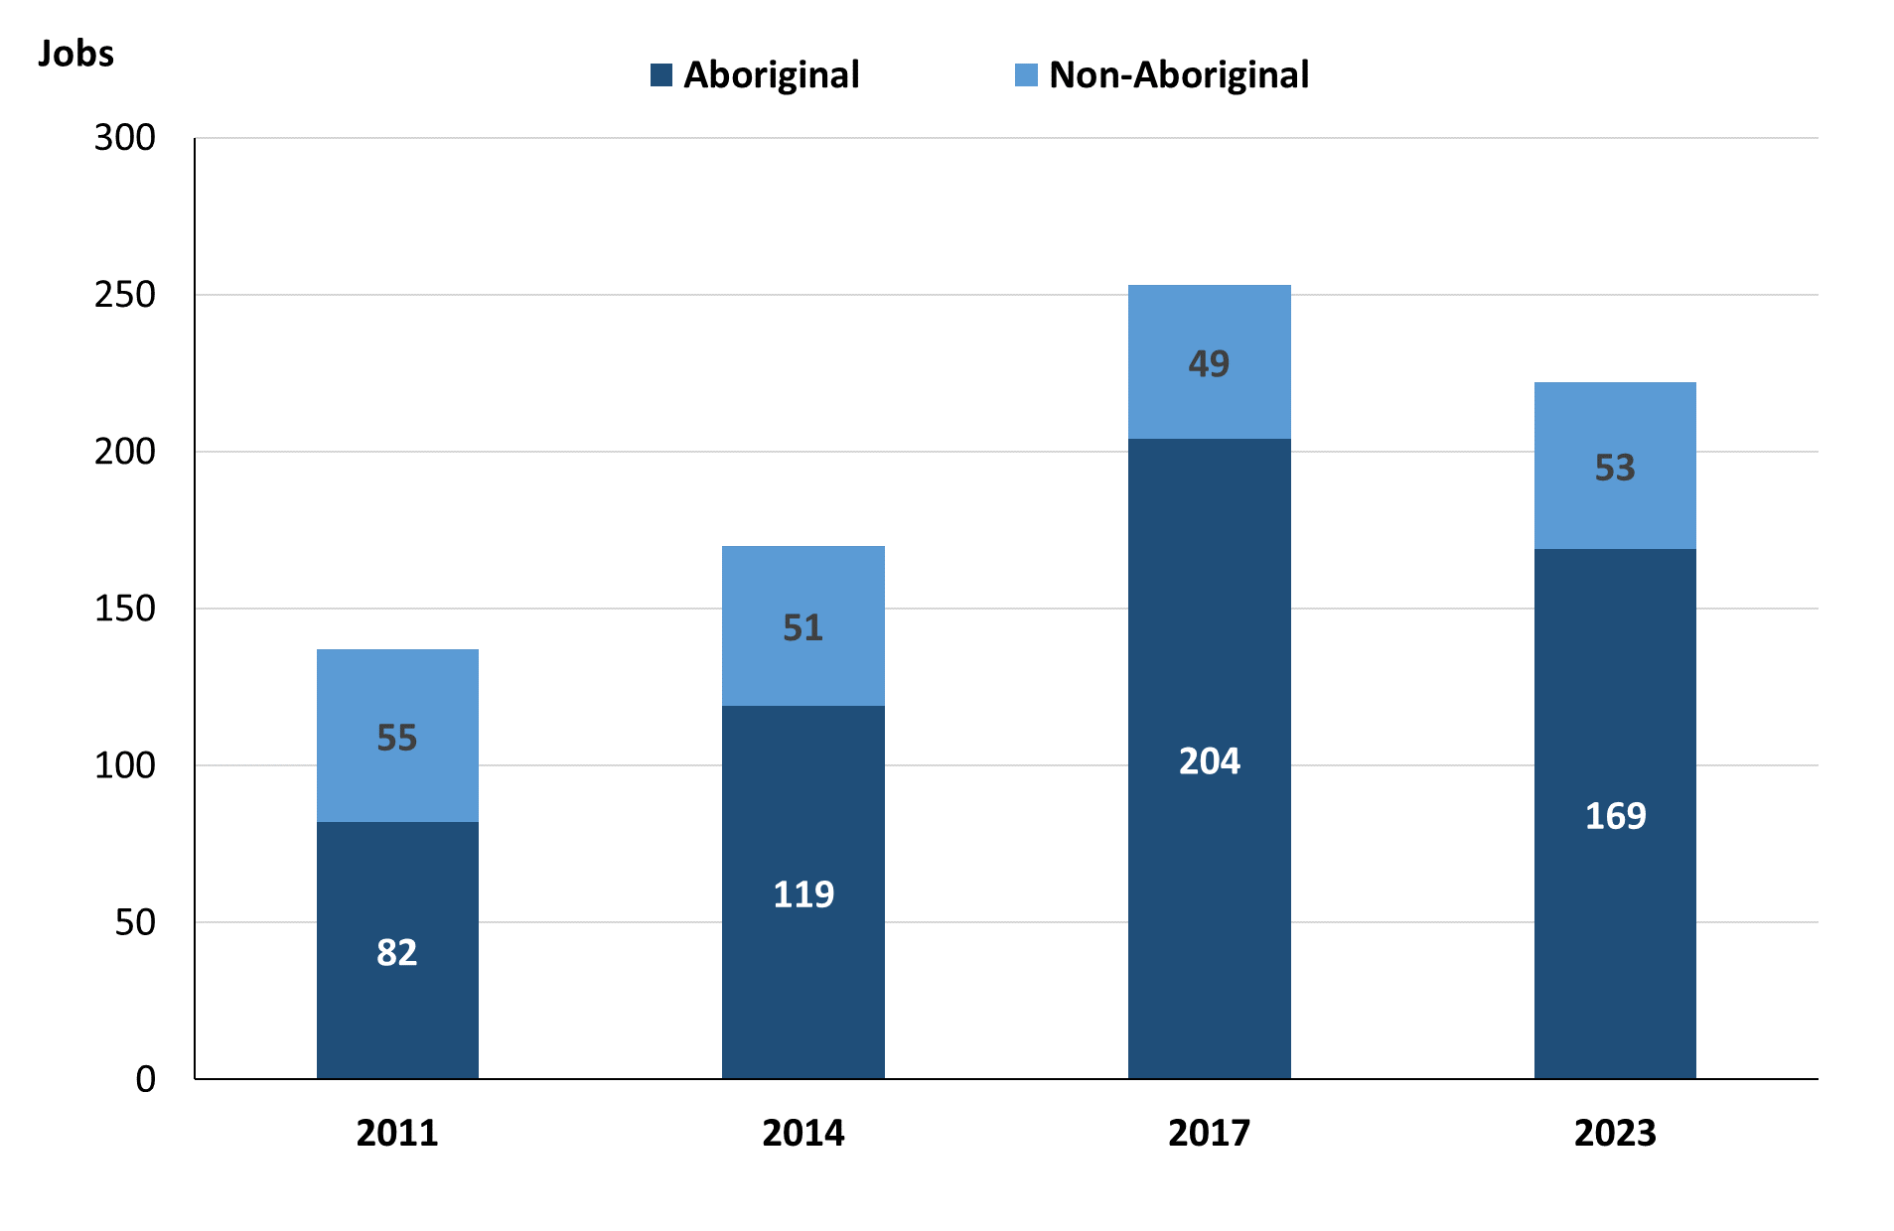

Source: Northern Territory Department of Industry, Tourism and Trade

In 2023 in Ramingining:

* of the 222 **filled jobs**:
* **Aboriginal** people filled 169 jobs, a decrease of 35 jobs from 2017 and an increase of 50 jobs from 2014
* **non-Aboriginal** people filled 53 jobs, an increase of 4 jobs from 2017 and an increase of 2 jobs from 2014
* **Aboriginal** people accounted for 76% of job holders compared to 81% in 2017 and 70% in 2014.

**Table 2a: Count of filled jobs by full-time/part-time status, 2011, 2014, 2017 & 2023 (a)(b)(c)**

|  |  |  |  |  |  |  |  |  |  |  |  |  |
| --- | --- | --- | --- | --- | --- | --- | --- | --- | --- | --- | --- | --- |
| **Indicator** | **2011** | | | **2014** | | | **2017** | | | **2023** | | |
| **Aboriginal** | **Non-Aboriginal** | **Total** | **Aboriginal** | **Non-Aboriginal** | **Total** | **Aboriginal** | **Non-Aboriginal** | **Total** | **Aboriginal** | **Non-Aboriginal** | **Total** |
| Full-time | 27 | 50 | **77** | 30 | 50 | **80** | 24 | 44 | **68** | 57 | 53 | **110** |
| Part-time | 55 | 5 | **60** | 89 | 1 | **90** | 180 | 5 | **185** | 112 | 0 | **112** |
| **Total** | **82** | **55** | **137** | **119** | **51** | **170** | **204** | **49** | **253** | **169** | **53** | **222** |

*Source: Northern Territory Department of Industry, Tourism and Trade*

**Table 2b: Count of filled jobs by full-time/part-time status, 2011-2014, 2014-2017 & 2017-2023** **(a)(b)(c)**

|  |  |  |  |  |  |  |  |  |  |
| --- | --- | --- | --- | --- | --- | --- | --- | --- | --- |
| **Indicator** | **Change 2011-2014** | | | **Change 2014-2017** | | | **Change 2017-2023** | | |
| **Aboriginal** | **Non-Aboriginal** | **Total** | **Aboriginal** | **Non-Aboriginal** | **Total** | **Aboriginal** | **Non-Aboriginal** | **Total** |
| Full-time | 3 | 0 | **3** | -6 | -6 | **-12** | 33 | 9 | **42** |
| Part-time | 34 | -4 | **30** | 91 | 4 | **95** | -68 | -5 | **-73** |
| **Total** | **37** | **-4** | **33** | **85** | **-2** | **83** | **-35** | **4** | **-31** |

*Source: Northern Territory Department of Industry, Tourism and Trade*

Chart 3: Count of filled jobs by full-time/part-time status, 2011, 2014, 2017 & 2023 (a)(b)(c)

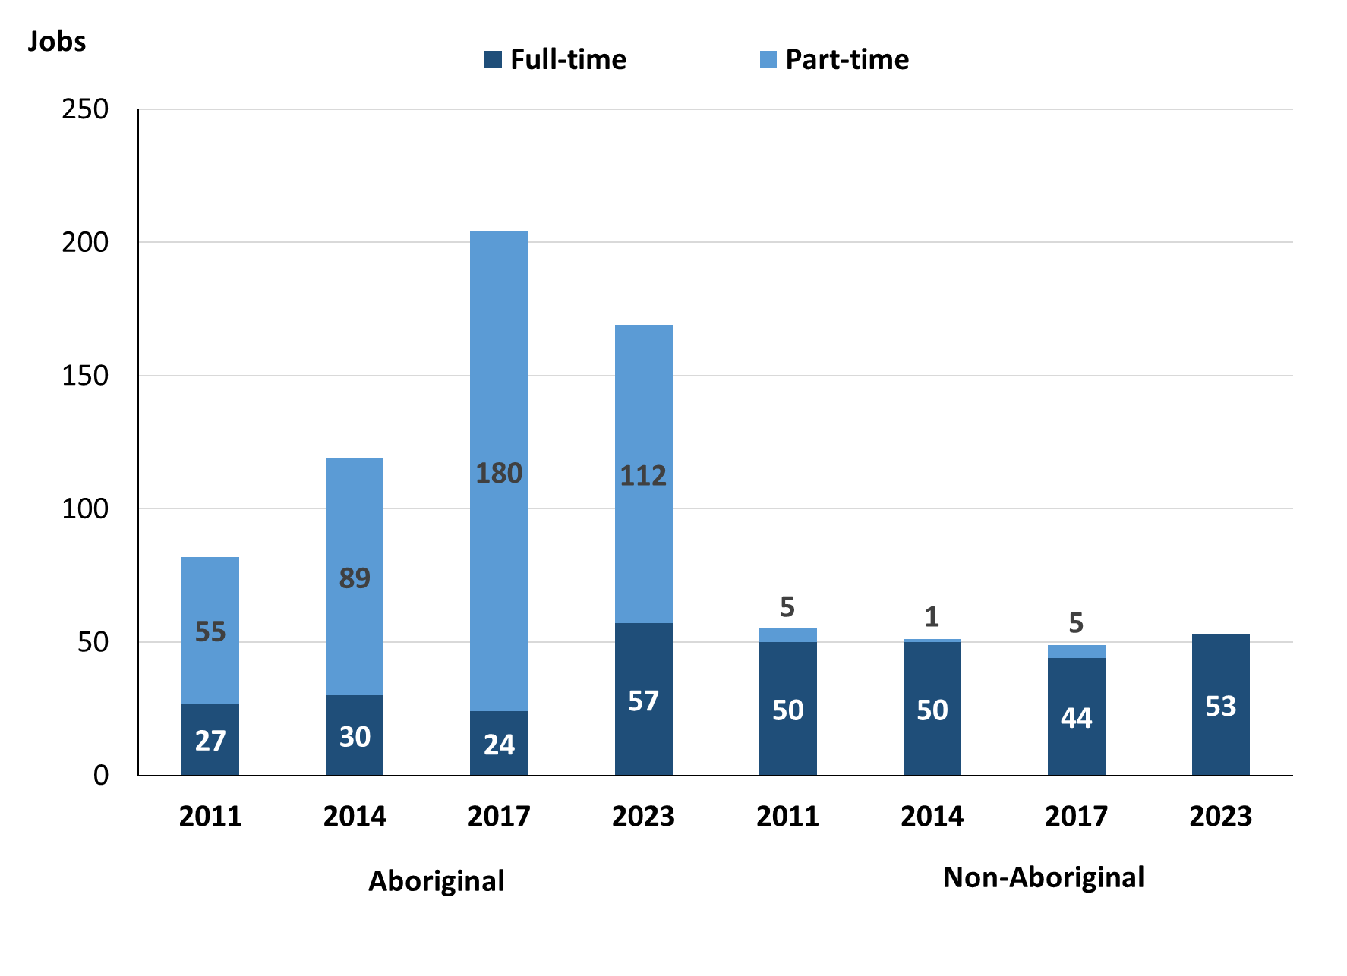

Source: Northern Territory Department of Industry, Tourism and Trade

In 2023 in Ramingining:

* of the 222 **filled jobs**:
* 57 were **full-time** jobs filled by **Aboriginal** people, an increase of 33 jobs from 2017 and an increase of 27 jobs from 2014
* 112 were **part-time** jobs filled by **Aboriginal** people, a decrease of 68 jobs from 2017 and an increase of 23 jobs from 2014
* 53 were **full-time** jobs filled by **non-Aboriginal** people, an increase of 9 jobs from 2017 and an increase of 3 jobs from 2014
* none were **part-time** jobs filled by **non-Aboriginal** people, a decrease of 5 jobs from 2017 and a decrease of 1 job from 2014.

# Jobs by Sector: Private and Public

Table 3a: Count of filled jobs by sector of business, 2011, 2014, 2017 & 2023 (a)(b)(c)

|  |  |  |  |  |  |  |  |  |  |  |  |  |
| --- | --- | --- | --- | --- | --- | --- | --- | --- | --- | --- | --- | --- |
| **Indicator** | **2011** | | | **2014** | | | **2017** | | | **2023** | | |
| **Aboriginal** | **Non-Aboriginal** | **Total** | **Aboriginal** | **Non-Aboriginal** | **Total** | **Aboriginal** | **Non-Aboriginal** | **Total** | **Aboriginal** | **Non-Aboriginal** | **Total** |
| **Public Sector** | 43 | 47 | **90** | 34 | 42 | **76** | 44 | 40 | **84** | 56 | 34 | **90** |
| Australian Government | 1 | 1 | **2** | 1 | 1 | **2** | 1 | 1 | **2** | 0 | 0 | **0** |
| Territory Government | 14 | 34 | **48** | 14 | 34 | **48** | 14 | 33 | **47** | 31 | 30 | **61** |
| Local Government | 28 | 12 | **40** | 19 | 7 | **26** | 29 | 6 | **35** | 25 | 4 | **29** |
| **Private Sector** | 39 | 8 | **47** | 85 | 9 | **94** | 160 | 9 | **169** | 113 | 19 | **132** |
| **Total** | **82** | **55** | **137** | **119** | **51** | **170** | **204** | **49** | **253** | **169** | **53** | **222** |

Source: Northern Territory Department of Industry, Tourism and Trade

Table 3b: Count of filled jobs by sector of business, 2011-2014, 2014-2017 & 2017-2023 (a)(b)(c)

|  |  |  |  |  |  |  |  |  |  |
| --- | --- | --- | --- | --- | --- | --- | --- | --- | --- |
| **Indicator** | **Change 2011-2014** | | | **Change 2014-2017** | | | **Change 2017-2023** | | |
| **Aboriginal** | **Non-Aboriginal** | **Total** | **Aboriginal** | **Non-Aboriginal** | **Total** | **Aboriginal** | **Non-Aboriginal** | **Total** |
| **Public Sector** | -9 | -5 | **-14** | 10 | -2 | **8** | 12 | -6 | **6** |
| Australian Government | 0 | 0 | **0** | 0 | 0 | **0** | -1 | -1 | **-2** |
| Territory Government | 0 | 0 | **0** | 0 | -1 | **-1** | 17 | -3 | **14** |
| Local Government | -9 | -5 | **-14** | 10 | -1 | **9** | -4 | -2 | **-6** |
| **Private Sector** | 46 | 1 | **47** | 75 | 0 | **75** | -47 | 10 | **-37** |
| **Total** | **37** | **-4** | **33** | **85** | **-2** | **83** | **-35** | **4** | **-31** |

Source: Northern Territory Department of Industry, Tourism and Trade

**Chart 4: Count of filled jobs by sector of business, 2011, 2014, 2017 & 2023 (a)(d)**

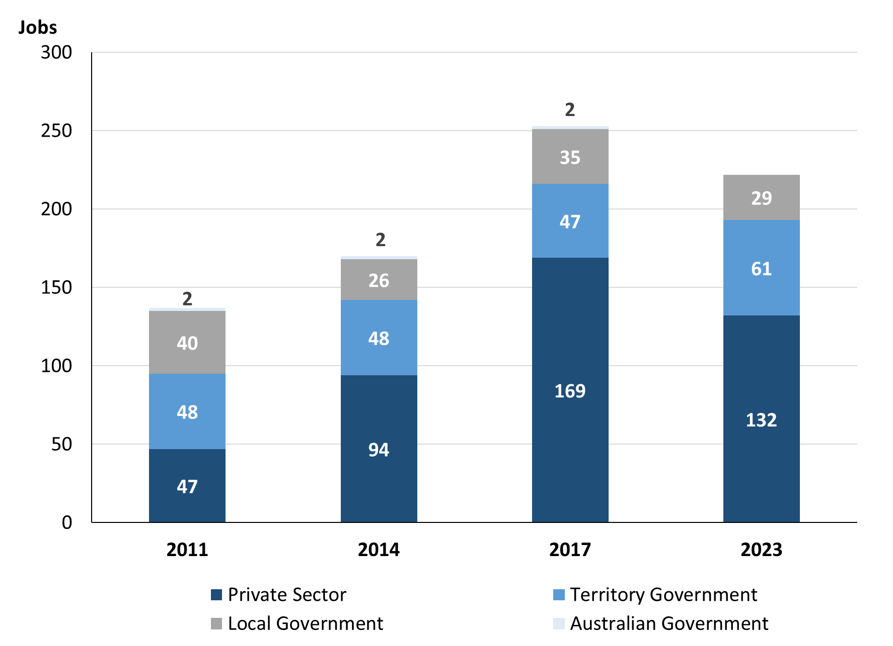

Source: Northern Territory Department of Industry, Tourism and Trade

Chart 5: Percentage of filled jobs by business sectors in 2023 (a)(d)

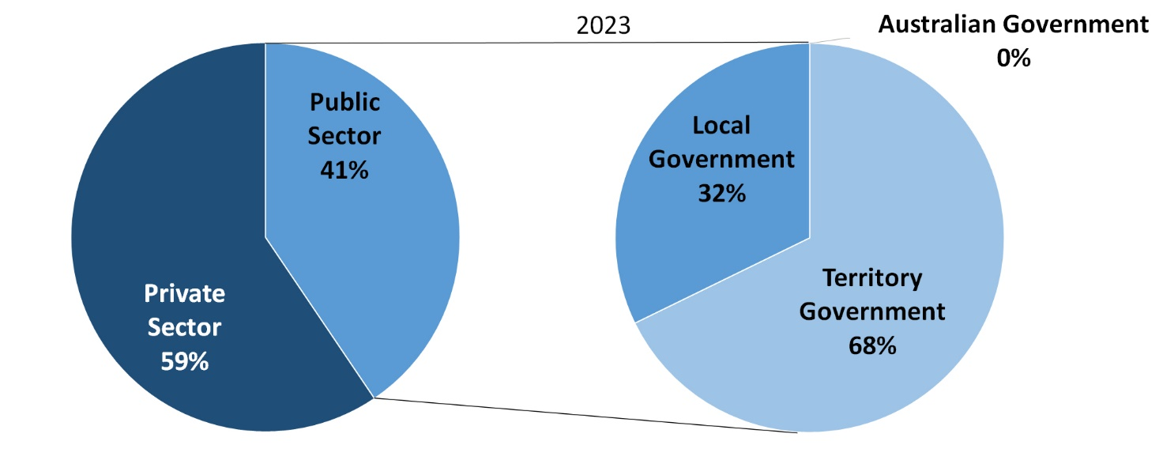

Source: Northern Territory Department of Industry, Tourism and Trade

In 2023 in Ramingining:

* there were 90 jobs in the **Public Sector**, an increase of 6 jobs from 2017 and an increase of 14 jobs from 2014
* of the 90 jobs in the **Public Sector**:
* none were in the Australian Government, a decrease of 2 jobs from both 2017 and 2014
* 61 jobs were in the Territory Government, an increase of 14 jobs from 2017 and an increase of 13 jobs 2014
* 29 jobs were in the Local Government, a decrease of 6 jobs from 2017 and an increase of 3 jobs from 2014
* there were 132 jobs in the **Private Sector**, a decrease of 37 jobs from 2017 and an increase of 38 jobs from 2014.

Chart 6: Count of filled jobs by sector, 2011, 2014, 2017 & 2023 (a)(c)(d)

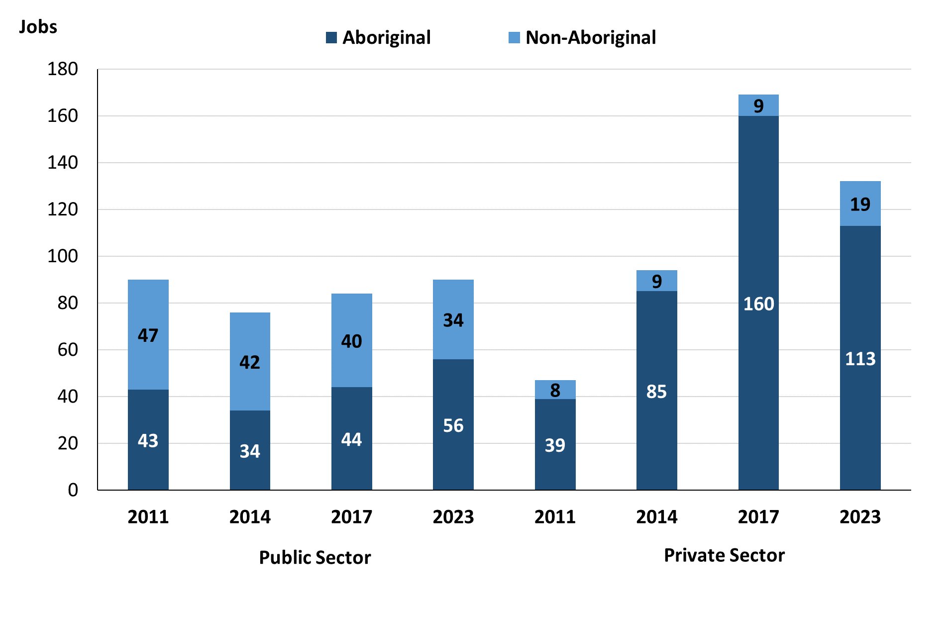

Source: Northern Territory Department of Industry, Tourism and Trade

In 2023 in Ramingining:

* of the 90 jobs in the **Public Sector:**
* 56 jobs were filled by **Aboriginal** people, an increase of 12 jobs from 2017 and an increase of 22 jobs from 2014
* 34 jobs were filled by **non-Aboriginal** people, a decrease of 6 jobs from 2017 and a decrease of 8 jobs from 2014
* of the 132 jobs in the **Private Sector:**
* 113 jobs were filled by **Aboriginal** people, a decrease of 47 jobs from 2017 and an increase of 28 jobs from 2014
* 19 jobs were filled by **non-Aboriginal** people, an increase of 10 jobs from both 2017 and 2014.

Chart 7: Count of filled jobs by sector and full-time/part-time status, 2011, 2014, 2017 & 2023 (a)(b)(d)

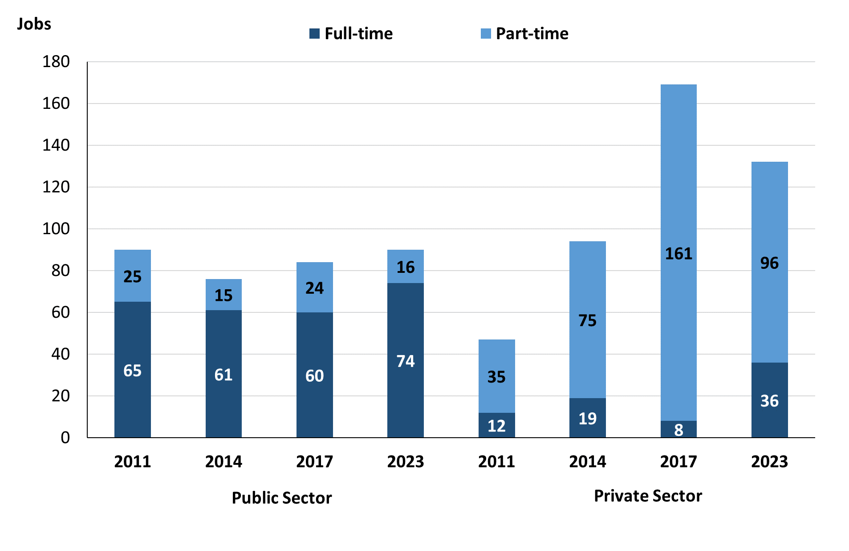

Source: Northern Territory Department of Industry, Tourism and Trade

In 2023 in Ramingining there were:

* of the 90 jobs in the **Public Sector**:
* 74 were **full-time** jobs, an increase of 14 jobs from 2017 and an increase of 13 jobs from 2014
* 16 were **part-time** jobs, a decrease of 8 jobs from 2017 and an increase of 1 job from 2014
* of the 132 jobs in the **Private Sector**:
* 36 were **full-time** jobs, an increase of 28 jobs from 2017 and an increase of 17 jobs from 2014
* 96 were **part-time** jobs, a decrease of 65 jobs from 2017 and an increase of 21 jobs from 2014.

Table 4: Count of filled jobs by full-time/part-time status by sector, 2011, 2014, 2017 & 2023 (a)(b)(c)(d)

|  |  |  |  |  |  |  |  |  |  |  |
| --- | --- | --- | --- | --- | --- | --- | --- | --- | --- | --- |
| **Indicator** | **2011** | | | | | | | | | |
| **Aboriginal** | | | **Non-Aboriginal** | | | **Total** | | | |
| **Full-time** | **Part-time** | **Total** | **Full-time** | **Part-time** | **Total** | **Full-time** | **Part-time** | **Total** |
| Public Sector | 22 | 21 | **43** | 43 | 4 | **47** | 65 | 25 | **90** |
| Private Sector | 5 | 34 | **39** | 7 | 1 | **8** | 12 | 35 | **47** |
| **Total** | **27** | **55** | **82** | **50** | **5** | **55** | **77** | **60** | **137** |

|  |  |  |  |  |  |  |  |  |  |  |
| --- | --- | --- | --- | --- | --- | --- | --- | --- | --- | --- |
| **Indicator** | **2014** | | | | | | | | | |
| **Aboriginal** | | | **Non-Aboriginal** | | | **Total** | | | |
| **Full-time** | **Part-time** | **Total** | **Full-time** | **Part-time** | **Total** | **Full-time** | **Part-time** | **Total** |
| Public Sector | 20 | 14 | **34** | 41 | 1 | **42** | 61 | 15 | **76** |
| Private Sector | 10 | 75 | **85** | 9 | 0 | **9** | 19 | 75 | **94** |
| **Total** | **30** | **89** | **119** | **50** | **1** | **51** | **80** | **90** | **170** |

|  |  |  |  |  |  |  |  |  |  |  |  |
| --- | --- | --- | --- | --- | --- | --- | --- | --- | --- | --- | --- |
| **Indicator** | **2017** | | | | | | | | | | |
| **Aboriginal** | | | **Non-Aboriginal** | | | | **Total** | | | |
| **Full-time** | **Part-time** | **Total** | **Full-time** | **Part-time** | **Total** | **Full-time** | | **Part-time** | **Total** |
| Public Sector | 24 | 20 | **44** | 36 | 4 | **40** | 60 | | 24 | **84** |
| Private Sector | 0 | 160 | **160** | 8 | 1 | **9** | 8 | | 161 | **169** |
| **Total** | **30** | **89** | **204** | **44** | **5** | **49** | **68** | | **185** | **253** |

|  |  |  |  |  |  |  |  |  |  |  |  |
| --- | --- | --- | --- | --- | --- | --- | --- | --- | --- | --- | --- |
| **Indicator** | **2023** | | | | | | | | | | |
| **Aboriginal** | | | **Non-Aboriginal** | | | | **Total** | | | |
| **Full-time** | **Part-time** | **Total** | **Full-time** | **Part-time** | **Total** | **Full-time** | | **Part-time** | **Total** |
| Public Sector | 40 | 16 | **56** | 34 | 0 | **34** | 74 | | 16 | **90** |
| Private Sector | 17 | 96 | **113** | 19 | 0 | **19** | 36 | | 96 | **132** |
| **Total** | **57** | **112** | **169** | **53** | **0** | **53** | **110** | | **112** | **222** |

Source: Northern Territory Department of Industry, Tourism and Trade

In 2023 in Ramingining there were:

* 56 jobs in the **Public Sector** filled by **Aboriginal** people, an increase of 12 jobs from 2017 and an increase of 22 jobs from 2014, of which:
* 40 were full-time jobs, an increase of 16 jobs from 2017 and an increase of 20 jobs from 2014
* 16 were part-time jobs, a decrease of 4 jobs from 2017 and an increase of 2 jobs from 2014
* 113 jobs in the **Private Sector** filled by **Aboriginal** people, a decrease of 47 jobs from 2017 and an increase of 28 jobs from 2014, of which:
* 17 were **full-time** jobs, an increase of 17 jobs from 2017 and an increase of 7 jobs from 2014
* 96 were **part-time** jobs, a decrease of 64 jobs from 2017 and an increase of 21 jobs from 2014
* 34 jobs in the **Public Sector** filled by **non-Aboriginal** people, a decrease of 6 jobs from 2017 and a decrease of 8 jobs from 2014, of which:
* 34 were **full-time** jobs, a decrease of 2 jobs from 2017 and a decrease of 7 jobs from 2014
* none were **part-time** jobs, a decrease of 4 jobs from 2017 and a decrease of 1 job from 2014
* 19 jobs in the **Private Sector** filled by **non-Aboriginal** people, an increase of 10 jobs from 2017 and an increase of 10 jobs from 2014, of which:
* 19 were **full-time** jobs, an increase of 11 jobs from 2017 and an increase of 10 jobs from 2014
* none were **part-time** jobs, a decrease of 1 job from 2017 and unchanged from 2014.

# Job Status: Permanent and Temporary

Table 5a: Count of filled jobs by employment status, 2011, 2014, 2017 & 2023 (a)(c)(e)

|  |  |  |  |  |  |  |  |  |  |  |  |  |
| --- | --- | --- | --- | --- | --- | --- | --- | --- | --- | --- | --- | --- |
| **Indicator** | **2011** | | | **2014** | | | **2017** | | | **2023** | | |
| **Aboriginal** | **Non-Aboriginal** | **Total** | **Aboriginal** | **Non-Aboriginal** | **Total** | **Aboriginal** | **Non-Aboriginal** | **Total** | **Aboriginal** | **Non-Aboriginal** | **Total** |
| Permanent | 56 | 19 | **75** | 38 | 36 | **74** | 68 | 20 | **88** | 114 | 30 | **144** |
| Temporary | 26 | 36 | **62** | 81 | 15 | **96** | 136 | 29 | **165** | 55 | 23 | **78** |
| **Total** | **82** | **55** | **137** | **119** | **51** | **170** | **204** | **49** | **253** | **169** | **53** | **222** |

Source: Northern Territory Department of Industry, Tourism and Trade

Table 5b: Count of filled jobs by employment status, 2011-2014, 2014-2017 & 2017-2023 (a)(c)(e)

|  |  |  |  |  |  |  |  |  |  |
| --- | --- | --- | --- | --- | --- | --- | --- | --- | --- |
| **Indicator** | **Change 2011-2014** | | | **Change 2014-2017** | | | **Change**  **2017-2023** | | |
| **Aboriginal** | **Non-Aboriginal** | **Total** | **Aboriginal** | **Non-Aboriginal** | **Total** | **Aboriginal** | **Non-Aboriginal** | **Total** |
| Permanent | -18 | 17 | **-1** | 30 | -16 | **14** | 46 | 10 | **56** |
| Temporary | 55 | -21 | **34** | 55 | 14 | **69** | -81 | -6 | **-87** |
| **Total** | **37** | **-4** | **33** | **85** | **-2** | **83** | **-35** | **4** | **-31** |

Source: Northern Territory Department of Industry, Tourism and Trade

Chart 8: Count of filled jobs by employment status, 2011, 2014, 2017 & 2023 (a)(c)(e)

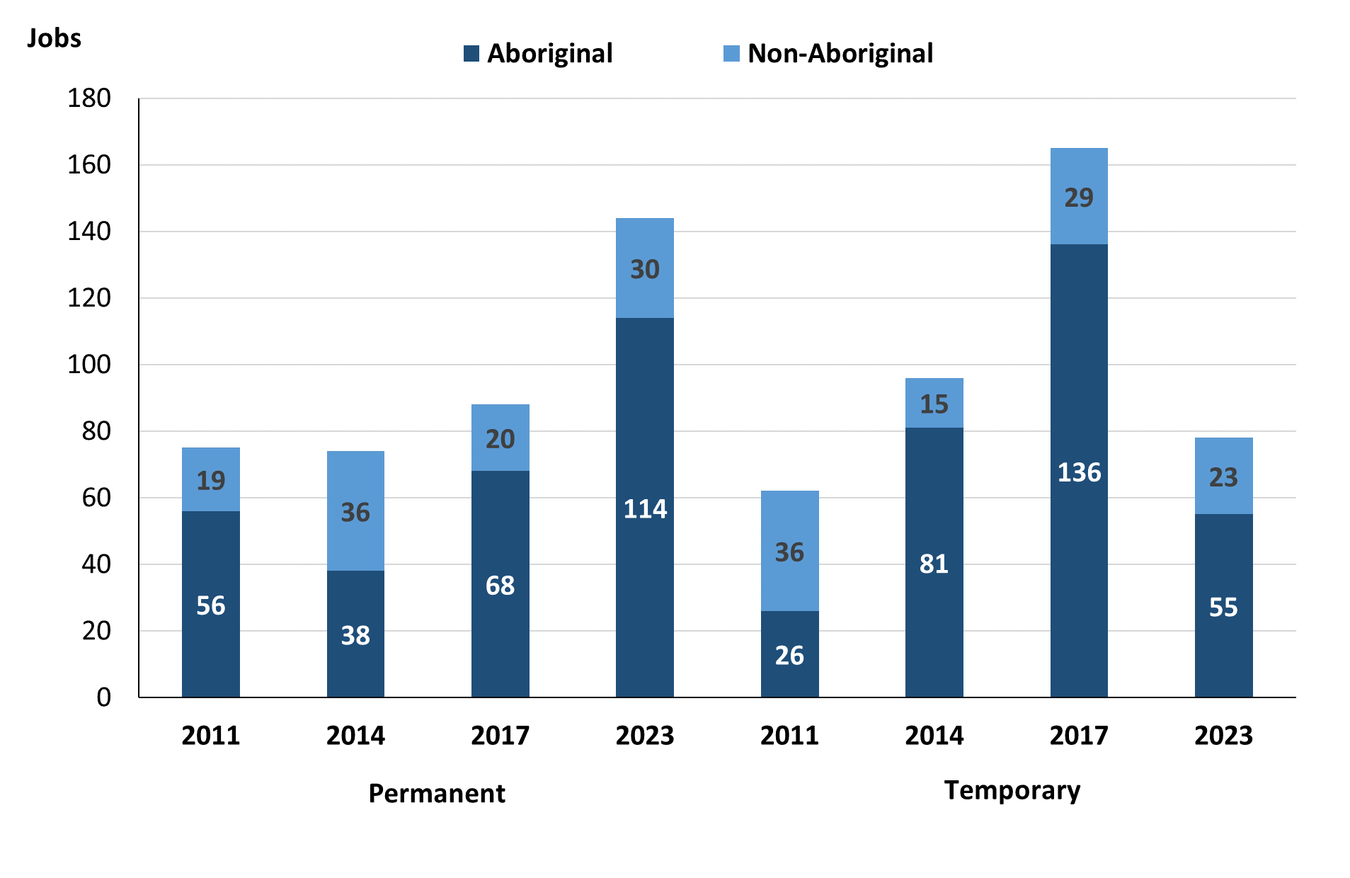

Source: Northern Territory Department of Industry, Tourism and Trade

In 2023 in Ramingining:

* there were 144 **permanent** jobs, an increase of 56 jobs from 2017, and an increase of 70 jobs from 2014, of which:
* **Aboriginal** people filled 114 jobs, an increase of 46 jobs from 2017 and an increase of 76 jobs from 2014
* **non-Aboriginal** people filled 30 jobs, an increase of 10 jobs from 2017 and a decrease of 6 jobs from 2014
* there were 78 **temporary** jobs, a decrease of 87 jobs from 2017 and a decrease of 18 jobs from 2014, of which:
* **Aboriginal** people filled 55 jobs, a decrease of 81 jobs from 2017 and a decrease of 26 jobs from 2014
* **non-Aboriginal** people filled 23 jobs, a decrease of 6 jobs from 2017 and an increase of 8 jobs from 2014.

Table 6: Count of filled jobs by sector and employment status, 2011, 2014, 2017 & 2023 (a)(c)(d)(e)

|  |  |  |  |  |  |  |  |  |  |
| --- | --- | --- | --- | --- | --- | --- | --- | --- | --- |
| **Indicator** | **2011** | | | | | | | | |
| **Aboriginal** | | | **Non-Aboriginal** | | | **Total** | | |
| **Perm** | **Temp** | **Total** | **Perm** | **Temp** | **Total** | **Perm** | **Temp** | **Total** |
| Public Sector | 34 | 9 | **43** | 16 | 31 | **47** | 50 | 40 | **90** |
| Private Sector | 22 | 17 | **39** | 3 | 5 | **8** | 25 | 22 | **47** |
| **Total** | **56** | **26** | **82** | **19** | **36** | **55** | **75** | **62** | **137** |

|  |  |  |  |  |  |  |  |  |  |
| --- | --- | --- | --- | --- | --- | --- | --- | --- | --- |
| **Indicator** | **2014** | | | | | | | | |
| **Aboriginal** | | | **Non-Aboriginal** | | | **Total** | | |
| **Perm** | **Temp** | **Total** | **Perm** | **Temp** | **Total** | **Perm** | **Temp** | **Total** |
| Public Sector | 16 | 18 | **34** | 32 | 10 | **42** | 48 | 28 | **76** |
| Private Sector | 22 | 63 | **85** | 4 | 5 | **9** | 26 | 68 | **94** |
| **Total** | **38** | **81** | **119** | **36** | **15** | **51** | **74** | **96** | **170** |

|  |  |  |  |  |  |  |  |  |  |
| --- | --- | --- | --- | --- | --- | --- | --- | --- | --- |
| **Indicator** | **2017** | | | | | | | | |
| **Aboriginal** | | | **Non-Aboriginal** | | | **Total** | | |
| **Perm** | **Temp** | **Total** | **Perm** | **Temp** | **Total** | **Perm** | **Temp** | **Total** |
| Public Sector | 28 | 16 | **44** | 14 | 26 | **40** | 42 | 42 | **84** |
| Private Sector | 40 | 120 | **160** | 6 | 3 | **9** | 46 | 123 | **169** |
| **Total** | **68** | **136** | **204** | **20** | **29** | **49** | **88** | **165** | **253** |

|  |  |  |  |  |  |  |  |  |  |
| --- | --- | --- | --- | --- | --- | --- | --- | --- | --- |
| **Indicator** | **2023** | | | | | | | | |
| **Aboriginal** | | | **Non-Aboriginal** | | | **Total** | | |
| **Perm** | **Temp** | **Total** | **Perm** | **Temp** | **Total** | **Perm** | **Temp** | **Total** |
| Public Sector | 28 | 28 | **56** | 16 | 18 | **34** | 44 | 46 | **90** |
| Private Sector | 86 | 27 | **113** | 14 | 5 | **19** | 100 | 32 | **132** |
| **Total** | **114** | **55** | **169** | **30** | **23** | **53** | **144** | **78** | **222** |

Source: Northern Territory Department of Industry, Tourism and Trade

In 2023 in Ramingining there were:

* 90 jobs in the **Public Sector**, an increase of 6 jobs from 2017 and an increase of 14 jobs from 2014, of which:
* 44 jobs were **permanent**, an increase of 2 jobs from 2017 and a decrease of 4 jobs from 2014, of which:
* **Aboriginal** people filled 28 jobs, unchanged from 2017 and an increase of 12 jobs from 2014
* **non-Aboriginal** people filled 16 jobs, an increase of 2 jobs from 2017 and a decrease of 16 jobs from 2014
* 46 jobs were **temporary**, an increase of 4 jobs from 2017 and an increase of 18 jobs from 2014, of which:
* **Aboriginal** people filled 28 jobs, an increase of 12 jobs from 2017 and an increase of 10 jobs from 2014
* **non-Aboriginal** people filled 18 jobs, a decrease of 8 jobs from both 2017 and 2014
* 132 jobs in the **Private Sector**, a decrease of 37 jobs from 2017 and an increase of 38 jobs from 2014, of which:
* 100 jobs were **permanent**, an increase of 54 jobs from 2017 and an increase of 74 jobs from 2014, of which:
* **Aboriginal** people filled 86 jobs, an increase of 46 jobs from 2017 and an increase of 64 jobs from 2014
* **non-Aboriginal** people filled 14 jobs, an increase of 8 jobs from 2017 and an increase of 10 jobs from 2014
* 32 jobs were **temporary,** a decrease of 91 jobs from 2017 and a decrease of 36 jobs from 2014, of which:
* **Aboriginal** people filled 27 jobs, a decrease of 93 jobs from 2017 and a decrease of 36 jobs from 2014
* **non-Aboriginal** people filled 5 jobs, an increase of 2 jobs from 2017 and unchanged from 2014.

# Job Vacancies

Table 7: Job vacancies, 2011, 2014, 2017 & 2023

|  |  |  |  |  |  |  |  |
| --- | --- | --- | --- | --- | --- | --- | --- |
| **Indicator** | **2011** | **2014** | **2017** | **2023** | **Change 2011-2014** | **Change 2014-2017** | **Change 2017-2023** |
| **Job vacancies** | **11** | **12** | **13** | **36** | **1** | **1** | **23** |

Source: Northern Territory Department of Industry, Tourism and Trade

Table 8a: Job vacancies by occupation, 2011, 2014, 2017 & 2023 (f)(g)

|  |  |  |  |  |
| --- | --- | --- | --- | --- |
| **Occupation (ANZSCO major group)** | **2011** | **2014** | **2017** | **2023** |
| Clerical and Administrative Workers | 0 | 0 | 2 | 3 |
| Community and Personal Service Workers | 4 | 4 | 7 | 6 |
| Labourers | 1 | 2 | 2 | 3 |
| Professionals | 5 | 5 | 2 | 9 |
| Technicians and Trades Workers | 0 | 1 | 0 | 1 |
| Other Occupations | 1 | 0 | 0 | 14 |
| **Total** | **11** | **12** | **13** | **36** |

Source: Northern Territory Department of Industry, Tourism and Trade

Table 8b: Job vacancies by occupation, 2011-2014, 2014-2017 & 2017-2023 (f)(g)

|  |  |  |  |
| --- | --- | --- | --- |
| **Occupation (ANZSCO major group)** | **Change 2011-2014** | **Change 2014-2017** | **Change 2017-2023** |
| Clerical and Administrative Workers | 0 | 2 | 1 |
| Community and Personal Service Workers | 0 | 3 | -1 |
| Labourers | 1 | 0 | 1 |
| Professionals | 0 | -3 | 7 |
| Technicians and Trades Workers | 1 | -1 | 1 |
| Other Occupations | -1 | 0 | 14 |
| **Total** | **1** | **1** | **23** |

Source: Northern Territory Department of Industry, Tourism and Trade

Table 9: Job vacancies by job title, 2023 profile (f)

|  |  |
| --- | --- |
| **Job Vacancy** | **No.** |
| Aboriginal and Torres Strait Islander Education Worker | 4 |
| Classroom Teacher | 7 |
| Clerical and Office Support Worker | 1 |
| Commercial Cleaner | 2 |
| Early Childhood (Pre-Primary) School Teacher | 1 |
| Engineering, ICT and Science Technician | 1 |
| General Clerk | 1 |
| Handyperson | 1 |
| Liaison Officer | 1 |
| Police Officer | 1 |
| Program or Project Administrator | 1 |
| Senior Teacher | 1 |
| Other (not well described) | 14 |
| **Total** | **36** |

Source: Northern Territory Department of Industry, Tourism and Trade

In 2023 in Ramingining:

* there were 36 **vacancies** reported, an increase of 23 vacancies from 2017 and an increase of 24 vacancies from 2014
* Of the 36 reported **vacancies,** the largest requirements were for:
* 9 Professionals, the majority of which is in the following job:
* Classroom Teacher
* 6 Community and Personal Service Workers, the majority of which is in the following job:
* Aboriginal and Torres Strait Islander Education Worker
* 3 Clerical and Administrative Workers in the following jobs:
* Clerical and Office Support Worker
* General Clerk
* Program or Project Administrator
* 3 Labourers in the following jobs:
* Commercial Cleaner
* Handyperson.

# Jobs by Industry

Table 10: Count of filled jobs by industry of business, 2011, 2014, 2017, 2023 and change in count of filled jobs by industry 2011-2014, 2014-2017 & 2017-2023 (a)(h)

|  |  |  |  |  |  |  |  |  |  |  |  |
| --- | --- | --- | --- | --- | --- | --- | --- | --- | --- | --- | --- |
| **Industry (ANZSIC Division)** | **2011** | | **2014** | | **2017** | | **2023** | | **Change 2011-2014** | **Change 2014-2017** | **Change 2017-2023** |
| **Total** | **% of Total** | **Total** | **% of Total** | **Total** | **% of Total** | **Total** | **% of Total** | **Total** | **Total** | **Total** |
| Accommodation and Food Services | 0 | 0.0% | 0 | 0.0% | 0 | 0.0% | 9 | 4.1% | 0 | 0 | 9 |
| Arts and Recreation Services | 4 | 2.9% | 3 | 1.8% | 16 | 6.3% | 7 | 3.2% | -1 | 13 | -9 |
| Construction | 0 | 0.0% | 0 | 0.0% | 30 | 11.9% | 0 | 0.0% | 0 | 30 | -30 |
| Education and Training | 37 | 27.0% | 32 | 18.8% | 34 | 13.4% | 55 | 24.8% | -5 | 2 | 21 |
| Electricity, Gas, Water and Waste Services | 1 | 0.7% | 2 | 1.2% | 0 | 0.0% | 0 | 0.0% | 1 | -2 | 0 |
| Financial and Insurance Services | 4 | 2.9% | 3 | 1.8% | 4 | 1.6% | 6 | 2.7% | -1 | 1 | 2 |
| Health Care and Social Assistance | 9 | 6.6% | 12 | 7.1% | 9 | 3.6% | 20 | 9.0% | 3 | -3 | 11 |
| Professional, Scientific and Technical Services | 0 | 0.0% | 0 | 0.0% | 0 | 0.0% | 9 | 4.1% | 0 | 0 | 9 |
| Public Administration and Safety | 48 | 35.0% | 42 | 24.7% | 76 | 30.0% | 58 | 26.1% | -6 | 34 | -18 |
| Retail Trade | 31 | 22.6% | 74 | 43.5% | 83 | 32.8% | 58 | 26.1% | 43 | 9 | -25 |
| Transport, Postal and Warehousing | 0 | 0.0% | 2 | 1.2% | 1 | 0.4% | 0 | 0.0% | 2 | -1 | -1 |
| **Total** | **137** | **100.0%** | **170** | **100.0%** | **253** | **100.0%** | **222** | **100.0%** | **33** | **83** | **-31** |

Source: Northern Territory Department of Industry, Tourism and Trade

In 2023 in Ramingining:

* Public Administration and Safety and Retail Trade industries were the **largest** **industry** **employers**, with 58 filled jobs or 26.1% of filled jobs each. Public Administration and Safety had a decrease of 18 jobs from 2017 and an increase of 16 jobs from 2014. Retail Trade had a decrease of 25 jobs from 2017 and a decrease of 16 jobs from 2014.
* **other** **significant** industry employers were:
* Education and Training with 55 jobs (or 24.8% of filled jobs), an increase of 21 jobs from 2017 and an increase of 23 jobs from 2014
* Health Care and Social Assistance with 20 jobs (or 9.0% of filled jobs), an increase of 11 jobs from 2017 and an increase of 8 jobs from 2014.

Table 11a: Count of filled jobs by industry of business, 2011, 2014, 2017 & 2023 (a)(c)(h)

|  |  |  |  |  |  |  |  |  |  |  |  |  |
| --- | --- | --- | --- | --- | --- | --- | --- | --- | --- | --- | --- | --- |
| **Industry (ANZSIC division)** | **2011** | | | **2014** | | | **2017** | | | **2023** | | |
| **Aboriginal** | **Non-Aboriginal** | **Total** | **Aboriginal** | **Non-Aboriginal** | **Total** | **Aboriginal** | **Non-Aboriginal** | **Total** | **Aboriginal** | **Non-Aboriginal** | **Total** |
| Accommodation and Food Services | 0 | 0 | **0** | 0 | 0 | **0** | 0 | 0 | **0** | 7 | 2 | **9** |
| Arts and Recreation Services | 0 | 4 | **4** | 2 | 1 | **3** | 14 | 2 | **16** | 7 | 0 | **7** |
| Construction | 0 | 0 | **0** | 0 | 0 | **0** | 30 | 0 | **30** | 0 | 0 | **0** |
| Education and Training | 9 | 28 | **37** | 9 | 23 | **32** | 7 | 27 | **34** | 27 | 28 | **55** |
| Electricity, Gas, Water and Waste Services | 0 | 1 | **1** | 1 | 1 | **2** | 0 | 0 | **0** | 0 | 0 | **0** |
| Financial and Insurance Services | 4 | 0 | **4** | 3 | 0 | **3** | 4 | 0 | **4** | 6 | 0 | **6** |
| Health Care and Social Assistance | 6 | 3 | **9** | 4 | 8 | **12** | 5 | 4 | **9** | 16 | 4 | **20** |
| Professional, Scientific and Technical Services | 0 | 0 | **0** | 0 | 0 | **0** | 0 | 0 | **0** | 3 | 6 | **9** |
| Public Administration and Safety | 34 | 14 | **48** | 30 | 12 | **42** | 65 | 11 | **76** | 48 | 10 | **58** |
| Retail Trade | 28 | 3 | **31** | 70 | 4 | **74** | 79 | 4 | **83** | 55 | 3 | **58** |
| Transport, Postal and Warehousing | 0 | 0 | **0** | 0 | 2 | **2** | 0 | 1 | **1** | 0 | 0 | **0** |
| **Total** | **82** | **55** | **137** | **119** | **51** | **170** | **204** | **49** | **253** | **169** | **53** | **222** |

Source: Northern Territory Department of Industry, Tourism and Trade

Table 11b: Count of filled jobs by industry of business, 2011-2014, 2014-2017 & 2017-2023 (a)(c)(h)

|  |  |  |  |  |  |  |  |  |  |
| --- | --- | --- | --- | --- | --- | --- | --- | --- | --- |
| **Industry (ANZSIC division)** | **Change 2011-2014** | | | **Change  2014-2017** | | | **Change 2017-2023** | | |
| **Aboriginal** | **Non-Aboriginal** | **Total** | **Aboriginal** | **Non-Aboriginal** | **Total** | **Aboriginal** | **Non-Aboriginal** | **Total** |
| Arts and Recreation Services | 2 | -3 | **-1** | 12 | 1 | **13** | 7 | 2 | **9** |
| Construction | 0 | 0 | **0** | 30 | 0 | **30** | -7 | -2 | **-9** |
| Education and Training | 0 | -5 | **-5** | -2 | 4 | **2** | -30 | 0 | **-30** |
| Electricity, Gas, Water and Waste Services | 1 | 0 | **1** | -1 | -1 | **-2** | 20 | 1 | **21** |
| Financial and Insurance Services | -1 | 0 | **-1** | 1 | 0 | **1** | 0 | 0 | **0** |
| Health Care and Social Assistance | -2 | 5 | **3** | 1 | -4 | **-3** | 2 | 0 | **2** |
| Public Administration and Safety | -4 | -2 | **-6** | 35 | -1 | **34** | 11 | 0 | **11** |
| Retail Trade | 42 | 1 | **43** | 9 | 0 | **9** | 3 | 6 | **9** |
| Transport, Postal and Warehousing | 0 | 2 | **2** | 0 | -1 | **-1** | -17 | -1 | **-18** |
| **Total** | **37** | **-4** | **33** | **85** | **-2** | **83** | **-24** | **-1** | **-25** |

Source: Northern Territory Department of Industry, Tourism and Trade

Chart 9: Count of filled jobs by top 5 industries, 2023 (a)(c)(h)

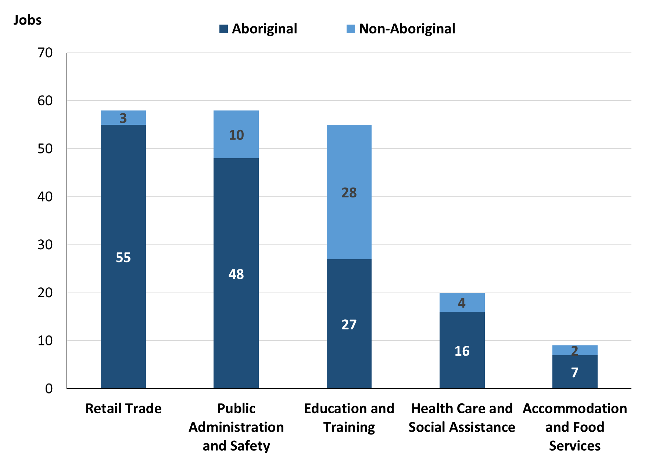

Source: Northern Territory Department of Industry, Tourism and Trade

In 2023 in Ramingining:

* of the 169 **jobs filled** by **Aboriginal** people, there were:
* 55 jobs in Retail Trade, a decrease of 24 jobs from 2017 and a decrease of 15 jobs from 2014
* 48 jobs in Public Administration and Safety, a decrease of 17 jobs from 2017 and an increase of 18 jobs from 2014
* 27 jobs in Education and Training, an increase of 20 jobs from 2017 and an increase of 18 jobs from 2014
* of the 53 **jobs filled** by **non-Aboriginal** people, there were:
* 28 jobs in Education and Training, an increase of 1 job from 2017 and an increase of 5 jobs from 2014
* 10 jobs in Public Administration and Safety, a decrease of 1 job from 2017 and a decrease of 2 jobs from 2014
* 6 jobs in Professional, Scientific and Technical Services, an increase of 6 jobs from both 2017 2014.

Table 12: Count of filled jobs by industry and employment status, 2011 (a)(c)(e)(h)

|  |  |  |  |  |  |  |  |  |  |
| --- | --- | --- | --- | --- | --- | --- | --- | --- | --- |
| **Industry (ANZSIC division)** | **2011** | | | | | | | | |
| **Aboriginal** | | | **Non-Aboriginal** | | | **Total** | | |
| **Perm** | **Temp** | **Total** | **Perm** | **Temp** | **Total** | **Perm** | **Temp** | **Total** |
| Arts and Recreation Services | 0 | 0 | **0** | 2 | 2 | **4** | 2 | 2 | **4** |
| Education and Training | 6 | 3 | **9** | 9 | 19 | **28** | 15 | 22 | **37** |
| Electricity, Gas, Water and Waste Services | 0 | 0 | **0** | 1 | 0 | **1** | 1 | 0 | **1** |
| Financial and Insurance Services | 4 | 0 | **4** | 0 | 0 | **0** | 4 | 0 | **4** |
| Health Care and Social Assistance | 1 | 5 | **6** | 0 | 3 | **3** | 1 | 8 | **9** |
| Public Administration and Safety | 32 | 2 | **34** | 7 | 7 | **14** | 39 | 9 | **48** |
| Retail Trade | 12 | 16 | **28** | 0 | 3 | **3** | 12 | 19 | **31** |
| **Total** | **56** | **26** | **82** | **19** | **36** | **55** | **75** | **62** | **137** |

Source: Northern Territory Department of Industry, Tourism and Trade

Table 13: Count of filled jobs by industry and employment status, 2014 (a)(c)(e)(h)

|  |  |  |  |  |  |  |  |  |  |
| --- | --- | --- | --- | --- | --- | --- | --- | --- | --- |
| **Industry (ANZSIC division)** | **2014** | | | | | | | | |
| **Aboriginal** | | | **Non-Aboriginal** | | | **Total** | | |
| **Perm** | **Temp** | **Total** | **Perm** | **Temp** | **Total** | **Perm** | **Temp** | **Total** |
| Arts and Recreation Services | 2 | 0 | **2** | 1 | 0 | **1** | 3 | 0 | **3** |
| Education and Training | 5 | 4 | **9** | 14 | 9 | **23** | 19 | 13 | **32** |
| Electricity, Gas, Water and Waste Services | 0 | 1 | **1** | 0 | 1 | **1** | 0 | 2 | **2** |
| Financial and Insurance Services | 3 | 0 | **3** | 0 | 0 | **0** | 3 | 0 | **3** |
| Health Care and Social Assistance | 4 | 0 | **4** | 8 | 0 | **8** | 12 | 0 | **12** |
| Public Administration and Safety | 8 | 22 | **30** | 10 | 2 | **12** | 18 | 24 | **42** |
| Retail Trade | 16 | 54 | **70** | 3 | 1 | **4** | 19 | 55 | **74** |
| Transport, Postal and Warehousing | 0 | 0 | **0** | 0 | 2 | **2** | 0 | 2 | **2** |
| **Total** | **38** | **81** | **119** | **36** | **15** | **51** | **74** | **96** | **170** |

Source: Northern Territory Department of Industry, Tourism and Trade

Table 14: Count of filled jobs by industry and employment status, 2017 (a)(c)(e)(h)

|  |  |  |  |  |  |  |  |  |  |
| --- | --- | --- | --- | --- | --- | --- | --- | --- | --- |
| **Industry (ANZSIC division)** | **2017** | | | | | | | | |
| **Aboriginal** | | | **Non-Aboriginal** | | | **Total** | | |
| **Perm** | **Temp** | **Total** | **Perm** | **Temp** | **Total** | **Perm** | **Temp** | **Total** |
| Arts and Recreation Services | 0 | 14 | **14** | 2 | 0 | **2** | 2 | 14 | **16** |
| Construction | 0 | 30 | **30** | 0 | 0 | **0** | 0 | 30 | **30** |
| Education and Training | 5 | 2 | **7** | 9 | 18 | **27** | 14 | 20 | **34** |
| Financial and Insurance Services | 3 | 1 | **4** | 0 | 0 | **0** | 3 | 1 | **4** |
| Health Care and Social Assistance | 0 | 5 | **5** | 1 | 3 | **4** | 1 | 8 | **9** |
| Public Administration and Safety | 23 | 42 | **65** | 4 | 7 | **11** | 27 | 49 | **76** |
| Retail Trade | 37 | 42 | **79** | 4 | 0 | **4** | 41 | 42 | **83** |
| Transport, Postal and Warehousing | 0 | 0 | **0** | 0 | 1 | **1** | 0 | 1 | **1** |
| **Total** | **68** | **136** | **204** | **20** | **29** | **49** | **88** | **165** | **253** |

Source: Northern Territory Department of Industry, Tourism and Trade

Table 15: Count of filled jobs by industry and employment status, 2023 (a)(c)(e)(h)

|  |  |  |  |  |  |  |  |  |  |
| --- | --- | --- | --- | --- | --- | --- | --- | --- | --- |
| **Industry (ANZSIC division)** | **2023** | | | | | | | | |
| **Aboriginal** | | | **Non-Aboriginal** | | | **Total** | | |
| **Perm** | **Temp** | **Total** | **Perm** | **Temp** | **Total** | **Perm** | **Temp** | **Total** |
| Accommodation and Food Services | 0 | 7 | **7** | 2 | 0 | **2** | 2 | 7 | **9** |
| Arts and Recreation Services | 1 | 6 | **7** | 0 | 0 | **0** | 1 | 6 | **7** |
| Education and Training | 2 | 25 | **27** | 10 | 18 | **28** | 12 | 43 | **55** |
| Financial and Insurance Services | 6 | 0 | **6** | 0 | 0 | **0** | 6 | 0 | **6** |
| Health Care and Social Assistance | 4 | 12 | **16** | 4 | 0 | **4** | 8 | 12 | **20** |
| Professional, Scientific and Technical Services | 1 | 2 | **3** | 1 | 5 | **6** | 2 | 7 | **9** |
| Public Administration and Safety | 45 | 3 | **48** | 10 | 0 | **10** | 55 | 3 | **58** |
| Retail Trade | 55 | 0 | **55** | 3 | 0 | **3** | 58 | 0 | **58** |
| **Total** | **114** | **55** | **169** | **30** | **23** | **53** | **144** | **78** | **222** |

Source: Northern Territory Department of Industry, Tourism and Trade

In 2023 in Ramingining:

* of the 144 **permanent** jobs, there were:
* 58 jobs in Retail Trade, an increase of 17 jobs from 2017 and an increase of 39 jobs from 2014, including:
* 55 jobs filled by **Aboriginal** people, an increase of 18 jobs from 2017 and an increase of 39 jobs from 2014
* 3 jobs filled by **non-Aboriginal** people, a decrease of 1 job from 2017 and unchanged from 2014
* 55 jobs in Public Administration and Safety, an increase of 28 jobs from 2017 and an increase of 37 jobs from 2014, including:
* 45 jobs filled by **Aboriginal** people, an increase of 22 jobs from 2017 and an increase of 37 jobs from 2014
* 10 jobs filled by **non-Aboriginal** people, an increase of 6 jobs from 2017 and unchanged from 2014
* 12 jobs in Education and Training, a decrease of 2 jobs from 2017 and a decrease of 7 jobs from 2014, including:
* 2 jobs filled by **Aboriginal** people, a decrease of 3 jobs from both 2017 and 2014
* 10 jobs filled by **non-Aboriginal** people, an increase of 1 job from 2017 and a decrease of 4 jobs from 2014
* of the 78 **temporary** jobs, there were:
* 43 jobs in Education and Training, an increase of 23 jobs from 2017 and an increase of 30 jobs from 2014, including:
* 25 jobs filled by **Aboriginal** people, an increase of 23 jobs from 2017 and an increase of 21 jobs from 2014
* 18 jobs filled by **non-Aboriginal** people, unchanged from 2017 and an increase of 9 jobs from 2014
* 12 jobs in Health Care and Social Assistance, an increase of 4 jobs from 2017 and an increase of 12 jobs from 2014, including:
* 12 jobs filled by **Aboriginal** people, an increase of 7 jobs from 2017 and an increase of 12 jobs from 2014
* none were filled by **non-Aboriginal** people, a decrease of 3 jobs from 2017 and unchanged from 2014
* 7 jobs in Accommodation and Food Services, an increase of 7 jobs from both 2017 and 2014, including
* 7 jobs filled by **Aboriginal** people, an increase of 7 jobs from both 2017 and 2014
* none were filled by **non-Aboriginal** people, unchanged from both 2017 and 2014.

# Jobs by Occupation

Table 16a: Count of filled jobs by occupation, 2011, 2014, 2017 & 2023 (a)(f)(g)

|  |  |  |  |  |  |  |  |  |
| --- | --- | --- | --- | --- | --- | --- | --- | --- |
| **Occupation (ANZSCO major group)** | **2011** | | **2014** | | **2017** | | **2023** | |
| **Total** | **% of Total** | **Total** | **% of Total** | **Total** | **% of Total** | **Total** | **% of Total** |
| Clerical and Administrative Workers | 17 | 12.4% | 51 | 30.0% | 31 | 12.3% | 30 | 13.5% |
| Community and Personal Service Workers | 24 | 17.5% | 30 | 17.6% | 53 | 20.9% | 42 | 18.9% |
| Labourers | 11 | 8.0% | 10 | 5.9% | 45 | 17.8% | 16 | 7.2% |
| Machinery Operators and Drivers | 1 | 0.7% | 0 | 0.0% | 0 | 0.0% | 6 | 2.7% |
| Managers | 7 | 5.1% | 10 | 5.9% | 9 | 3.6% | 10 | 4.5% |
| Professionals | 40 | 29.2% | 42 | 24.7% | 69 | 27.3% | 55 | 24.8% |
| Sales Workers | 29 | 21.2% | 26 | 15.3% | 44 | 17.4% | 55 | 24.8% |
| Technicians and Trades Workers | 6 | 4.4% | 1 | 0.6% | 2 | 0.8% | 8 | 3.6% |
| **Total** | **137** | **100.0%** | **170** | **100.0%** | **253** | **100.0%** | **222** | **100.0%** |

Source: Northern Territory Department of Industry, Tourism and Trade

Table 16b: Count of filled jobs by occupation, 2011-2014, 2014-2017 & 2017-2023 (a)(f)(g)

|  |  |  |  |
| --- | --- | --- | --- |
| **Occupation (ANZSCO major group)** | **Change 2011-2014** | **Change 2014-2017** | **Change 2017-2023** |
| **Total** | **Total** | **Total** |
| Clerical and Administrative Workers | 34 | -20 | -1 |
| Community and Personal Service Workers | 6 | 23 | -11 |
| Labourers | -1 | 35 | -29 |
| Machinery Operators and Drivers | -1 | 0 | 6 |
| Managers | 3 | -1 | 1 |
| Professionals | 2 | 27 | -14 |
| Sales Workers | -3 | 18 | 11 |
| Technicians and Trades Workers | -5 | 1 | 6 |
| **Total** | **33** | **83** | **-31** |

Source: Northern Territory Department of Industry, Tourism and Trade

Chart 10: Percentage and count of top 6 filled jobs by occupation, 2011, 2014, 2017 & 2023 (a)(f)(g)

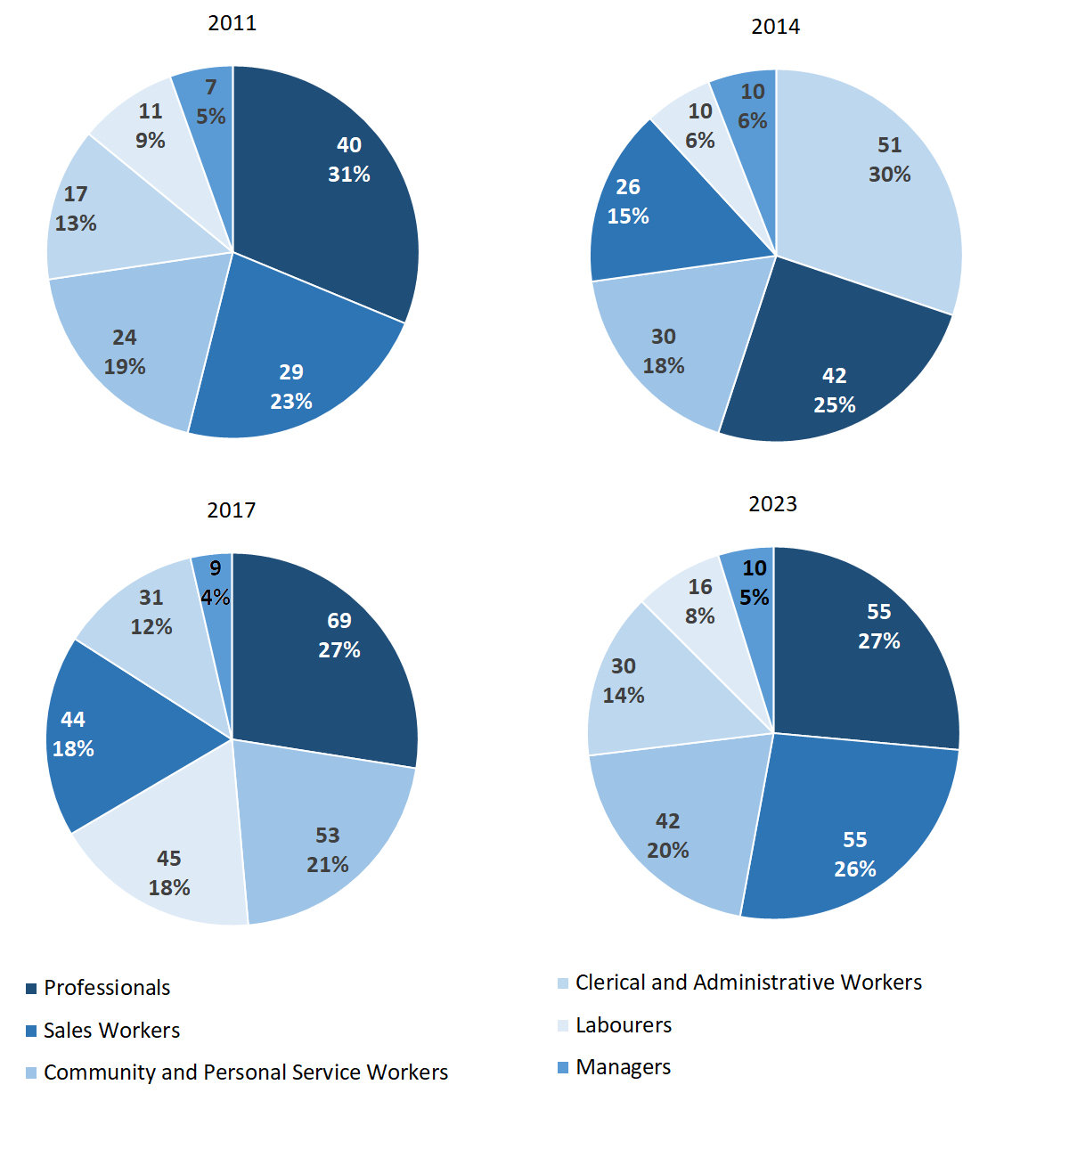Source: Northern Territory Department of Industry, Tourism and Trade

In 2023 in Ramingining:

* Professionals and Sales Workers were the two **largest** **occupation** **classifications** in terms of filled jobs, accounting for 55 jobs (24.8% of total filled jobs) each,
* Professionals had a decrease of 14 jobs from 2017 and an increase of 13 jobs from 2014,
* Sales Workers had an increase of 11 jobs from 2017 and an increase of 29 jobs from 2014.
* **other** **significant** occupation classifications were:
* Community and Personal Service Workers accounting for 42 jobs or 18.9% of total jobs, a decrease of 11 jobs from 2017 and an increase of 12 jobs from 2014
* Clerical and Administrative Workers accounting for 30 jobs or 13.5% of total jobs, a decrease of 1 job from 2017 and a decrease of 21 jobs from 2014.

**Table 17a: Count of filled jobs by ANZSCO occupation, 2011, 2014, 2017 & 2023 (a)(c)(f)(g)**

|  |  |  |  |  |  |  |  |  |  |  |  |  |
| --- | --- | --- | --- | --- | --- | --- | --- | --- | --- | --- | --- | --- |
| **Occupation (ANZSCO major group)** | **2011** | | | **2014** | | | **2017** | | | **2023** | | |
| **Aboriginal** | **Non-Aboriginal** | **Total** | **Aboriginal** | **Non-Aboriginal** | **Total** | **Aboriginal** | **Non-Aboriginal** | **Total** | **Aboriginal** | **Non-Aboriginal** | **Total** |
| Clerical and Administrative Workers | 8 | 9 | **17** | 46 | 5 | **51** | 27 | 4 | **31** | 19 | 11 | **30** |
| Community and Personal Service Workers | 19 | 5 | **24** | 22 | 8 | **30** | 47 | 6 | **53** | 36 | 6 | **42** |
| Labourers | 10 | 1 | **11** | 9 | 1 | **10** | 39 | 6 | **45** | 12 | 4 | **16** |
| Machinery Operators and Drivers | 0 | 1 | **1** | 0 | 0 | **0** | 0 | 0 | **0** | 6 | 0 | **6** |
| Managers | 0 | 7 | **7** | 0 | 10 | **10** | 2 | 7 | **9** | 2 | 8 | **10** |
| Professionals | 13 | 27 | **40** | 16 | 26 | **42** | 44 | 25 | **69** | 32 | 23 | **55** |
| Sales Workers | 29 | 0 | **29** | 26 | 0 | **26** | 44 | 0 | **44** | 55 | 0 | **55** |
| Technicians and Trades Workers | 1 | 5 | **6** | 0 | 1 | **1** | 1 | 1 | **2** | 7 | 1 | **8** |
| **Total** | **82** | **55** | **137** | **119** | **51** | **170** | **204** | **49** | **253** | **169** | **53** | **222** |

Source: Northern Territory Department of Industry, Tourism and Trade

**Table 17b: Count of filled jobs by ANZSCO occupation, 2011-2014, 2014-2017 & 2017-2023 (a)(c)(f)(g)**

|  |  |  |  |  |  |  |  |  |  |
| --- | --- | --- | --- | --- | --- | --- | --- | --- | --- |
| **Occupation (ANZSCO major group)** | **Change 2011-2014** | | | **Change 2014-2017** | | | **Change 2017-2023** | | |
| **Aboriginal** | **Non-Aboriginal** | **Total** | **Aboriginal** | **Non-Aboriginal** | **Total** | **Aboriginal** | **Non-Aboriginal** | **Total** |
| Clerical and Administrative Workers | 38 | -4 | **34** | -19 | -1 | **-20** | -8 | 7 | **-1** |
| Community and Personal Service Workers | 3 | 3 | **6** | 25 | -2 | **23** | -11 | 0 | **-11** |
| Labourers | -1 | 0 | **-1** | 30 | 5 | **35** | -27 | -2 | **-29** |
| Machinery Operators and Drivers | 0 | -1 | **-1** | 0 | 0 | **0** | 6 | 0 | **6** |
| Managers | 0 | 3 | **3** | 2 | -3 | **-1** | 0 | 1 | **1** |
| Professionals | 3 | -1 | **2** | 28 | -1 | **27** | -12 | -2 | **-14** |
| Sales Workers | -3 | 0 | **-3** | 18 | 0 | **18** | 11 | 0 | **11** |
| Technicians and Trades Workers | -1 | -4 | **-5** | 1 | 0 | **1** | 6 | 0 | **6** |
| **Total** | **37** | **-4** | **33** | **85** | **-2** | **83** | **-35** | **4** | **-31** |

Source: Northern Territory Department of Industry, Tourism and Trade

In 2023 in Ramingining:

* of the 169 **jobs filled** by **Aboriginal** people, there were:
* 55 Sales Workers, an increase of 11 jobs from 2017 and an increase of 29 jobs from 2014
* 36 Community and Personal Service Workers, a decrease of 11 jobs from 2017 and an increase of 14 jobs from 2014
* 32 Professionals, a decrease of 12 jobs from 2017 and an increase of 16 jobs from 2014
* of the 53 **jobs filled** by **non-Aboriginal** people, there were:
* 23 Professionals, a decrease of 2 jobs from 2017 and a decrease of 3 jobs from 2014
* 11 Clerical and Administrative Workers, an increase of 7 jobs from 2017 and an increase of 6 jobs from 2014
* 8 Managers, an increase of 1 job from 2017 and a decrease of 2 jobs from 2014.

# Jobs by Industry by Occupation

Table 18: Count of filled jobs by industry by occupation, 2011 (a)(f)(g)(h)

|  |  |  |  |  |  |  |  |  |  |  |
| --- | --- | --- | --- | --- | --- | --- | --- | --- | --- | --- |
| **2011** | | | | | | | | | | |
| **Industry (ANZSIC Division)** |  | **Occupation (ANZSCO major group)** | | | | | | | | |
| **Clerical and Administrative Workers** | **Community and Personal Service Workers** | **Labourers** | **Machinery Operators and Drivers** | **Managers** | **Professionals** | **Sales Workers** | **Technicians and Trades Workers** | **Other Occupations** | **Total** |
| Arts and Recreation Services | 0 | 0 | 0 | 1 | 1 | 2 | 0 | 0 | 0 | **4** |
| Education and Training | 4 | 7 | 3 | 0 | 1 | 22 | 0 | 0 | 0 | **37** |
| Electricity, Gas, Water and Waste Services | 0 | 0 | 0 | 0 | 0 | 0 | 0 | 1 | 0 | **1** |
| Financial and Insurance Services | 4 | 0 | 0 | 0 | 0 | 0 | 0 | 0 | 0 | **4** |
| Health Care and Social Assistance | 0 | 2 | 1 | 0 | 0 | 4 | 0 | 0 | 2 | **9** |
| Public Administration and Safety | 9 | 13 | 7 | 0 | 2 | 11 | 1 | 5 | 0 | **48** |
| Retail Trade | 0 | 0 | 0 | 0 | 3 | 0 | 28 | 0 | 0 | **31** |
| **Total** | **17** | **24** | **11** | **1** | **7** | **40** | **29** | **6** | **2** | **137** |

Source: Northern Territory Department of Industry, Tourism and Trade

Table 19: Count of filled jobs by industry by occupation, 2014 (a)(f)(g)(h)

|  |  |  |  |  |  |  |  |  |  |  |
| --- | --- | --- | --- | --- | --- | --- | --- | --- | --- | --- |
| **2014** | | | | | | | | | | |
| **Industry (ANZSIC Division)** |  | **Occupation (ANZSCO major group)** | | | | | | | | |
| **Clerical and Administrative Workers** | **Community and Personal Service Workers** | **Labourers** | **Machinery Operators and Drivers** | **Managers** | **Professionals** | **Sales Workers** | **Technicians and Trades Workers** | **Other Occupations** | **Total** |
| Arts and Recreation Services | 0 | 0 | 0 | 0 | 0 | 3 | 0 | 0 | 0 | **3** |
| Education and Training | 1 | 7 | 2 | 0 | 4 | 18 | 0 | 0 | 0 | **32** |
| Electricity, Gas, Water and Waste Services | 0 | 0 | 1 | 0 | 0 | 0 | 0 | 1 | 0 | **2** |
| Financial and Insurance Services | 3 | 0 | 0 | 0 | 0 | 0 | 0 | 0 | 0 | **3** |
| Health Care and Social Assistance | 2 | 4 | 1 | 0 | 2 | 3 | 0 | 0 | 0 | **12** |
| Public Administration and Safety | 4 | 15 | 6 | 0 | 1 | 16 | 0 | 0 | 0 | **42** |
| Retail Trade | 41 | 4 | 0 | 0 | 3 | 0 | 26 | 0 | 0 | **74** |
| Transport, Postal and Warehousing | 0 | 0 | 0 | 0 | 0 | 2 | 0 | 0 | 0 | **2** |
| **Total** | **51** | **30** | **10** | **0** | **10** | **42** | **26** | **1** | **0** | **170** |

Source: Northern Territory Department of Industry, Tourism and Trade

Table 20: Count of filled jobs by occupation and by industry, 2017 (a)(f)(g)(h)

|  |  |  |  |  |  |  |  |  |  |  |
| --- | --- | --- | --- | --- | --- | --- | --- | --- | --- | --- |
| **2017** | | | | | | | | | | |
| **Industry (ANZSIC Division)** |  | **Occupation (ANZSCO major group)** | | | | | | | | |
| **Clerical and Administrative Workers** | **Community and Personal Service Workers** | **Labourers** | **Machinery Operators and Drivers** | **Managers** | **Professionals** | **Sales Workers** | **Technicians and Trades Workers** | **Other Occupations** | **Total** |
| Arts and Recreation Services | 0 | 11 | 0 | 0 | 1 | 4 | 0 | 0 | 0 | **16** |
| Construction | 0 | 0 | 30 | 0 | 0 | 0 | 0 | 0 | 0 | **30** |
| Education and Training | 3 | 5 | 2 | 0 | 3 | 21 | 0 | 0 | 0 | **34** |
| Financial and Insurance Services | 4 | 0 | 0 | 0 | 0 | 0 | 0 | 0 | 0 | **4** |
| Health Care and Social Assistance | 2 | 3 | 0 | 0 | 1 | 3 | 0 | 0 | 0 | **9** |
| Public Administration and Safety | 5 | 19 | 9 | 0 | 3 | 39 | 0 | 1 | 0 | **76** |
| Retail Trade | 17 | 15 | 4 | 0 | 1 | 1 | 44 | 1 | 0 | **83** |
| Transport, Postal and Warehousing | 0 | 0 | 0 | 0 | 0 | 1 | 0 | 0 | 0 | **1** |
| **Total** | **31** | **53** | **45** | **0** | **9** | **69** | **44** | **2** | **0** | **253** |

Source: Northern Territory Department of Industry, Tourism and Trade

Table 21: Count of filled jobs by occupation and by industry, 2023 (a)(f)(g)(h)

|  |  |  |  |  |  |  |  |  |  |  |  |
| --- | --- | --- | --- | --- | --- | --- | --- | --- | --- | --- | --- |
| **2023** | | | | | | | | | | | |
| **Industry (ANZSIC Division)** |  | **Occupation (ANZSCO major group)** | | | | | | | | | |
| **Clerical and Administrative Workers** | **Community and Personal Service Workers** | **Labourers** | **Machinery Operators and Drivers** | **Managers** | **Professionals** | **Sales Workers** | **Technicians and Trades Workers** | **Other Occupations** | **Total** |
| Accommodation and Food Services | 1 | 0 | 6 | 0 | 1 | 1 | 0 | 0 | 0 | **9** |
| Arts and Recreation Services | 0 | 0 | 0 | 0 | 1 | 2 | 4 | 0 | 0 | **7** |
| Education and Training | 7 | 18 | 7 | 0 | 1 | 22 | 0 | 0 | 0 | **55** |
| Financial and Insurance Services | 6 | 0 | 0 | 0 | 0 | 0 | 0 | 0 | 0 | **6** |
| Health Care and Social Assistance | 2 | 4 | 2 | 6 | 0 | 6 | 0 | 0 | 0 | **20** |
| Professional, Scientific and Technical Services | 5 | 1 | 0 | 0 | 3 | 0 | 0 | 0 | 0 | **9** |
| Public Administration and Safety | 7 | 19 | 1 | 0 | 3 | 24 | 0 | 4 | 0 | **58** |
| Retail Trade | 2 | 0 | 0 | 0 | 1 | 0 | 51 | 4 | 0 | **58** |
| **Total** | **30** | **42** | **16** | **6** | **10** | **55** | **55** | **8** | **0** | **222** |

Source: Northern Territory Department of Industry, Tourism and Trade

In 2023 in Ramingining:

* Professionals had the majority of jobs with 55 jobs (one of the two largest occupation groups) were shared across the Public Administration and Safety with 24 jobs and Education and Training industries with 22 jobs,
* Sales Workers had the majority of jobs with 55 jobs (one of the two largest occupation groups) were in the Retail Trade industry with 51 jobs,
* Labourers’ occupation group showed a decrease of 29 filled jobs between 2023 and 2017,
* Public Administration and Safety and Retail Trade (the two largest industries) had a decrease in filled jobs of 18 and 25 respectively between 2023 and 2017,
* Construction had the largest decrease in filled jobs of 30 between 2023 and 2017,
* new industries in 2023 were Accommodation and Food Services and Professional, Scientific and Technical Services which filled 9 jobs each; these two industries had nil jobs filled in 2017.

# Jobs by Gender

Table 22a: Count of filled jobs by gender, 2011, 2014, 2017 & 2023 (a)(c)(i)

|  |  |  |  |  |  |  |  |  |  |  |  |  |
| --- | --- | --- | --- | --- | --- | --- | --- | --- | --- | --- | --- | --- |
| **Indicator** | **2011** | | | **2014** | | | **2017** | | | **2023** | | |
| **Aboriginal** | **Non-Aboriginal** | **Total** | **Aboriginal** | **Non-Aboriginal** | **Total** | **Aboriginal** | **Non-Aboriginal** | **Total** | **Aboriginal** | **Non-Aboriginal** | **Total** |
| Male | 34 | 29 | **63** | 66 | 22 | **88** | 125 | 20 | **145** | 75 | 19 | **94** |
| Female | 48 | 26 | **74** | 53 | 29 | **82** | 79 | 29 | **108** | 91 | 34 | **125** |
| **Total** | **82** | **55** | **137** | **119** | **51** | **170** | **204** | **49** | **253** | **169** | **53** | **222** |

Source: Northern Territory Department of Industry, Tourism and Trade

Table 22b: Count of filled jobs by gender, 2011-2014, 2014-2017 & 2017-2023 (a)(c)(i)

|  |  |  |  |  |  |  |  |  |  |
| --- | --- | --- | --- | --- | --- | --- | --- | --- | --- |
| **Indicator** | **2011-2014 Change** | | | **2014-2017 Change** | | | **2017-2023 Change** | | |
| **Aboriginal** | **Non-Aboriginal** | **Total** | **Aboriginal** | **Non-Aboriginal** | **Total** | **Aboriginal** | **Non-Aboriginal** | **Total** |
| Male | 32 | -7 | **25** | 59 | -2 | **57** | -50 | -1 | **-51** |
| Female | 5 | 3 | **8** | 26 | 0 | **26** | 12 | 5 | **17** |
| **Total** | **37** | **-4** | **33** | **85** | **-2** | **83** | **-35** | **4** | **-31** |

Source: Northern Territory Department of Industry, Tourism and Trade

Chart 11: Count of filled jobs by gender, 2011, 2014, 2017 & 2023 (a)(c)(i)

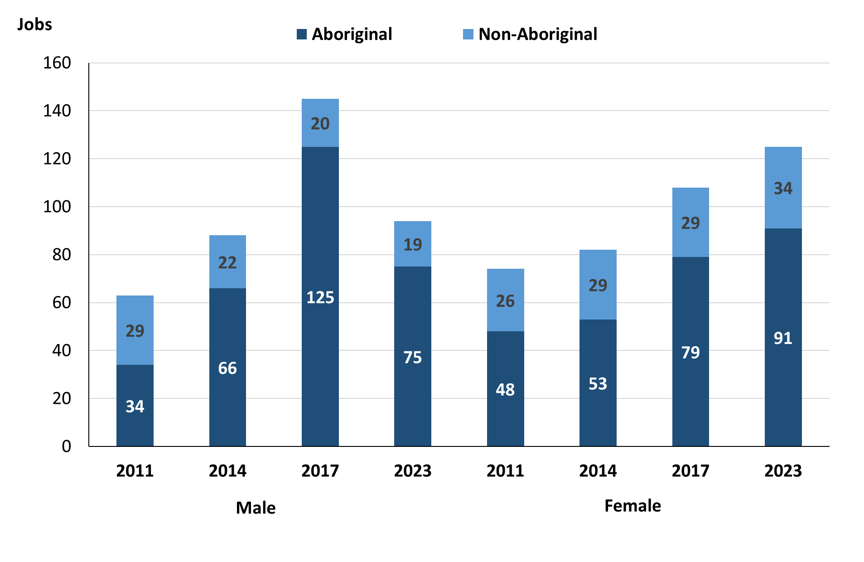

Source: Northern Territory Department of Industry, Tourism and Trade

In 2023 in Ramingining:

* there were 94 jobs **filled** by **males**, a decrease of 51 jobs from 2017 and an increase of 6 jobs from 2014
* of the 94 jobs **filled by males**:
* 75 were **Aboriginal**, a decrease of 50 jobs from 2017 and an increase of 9 jobs from 2014
* 19 were **non-Aboriginal**, a decrease of 1 job from 2017 and a decrease of 3 jobs from 2014
* there were 125 jobs **filled** **by** **females**, an increase of 17 jobs from 2017 and an increase of 43 jobs from 2014
* of the 125 jobs **filled** by **females**:
* 91 were **Aboriginal**, an increase of 12 jobs from 2017 and an increase of 38 jobs from 2014
* 34 were **non-Aboriginal**, an increase of 5 jobs from both 2017 and 2014.

Table 23: Count of filled jobs by gender, by full-time/part-time status, by job permanency and by sector 2011 (a)(b)(c)(d)(e)(i)

|  |  |  |  |  |  |  |  |  |  |  |
| --- | --- | --- | --- | --- | --- | --- | --- | --- | --- | --- |
| **2011** | | | | | | | | | | |
| **Indicator** | **Male** | | | **Female** | | | **Total** | | | |
| **Aboriginal** | **Non-Aboriginal** | **Total** | **Aboriginal** | **Non-Aboriginal** | **Total** | **Aboriginal** | **Non-Aboriginal** | **Total** |
| Full-time | 15 | 26 | **41** | 12 | 24 | **36** | 27 | 50 | **77** |
| Part-time | 19 | 3 | **22** | 36 | 2 | **38** | 55 | 5 | **60** |
| **Total** | **34** | **29** | **63** | **48** | **26** | **74** | **82** | **55** | **137** |
| Permanent | 29 | 10 | **39** | 27 | 9 | **36** | 56 | 19 | **75** |
| Temporary | 5 | 19 | **24** | 21 | 17 | **38** | 26 | 36 | **62** |
| **Total** | **34** | **29** | **63** | **48** | **26** | **74** | **82** | **55** | **137** |
| Public Sector | 19 | 24 | **43** | 24 | 23 | **47** | 43 | 47 | **90** |
| Private Sector | 15 | 5 | **20** | 24 | 3 | **27** | 39 | 8 | **47** |
| **Total** | **34** | **29** | **63** | **48** | **26** | **74** | **82** | **55** | **137** |

Source: Northern Territory Department of Industry, Tourism and Trade

Table 24: Count of filled jobs by gender, by full-time/part-time status, by job permanency and by sector 2014 (a)(b)(c)(d)(e)(i)

|  |  |  |  |  |  |  |  |  |  |
| --- | --- | --- | --- | --- | --- | --- | --- | --- | --- |
| **2014** | | | | | | | | | |
| **Indicator** | **Male** | | | **Female** | | | **Total** | | |
| **Aboriginal** | **Non-Aboriginal** | **Total** | **Aboriginal** | **Non-Aboriginal** | **Total** | **Aboriginal** | **Non-Aboriginal** | **Total** |
| Full-time | 20 | 21 | **41** | 10 | 29 | **39** | 30 | 50 | **80** |
| Part-time | 46 | 1 | **47** | 43 | 0 | **43** | 89 | 1 | **90** |
| **Total** | **66** | **22** | **88** | **53** | **29** | **82** | **119** | **51** | **170** |
| Permanent | 19 | 15 | **34** | 19 | 21 | **40** | 38 | 36 | **74** |
| Temporary | 47 | 7 | **54** | 34 | 8 | **42** | 81 | 15 | **96** |
| **Total** | **66** | **22** | **88** | **53** | **29** | **82** | **119** | **51** | **170** |
| Public Sector | 16 | 16 | **32** | 18 | 26 | **44** | 34 | 42 | **76** |
| Private Sector | 50 | 6 | **56** | 35 | 3 | **38** | 85 | 9 | **94** |
| **Total** | **66** | **22** | **88** | **53** | **29** | **82** | **119** | **51** | **170** |

Source: Northern Territory Department of Industry, Tourism and Trade

Table 25: Count of filled jobs by gender, by full-time/part-time status, by job permanency and by sector 2017 (a)(b)(c)(d)(e)(i)

|  |  |  |  |  |  |  |  |  |  |
| --- | --- | --- | --- | --- | --- | --- | --- | --- | --- |
| **2017** | | | | | | | | | |
| **Indicator** | **Male** | | | **Female** | | | **Total** | | |
| **Aboriginal** | **Non-Aboriginal** | **Total** | **Aboriginal** | **Non-Aboriginal** | **Total** | **Aboriginal** | **Non-Aboriginal** | **Total** |
| Full-time | 10 | 17 | **27** | 14 | 27 | **41** | 24 | 44 | **68** |
| Part-time | 115 | 3 | **118** | 65 | 2 | **67** | 180 | 5 | **185** |
| **Total** | **125** | **20** | **145** | **79** | **29** | **108** | **204** | **49** | **253** |
| Permanent | 34 | 9 | **43** | 34 | 11 | **45** | 68 | 20 | **88** |
| Temporary | 91 | 11 | **102** | 45 | 18 | **63** | 136 | 29 | **165** |
| **Total** | **125** | **20** | **145** | **79** | **29** | **108** | **204** | **49** | **253** |
| Public Sector | 18 | 14 | **32** | 26 | 26 | **52** | 44 | 40 | **84** |
| Private Sector | 107 | 6 | **113** | 53 | 3 | **56** | 160 | 9 | **169** |
| **Total** | **125** | **20** | **145** | **79** | **29** | **108** | **204** | **49** | **253** |

Source: Northern Territory Department of Industry, Tourism and Trade

Table 26: Count of filled jobs by gender, by full-time/part-time status, by job permanency and by sector 2023 (a)(b)(c)(d)(e)(i)

|  |  |  |  |  |  |  |  |  |  |
| --- | --- | --- | --- | --- | --- | --- | --- | --- | --- |
| **2023** | | | | | | | | | |
| **Indicator** | **Male** | | | **Female** | | | **Total** | | |
| **Aboriginal** | **Non-Aboriginal** | **Total** | **Aboriginal** | **Non-Aboriginal** | **Total** | **Aboriginal** | **Non-Aboriginal** | **Total** |
| Full-time | 28 | 19 | **47** | 26 | 34 | **60** | 57 | 53 | **110** |
| Part-time | 47 | 0 | **47** | 65 | 0 | **65** | 112 | 0 | **112** |
| **Total** | **75** | **19** | **94** | **91** | **34** | **125** | **169** | **53** | **222** |
| Permanent | 51 | 12 | **63** | 62 | 18 | **80** | 114 | 30 | **144** |
| Temporary | 24 | 7 | **31** | 29 | 16 | **45** | 55 | 23 | **78** |
| **Total** | **75** | **19** | **94** | **91** | **34** | **125** | **169** | **53** | **222** |
| Public Sector | 23 | 11 | **34** | 31 | 23 | **54** | 56 | 34 | **90** |
| Private Sector | 52 | 8 | **60** | 60 | 11 | **71** | 113 | 19 | **132** |
| **Total** | **75** | **19** | **94** | **91** | **34** | **125** | **169** | **53** | **222** |

Source: Northern Territory Department of Industry, Tourism and Trade

In 2023 in Ramingining:

* of the 94 **jobs** **filled** **by** **males**, there were:
* 75 jobs filled by **Aboriginal** **males,** a decrease of 50 jobs from 2017 and an increase of 9 jobs from 2014, including:
* 28 full-time jobs, an increase of 18 jobs from 2017 and an increase of 8 jobs from 2014
* 47 part-time jobs, a decrease of 68 jobs from 2017 and an increase of 1 job from 2014
* 51 permanent jobs, an increase of 17 jobs from 2017 and an increase of 32 jobs from 2014
* 24 temporary jobs, a decrease of 67 jobs from 2017 and a decrease of 23 jobs from 2014
* 23 Public Sector jobs, an increase of 5 jobs from 2017 and an increase of 7 jobs from 2014
* 52 Private Sector jobs, a decrease of 55 jobs from 2017 and an increase of 2 jobs from 2014
* 19 jobs filled by **non-Aboriginal** **males,** a decrease of 1 job from 2017 and a decrease of 3 jobs from 2014, including:
* 19 full-time jobs, an increase of 2 jobs from both 2017 and 2014
* no part-time jobs, a decrease of 3 jobs from 2017 and a decrease of 1 job from 2014
* 12 permanent jobs, an increase of 3 jobs from both 2017 and 2014
* 7 temporary jobs, a decrease of 4 jobs from 2017 and unchanged from 2014
* 11 Public Sector jobs, a decrease of 3 jobs from 2017 and a decrease of 5 jobs from 2014
* 8 Private Sector jobs, an increase of 2 jobs from both 2017 and 2014
* of the 125 **jobs** **filled** **by** **females**, there were:
* 91 jobs filled by **Aboriginal** **females**, an increase of 12 jobs from 2017 and an increase of 38 jobs from 2014, including:
* 26 full-time jobs, an increase of 12 jobs from 2017 and an increase of 16 jobs from 2014
* 65 part-time jobs, unchanged from 2017 and an increase of 22 jobs from 2014
* 62 permanent jobs, an increase of 28 jobs from 2017 and an increase of 43 jobs from 2014
* 29 temporary jobs, a decrease of 16 jobs from 2017 and a decrease of 5 jobs from 2014
* 31 Public Sector jobs, an increase of 5 jobs from 2017 and an increase of 13 jobs from 2014
* 60 Private Sector jobs, an increase of 7 jobs from 2017 and an increase of 25 jobs from 2014
* 34 jobs filled by **non-Aboriginal** **females,** an increase of 5 jobs from 2017 and an increase of 5 jobs from 2014, including:
* 34 full-time jobs, an increase of 7 jobs from 2017 and an increase of 5 jobs from 2014
* 0 part-time jobs, a decrease of 2 jobs from 2017 and unchanged from 2014
* 18 permanent jobs, an increase of 7 jobs from 2017 and a decrease of 3 jobs from 2014
* 16 temporary jobs, a decrease of 2 jobs from 2017 and an increase of 8 jobs from 2014
* 23 Public Sector jobs, a decrease of 3 jobs from both 2017 and 2014
* 11 Private Sector jobs, an increase of 8 jobs from both 2017 and 2014.

# Jobs by Age

Table 27a: Count of filled jobs by age, 2011, 2014, 2017 & 2023 (a)(c)(j)

|  |  |  |  |  |  |  |  |  |  |  |  |  |
| --- | --- | --- | --- | --- | --- | --- | --- | --- | --- | --- | --- | --- |
| **Indicator** | **2011** | | | **2014** | | | **2017** | | | **2023** | | |
| **Aboriginal** | **Non-Aboriginal** | **Total** | **Aboriginal** | **Non-Aboriginal** | **Total** | **Aboriginal** | **Non-Aboriginal** | **Total** | **Aboriginal** | **Non-Aboriginal** | **Total** |
| 15-24 years | 21 | 4 | **25** | 8 | 1 | **9** | 21 | 0 | **21** | 29 | 4 | **33** |
| 25-44 years | 44 | 28 | **72** | 62 | 29 | **91** | 125 | 24 | **149** | 87 | 23 | **110** |
| 45+ years | 17 | 23 | **40** | 49 | 21 | **70** | 58 | 25 | **83** | 52 | 26 | **78** |
| **Total** | **82** | **55** | **137** | **119** | **51** | **170** | **204** | **49** | **253** | **169** | **53** | **222** |

Source: Northern Territory Department of Industry, Tourism and Trade

Table 27b: Count of filled jobs by age, 2011-2014, 2014-2017 & 2017-2023 (a)(c)(j)

|  |  |  |  |  |  |  |  |  |  |
| --- | --- | --- | --- | --- | --- | --- | --- | --- | --- |
| **Indicator** | **Change 2011-2014** | | | **Change 2014-2017** | | | **Change 2017-2023** | | |
| **Aboriginal** | **Non-Aboriginal** | **Total** | **Aboriginal** | **Non-Aboriginal** | **Total** | **Aboriginal** | **Non-Aboriginal** | **Total** |
| 15-24 years | -13 | -3 | **-16** | 13 | -1 | **12** | 8 | 4 | **12** |
| 25-44 years | 18 | 1 | **19** | 63 | -5 | **58** | -38 | -1 | **-39** |
| 45+ years | 32 | -2 | **30** | 9 | 4 | **13** | -6 | 1 | **-5** |
| **Total** | **37** | **-4** | **33** | **85** | **-2** | **83** | **-35** | **4** | **-31** |

Source: Northern Territory Department of Industry, Tourism and Trade

Chart 12: Count of filled jobs by age, 2011, 2014, 2017 & 2023 (a)(c)(j)

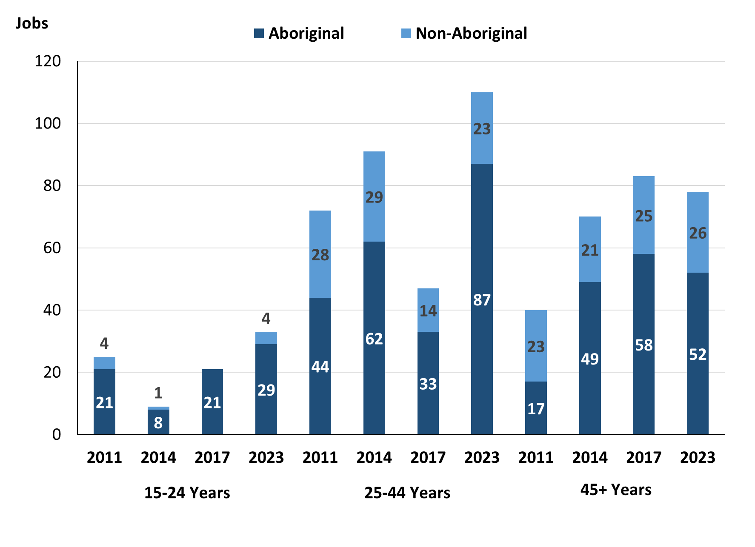

Source: Northern Territory Department of Industry, Tourism and Trade

In 2023 in Ramingining:

* there were 33 **jobs** **filled** by people aged **15-24 years**, an increase of 12 jobs from 2017 and an increase of 24 jobs from 2014. Of these:
* **Aboriginal** people filled 29 jobs, an increase of 8 jobs from 2017 and an increase of 21 jobs from 2014
* **non-Aboriginal** people filled 4 jobs, an increase of 4 jobs from 2017 and an increase of 3 jobs from 2014
* there were 110 **jobs** **filled** by people aged **25-44 years**, a decrease of 39 jobs from 2017 and an increase of 19 jobs from 2014. Of these:
* **Aboriginal** people filled 87 jobs, a decrease of 38 jobs from 2017 and an increase of 25 jobs from 2014
* **non-Aboriginal** people filled 23 jobs, a decrease of 1 job from 2017 and a decrease of 6 jobs from 2014
* there were 78 **jobs** **filled** by people aged **45+ years**, a decrease of 5 jobs from 2017 and an increase of 8 jobs from 2014. Of these:
* **Aboriginal** people filled 52 jobs, a decrease of 6 jobs from 2017 and an increase of 3 jobs from 2014
* **non-Aboriginal** people filled 26 jobs, an increase of 1 job from 2017 and an increase of 5 jobs from 2014.

Table 28: Count of filled jobs by age, by full-time/part-time status, by job permanency and by sector June-July 2011 (a)(b)(c)(d)(e)(i)

|  |  |  |  |  |  |  |  |  |  |  |  |  |  |
| --- | --- | --- | --- | --- | --- | --- | --- | --- | --- | --- | --- | --- | --- |
| **2011** | | | | | | | | | | | | | |
| **Indicator** | **15-24 years** | | | **25-44 years** | | | **45+ years** | | | **Total** | | | |
| **Aboriginal** | **Non-Aboriginal** | **Total** | **Aboriginal** | **Non-Aboriginal** | **Total** | **Aboriginal** | **Non-Aboriginal** | **Total** | **Aboriginal** | **Non-Aboriginal** | **Total** |
| Full-time | 4 | 4 | **8** | 14 | 26 | **40** | 9 | 20 | **29** | 27 | 50 | **77** |
| Part-time | 17 | 0 | **17** | 30 | 2 | **32** | 8 | 3 | **11** | 55 | 5 | **60** |
| **Total** | **21** | **4** | **25** | **44** | **28** | **72** | **17** | **23** | **40** | **82** | **55** | **137** |
| Permanent | 4 | 0 | **4** | 40 | 9 | **49** | 12 | 10 | **22** | 56 | 19 | **75** |
| Temporary | 17 | 4 | **21** | 4 | 19 | **23** | 5 | 13 | **18** | 26 | 36 | **62** |
| **Total** | **21** | **4** | **25** | **44** | **28** | **72** | **17** | **23** | **40** | **82** | **55** | **137** |
| Public Sector | 6 | 4 | **10** | 21 | 22 | **43** | 16 | 21 | **37** | 43 | 47 | **90** |
| Private Sector | 15 | 0 | **15** | 23 | 6 | **29** | 1 | 2 | **3** | 39 | 8 | **47** |
| **Total** | **21** | **4** | **25** | **44** | **28** | **72** | **17** | **23** | **40** | **82** | **55** | **137** |

Source: Northern Territory Department of Industry, Tourism and Trade

Table 29: Count of filled jobs by age, by full-time/part-time status, by job permanency and by sector June-July 2014 (a)(b)(c)(d)(e)(i)

|  |  |  |  |  |  |  |  |  |  |  |  |  |  |
| --- | --- | --- | --- | --- | --- | --- | --- | --- | --- | --- | --- | --- | --- |
| **2014** | | | | | | | | | | | | | |
| **Indicator** | **15-24 years** | | | **25-44 years** | | | **45+ years** | | | **Total** | | | |
| **Aboriginal** | **Non-Aboriginal** | **Total** | **Aboriginal** | **Non-Aboriginal** | **Total** | **Aboriginal** | **Non-Aboriginal** | **Total** | **Aboriginal** | **Non-Aboriginal** | **Total** |
| Full-time | 0 | 0 | **0** | 15 | 29 | **44** | 15 | 21 | **36** | 30 | 50 | **80** |
| Part-time | 8 | 1 | **9** | 47 | 0 | **47** | 34 | 0 | **34** | 89 | 1 | **90** |
| **Total** | **8** | **1** | **9** | **62** | **29** | **91** | **49** | **21** | **70** | **119** | **51** | **170** |
| Permanent | 0 | 0 | **0** | 20 | 21 | **41** | 18 | 15 | **33** | 38 | 36 | **74** |
| Temporary | 8 | 1 | **9** | 42 | 8 | **50** | 31 | 6 | **37** | 81 | 15 | **96** |
| **Total** | **8** | **1** | **9** | **62** | **29** | **91** | **49** | **21** | **70** | **119** | **51** | **170** |
| Public Sector | 2 | 1 | **3** | 21 | 22 | **43** | 11 | 19 | **30** | 34 | 42 | **76** |
| Private Sector | 6 | 0 | **6** | 41 | 7 | **48** | 38 | 2 | **40** | 85 | 9 | **94** |
| **Total** | **8** | **1** | **9** | **62** | **29** | **91** | **49** | **21** | **70** | **119** | **51** | **170** |

Source: Northern Territory Department of Industry, Tourism and Trade

Table 30: Count of filled jobs by age, by full-time/part-time status, by job permanency and by sector June-July 2017 (a)(b)(c)(d)(e)(i)

|  |  |  |  |  |  |  |  |  |  |  |  |  |
| --- | --- | --- | --- | --- | --- | --- | --- | --- | --- | --- | --- | --- |
| **2017** | | | | | | | | | | | | |
| **Indicator** | **15-24 years** | | | **25-44 years** | | | **45+ years** | | | **Total** | | |
| **Aboriginal** | **Non-Aboriginal** | **Total** | **Aboriginal** | **Non-Aboriginal** | **Total** | **Aboriginal** | **Non-Aboriginal** | **Total** | **Aboriginal** | **Non-Aboriginal** | **Total** |
| Full-time | 0 | 0 | **0** | 10 | 19 | **29** | 14 | 25 | **39** | 24 | 44 | **68** |
| Part-time | 21 | 0 | **21** | 115 | 5 | **120** | 44 | 0 | **44** | 180 | 5 | **185** |
| **Total** | **21** | **0** | **21** | **125** | **24** | **149** | **58** | **25** | **83** | **204** | **49** | **253** |
| Permanent | 6 | 0 | **6** | 30 | 8 | **38** | 32 | 12 | **44** | 68 | 20 | **88** |
| Temporary | 15 | 0 | **15** | 95 | 16 | **111** | 26 | 13 | **39** | 136 | 29 | **165** |
| **Total** | **21** | **0** | **21** | **125** | **24** | **149** | **58** | **25** | **83** | **204** | **49** | **253** |
| Public Sector | 1 | 0 | **1** | 21 | 20 | **41** | 22 | 20 | **42** | 44 | 40 | **84** |
| Private Sector | 20 | 0 | **20** | 104 | 4 | **108** | 36 | 5 | **41** | 160 | 9 | **169** |
| **Total** | **21** | **0** | **21** | **125** | **24** | **149** | **58** | **25** | **83** | **204** | **49** | **253** |

Source: Northern Territory Department of Industry, Tourism and Trade

Table 31: Count of filled jobs by age, by full-time/part-time status, by job permanency and by sector September 2023 (a)(b)(c)(d)(e)(i)

|  |  |  |  |  |  |  |  |  |  |  |  |  |
| --- | --- | --- | --- | --- | --- | --- | --- | --- | --- | --- | --- | --- |
| **2023** | | | | | | | | | | | | |
| **Indicator** | **15-24 years** | | | **25-44 years** | | | **45+ years** | | | **Total** | | |
| **Aboriginal** | **Non-Aboriginal** | **Total** | **Aboriginal** | **Non-Aboriginal** | **Total** | **Aboriginal** | **Non-Aboriginal** | **Total** | **Aboriginal** | **Non-Aboriginal** | **Total** |
| Full-time | 9 | 4 | **13** | 22 | 23 | **45** | 25 | 26 | **51** | 57 | 53 | **110** |
| Part-time | 20 | 0 | **20** | 65 | 0 | **65** | 27 | 0 | **27** | 112 | 0 | **112** |
| **Total** | **29** | **4** | **33** | **87** | **23** | **110** | **52** | **26** | **78** | **169** | **53** | **222** |
| Permanent | 22 | 1 | **23** | 58 | 12 | **70** | 33 | 17 | **50** | 114 | 30 | **144** |
| Temporary | 7 | 3 | **10** | 29 | 11 | **40** | 19 | 9 | **28** | 55 | 23 | **78** |
| **Total** | **29** | **4** | **33** | **87** | **23** | **110** | **52** | **26** | **78** | **169** | **53** | **222** |
| Public Sector | 9 | 3 | **12** | 27 | 14 | **41** | 20 | 17 | **37** | 56 | 34 | **90** |
| Private Sector | 20 | 1 | **21** | 60 | 9 | **69** | 32 | 9 | **41** | 113 | 19 | **132** |
| **Total** | **29** | **4** | **33** | **87** | **23** | **110** | **52** | **26** | **78** | **169** | **53** | **222** |

Source: Northern Territory Department of Industry, Tourism and Trade

In 2023 in Ramingining:

* of the 33 **jobs** **filled** by people aged **15-24 years**, there were:
* 29 jobs filled by **Aboriginal** people, of which
* 9 were full-time jobs, an increase of 9 jobs from both 2017 and 2014
* 20 were part-time jobs, a decrease of 1 job from 2017 and an increase of 12 jobs from 2014
* 22 were permanent jobs, an increase of 16 jobs from 2017 and an increase of 22 jobs from 2014
* 7 were temporary jobs, a decrease of 8 jobs from 2017 and a decrease of 1 job from 2014
* 9 were Public Sector jobs, an increase of 8 jobs from 2017 and an increase of 7 jobs from 2014
* 20 were Private Sector jobs, unchanged from 2017 and an increase of 14 jobs from 2014
* 4 jobs filled by **non-Aboriginal** people, of which:
* 4 were full-time jobs, an increase of 4 jobs from both 2017 and 2014
* none were part-time jobs, unchanged from 2017 and a decrease of 1 job from 2014
* 1 was a permanent job, an increase of 1 job from both 2017 and 2014
* 3 were temporary jobs, an increase of 3 jobs from 2017 and an increase of 2 jobs from 2014
* 3 were Public Sector jobs, an increase of 3 jobs from 2017 and an increase of 2 jobs from 2014
* 1 was a Private Sector job, an increase of 1 job from both 2017 and 2014
* of the 110 **jobs** **filled** by people aged **25-44 years**, there were:
* 87 jobs filled by **Aboriginal** people, of which:
* 22 were full-time jobs, an increase of 12 jobs from 2017 and an increase of 7 jobs from 2014
* 65 were part-time jobs, a decrease of 50 jobs from 2017 and an increase of 18 jobs from 2014
* 58 were permanent jobs, an increase of 28 jobs from 2017 and an increase of 38 jobs from 2014
* 29 were temporary jobs, a decrease of 66 jobs from 2017 and a decrease of 13 jobs from 2014
* 27 were Public Sector jobs, an increase of 6 jobs from both 2017 and 2014
* 60 were Private Sector jobs, a decrease of 44 jobs from 2017 and an increase of 19 jobs from 2014
* 23 jobs filled by **non-Aboriginal** people, of which:
* 23 were full-time jobs, an increase of 4 jobs from 2017 and a decrease of 6 jobs from 2014
* none were part-time jobs, a decrease of 5 jobs from 2017 and unchanged from 2014
* 12 were permanent jobs, an increase of 4 jobs from 2017 and a decrease of 9 jobs from 2014
* 11 were temporary jobs, a decrease of 5 jobs from 2017 and an increase of 3 jobs from 2014
* 14 were Public Sector jobs, a decrease of 6 jobs from 2017 and a decrease of 8 jobs from 2014
* 9 were Private Sector jobs, an increase of 5 jobs from 2017 and an increase of 2 jobs from 2014
* of the 78 **jobs** **filled** by people aged **45+ years**, there were:
* 52 jobs filled by **Aboriginal** people, of which:
* 25 were full-time jobs, an increase of 11 jobs from 2017 and an increase of 10 jobs from 2014
* 27 were part-time jobs, a decrease of 17 jobs from 2017 and a decrease of 7 jobs from 2014
* 33 were permanent jobs, an increase of 1 job from 2017 and an increase of 15 jobs from 2014
* 19 were temporary jobs, a decrease of 7 jobs from 2017 and a decrease of 12 jobs from 2014
* 20 were Public Sector jobs, a decrease of 2 jobs from 2017 and an increase of 9 jobs from 2014
* 32 were Private Sector jobs, a decrease of 4 jobs from 2017 and a decrease of 6 jobs from 2014
* 26 jobs filled by **non-Aboriginal** people, of which:
* 26 were full-time jobs, an increase of 1 job from 2017 and an increase of 5 jobs from 2014
* none were part-time jobs, unchanged from 2017 and unchanged from 2014
* 17 were permanent jobs, an increase of 5 jobs from 2017 and an increase of 2 jobs from 2014
* 9 were temporary jobs, a decrease of 4 jobs from 2017 and an increase of 3 jobs from 2014
* 17 were Public Sector jobs, a decrease of 3 jobs from 2017 and a decrease of 2 jobs from 2014
* 9 were Private Sector jobs, an increase of 4 jobs from 2017 and an increase of 7 jobs from 2014.

# Vocational Education and Training

Note: *The 2010 data is in accordance with the new, standardised reporting procedures that focus on all training activities conducted in the remote town, irrespective of funding source, as compared to earlier publications. As a result, the 2010 VET data values in this publication might not match those in earlier publications.*

*The impact of the Remote Jobs and Communities Program (RJCP), established in 2013, has played a significant role in the reduction of accredited training in many remote towns across the Territory.*

Table 32a: Northern Territory Vocational Education and Training (VET) students, 2010, 2013, 2016 and 2023 (k)

|  |  |  |  |  |  |  |  |  |  |  |  |  |
| --- | --- | --- | --- | --- | --- | --- | --- | --- | --- | --- | --- | --- |
| **VET Funding Group** | **2010** | | | **2013** | | | **2016** | | | **2023** | | |
| **No.** | **% of Total** | **No.** | | **% of Total** | **No.** | | **% of Total** | **No.** | | **% of Total** |
| Arts, Entertainment, Sports and Recreation | 24 | 12% | 24 | | 12% | 0 | | 0% | 0 | | 0% |
| Building and Construction | 11 | 6% | 27 | | 13% | 74 | | 51% | 68 | | 22% |
| Business and Clerical | 2 | 1% | 0 | | 0% | 0 | | 0% | 8 | | 3% |
| Community Services, Health and Education | 49 | 25% | 34 | | 17% | 27 | | 19% | 42 | | 14% |
| Engineering and Mining | 12 | 6% | 28 | | 14% | 0 | | 0% | 0 | | 0% |
| Finance, Banking and Insurance | 1 | 1% | 5 | | 2% | 3 | | 2% | 0 | | 0% |
| General Education and Training | 0 | 0% | 0 | | 0% | 0 | | 0% | 17 | | 6% |
| Primary Industry | 66 | 34% | 28 | | 14% | 0 | | 0% | 73 | | 24% |
| Sales and Personal Services | 20 | 10% | 24 | | 12% | 16 | | 11% | 66 | | 22% |
| Textiles, Clothing, Footwear and Furnishings | 0 | 0% | 3 | | 1% | 0 | | 0% | 12 | | 4% |
| Tourism and Hospitality | 9 | 5% | 0 | | 0% | 15 | | 10% | 0 | | 0% |
| Transport and Storage | 3 | 2% | 33 | | 16% | 10 | | 7% | 17 | | 6% |
| Other | 0 | 0% | 0 | | 0% | 0 | | 0% | 2 | | 1% |
| **Total** | **197** | **100%** | **206** | | **100%** | **145** | | **100%** | **256** | | **100%** |

Source: Northern Territory Department of Industry, Tourism and Trade

Table 32b: Northern Territory Vocational Education and Training (VET) students, 2010-2013, 2013-2016 and 2016-2023 (k)

|  |  |  |  |
| --- | --- | --- | --- |
| **VET Funding Group** | **Change** | | |
| **2010-2013** | **2013-2016** | **2016-2023** |
| Arts, Entertainment, Sports and Recreation | 0 | - 24 | 0 |
| Building and Construction | 16 | 47 | -6 |
| Business and Clerical | - 2 | 0 | 8 |
| Community Services, Health and Education | - 15 | - 7 | 15 |
| Engineering and Mining | 16 | - 28 | 0 |
| Finance, Banking and Insurance | 4 | - 2 | -3 |
| General Education and Training | 0 | 0 | 17 |
| Primary Industry | - 38 | - 28 | 73 |
| Sales and Personal Services | 4 | - 8 | 50 |
| Textiles, Clothing, Footwear and Furnishings | 3 | - 3 | 12 |
| Tourism and Hospitality | - 9 | 15 | -15 |
| Transport and Storage | 30 | - 23 | 7 |
| Other | 0 | 0 | 2 |
| **Total** | **9** | **- 61** | **111** |

Source: Northern Territory Department of Industry, Tourism and Trade

In 2023 in Ramingining:

* there were 256 **VET students**, an increase of 111 students from 2016 and an increase of 50 students from 2013,
* VET activity with the most students were Primary Industry with 73 students,
* Building and Construction had 68 students,
* and Sales and Personal Services had 66 students,
* Primary Industry reported the largest increase in students with 73 more students compared to 2016,
* Tourism and Hospitality reported the largest decrease in students with 15 less students over the same period.

Table 33a: Northern Territory Vocational Education and Training (VET) unit enrolments, 2010, 2013, 2016 and 2023 (l)

|  |  |  |  |  |  |  |  |  |
| --- | --- | --- | --- | --- | --- | --- | --- | --- |
| **VET Funding Group** | **2010** | | **2013** | | **2016** | | **2023** | |
| **No.** | **% of Total** | **No.** | **% of Total** | **No.** | **% of Total** | **No.** | **% of Total** |
| Arts, Entertainment, Sports and Recreation | 107 | 12% | 111 | 14% | 0 | 0% | 0 | 0% |
| Building and Construction | 11 | 1% | 73 | 9% | 322 | 45% | 179 | 16% |
| Business and Clerical | 11 | 1% | 0 | 0% | 0 | 0% | 39 | 3% |
| Community Services, Health and Education | 231 | 26% | 134 | 17% | 82 | 11% | 164 | 14% |
| Engineering and Mining | 77 | 9% | 184 | 23% | 0 | 0% | 0 | 0% |
| Finance, Banking and Insurance | 1 | 0% | 17 | 2% | 30 | 4% | 0 | 0% |
| General Education and Training | 0 | 0% | 0 | 0% | 0 | 0% | 17 | 1% |
| Primary Industry | 291 | 32% | 101 | 12% | 0 | 0% | 292 | 25% |
| Sales and Personal Service | 88 | 10% | 152 | 19% | 143 | 20% | 313 | 27% |
| Textiles, Clothing, Footwear and Furnishings | 0 | 0% | 6 | 1% | 0 | 0% | 12 | 1% |
| Tourism and Hospitality | 58 | 6% | 0 | 0% | 90 | 13% | 0 | 0% |
| Transport and Storage | 27 | 3% | 33 | 4% | 47 | 7% | 136 | 12% |
| Other | 0 | 0% | 0 | 0% | 0 | 0% | 2 | 0% |
| **Total** | **902** | **100%** | **811** | **100%** | **714** | **100%** | **1154** | **100%** |

Source: Northern Territory Department of Industry, Tourism and Trade

Table 33b: Northern Territory Vocational Education and Training (VET) unit enrolments, 2010-2013, 2013-2016 and 2016-2023 (l)

|  |  |  |  |
| --- | --- | --- | --- |
| **VET Funding Group** | **Change** | | |
| **2010-2013** | **2013-2016** | **2016-2023** |
| Arts, Entertainment, Sports and Recreation | 4 | - 111 | 0 |
| Building and Construction | 62 | 249 | -143 |
| Business and Clerical | - 11 | 0 | 39 |
| Community Services, Health and Education | - 97 | - 52 | 82 |
| Engineering and Mining | 107 | - 184 | 0 |
| Finance, Banking and Insurance | 16 | 13 | -30 |
| General Education and Training | 0 | 0 | 17 |
| Primary Industry | - 190 | - 101 | 292 |
| Sales and Personal Service | 64 | - 9 | 170 |
| Textiles, Clothing, Footwear and Furnishings | 6 | - 6 | 12 |
| Tourism and Hospitality | - 58 | 90 | -90 |
| Transport and Storage | 6 | 14 | 89 |
| Other | 0 | 0 | 2 |
| **Total** | **- 91** | **- 97** | **440** |

Source: Northern Territory Department of Industry, Tourism and Trade

In 2023 in Ramingining:

* there were 1,154 **VET unit enrolments**, an increase of 44-unit enrolments from 2016 and an increase of 343-unit enrolments from 2013,
* VET activity with the most unit enrolments were Sales and Personal Service with 313 enrolments,
* Primary Industry had 292-unit enrolments,
* Building and Construction had 179-unit enrolments,
* Primary Industry reported the largest increase in unit enrolments with 292 more-unit enrolments compared to 2016,
* Building and Construction reported the largest decrease in unit enrolments with 143 less unit enrolments over the same period.

Table 34a: Northern Territory Vocational Education and Training (VET) nominal hours, 2010, 2013, 2016 and 2023 (m)

|  |  |  |  |  |  |  |  |  |  |
| --- | --- | --- | --- | --- | --- | --- | --- | --- | --- |
| **VET Funding Group** | **2010** | | **2013** | | **2016** | | | **2023** | |
| **No.** | **% of Total** | **No.** | **% of Total** | **No.** | **% of Total** | **No.** | | **% of Total** |
| Arts, Entertainment, Sports and Recreation | 4,550 | 19% | 4,370 | 16% | 0 | 0% | 0 | | 0% |
| Building and Construction | 66 | 0% | 2,222 | 8% | 5,412 | 35% | 7,660 | | 17% |
| Business and Clerical | 445 | 2% | 0 | 0% | 0 | 0% | 1,455 | | 3% |
| Community Services, Health and Education | 5,547 | 23% | 4,639 | 17% | 1,875 | 12% | 6,286 | | 14% |
| Engineering and Mining | 1,390 | 6% | 7,740 | 28% | 0 | 0% | 0 | | 0% |
| Finance, Banking and Insurance | 30 | 0% | 445 | 2% | 675 | 4% | 0 | | 0% |
| General Education and Training | 0 | 0% | 0 | 0% | 0 | 0% | 1,300 | | 3% |
| Primary Industry | 7,390 | 30% | 2,810 | 10% | 0 | 0% | 11,370 | | 26% |
| Sales and Personal Service | 2,530 | 10% | 3,252 | 12% | 3,685 | 24% | 9,590 | | 22% |
| Textiles, Clothing, Footwear and Furnishings | 0 | 0% | 360 | 1% | 0 | 0% | 288 | | 1% |
| Tourism and Hospitality | 1,523 | 6% | 0 | 0% | 1,680 | 11% | 0 | | 0% |
| Transport and Storage | 795 | 3% | 1,320 | 5% | 2,220 | 14% | 6,360 | | 14% |
| Other | 0 | 0% | 0 | 0% | 0 | 0% | 60 | | 0% |
| **Total** | **24,266** | **100%** | **27,158** | **100%** | **15,547** | **100%** | **44,369** | | **100%** |

Source: Northern Territory Department of Industry, Tourism and Trade

Table 34b: Northern Territory Vocational Education and Training (VET) nominal hours, 2010-2013, 2013-2016 and 2016-2023 (m)

|  |  |  |  |
| --- | --- | --- | --- |
| **VET Funding Group** | **Change** | | |
| **2010-2013** | **2013-2016** | **2016-2023** |
| Arts, Entertainment, Sports and Recreation | - 180 | -4,370 | 0 |
| Building and Construction | 2,156 | 3,190 | 2,248 |
| Business and Clerical | - 445 | 0 | 1,455 |
| Community Services, Health and Education | - 908 | -2,764 | 4,411 |
| Engineering and Mining | 6,350 | -7,740 | 0 |
| Finance, Banking and Insurance | 415 | 230 | -675 |
| General Education and Training | 0 | 0 | 1,300 |
| Primary Industry | -4,580 | -2,810 | 11,370 |
| Sales and Personal Service | 722 | 433 | 5,905 |
| Textiles, Clothing, Footwear and Furnishings | 360 | - 360 | 288 |
| Tourism and Hospitality | -1,523 | 1,680 | -1,680 |
| Transport and Storage | 525 | 900 | 4,140 |
| Other | 0 | 0 | 60 |
| **Total** | **2,892** | **-11,611** | **28,822** |

Source: Northern Territory Department of Industry, Tourism and Trade

In 2023 in Ramingining:

* there were 44,369 **VET nominal hours** delivered, an increase of 28,822 nominal hours delivered from 2016 and an increase of 17,211 nominal hours delivered from 2013,
* VET activity with the most nominal hours delivered were Primary Industry with 11,370 hours,
* Sales and Personal Service had 9,590 nominal hours,
* Building and Construction had 7,660 nominal hours,
* Primary Industry reported the largest increase in nominal hours delivered with 11,370 more nominal hours compared to 2016,
* Tourism and Hospitality reported the largest decrease in nominal hours delivered with 1,680 less nominal hours over the same period.

Caveat: *Nominal hours are based on the hours funded through Northern Territory Government contracts and fee for service. Students and units include delivery that may have been funded in a previous year. Because of these factors, a direct match cannot be made between hours and student/units.*

Table 35a: Northern Territory Vocational Education and Training (VET) unit completions, 2010, 2013, 2016 and 2023 (n)

|  |  |  |  |  |  |  |  |  |  |  |  |
| --- | --- | --- | --- | --- | --- | --- | --- | --- | --- | --- | --- |
| **VET Funding Group** | **2010** | | | **2013** | | | **2016** | | | **2023** | |
| **No.** | **% of Total** | **No.** | | **% of Total** | **No.** | | **% of Total** | **No.** | | **% of Total** |
| Arts, Entertainment, Sports and Recreation | 0 | 0% | 24 | | 5% | 0 | | 0% | 0 | | 0% |
| Building and Construction | 10 | 2% | 33 | | 7% | 166 | | 37% | 80 | | 10% |
| Business and Clerical | 3 | 0% | 0 | | 0% | 0 | | 0% | 8 | | 1% |
| Community Services, Health and Education | 165 | 27% | 77 | | 15% | 41 | | 9% | 91 | | 11% |
| Engineering and Mining | 77 | 13% | 102 | | 20% | 0 | | 0% | 0 | | 0% |
| Finance, Banking and Insurance | 1 | 0% | 11 | | 2% | 21 | | 5% | 0 | | 0% |
| General Education and Training | 0 | 0% | 0 | | 0% | 0 | | 0% | 0 | | 0% |
| Primary Industry | 183 | 30% | 67 | | 13% | 0 | | 0% | 254 | | 32% |
| Sales and Personal Service | 80 | 13% | 150 | | 30% | 132 | | 29% | 260 | | 32% |
| Textiles, Clothing, Footwear and Furnishings | 0 | 0% | 6 | | 1% | 0 | | 0% | 7 | | 1% |
| Tourism and Hospitality | 58 | 10% | 0 | | 0% | 48 | | 11% | 0 | | 0% |
| Transport and Storage | 27 | 4% | 29 | | 6% | 44 | | 10% | 99 | | 12% |
| Other | 0 | 0% | 0 | | 0% | 0 | | 0% | 2 | | 0% |
| **Total** | **604** | **100%** | **499** | | **100%** | **452** | | **100%** | **801** | | **100%** |

Source: Northern Territory Department of Industry, Tourism and Trade

Table 35b: Northern Territory Vocational Education and Training (VET) unit completions, 2010-2013, 2013-2016 and 2016-2023 (n)

|  |  |  |  |
| --- | --- | --- | --- |
| **VET Funding Group** | **Change** | | |
| **2010-2013** | **2013-2016** | **2016-2023** |
| Arts, Entertainment, Sports and Recreation | 24 | - 24 | 0 |
| Building and Construction | 23 | 133 | -86 |
| Business and Clerical | - 3 | 0 | 8 |
| Community Services, Health and Education | - 88 | - 36 | 50 |
| Engineering and Mining | 25 | - 102 | 0 |
| Finance, Banking and Insurance | 10 | 10 | -21 |
| General Education and Training | 0 | 0 | 0 |
| Primary Industry | - 116 | - 67 | 254 |
| Sales and Personal Service | 70 | - 18 | 128 |
| Textiles, Clothing, Footwear and Furnishings | 6 | - 6 | 7 |
| Tourism and Hospitality | - 58 | 48 | -48 |
| Transport and Storage | 2 | 15 | 55 |
| Other | 0 | 0 | 2 |
| **Total** | **- 105** | **- 47** | **349** |

Source: Northern Territory Department of Industry, Tourism and Trade

In 2023 in Ramingining:

* there were 801 **VET unit completions**, an increase of 349-unit completions from 2016 and an increase of 302-unit completions from 2013
* VET activity with the most unit completions were Sales and Personal Service with 260 completions,
* Primary Industry had 254-unit completions,
* Transport and Storage had 99-unit completions,
* Primary Industry reported the largest increase in unit completions with 254 more-unit completions compared to 2016,
* Building and Construction reported the largest decrease in unit completions with 86 less unit completions over the same period.

# Population

**Table 36: Population distribution by gender and age (p)(r)**

|  |  |  |  |  |  |  |  |  |  |
| --- | --- | --- | --- | --- | --- | --- | --- | --- | --- |
| **Indicator** | **2011** | | | **2021** | | | **Change (2011-2021)** | | |
| **Male** | **Female** | **Total** | **Male** | **Female** | **Total** | **Male** | **Female** | **Total** |
| **0-4 years** | 54 | 34 | **88** | 26 | 20 | **46** | -28 | -14 | **-42** |
| **5-14 years** | 69 | 73 | **142** | 83 | 65 | **148** | 14 | -8 | **6** |
| **15-24 years** | 74 | 83 | **157** | 63 | 67 | **130** | -11 | -16 | **-27** |
| **25-44 years** | 120 | 168 | **288** | 145 | 139 | **284** | 25 | -29 | **-4** |
| **45-64 years** | 63 | 67 | **130** | 75 | 83 | **158** | 12 | 16 | **28** |
| **65+ years** | 14 | 12 | **26** | 19 | 17 | **36** | 5 | 5 | **10** |
| **Total** | **402** | **431** | **833** | **413** | **399** | **812** | **11** | **-32** | **-21** |

*Source: Australian Bureau of Statistics*

In 2021 in Ramingining:

* there were an estimated 812 people, of which:
* 413 (50.9%) were male
* 399 (49.1%) were female
* between 2011 and 2021, the overall population in Ramingining decreased by 21 people from 2011, or an average of -0.3% per year compared to -0.5% across the 28 remote towns and 1.0% Territory wide
* the male population increased by 11 people from 2011
* the female population decreased by 32 people from 2011
* in 2021, the working age population (15 years and over) in Ramingining was an estimated 608 people (74.9% of the total population) compared with 601 people (72.1% of the total population) in 2011. Of these:
* 130 (16.0%) were between 15 and 24 years of age
* 284 (35.0%) were between 25 and 44 years of age
* 158 (19.5%) were between 45 and 64 years of age
* 36 (4.4%) were over 65 years of age
* of the 608 people of working age:
* 302 (49.7%) were male
* 306 (50.3%) were female.

There were 0.4 jobs in Ramingining per working age person compared to 0.3 jobs per working age person across the 28 remote towns in the Northern Territory.

**Chart 13: Population comparison (p)(q)**

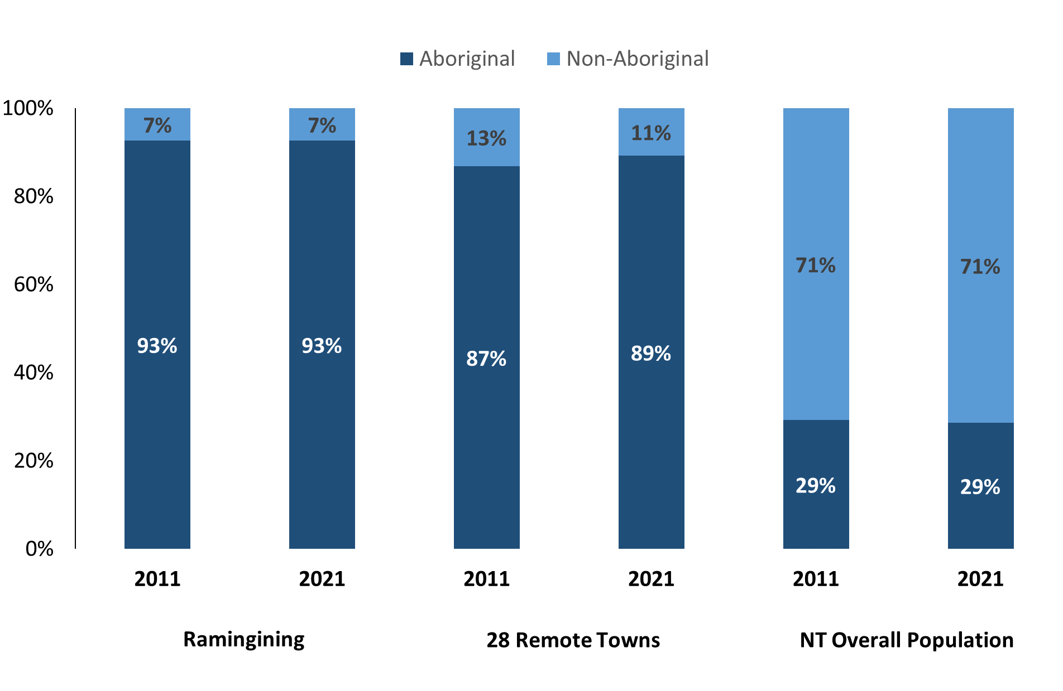

*Source: Australian Bureau of Statistics*

In 2021 in Ramingining:

* 93% of the population in Ramingining were **Aboriginal**, compared to 93% in 2011
* 89% of the population across all 28 remote towns were **Aboriginal**
* 29% of the NT population were **Aboriginal**.

**Table 37: Unemployment and Aboriginal participation rates (q)**

|  |  |  |  |  |  |  |
| --- | --- | --- | --- | --- | --- | --- |
|  | **Ramingining** | | | **Northern Territory** | | |
| **Aboriginal** | **Non-Aboriginal** | **Total** | **Aboriginal** | **Non-Aboriginal** | **Total** |
| **Unemployment rate** | 30.0% | 6.5% | 20.7% | 20.8% | 3.2% | 5.6% |
| **Participation rate** | 12.7% | 90.2% | 22.8% | 35.4% | 78.3% | 64.9% |

*Source: Australian Bureau of Statistics*

In 2021 in Ramingining the:

* **total unemployment rate** was 20.7% compared to 5.6% for the total Northern Territory
* **Aboriginal unemployment rate** was 30.0% compared to 20.8% for the total Northern Territory
* **non-Aboriginal unemployment rate** was 6.5% compared to 3.2% for the total Northern Territory
* **total participation rate** was 22.8% compared to 64.9% for the total Northern Territory
* **Aboriginal participation rate** was 12.7% compared to 35.4% for the total Northern Territory
* **non-Aboriginal participation rate** was 90.2% compared to 78.3% for the total Northern Territory.

# Community Development Program

**Table 38: Community Development Program Aboriginal Job Seekers, 31 December 2023 (o)**

|  |  |  |
| --- | --- | --- |
| **Indicator** | **Aboriginal** | |
| **No.** | **%** |
| **Total Aboriginal Job Seekers** | 425 | N/A |
| **Age (years)** | | |
| 15-24 | 100 | 23.5% |
| 25-44 | 218 | 51.3% |
| 45+ | 107 | 25.2% |
| **Total** | 425 | 100.0% |
| **Gender** | | |
| Male | 231 | 54.4% |
| Female | 194 | 45.6% |
| **Total** | 425 | 100.0% |
| **Employment Outcome – 1 January 2023 to 31 December 2023** | | |
| 13 Weeks | 40 | 62.5% |
| 26 Weeks | 24 | 37.5% |

*Source: Department of Prime Minister and Cabinet*

**Chart 14: Community Development Program Aboriginal Job Seekers by Gender and Age Group, 31 December 2023 (o)**

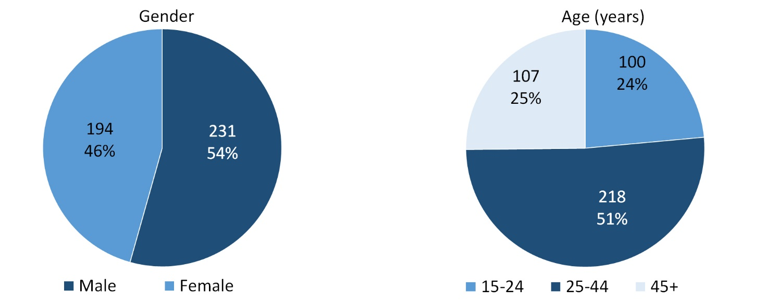

*Source: Department of Prime Minister and Cabinet*

As at 31 December 2023, in Ramingining, there were 425 CDP **Aboriginal** job seekers, of these:

* 231 (54.4%) were male and 194 (45.6%) were female
* 100 (23.5%) were aged 15-24 years, 218 (51.3%) were aged 25-44 years, and 107 (25.2%) were aged 45+ years
* between 1 January 2023 to 31 December 2023, 40 had reached the 13 week reporting milestone and 24 had reached the 26 week reporting milestone.

# Businesses

**Table 39: Businesses by sector (d)(s)**

|  |  |  |  |  |
| --- | --- | --- | --- | --- |
| **Business Name** | **Reported on in 2011** | **Reported on in 2014** | **Reported on in 2017** | **Reported on in 2023** |
| **PUBLIC SECTOR** | | | | | |
| **Department of Education** | Yes | Yes | Yes | **Yes** |
| Department of Health | Yes | Yes | Yes | No |
| Department of the Prime Minister and Cabinet | Yes | Yes | Yes | No |
| **East Arnhem Regional Council** | Yes | Yes | Yes | **Yes** |
| **Northern Territory Police, Fire Emergency Services** | Yes | Yes | Yes | **Yes** |
| **Territory Families** | No | No | No | **Yes** |
| **PRIVATE SECTOR** | | | | | |
| AA Electrical Pty Ltd | Yes | No | No | No |
| Abacus Plumbing and Electrical Pty Ltd | No | Yes | No | No |
| **Arafura Swamp Rangers Aboriginal Corporation** | No | No | Yes | **Yes** |
| **Bula'bula Arts Aboriginal Corporation (BAAC)** | Yes | Yes | Yes | **Yes** |
| **Dinybulu Regional Services** (& Workshop) **– ALPA** | No | No | Yes | **Yes** |
| **East Arnhem Real Estate** | No | No | No | **Yes** |
| Fly Tiwi | Yes | No | No | No |
| MAF International trading as Mission Aviation Fellowship | Yes | Yes | Yes | No |
| Menzies School of Health Research | Yes | No | No | No |
| **Miwatj Health Aboriginal Corporation** | No | No | Yes | **Yes** |
| Northern Land Council | Yes | Yes | Yes | No |
| **The Arnhem Land Progress Aboriginal Corporation (ALPA)** | Yes | Yes | Yes | **Yes** |
| **Traditional Credit Union (TCU)** | Yes | Yes | Yes | **Yes** |

*Source: Northern Territory Department of Industry, Tourism and Trade*

*Note: Business names captured across the four survey periods have been identified by the current 2023 Business ABN name listed as at 2023.*

In 2023 in Ramingining:

* there were 11 businesses reported on, of which:
* 4 businesses were from the Public Sector (36%)
* 7 businesses were from the Private Sector (64%)
* there were 2 businesses operating that were not operation in 2017.

# Notes

1. These counts represent numbers of filled jobs and not the number of people. As such the totals represent the total number of filled jobs, not the total number of employees. This count is not directly comparable to the total number of employed people as a person may have several jobs or one job may be shared by more than one person.
2. Full-time is defined as a job usually requiring 35 hours or more per week or that required 35 hours or more work during the reference week. Part-time is defined as a job usually requiring less than 35 hours per week or that required less than 35 hours work during the reference week. The reference week refers to the period that respondents were asked to provide information about. In most instances it would be the week prior to the week the questionnaire was completed. Questionnaires were predominantly conducted in June and July.
3. Care needs to be taken when analysing the counts of filled jobs by Aboriginal people. Aboriginality was reported by the business representative completing the questionnaire.
4. Sector was classified using the Standard Economic Sector of Classifications of Australia (SESCA), 2008.
5. Job permanency is classified according to what the business believes the level of job permanency is based on guidelines provided by data collectors. Those guidelines state a permanent job has paid annual and/or sick leave entitlements while a temporary job includes casual and fixed-term contract jobs.
6. Classified according to the Australian and New Zealand Standard Classification of Occupations (ANZSCO), 2006, major occupation level.
7. Other Occupations include jobs where occupation was not stated, not known or inadequately described.
8. Classified using the Australian and New Zealand Standard Industrial Classification (ANZSIC), 2006, division level.
9. Care needs to be taken when analysing the counts of filled jobs by the gender of people in the jobs. The gender of the person employed in a job is reported by the business representative completing the questionnaire.
10. Care needs to be taken when analysing the counts of filled jobs by the age of people in the jobs. The age of the person employed in a job is reported by the business representative completing the questionnaire.
11. Students represent the number of individual clients that enrolled in a Vocational Education and Training unit during the calendar year.
12. Unit enrolments represent the count of individual units that students enrolled in during the calendar year.
13. Nominal hours delivered is the sum of the nominal hours of the units commenced during the calendar year regardless of when the course enrolment commenced.
14. Unit completions are the count of all successfully completed units reported in the calendar year regardless of the year of commencement of the units.
15. The Community Development Program (CDP) supports job seekers in remote Australia to build skills, address barriers and contribute to their communities through a range of flexible activities. Under the CDP, job seekers with activity requirements are expected to do up to 25 hours per week of work-like activities that benefit their community. It should be noted that some CDP participants may be reported on within the profile if they are attached to a filled position with an employer captured in the survey. Due to confidentiality issues, data below 20 people is not published.
16. Population estimates for both 2011 and 2021 are taken from the estimated resident population (ERP) data produced by the Australian Bureau of Statistics (ABS) and based on Australian Statistical Geography Standard (ASGS) Statistical Area Level 1 (SA1) regions. ERP are official estimates of the Australian population, which link people to a place of usual residence with Australia. All ERP data sources, including the Census of Population and Housing (Census), are subject to error (including inaccuracies in collection, recording and processing data) and should be used with caution.
17. Indigenous population proportions, unemployment and workforce participation rates are based on ABS Census counts at ASGS Indigenous Locations (ILOCs) for each remote town.
18. Working-age population includes all residents aged 15 years and over (commonly referred to as the civilian population) and consists of people that are employed, unemployed or not in the labour force.
19. A ‘business’ has been defined as any organisation that has undertaken productive activities in the last year, including companies, non-profit organisations, government departments and enterprises operating within the designated remote geography (town), and has one or more employees in paid employment and an Australian Business Number (ABN).

# Abbreviations and Acronyms

ABN Australian Business Number

ABS Australian Bureau of Statistics

ANZSCO Australian and New Zealand Standard Classification of Occupations

ANZSIC Australian and New Zealand Standard Industrial Classification

ASGS Australian Statistical Geography Standard

CDP Community Development Program

ERP Estimated Resident Population

ILOC Indigenous Locations

nec Not Elsewhere Classified

No. Number

Perm Permanent

ppt Percentage point

RJCP Remote Jobs and Communities Program

Temp Temporary

SA1 Statistical Area Level 1

VET Vocational Education and Training

1. The number of filled jobs does not represent the number of people as a person may have several jobs or one job may be shared by more than one person.