Mineral Titles Act 2010
NOTICE OF LAND CEASING TO BE A MINERAL TITLE AREA
Title Type and Number: | Exploration Licence 33194
Area Ceased on: | 12 January 2025
Area: | 23 Blocks, 74.58 km²
Locality: | SHORT RANGE
Name of Applicant(s)/Holder(s): | 100% HEAVY RARE EARTHS LIMITED* [ACN. 648 991 039]
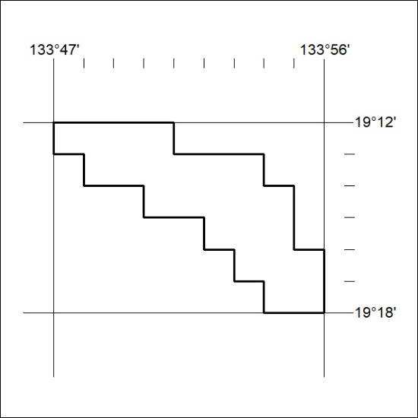
26/25

Mineral Titles Act 2010
NOTICE OF LAND CEASING TO BE A MINERAL TITLE AREA
Title Type and Number: | Exploration Licence 33201
Area Ceased on: | 12 January 2025
Area: | 123 Blocks, 389.13 km²
Locality: | AILERON
Name of Applicant(s)/Holder(s): | 100% URO CORPORATION PTY LTD [ACN. 653 927 998]
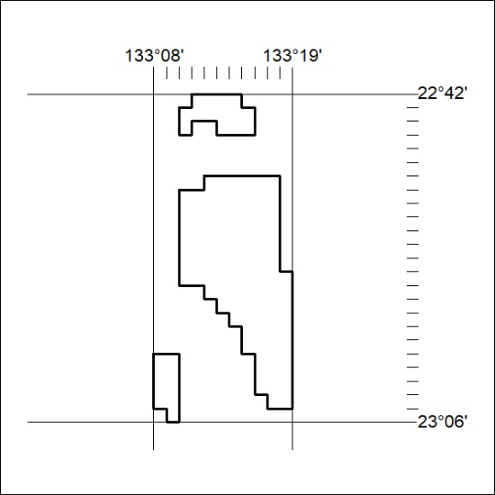
27/25

