Mineral Titles Act 2010
NOTICE OF LAND CEASING TO BE A MINERAL TITLE AREA
Title Type and Number: | Mineral Authority 23919
Area ceased on: | 23 October 2007
Locality: | NOONAMAH
Name of Applicants(s)Holder(s): | 100% COLEMAN Craig Bruce
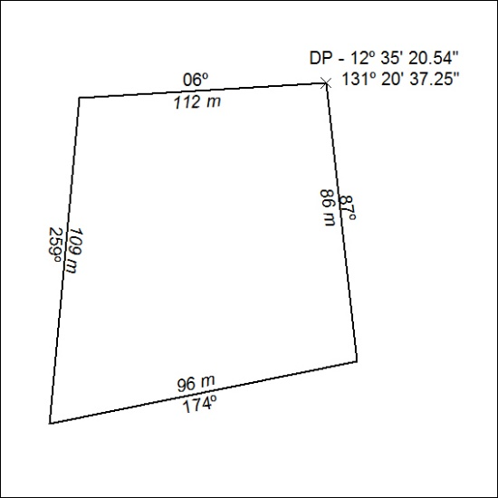

469/24

Mineral Titles Act 2010
NOTICE OF LAND CEASING TO BE A MINERAL TITLE AREA
Title Type and Number: | Exploration Licence 32758
Area Ceased on: | 18 December 2024
Area: | 36 Blocks, 109.38 km²
Locality: | LAUGHLEN
Name of Applicant(s)/Holder(s): | 100% GEMPART (NT) PTY LTD* [ACN. 081 859 896]
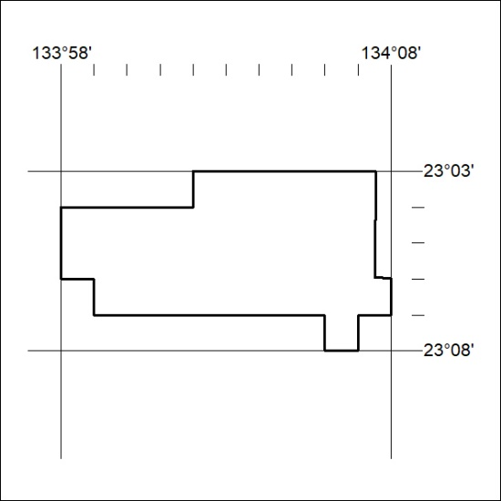

470/24

Mineral Titles Act
NOTICE OF GRANT OF A MINERAL TITLE
Title Type and Number: | Extractive Mineral Exploration Licence 33946
Granted: | 18 December 2024, for a period of 2 Years
Area: | 4 Blocks, 13.40 km²
Locality: | BYNOE
Name of Holder/s: | 50% JETTNER Luke Allan, 50% JETTNER William Nicholas Martin
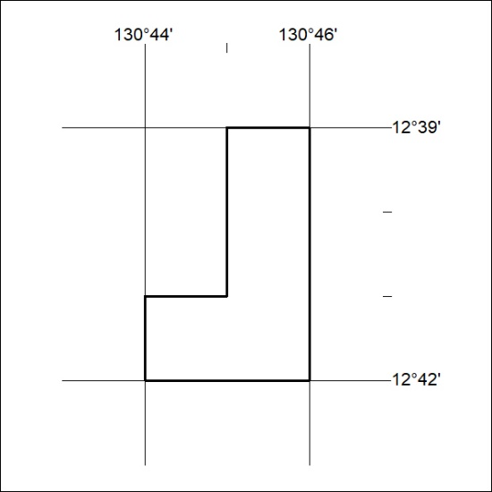
Area granted is indicated above. The titleholder is not permitted to exercise occupational rights on any land that is subject to a development title, or an application for a development title. Any land the subject of a Reserved Land gazettal under the Mineral Titles Act and all land vested in the Commonwealth of Australia is also excluded by description but not excised from the grant area.

471/24

