Mineral Titles Act 2010
NOTICE OF LAND CEASING TO BE A MINERAL TITLE AREA
Title Type and Number: | Exploration Licence 32477
Area Ceased on: | 26 September 2024
Area: | 138 Blocks, 448.00 km²
Locality: | GALLIPOLI
Name of Applicant(s)/Holder(s): | 100% BAUDIN RESOURCES PTY LTD [ACN. 618 455 593]
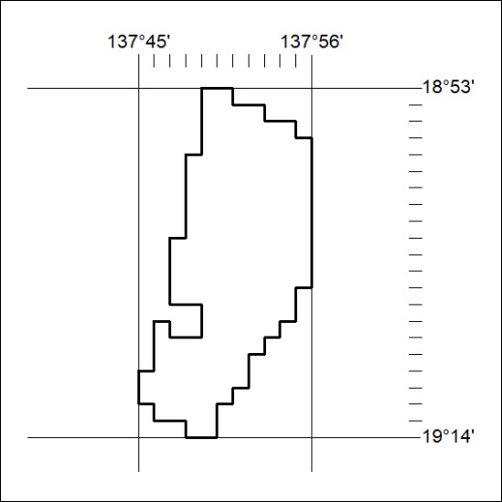

329/24

Mineral Titles Act 2010
NOTICE OF LAND CEASING TO BE A MINERAL TITLE AREA
Title Type and Number: | Exploration Licence 32813
Area Ceased on: | 26 September 2024
Area: | 4 Blocks, 12.98 km²
Locality: | GALLIPOLI
Name of Applicant(s)/Holder(s): | 100% BAUDIN RESOURCES PTY LTD [ACN. 618 455 593]
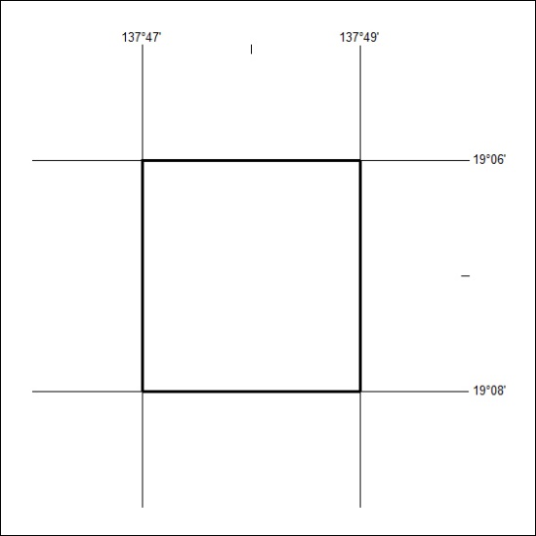

330/24

