Mineral Titles Act 2010
NOTICE OF LAND CEASING TO BE A MINERAL TITLE AREA
Title Type and Number: | Exploration Licence 32999
Area Ceased on: | 23 August 2024
Area: | 4 Blocks, 12.74 km²
Locality: | VAUGHAN
Name of Applicant(s)/Holder(s): | 100% URO CORPORATION PTY LTD [ACN. 653 927 998]
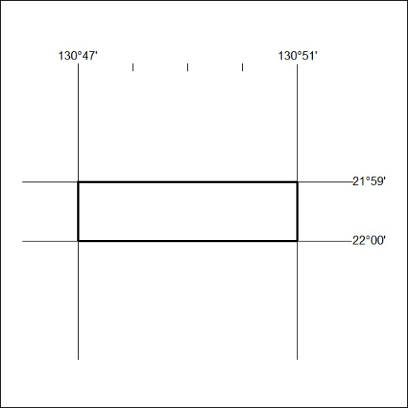

322/24

Mineral Titles Act 2010
NOTICE OF LAND CEASING TO BE A MINERAL TITLE AREA
Title Type and Number: | Exploration Licence 32918
Area Ceased on: | 30 August 2024
Area: | 18 Blocks, 57.00 km²
Locality: | JERVOIS RANGE
Name of Applicant(s)/Holder(s): | 100% WRIGHT Anthony
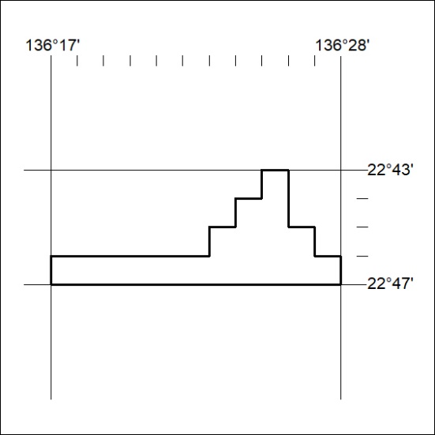

323/24

