Mineral Titles Act 2010
NOTICE OF LAND CEASING TO BE A MINERAL TITLE APPLICATION AREA
Title Type and Number: | Exploration Licence 33661
Area Ceased on: | 29 August 2024
Area: | 244 Blocks, 723.35 km²
Locality: | NEWRY
Name of Applicant(s)/Holder(s): | 100% BAUDIN RESOURCES PTY LTD [ACN. 618 455 593]
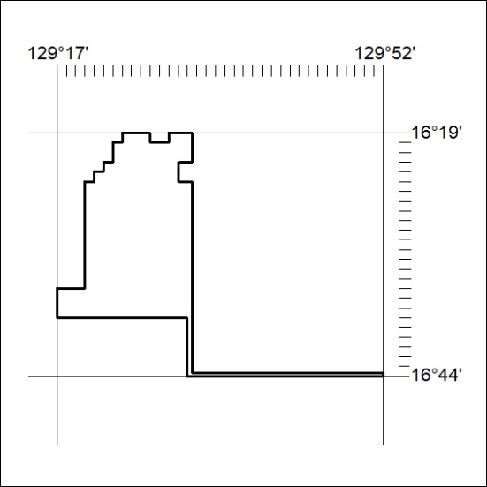
293/24

Mineral Titles Act 2010
NOTICE OF LAND CEASING TO BE A MINERAL TITLE AREA
Title Type and Number: | Exploration Licence 32963
Area Ceased on: | 29 August 2024
Area: | 39 Blocks, 130.07 km²
Locality: | DALY RIVER
Name of Applicant(s)/Holder(s): | 100% ALTAN NEVADA MINERALS (AUST) PTY LTD [ACN. 632 387 878]
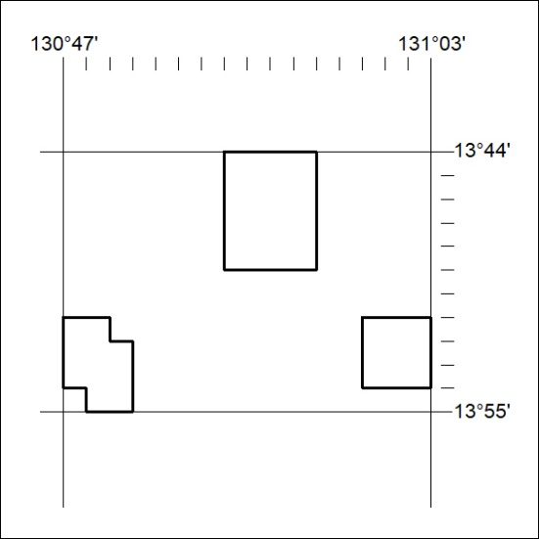
294/24

Mineral Titles Act 2010
NOTICE OF LAND CEASING TO BE A MINERAL TITLE AREA
Title Type and Number: | Extractive Mineral Exploration Licence 33153
Area Ceased on: | 28 August 2024
Area: | 3 Blocks, 3.63 km²
Locality: | NOONAMAH
Name of Applicant(s)/Holder(s): | 100% OSTOJIC GROUP PTY LTD* [ACN. 009 629 805]
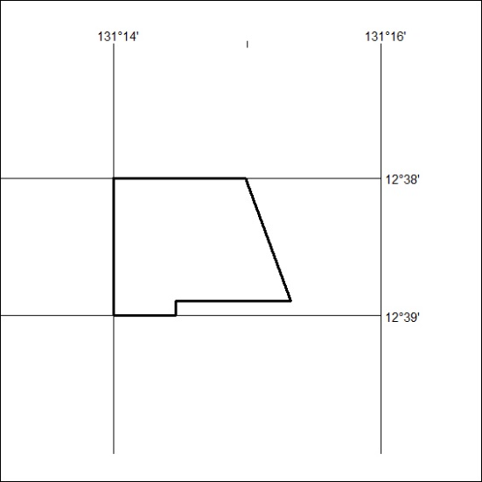
295/24

Mineral Titles Act 2010
NOTICE OF LAND CEASING TO BE A MINERAL TITLE AREA
Title Type and Number: | Extractive Mineral Exploration Licence 33154
Area Ceased on: | 28 August 2024
Area: | 4 Blocks, 7.63 km²
Locality: | NOONAMAH
Name of Applicant(s)/Holder(s): | 100% OSTOJIC GROUP PTY LTD* [ACN. 009 629 805]
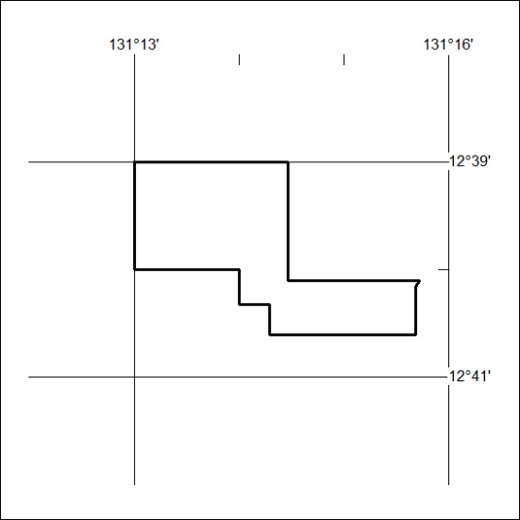
296/24

