Mineral Titles Act 2010
NOTICE OF LAND CEASING TO BE A MINERAL TITLE AREA
Title Type and Number: | Exploration Licence 33128
Area Ceased on: | 23 August 2024
Area: | 108 Blocks, 353.82 km²
Locality: | BLOODWOOD CREEK
Name of Applicant(s)/Holder(s): | 100% GREEN CRITICAL MINERALS LIMITED* [ACN. 118 788 846]
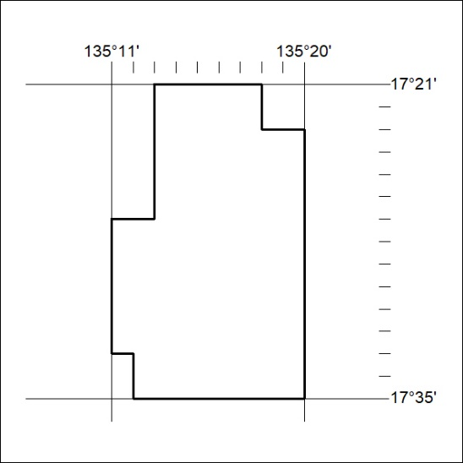

282/24

Mineral Titles Act 2010
NOTICE OF LAND CEASING TO BE A MINERAL TITLE AREA
Title Type and Number: | Exploration Licence 33129
Area Ceased on: | 23 August 2024
Area: | 112 Blocks, 366.49 km²
Locality: | MONGALA
Name of Applicant(s)/Holder(s): | 100% GREEN CRITICAL MINERALS LIMITED* [ACN. 118 788 846]
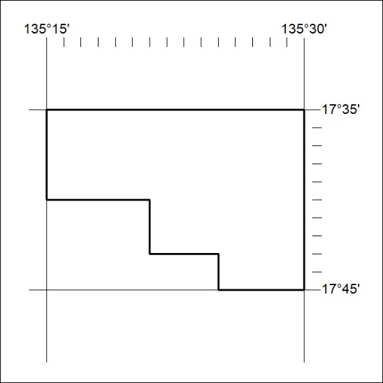

283/24
Mineral Titles Act 2010
NOTICE OF LAND CEASING TO BE A MINERAL TITLE AREA
Title Type and Number: | Exploration Licence 33130
Area Ceased on: | 23 August 2024
Area: | 104 Blocks, 340.93 km²
Locality: | BLOODWOOD CREEK
Name of Applicant(s)/Holder(s): | 100% GREEN CRITICAL MINERALS LIMITED* [ACN. 118 788 846]
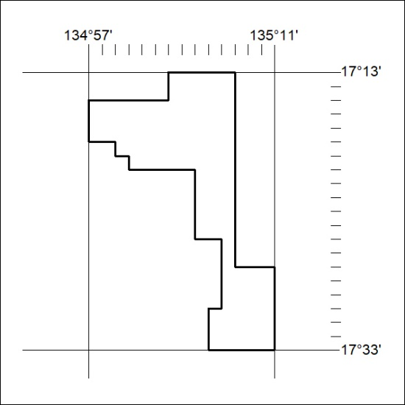

284/24

Mineral Titles Act
NOTICE OF GRANT OF A MINERAL TITLE
Title Type and Number: | Exploration Licence 33742
Granted: | 23 August 2024, for a period of 6 Years
Area: | 250 Blocks, 813.09 km²
Locality: | MITCHIEBO
Name of Holder/s: | 100% BAUDIN RESOURCES PTY LTD [ACN. 618 455 593]
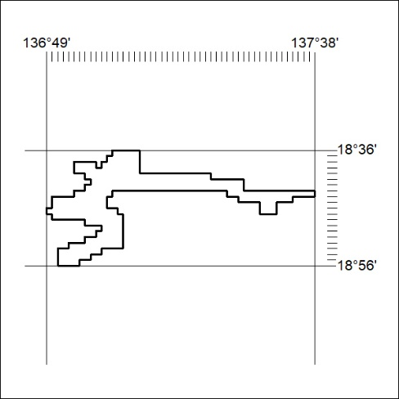
Area granted is indicated above. The titleholder is not permitted to exercise occupational rights on any land that is subject to a development title, or an application for a development title. Any land the subject of a Reserved Land gazettal under the Mineral Titles Act and all land vested in the Commonwealth of Australia is also excluded by description but not excised from the grant area.

285/24

