Mineral Titles Act 2010
NOTICE OF LAND CEASING TO BE A MINERAL TITLE AREA
Title Type and Number: | Exploration Licence 31799
Area Ceased on: | 31 July 2024
Area: | 53 Blocks, 170.56 km²
Locality: | BREADEN
Name of Applicant(s)/Holder(s): | 100% NORTHERN STAR (TANAMI) PTY LTD [ACN. 603 860 831]
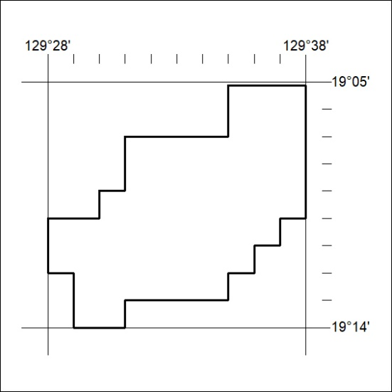
220/24

Mineral Titles Act 2010
NOTICE OF LAND CEASING TO BE A MINERAL TITLE AREA
Title Type and Number: | Exploration Licence 33389
Area Ceased on: | 01 August 2024
Area: | 15 Blocks, 47.37 km²
Locality: | RIDDOCH
Name of Applicant(s)/Holder(s): | 100% SANDFIRE RESOURCES LIMITED* [ACN. 105 154 185]
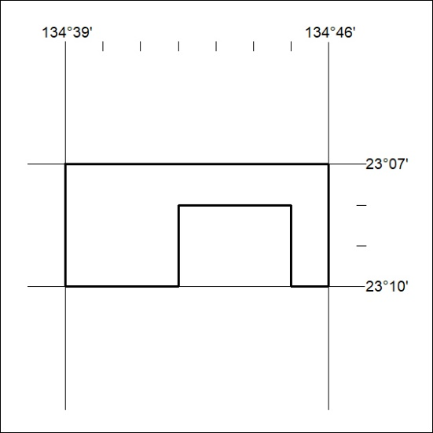
221/24

Mineral Titles Act 2010
NOTICE OF LAND CEASING TO BE A MINERAL TITLE AREA
Title Type and Number: | Mineral Lease (Central) 506
Area ceased on: | 31 July 2024
Area: | 6.00 Hectare
Locality: | FLYNN
Name of Applicants(s)Holder(s): | 60% CUFE TENNANT CREEK PTY LTD [ACN. 655 367 105], 40% GECKO MINING COMPANY PTY LTD* [ACN. 169 920 745]
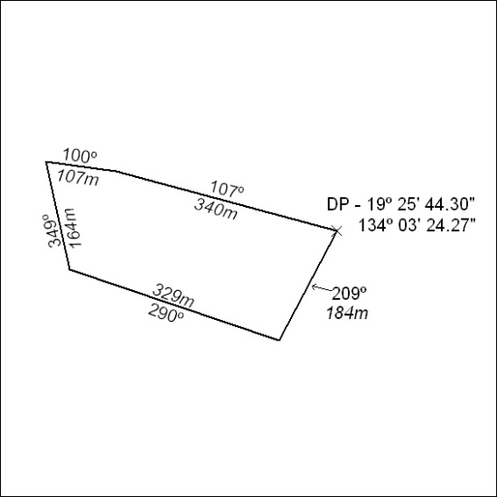
(Area now amalgamated into Mineral Lease 33872 under s102)
222/24

Mineral Titles Act 2010
NOTICE OF LAND CEASING TO BE A MINERAL TITLE AREA
Title Type and Number: | Mineral Lease (Central) 327
Area ceased on: | 31 July 2024
Area: | 8.00 Hectare
Locality: | FLYNN
Name of Applicants(s)Holder(s): | 60% CUFE TENNANT CREEK PTY LTD [ACN. 655 367 105], 40% GECKO MINING COMPANY PTY LTD* [ACN. 169 920 745]
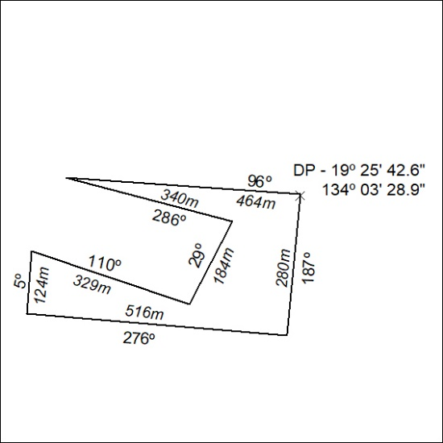
(Area now amalgamated into Mineral Lease 33872 under s102)
223/24

Mineral Titles Act 2010
NOTICE OF LAND CEASING TO BE A MINERAL TITLE AREA
Title Type and Number: | Mineral Lease (Central) 326
Area ceased on: | 31 July 2024
Area: | 14.00 Hectare
Locality: | FLYNN
Name of Applicants(s)Holder(s): | 60% CUFE TENNANT CREEK PTY LTD [ACN. 655 367 105], 40% GECKO MINING COMPANY PTY LTD* [ACN. 169 920 745]
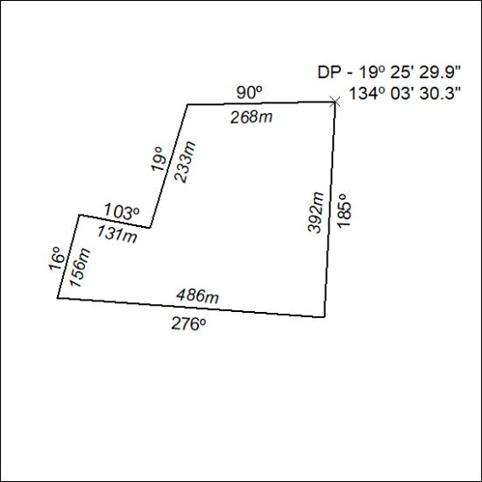
(Area now amalgamated into Mineral Lease 33872 under s102)
224/24

Mineral Titles Act 2010
NOTICE OF LAND CEASING TO BE A MINERAL TITLE AREA
Title Type and Number: | Mineral Lease (Central) 325
Area ceased on: | 31 July 2024
Area: | 13.00 Hectare
Locality: | FLYNN
Name of Applicants(s)Holder(s): | 60% CUFE TENNANT CREEK PTY LTD [ACN. 655 367 105], 40% GECKO MINING COMPANY PTY LTD* [ACN. 169 920 745]
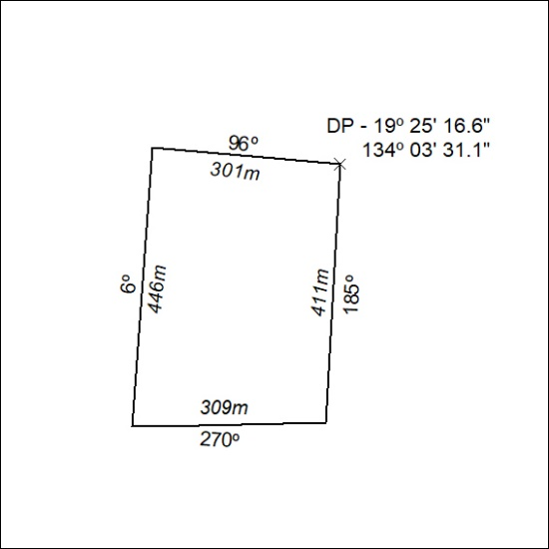
225/24

Mineral Titles Act 2010
NOTICE OF LAND CEASING TO BE A MINERAL TITLE AREA
Title Type and Number: | Mineral Lease (Central) 324
Area ceased on: | 31 July 2024
Area: | 15.00 Hectare
Locality: | FLYNN
Name of Applicants(s)Holder(s): | 60% CUFE TENNANT CREEK PTY LTD [ACN. 655 367 105], 40% GECKO MINING COMPANY PTY LTD* [ACN. 169 920 745]
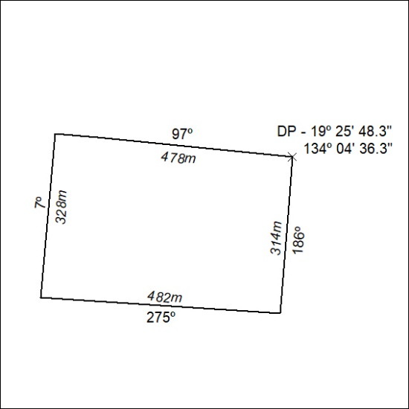
(Area now amalgamated into Mineral Lease 33872 under s102)
226/24

Mineral Titles Act 2010
NOTICE OF LAND CEASING TO BE A MINERAL TITLE AREA
Title Type and Number: | Mineral Lease (Central) 323
Area ceased on: | 31 July 2024
Area: | 15.00 Hectare
Locality: | FLYNN
Name of Applicants(s)Holder(s): | 60% CUFE TENNANT CREEK PTY LTD [ACN. 655 367 105], 40% GECKO MINING COMPANY PTY LTD* [ACN. 169 920 745]
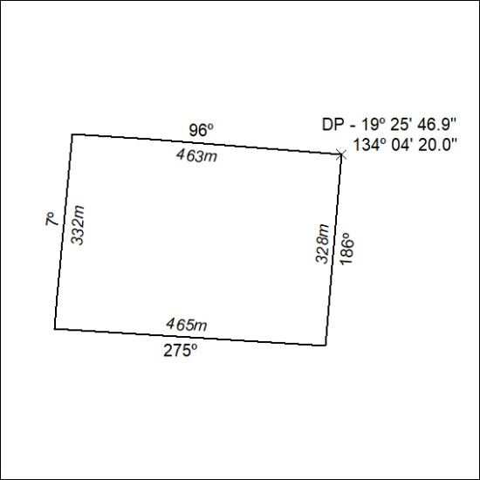
(Area now amalgamated into Mineral Lease 33872 under s102)
227/24

Mineral Titles Act 2010
NOTICE OF LAND CEASING TO BE A MINERAL TITLE AREA
Title Type and Number: | Mineral Lease (Central) 90
Area ceased on: | 31 July 2024
Area: | 16.00 Hectare
Locality: | FLYNN
Name of Applicants(s)Holder(s): | 60% CUFE TENNANT CREEK PTY LTD [ACN. 655 367 105], 40% GECKO MINING COMPANY PTY LTD* [ACN. 169 920 745]
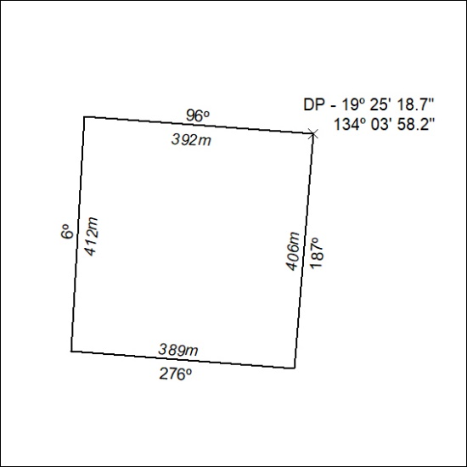
(Area now amalgamated into Mineral Lease 33872 under s102)
228/24

Mineral Titles Act 2010
NOTICE OF LAND CEASING TO BE A MINERAL TITLE AREA
Title Type and Number: | Mineral Lease (Central) 89
Area ceased on: | 31 July 2024
Area: | 16.00 Hectare
Locality: | FLYNN
Name of Applicants(s)Holder(s): | 60% CUFE TENNANT CREEK PTY LTD [ACN. 655 367 105], 40% GECKO MINING COMPANY PTY LTD* [ACN. 169 920 745]
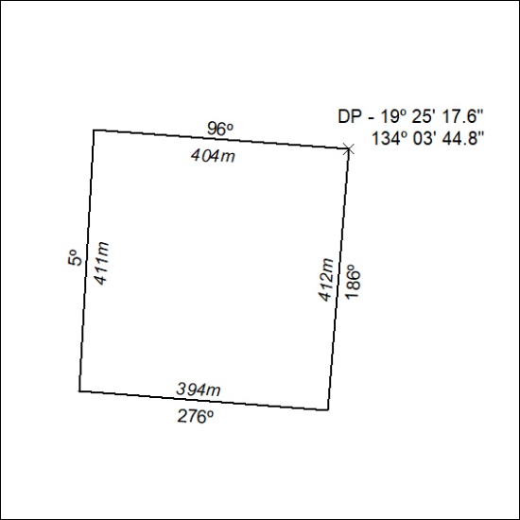
(Area now amalgamated into Mineral Lease 33872 under s102)
229/24

Mineral Titles Act 2010
NOTICE OF LAND CEASING TO BE A MINERAL TITLE AREA
Title Type and Number: | Mineral Lease (Central) 87
Area ceased on: | 31 July 2024
Area: | 14.00 Hectare
Locality: | FLYNN
Name of Applicants(s)Holder(s): | 60% CUFE TENNANT CREEK PTY LTD [ACN. 655 367 105], 40% GECKO MINING COMPANY PTY LTD* [ACN. 169 920 745]
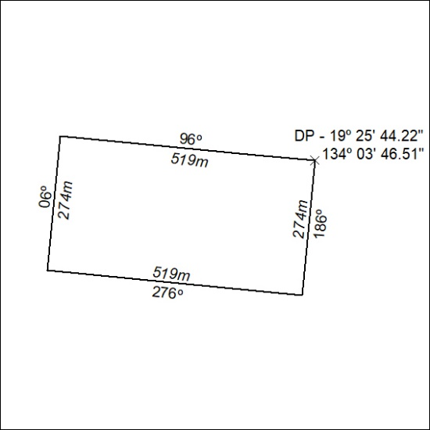
(Area now amalgamated into Mineral Lease 33872 under s102)
230/24

Mineral Titles Act 2010
NOTICE OF LAND CEASING TO BE A MINERAL TITLE AREA
Title Type and Number: | Mineral Lease (Central) 88
Area ceased on: | 31 July 2024
Area: | 15.00 Hectare
Locality: | FLYNN
Name of Applicants(s)Holder(s): | 60% CUFE TENNANT CREEK PTY LTD [ACN. 655 367 105], 40% GECKO MINING COMPANY PTY LTD* [ACN. 169 920 745]
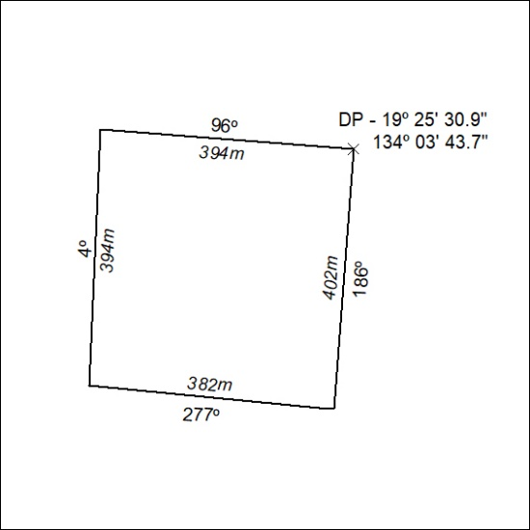
(Area now amalgamated into Mineral Lease 33872 under s102)
231/24

Mineral Titles Act 2010
NOTICE OF LAND CEASING TO BE A MINERAL TITLE AREA
Title Type and Number: | Mineral Lease (Central) 86
Area ceased on: | 31 July 2024
Area: | 16.00 Hectare
Locality: | FLYNN
Name of Applicants(s)Holder(s): | 60% CUFE TENNANT CREEK PTY LTD [ACN. 655 367 105], 40% GECKO MINING COMPANY PTY LTD* [ACN. 169 920 745]
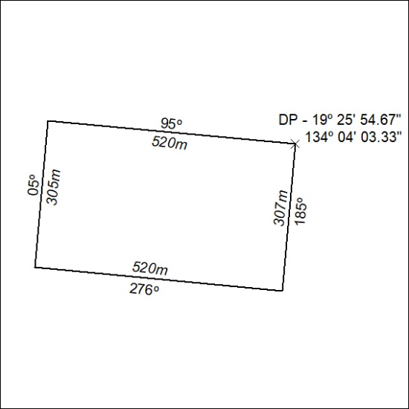
(Area now amalgamated into Mineral Lease 33872 under s102)
232/24

Mineral Titles Act 2010
NOTICE OF LAND CEASING TO BE A MINERAL TITLE AREA
Title Type and Number: | Mineral Lease (Central) 85
Area ceased on: | 31 July 2024
Area: | 16.00 Hectare
Locality: | FLYNN
Name of Applicants(s)Holder(s): | 60% CUFE TENNANT CREEK PTY LTD [ACN. 655 367 105], 40% GECKO MINING COMPANY PTY LTD* [ACN. 169 920 745]
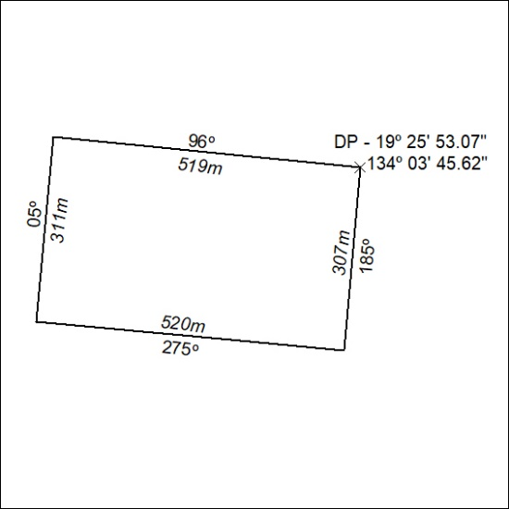
(Area now amalgamated into Mineral Lease 33872 under s102)
233/24

Mineral Titles Act 2010
NOTICE OF LAND CEASING TO BE A MINERAL TITLE AREA
Title Type and Number: | Mineral Lease (Central) 78
Area ceased on: | 31 July 2024
Area: | 16.00 Hectare
Locality: | FLYNN
Name of Applicants(s)Holder(s): | 60% CUFE TENNANT CREEK PTY LTD [ACN. 655 367 105], 40% GECKO MINING COMPANY PTY LTD* [ACN. 169 920 745]
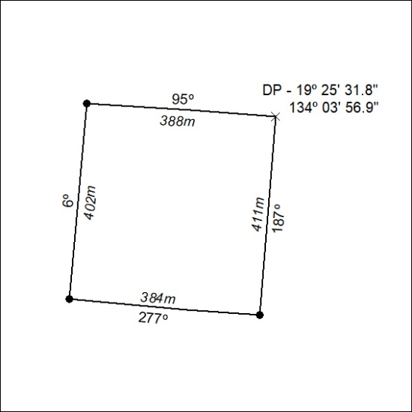
(Area now amalgamated into Mineral Lease 33872 under s102)
234/24

Mineral Titles Act 2010
NOTICE OF LAND CEASING TO BE A MINERAL TITLE AREA
Title Type and Number: | Mineral Lease (Central) 70
Area ceased on: | 31 July 2024
Area: | 17.00 Hectare
Locality: | FLYNN
Name of Applicants(s)Holder(s): | 60% CUFE TENNANT CREEK PTY LTD [ACN. 655 367 105], 40% GECKO MINING COMPANY PTY LTD* [ACN. 169 920 745]
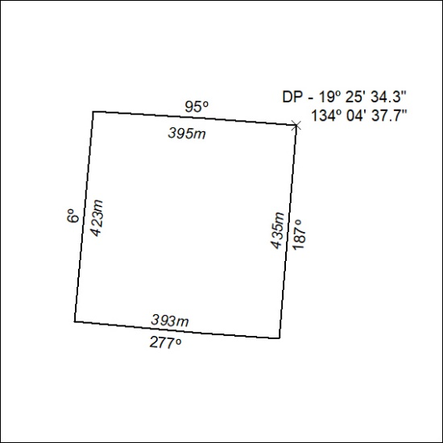
(Area now amalgamated into Mineral Lease 33872 under s102)
235/24

Mineral Titles Act 2010
NOTICE OF LAND CEASING TO BE A MINERAL TITLE AREA
Title Type and Number: | Mineral Lease (Central) 69
Area ceased on: | 31 July 2024
Area: | 17.00 Hectare
Locality: | FLYNN
Name of Applicants(s)Holder(s): | 60% CUFE TENNANT CREEK PTY LTD [ACN. 655 367 105], 40% GECKO MINING COMPANY PTY LTD* [ACN. 169 920 745]
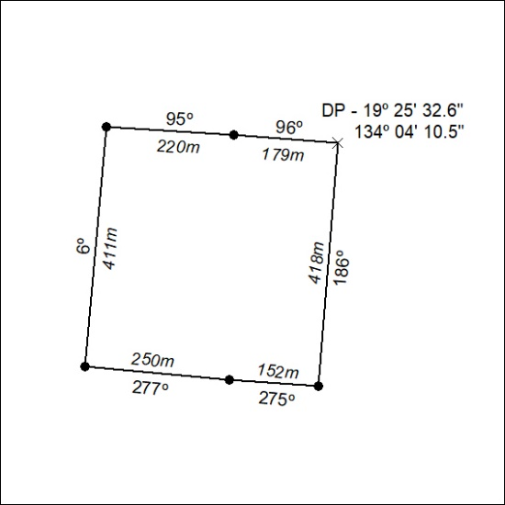
(Area now amalgamated into Mineral Lease 33872 under s102)
236/24

Mineral Titles Act 2010
NOTICE OF LAND CEASING TO BE A MINERAL TITLE AREA
Title Type and Number: | Mineral Lease (Central) 21
Area ceased on: | 31 July 2024
Area: | 17.00 Hectare
Locality: | FLYNN
Name of Applicants(s)Holder(s): | 60% CUFE TENNANT CREEK PTY LTD [ACN. 655 367 105], 40% GECKO MINING COMPANY PTY LTD* [ACN. 169 920 745]
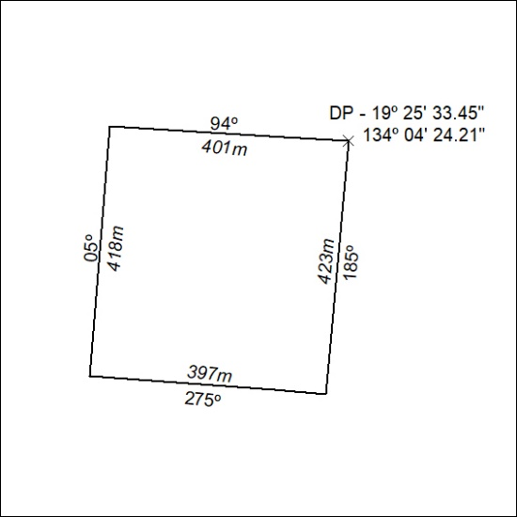
(Area now amalgamated into Mineral Lease 33872 under s102)
237/24

