Mineral Titles Act 2010
NOTICE OF LAND CEASING TO BE A MINERAL TITLE APPLICATION AREA
Title Type and Number: | Exploration Licence 33466
Area Ceased on: | 26 June 2024
Area: | 116 Blocks, 382.77 km²
Locality: | TANUMBIRINI
Name of Applicant(s)/Holder(s): | 100% GEMPART (NT) PTY LTD* [ACN. 081 859 896]
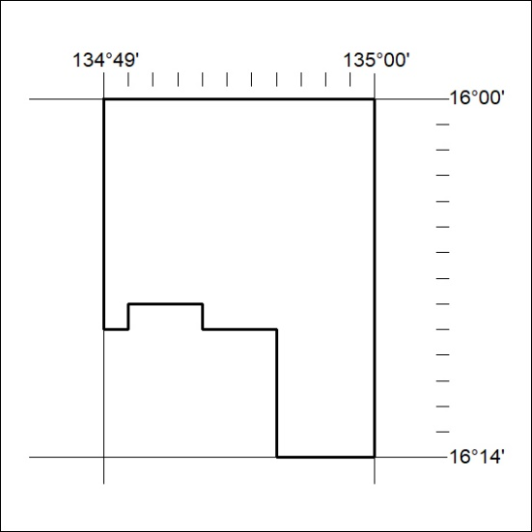
262/24

