Mineral Titles Act 2010
NOTICE OF LAND CEASING TO BE A MINERAL TITLE APPLICATION AREA
Title Type and Number: | Exploration Licence 33663
Area Ceased on: | 13 May 2024
Area: | 55 Blocks, 180.96 km²
Locality: | GLYDE
Name of Applicant(s)/Holder(s): | 100% TECK AUSTRALIA PTY LTD [ACN. 091 271 911]
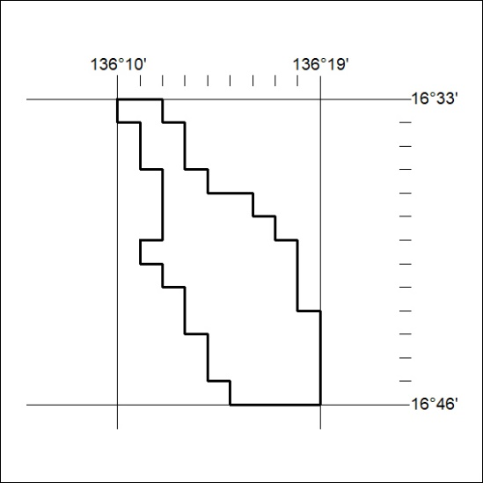
193/24

Mineral Titles Act 2010
NOTICE OF LAND CEASING TO BE A MINERAL TITLE APPLICATION AREA
Title Type and Number: | Exploration Licence 33401
Area Ceased on: | 13 May 2024
Area: | 216 Blocks, 696.60 km²
Locality: | SHAKESPEARE
Name of Applicant(s)/Holder(s): | 100% TECK AUSTRALIA PTY LTD [ACN. 091 271 911]
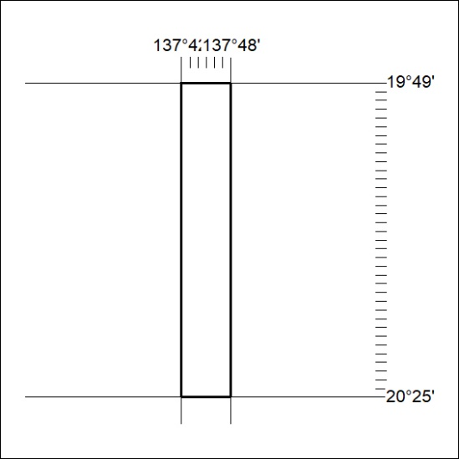
194/24

Mineral Titles Act 2010
NOTICE OF LAND CEASING TO BE A MINERAL TITLE APPLICATION AREA
Title Type and Number: | Exploration Licence 33400
Area Ceased on: | 13 May 2024
Area: | 216 Blocks, 696.60 km²
Locality: | SHAKESPEARE
Name of Applicant(s)/Holder(s): | 100% TECK AUSTRALIA PTY LTD [ACN. 091 271 911]
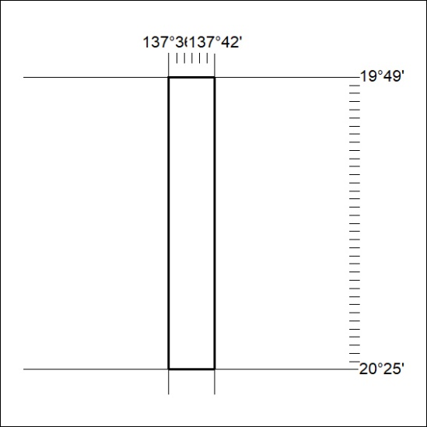
195/24

Mineral Titles Act 2010
NOTICE OF LAND CEASING TO BE A MINERAL TITLE AREA
Title Type and Number: | Exploration Licence 32226
Area Ceased on: | 10 May 2024
Area: | 248 Blocks, 813.56 km²
Locality: | BEETALOO
Name of Applicant(s)/Holder(s): | 100% BAUDIN RESOURCES PTY LTD [ACN. 618 455 593]
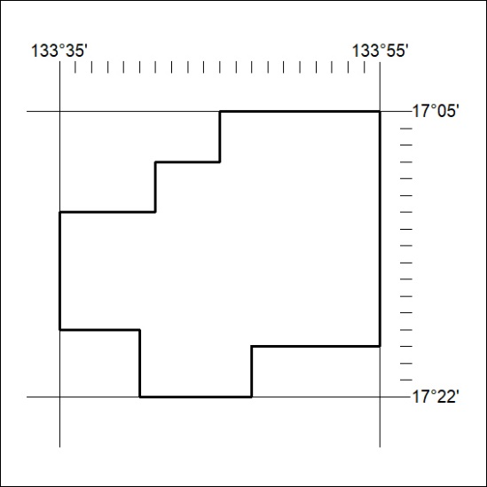
196/24

Mineral Titles Act 2010
NOTICE OF LAND CEASING TO BE A MINERAL TITLE AREA
Title Type and Number: | Exploration Licence 32437
Area Ceased on: | 10 May 2024
Area: | 184 Blocks, 601.11 km²
Locality: | UCHARONIDGE
Name of Applicant(s)/Holder(s): | 100% BAUDIN RESOURCES PTY LTD [ACN. 618 455 593]
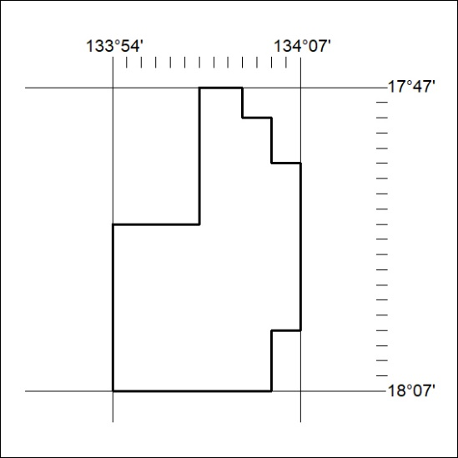
197/24

