  - Chemical control – buffel grass Central Australia

Background
Buffel grass is an introduced grass species that is resistant to drought and used primarily as a pasture species throughout Australia. As a grass species that thrives in sandy soils, buffel grass has become naturalised in areas around Central Australia and is becoming an increasing concern for personnel involved in fire management and protecting biodiversity.
Chemical control is a viable control method to assist in managing buffel grass, however users must be aware of the legislative requirements of using chemicals in accordance with the Agricultural and Veterinary Chemicals (Control of Use) Act 2004 (the Act).

Specified requirements

Non-commercial users
For non-commercial and residential users, over-the-counter chemicals containing glyphosate can be used.
In these circumstances users must:
- ensure glyphosate is kept in approved containers with attached labels
- adhere to all label instructions
- dispose of containers as per label instructions
- maintain records of glyphosate use when specified by a label or permit for a minimum of 2 years
- not spray any glyphosate products in public places without authorisation.

Commercial users
For commercial sprayers and primary production users a number of chemical products are available for use. This includes schedule 6 poisons such as flupropanate, haloxyfop and glyphosate and schedule 7 dangerous poisons such as methomyl, diquat and paraquat.
All schedule 7 dangerous poisons users must have an authorisation issued by Chemical Services prior to possession and use. Prior to issuing an authorisation users must have completed relevant training and maintain adequate storage facilities.
Chemical storage facilities must meet minimum safety requirements including:
- secure facility with access controls
- nearby wash facility or equipment
- access log and safety data sheets for all chemicals stored inside
- separate areas for wet and dry chemicals
- clear and appropriate signage.
For commercial sprayers, there are mandatory licensing requirements for both the business and individual applicators prior to the commencement of commercial spraying activities.
Section 95 of the Act allows the Chemical Coordinator or a chemical advisor to attend and inspect premises to investigate any potential offences. This includes the inspection of machines and equipment used with agricultural and veterinary chemicals, fertilisers and stock food.
Pursuant to Section 95(j) of the Act, where machinery and equipment does not meet specified requirements or poses a risk of harm to the health of the user, the public or the environment due to its condition, damage or serviceability; the chemical coordinator or chemical advisor can direct the person in charge to cease operating the equipment or machine until repairs are completed or the machine or equipment meets a specified requirement.
The user is responsible for ensuring that equipment is serviceable and in good working order to prevent the off target spray damage and spray drift.

Offences
The inappropriate use of chemicals and fertilisers constitutes an offence under Section 13 of the Act.
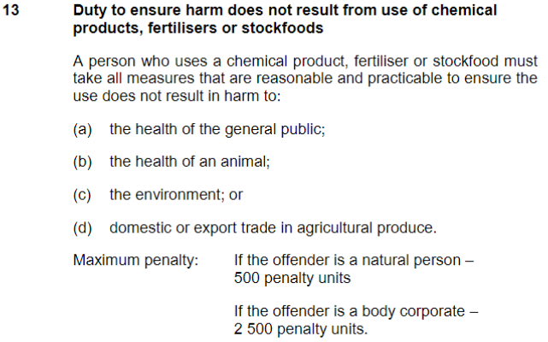

Specific laws are in place for Central Australia
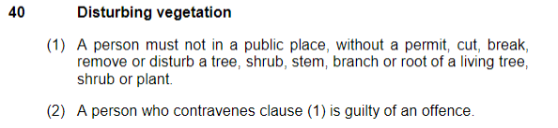
Unlawful spraying in Alice Springs Town Council public places that interferes with or damages vegetation constitutes an offence under the Alice Springs (Management of Public Places) By-Laws 2009:

Similarly unlawful spraying in Tennant Creek Town Council public places that interferes with or damages vegetation constitutes an offence under the Tennant Creek (Control of Public Places) By-Laws 1989:

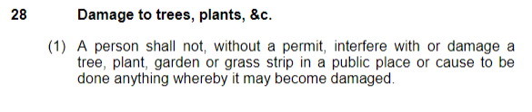

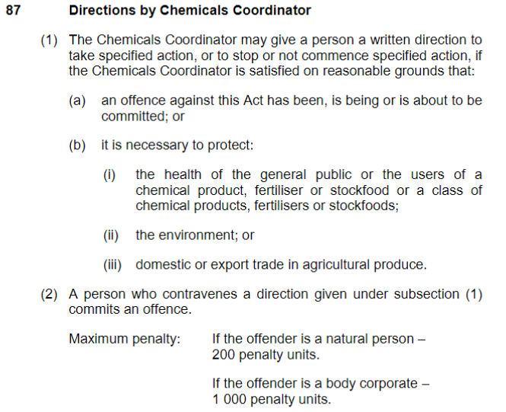
Furthermore a person who contravenes a direction by the Chemical Coordinator commits a further offence under Section 87 of the Act.

More information
Further information about buffel grass can be found on the Department of Environment, Parks and Water Security website located at: Buffel grass | NT.GOV.AU
Further information on the safety and handling of chemicals and fertilisers can be found on their respective labels, safety data sheets and on the APVMA website.

https://nt.gov.au/environment/weeds/weeds-in-the-nt/A-Z-list-of-weeds-in-the-NT/buffel-grass
https://portal.apvma.gov.au/pubcris

