Mineral Titles Act 2010
NOTICE OF LAND CEASING TO BE A MINERAL TITLE AREA
Title Type and Number: | Exploration Licence 32156
Area Ceased on: | 04 February 2024
Area: | 93 Blocks, 304.09 km²
Locality: | ELLIOTT
Name of Applicant(s)/Holder(s): | 100% BAUDIN RESOURCES PTY LTD [ACN. 618 455 593]
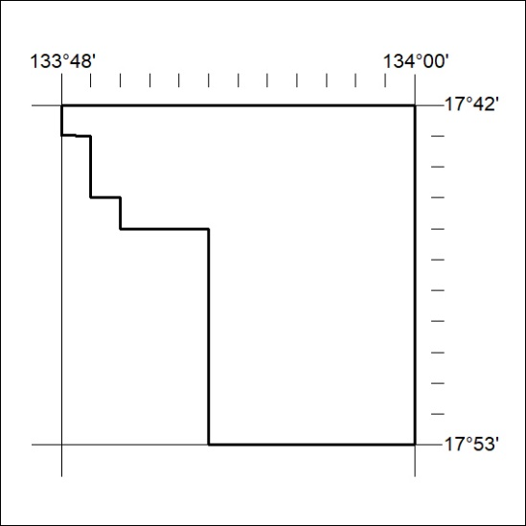

31/24

Mineral Titles Act 2010
NOTICE OF LAND CEASING TO BE A MINERAL TITLE AREA
Title Type and Number: | Exploration Licence 32157
Area Ceased on: | 04 February 2024
Area: | 110 Blocks, 360.10 km²
Locality: | ELLIOTT
Name of Applicant(s)/Holder(s): | 100% BAUDIN RESOURCES PTY LTD [ACN. 618 455 593]
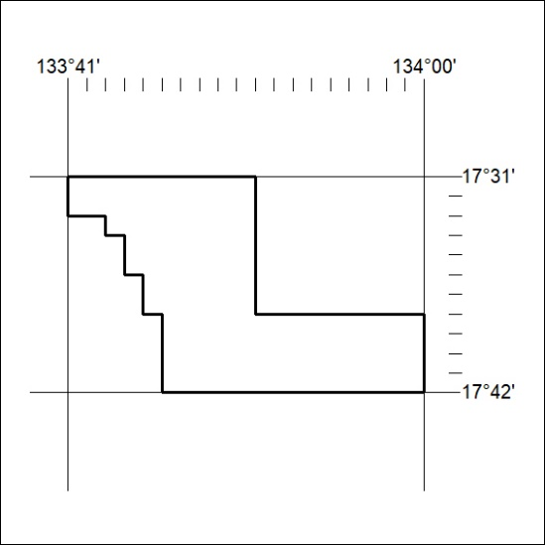

32/24
Mineral Titles Act 2010
NOTICE OF LAND CEASING TO BE A MINERAL TITLE AREA
Title Type and Number: | Exploration Licence 32158
Area Ceased on: | 04 February 2024
Area: | 16 Blocks, 52.29 km²
Locality: | HELEN
Name of Applicant(s)/Holder(s): | 100% BAUDIN RESOURCES PTY LTD [ACN. 618 455 593]
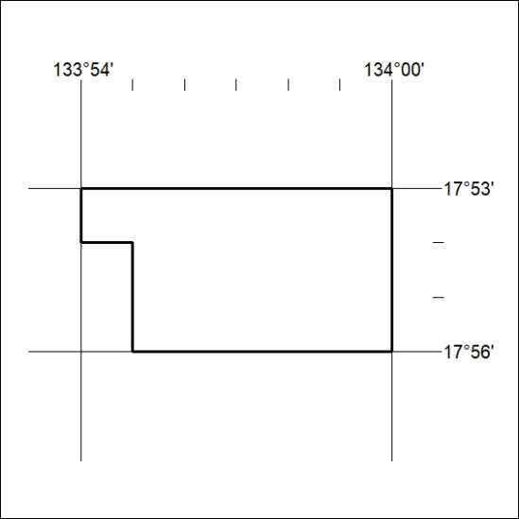

33/24

Mineral Titles Act 2010
NOTICE OF LAND CEASING TO BE A MINERAL TITLE AREA
Title Type and Number: | Exploration Licence 32159
Area Ceased on: | 04 February 2024
Area: | 111 Blocks, 363.77 km²
Locality: | BEETALOO
Name of Applicant(s)/Holder(s): | 100% BAUDIN RESOURCES PTY LTD [ACN. 618 455 593]
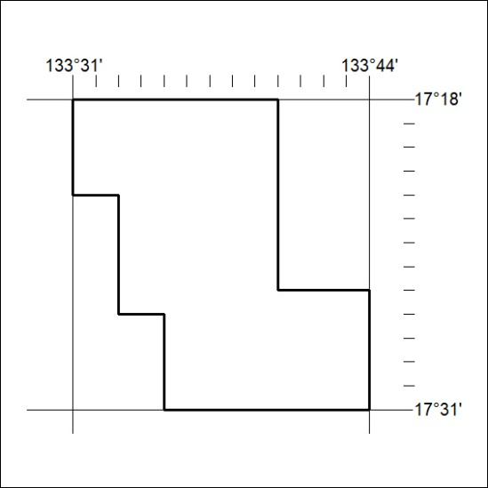

34/24

Mineral Titles Act 2010
NOTICE OF LAND CEASING TO BE A MINERAL TITLE APPLICATION AREA
Title Type and Number: | Exploration Licence 33229
Area Ceased on: | 09 February 2024
Area: | 189 Blocks, 620.69 km²
Locality: | BULOONUNGROO
Name of Applicant(s)/Holder(s): | 100% GREEN CRITICAL MINERALS LIMITED* [ACN. 118 788 846]
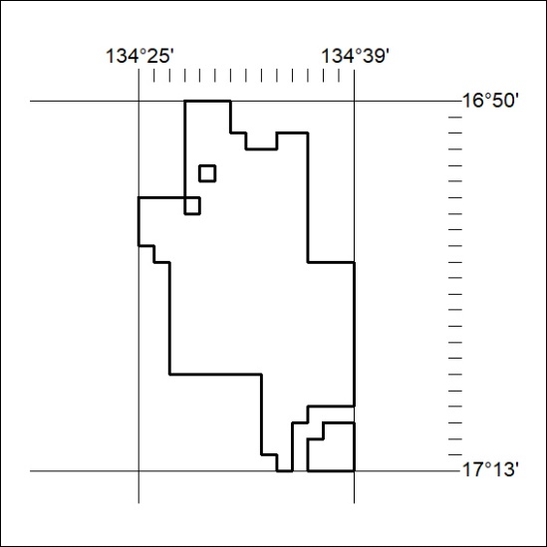

35/24

Mineral Titles Act 2010
NOTICE OF LAND CEASING TO BE A MINERAL TITLE APPLICATION AREA
Title Type and Number: | Exploration Licence 33230
Area Ceased on: | 09 February 2024
Area: | 184 Blocks, 603.66 km²
Locality: | BULOONUNGROO
Name of Applicant(s)/Holder(s): | 100% GREEN CRITICAL MINERALS LIMITED* [ACN. 118 788 846]
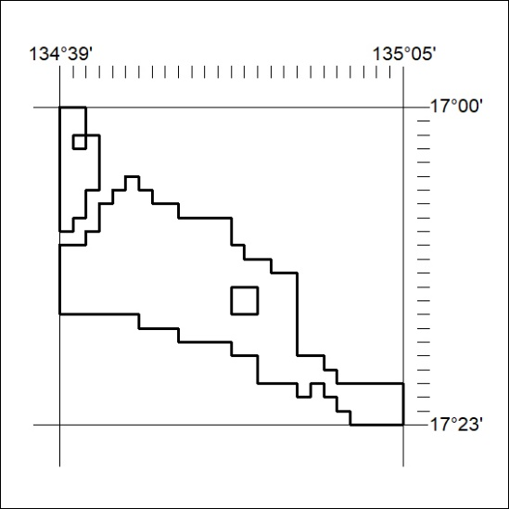

36/24

